Hi, I have 2 problems on drupal “Toyota-hawaii” project

1. All the images are not displayed when I go to the home page:

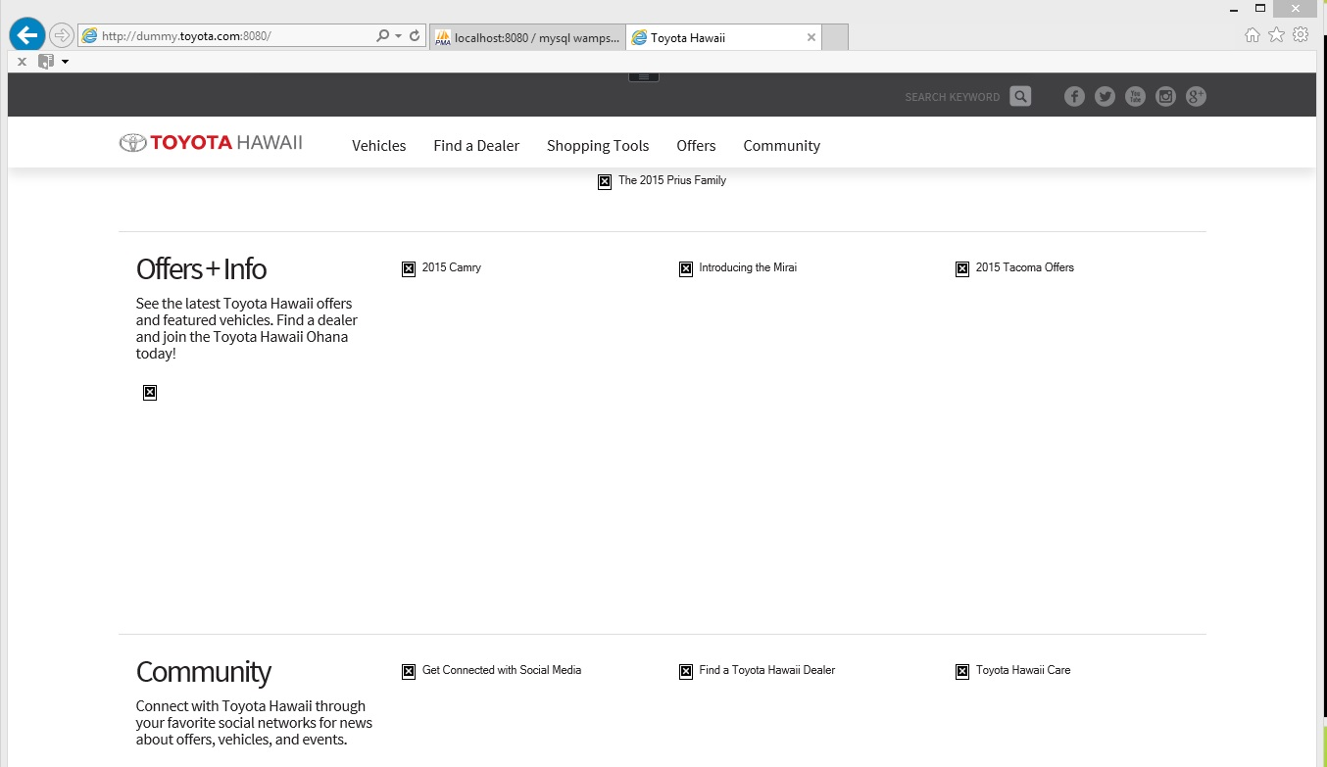

1. When I go to Vehicles 🡪 “pick a car for example 2015 Corolla” 🡪 Build

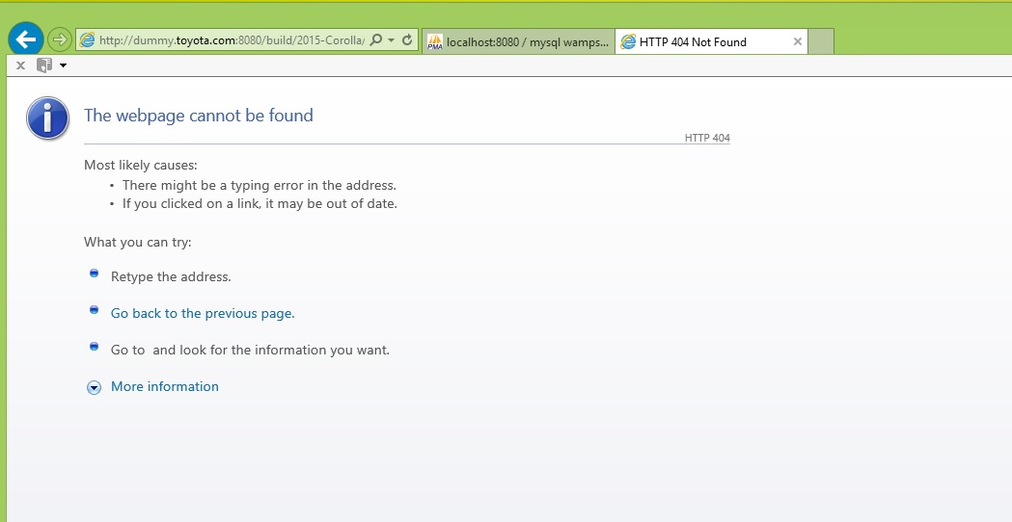

So, something is wrong. But the following pages I will explain what I did to setup the project:

1. I made sure my virtual hosts were working by doing the following:

(1A) Inside file C:\Windows\System32\drivers\etc\hosts, I added

127.0.0.1 localhost

127.0.0.1 dummy.cheeseburger.com

127.0.0.1 dummy.hotdog.com

127.0.0.1 dummy.chicken.com

127.0.0.1 dummy.toyota.com

(1B) Inside file C:\wamp\bin\apache\apache2.4.9\conf\httpd.conf

This is some of the settings:

# DocumentRoot: The directory out of which you will serve your

# documents. By default, all requests are taken from this directory, but

# symbolic links and aliases may be used to point to other locations.

#

DocumentRoot "c:/wamp/www/"

# Listen: Allows you to bind Apache to specific IP addresses and/or

# ports, instead of the default. See also the <VirtualHost>

# directive.

#

# Change this to Listen on specific IP addresses as shown below to

# prevent Apache from glomming onto all bound IP addresses.

#

#Listen 12.34.56.78:80

Listen 0.0.0.0:8080

Listen [::0]:8080

# Virtual hosts

Include conf/extra/httpd-vhosts.conf

(1C) Inside file C:\wamp\bin\apache\apache2.4.9\conf\extra\httpd-vhosts.conf

This is what my file looks like:

<VirtualHost *:8080>

ServerAdmin webmaster@dummy-host.example.com

DocumentRoot "C:\wamp\www\AAAAA"

ServerName dummy.cheeseburger.com

ErrorLog "logs/dummy.cheeseburger.com-error.log"

CustomLog "logs/dummy.cheeseburger.com-access.log" common

</VirtualHost>

<VirtualHost *:8080>

ServerAdmin webmaster@dummy-host2.example.com

DocumentRoot "C:\wamp\www\BBBBB"

ServerName dummy.hotdog.com

ErrorLog "logs/dummy.hotdog.com-error.log"

CustomLog "logs/dummy.hotdog.com-access.log" common

</VirtualHost>

<VirtualHost *:8080>

ServerAdmin webmaster@dummy-host3.example.com

DocumentRoot "C:\wamp\www\CCCCC"

ServerName dummy.chicken.com

ErrorLog "logs/dummy.chicken.com-error.log"

CustomLog "logs/dummy.chicken.com-access.log" common

</VirtualHost>

<VirtualHost *:8080>

ServerAdmin webmaster@dummy-host4.example.com

DocumentRoot "C:\wamp\www"

ServerName dummy.toyota.com

ErrorLog "logs/dummy.toyota.com-error.log"

CustomLog "logs/dummy.toyota.com-access.log" common

</VirtualHost>

(1D) I made a new folder C:\wamp\www\AAAAA

And put inside it a new file called index.php which looks like this:

<!DOCTYPE html>

<html>

<body>

<?php

echo "A";

echo "A";

echo "A";

echo "A";

echo "A";

?>

</body>

</html>

(1E) I made a new folder C:\wamp\www\BBBBB

And put inside it a new file called index.php which looks like this:

<!DOCTYPE html>

<html>

<body>

<?php

echo "B";

echo "B";

echo "B";

echo "B";

echo "B";

?>

</body>

</html>

(1F) I made a new folder C:\wamp\www\CCCCC

And put inside it a new file called index.php which looks like this:

<!DOCTYPE html>

<html>

<body>

<?php

echo "C";

echo "C";

echo "C";

echo "C";

echo "C";

?>

</body>

</html>

(1G) I cleared my internet explorer cache.

I did ipconfig /flushdns

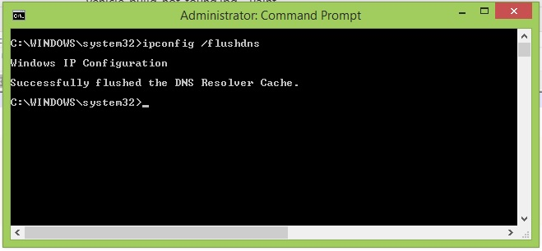

And then I did a “Restart All Services” on my WAMPServer

So now when I use my web-browser and go to

<http://dummy.cheeseburger.com:8080>

or

<http://dummy.hotdog.com:8080>

or

<http://dummy.chicken.com:8080>

I proved to myself that I successfully setup virtual hosts on my machine for Apache,

Because I get the following in internet-explorer web-browser:

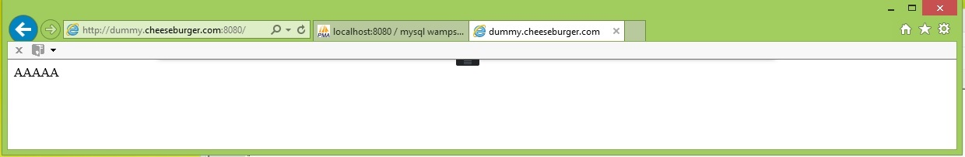

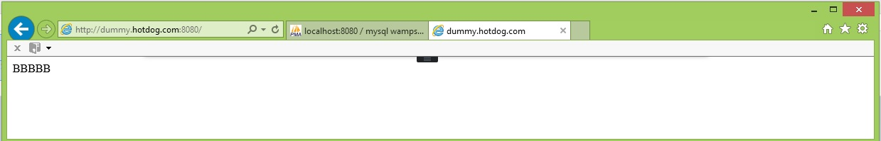

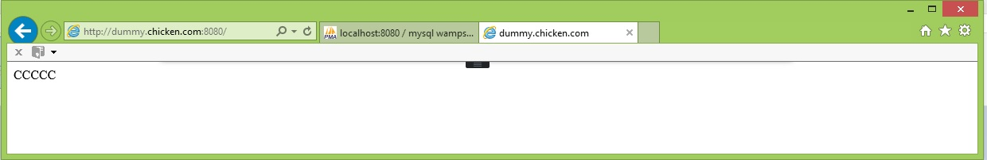

Ok so in the next pages, I get the code from github.

1. Ok, so then I went to github and got the latest code from

<https://github.com/RevaComm/toyota-hawaii>

and made sure all the code was inside

C:\wamp\www

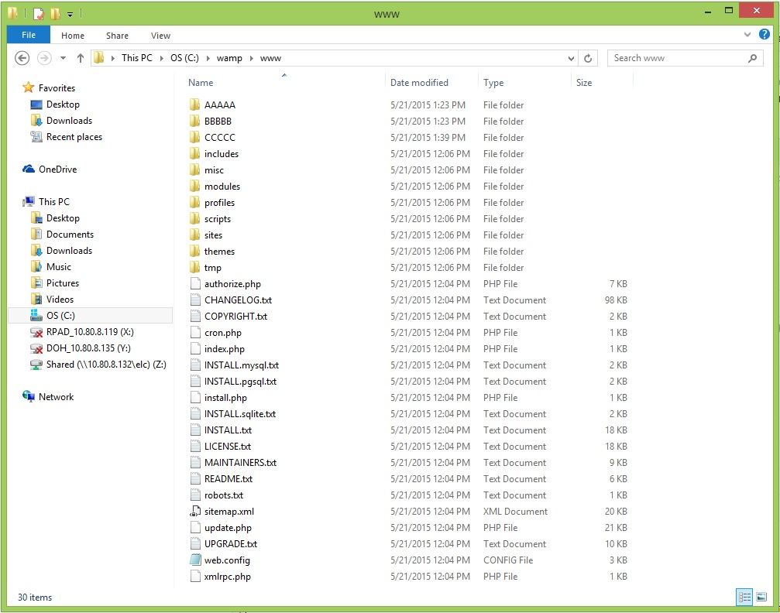

1. I went to my WAMP MySql using phpMyAdmin and created a user called

reva01sa

And granted reva01sa all Global privileges and power.

And then I created a new database called

toyota_live

And then I unzipped the email file attachment I got from Luke on May18,2015 and then imported into database toyota_live with the script called

toyota_live.sql

And the database was successfully updated:

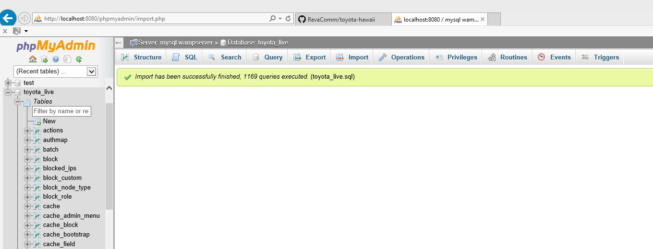

1. I copied the file

C:\wamp\www\sites\default\default.settings.php

To

C:\wamp\www\sites\default\settings.php

And then inside settings.php I made the following settings:

$databases = array (

'default' =>

array (

'default' =>

array (

'database' => 'toyota_live',

'username' => 'reva01sa',

'password' => 'abc',

'host' => 'devtwo',

'port' => '3306',

'driver' => 'mysql',

'prefix' => '',

),

),

);

$base_url = 'http://dummy.toyota.com:8080'; // NO trailing slash!

Ok so now I did a

1. Ipconfig /flushdns
2. Cleared my internet explorer cache again
3. And restarted all of my WAMP services again

Just to be on the safe side because I can get a little too paranoid

But when I go to <http://dummy.toyota.com:8080> I do not get all the images:



And when I go to click on Vehicles🡪Camry 2015🡪Build I get page not found:

