# Introduction

## Savannas

Savannas, a terrestrial biome characterized by coexistence of trees in a matrix of grasses, comprise 20% of the world’s land area. Savannas occur on every continent except Antarctica and often have high plant and animal diversity. They provide significant carbon sinks and contribute to human livelihoods through, among other ways, nature based tourism and pastoralism.

Savannas are physiognomically distinct from forests and grasslands, though functional groups features with both. The “savanna problem,” has long puzzled ecologists, and has been variably explained by investigating the mechanisms that control tree / grass competition and coexistence {sarmiento1984ecology}. The processes that control tree / grass coexistence and competition are broadly glossed as niche partitioning and disturbance mediation . In the former, trees and grasses differentially access nutrients and water, allowing for continued coexistence. In the latter, disturbances such as fire, frost, or herbivory serve as bottlenecks that favor grasses, which are more protected from the effects of fire, at the expense of woody plants.

Fire frequency and intensity are known to be linked to precipitation (**CN)**. As rainfall increases, grass biomass increases due to a combination of increased growth of grass and decreased herbivore pressure (**CN)**. Fire intensity, the rate of energy released by a fire, is driven by a number of factors (i.e., wind, fuel arrangement, fuel load, fuel moisture, etc.). In areas where grass is the primary carrier of fire, fire intensity tends to increase with grass biomass, which also increases with rainfall . Although fire frequency and fire intensity are generally considered inversely related (frequent fires reduce fuel accumulation and thus the potential for high intensity fires), in savannas, both tend to increase with rainfall.

Fire can ‘trap’ savanna trees in a persistent subadult state by causing topkill, the aboveground mortality of woody tissue. This can partially explain the abundance of small trees in savannas and the relative paucity of larger trees. Trees can escape this trap to grow into larger life stages, but it is not clear how sensitive the probability of escape is to variation in tree growth rates and fire dynamics.

Ultimately, topkill is a function of growth and disturbance. Trees have to grow sufficiently during fire free periods to reach a height outside of the flaming depth in order survive a fire. Growth is thought to generally increase with precipitation, and the critical height for surviving a fire is consider to be ≥ 1 m (**CN)**. Although bark thickness and other factors do play a role in survivability, height is often considered the *sine qua non* (**CN)**.

## Questions

All of these factors (growth, fire frequency, and fire intensity) might be expected to vary and interact across precipitation gradients, but this has not been investigated to date. This relationship is particularly noteworthy because of the suggestion that fire and other disturbances are more important at controlling woody cover in more mesic savannas and resource limitation is more important in controlling woody cover in more arid savannas {Sankaran:2005gw}. Understanding how co-linear processes interact to affect topkill can help us understand how tree dynamics vary by help

We seek to understand how multiple rainfall-linked processes interact to control the probability of a tree escaping topkill across a range of mean annual rainfall. We model fire frequency, fire intensity, and tree growth, and by doing so, investigate how do these factors interact to affect the likelihood of a tree escaping the cycle of fire-induced topkill and “escape the fire trap”.

# Methods

## Study System

Kruger National Park serves as an ideal study system for questions of savanna fire ecology. Kruger NP is located in eastern South Africa, sharing its eastern borders with Mozambique and northern border with Zimbabwe. The park is over 2 million ha, and spans 350 km from north to south. A north-south rainfall gradient spans the park, peaking at 950 mm yr-1 in the southwest and <400 mm yr-1 at Pafuri in the northeast{Mabunda:2003vc}. The park’s soils vary in productivity based on their parent material: in the west, low fertility granite, and to the east, high fertility basalt{Mabunda:2003vc}.

Fire is common in Kruger NP, and much of it is anthropogenic in origin \cite{VanWilgen:2000tc}. Fires vary in seasonality, intensity, and frequency, and are used by Kruger NP managers to meet specific and general objectives {Govender:2006im, Govender:2003uo}.

The wide rainfall gradient at Kruger National captures much of the range of many of the savannas of sub-Saharan Africa (Figure 1). This makes Kruger an ideal unit of analysis for understanding the drivers and patterns present in savannas across the continent.

## Model description

The model simulates a cohort of trees for a given mean annual rainfall (Figure 2, MAR). The trees grow annually as a function of MAR ({Higgins:2000up, Shackleton:ua}). At each year, rainfall is This rainfall is sampled from a range within the 95% confidence interval of the modeled bivariate relationship between mean fire return interval and MAR at Kruger National Park . Each year, the occurrence of a fire is calculated by sampling from a binomial distribution with a probability equal to the inverse of the sampled mean fire return interval (i.e., the fire frequency (fires yr-1)). If a fire occurs, the intensity of the fire is calculated as a function of MAR following Govender et al. (2006). Probability of topkill was calculated as a function of height and intensity {Higgins:2012fc}.

## Growth rates

We compared three different potential growth scenarios with regard to rainfall: positive, negative, and flat. The initial scenario was first outlined in Higgins et al. (2009) and described a general increase in growth rates (height increments, cm yr-1) across a rainfall gradient. This growth relationship was generalized from a study across South Africa ({Shackleton:ua}). We fit a linear model to this relationship so that we could predict growth rates anywhere along the curve.

For the negative relationship, we searched the available literature for diameter and height increments for a known dry site specialist, *Colophospermum mopane* ({Cowling:1997vb, palgrave1977trees}). We hypothesized that because of their range limitation, decreased growth rates in areas of increased MAR would be observed. Where necessary, we standardized the diameter increments to height increments using height ~ basal diameter relationships taken at Kruger National Park (Cummings and Holdo 2014, Unpublished Data).

For the null relationship, we combined growth rates used in the calibration of the negative and positive models and generated a sequence of values between the lowest and highest growth rates. We then fit a generalized linear model to them that assumes no relationship with rainfall.

To estimate changes in height, we used the same differenced growth rate established by Higgins (2012):



where *h* is height (cm), *h*y-1 is height (cm) from the previous year, *h*max is the maximum tree height (cm), and gs is the growth rate (cm yr-1). We held *h*max at the same value as Higgins (2012), 600 cm.

## Mean fire return interval and MAR

Gridded mean annual rainfall from *worldclim* was overlaid across the rasterized mean fire return interval (MFRI) for Kruger National Park, South Africa {WorldClimversion:2005tr, Smit:2012bs}. Smit et al. (2012)mapped fire extents from a 65 year period at Kruger National Park to calculate mean fire return interval. We modeled MFRI as a function of MAR by fitting a generalized linear model (glm) with a gamma distribution and a log link function. We compared this to a null model (MFRI ~ 1) and selected based on a likelihood ratio test as well as analyses of model suitably plots. We calculated the 95% confidence interval of the relationship between MFRI and MAR and sampled within this space for values relating this bivariate relationship.

## Fire intensity and MAR

After analyzing the results of the ongoing Kruger National Park experimental burn program, Govender et al. (2006) found a positive relationship between MAR and Byram’s fireline intensity. Fire intensity was calculated from a 30 year dataset from Kruger National Park’s Experimental Burn Plots. Byram’s fireline intensity was calculated using *I = Hwr*, with *I* being intensity (kW m-1), *H* is the known energy content of the grasses at Kruger National Park (16,890 J g-1), *w* is the grass biomass in the plot (kg ha-1), and *r* is the rate of spread of the head fire {Byram:1959ws, Govender:2006im}.

We reanalyzed this relationship by fitting a generalized linear model in the base *stats* package {RALanguageandEn:wf}. We related the previously calculated Byram’s fireline intensity to MAR at the site using a gamma distribution for the response variable (fireline intensity). We also calculated a null model (Fireline intensity ~ 1) that assumes no connection between fireline intensity and MAR. After assessing plots of model fit, we compared these two models with likelihood ratio tests.

## Probability of topkill and probability of escape



We calculated probability of topkill as a function of stem height (H) and fireline intensity (I) using Higgins et al. (2012) model (Eqn. 1.2). Their model was calibrated on a dataset of monitored species of different height in the Experimental Burn Plots at Kruger National Park. After an experimental fire treatment, individual-level topkill was recorded and associated with the Byram’s fireline intensity of the fire. Higgins et al. included season (S) as a covariate in their model; we hold this constant as a dry season fire. We parameterize the model with the general, non-species specific β terms, respectively -3.9, 0.05, 0.3, and 1.

We calculate probability of escape by assessing how many trees grew to heights greater than 1 m across all model runs and within binned rainfall values. These counts are divided this by the total amount of trees in each run within the rainfall bins.

## Model sensitivity

We assessed model sensitivity by delinking model components (*i.e.,* growth rates, MFRI, and fire intensity) from rainfall and comparing this to the standard model that includes rainfall-linked variability for call components. We then compare the estimates of probability of escape across rainfall gradients between the standard model and the rainfall delinked models by fitting a linear model with the standard model results as a response variable. These linear models are compared based on R2 values to determine which rainfall-linked variables best explain the results of the standard model.

# Results

## Growth rates

Linear models were fit to growth rate increments as a function of rainfall (Figure 3). *Colophospermum mopane* growth rates were identified from a number of sources and sites and calibrated to estimate height increments (Table 1, Figure 3, {Mushove:1995be, Worbes:1999we}**)**.

## Mean fire return interval and rainfall

Mean fire return interval (MFRI) was shown to generally increase with MAR. Using maximum likelihood estimation, a Gamma distributed model was fit to the relationship between MFRI and MAR (Figure 4). When tested with a likelihood ratio test, this fit significantly better than a null model (MFRI ~ 1, χ2 (1, 24136) = 1672.6, p ≤ 0.01). Fire frequency was calculated as the inverse of MFRI, *i.e.* 1 / MFRI.

## Fire intensity and rainfall

Fire intensity was also found to be Gamma distributed. Maximum likelihood estimation was used to generate gamma distributions as a function of MAR for the Experimental Burn Plots (Figure 5). A likelihood ratio test showed that fire intensity estimations as a function of MAR produced significantly better fits than a null model (Fire Intensity ~ 1, χ2 (1, 1235) = 26.809, p ≤ 0.01). As the model ran, fire intensity distributions were simulated for any input MAR from the model.

## Model sensitivity

## Growth rate variation

# Discussion

# Conclusions

# Acknowledgements

Tables  
Table 1. *Colophospermum mopane* annualradial increment measurements, adjusted height increments, the mean annual rainfall in which the samples were collected, and the studies that collected the data.

|  |  |  |  |  |
| --- | --- | --- | --- | --- |
| Site | MAR (mm yr-1) | Mean Diameter Increment (cm yr-1) | Est. Height Increment (cm yr-1) | Citation |
| Chiredzi, ZM | 564 | 0.21 | 74.44 | Mushove et al. 1995 |
| Kadoma, ZM | 780 | 0.17 | 63.12 | Mushove et al. 1995 |
| Katima Mulilo, NA | 654 | 0.17 | 60.28 | Worbes 1999 |
| Matapos, ZM | 825 | 0.17 | 60.28 | Mushove et al. 1995 |
| Oshikoto, NA | 504 | 0.22 | 77.98 | Mushove et al. 1995 |
| Zambezi Valley, ZM | 750 | 0.18 | 64.53 | Mushove et al. 1995 |

Table 2. Model preset values.

Table 3.

# Figures

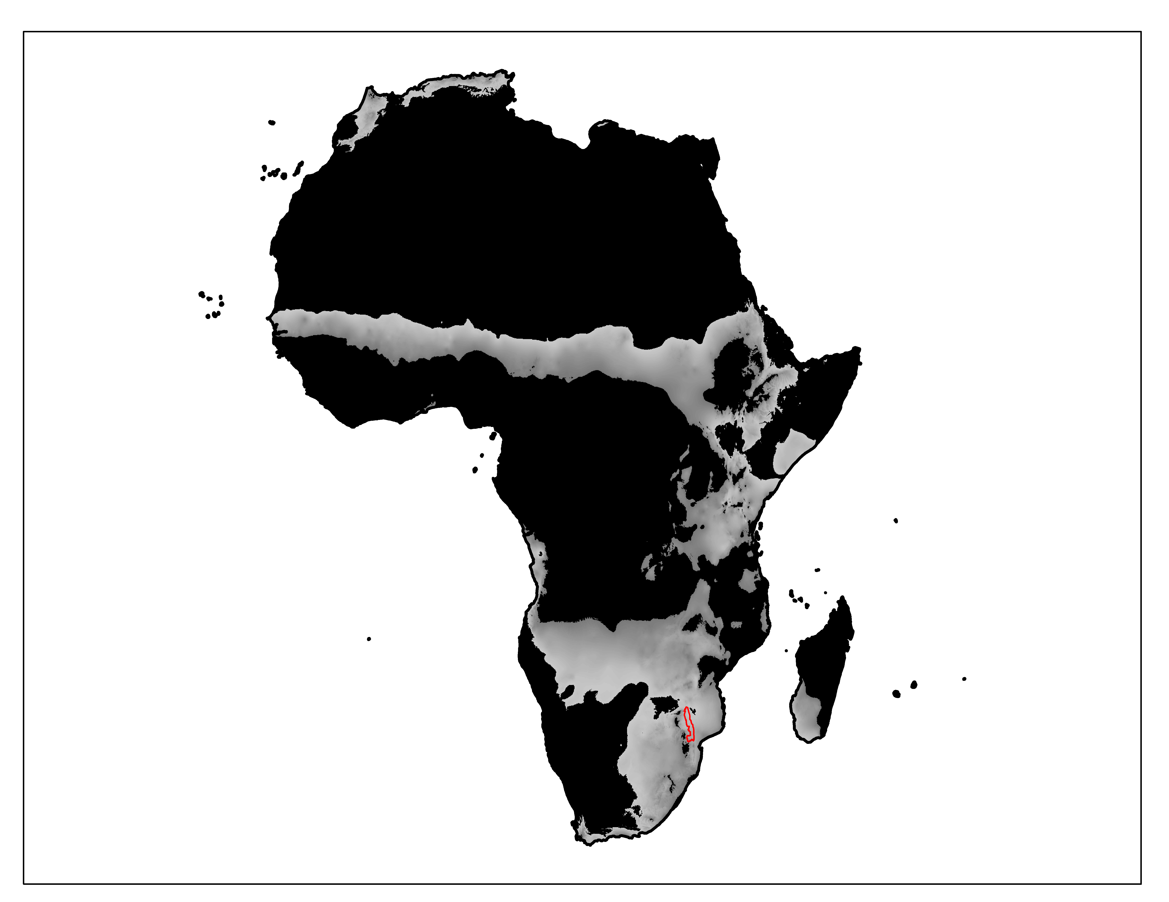Figure 1. Kruger National Park, South Africa (red) serves as an ideal model system for capturing rainfall-linked variation across the savanna biome in Africa by spanning a wide mean annual precipitation gradient (gray, 450 – 900 mm yr-1). Precipitation data from *worldclim.*

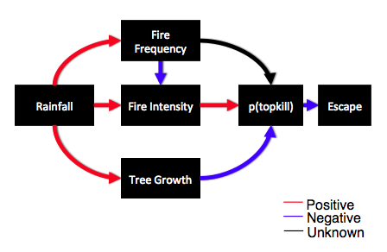

Figure 2. Model flowchart.

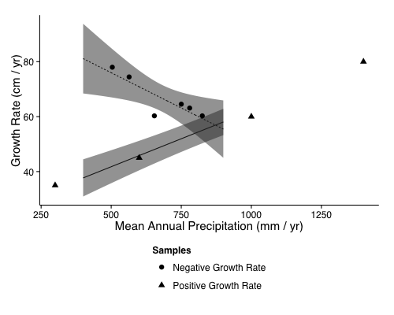

Figure 3. Samples (points) and linear models (lines) fit to positive growth rates (y = 0.04x + 21.4, R2 = 0.99, F1,2 = 236.7, p ≤ 0.01) and negative rainfall-linked growth rates (y = 0.05 + 101.6, R2 = 0.74, F1,4 = 11.56, p = 0.02). Models were predicted across the rainfall area of interest, 450 – 900 mm yr-1. Gray areas show 95% CI.

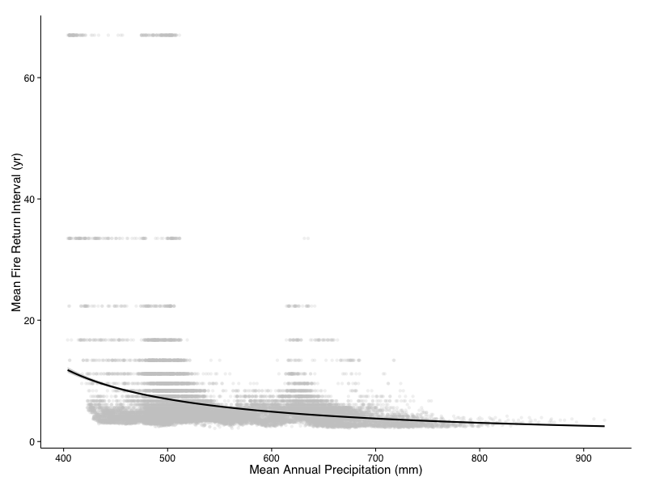Figure 4. Estimated mean fire return intervals as a function of MAR (gray) and the true values as extracted from Smit et al. (2012) and *worldclim*.

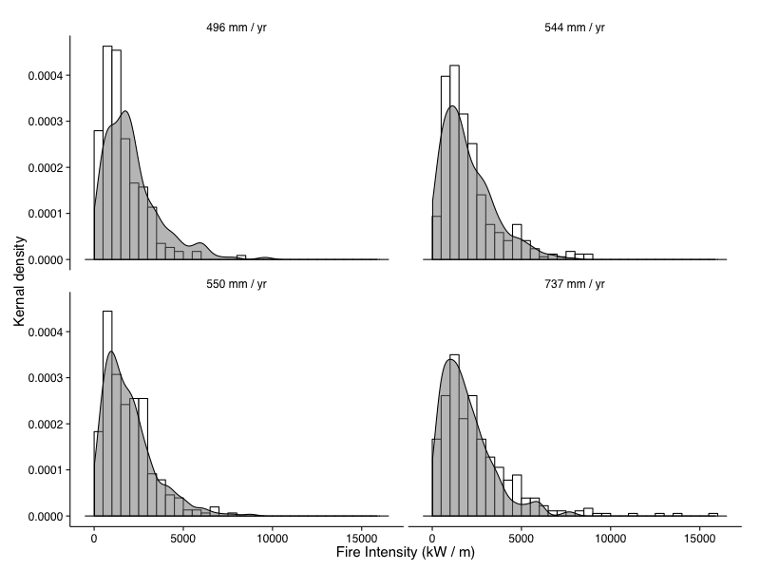

Figure 5. Estimated distributions Byram’s fireline intensity (gray) and the true values (white) as recorded at four different cites of varying rainfall.

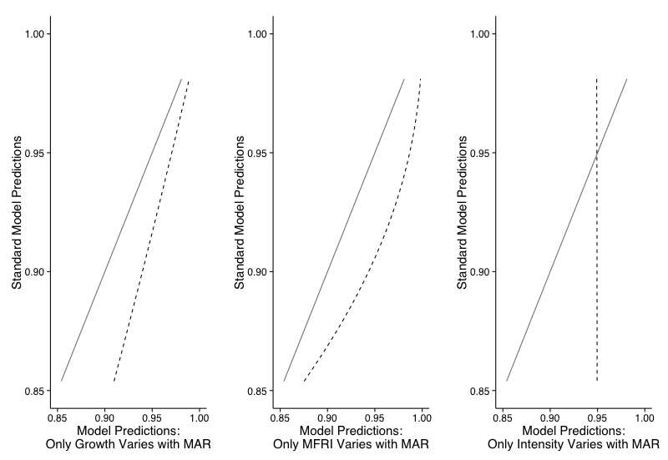

Figure 6. Sensitivity analysis.

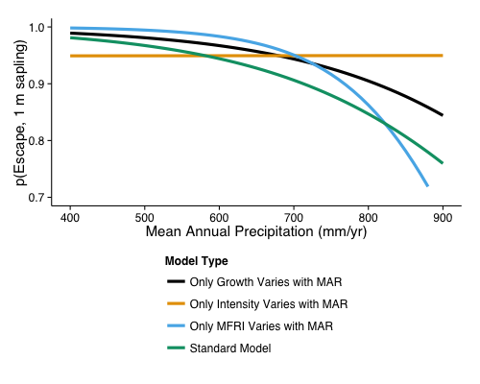

Figure 7. Results of sensitivity analysis. Model was rerun with only growth (black), intensity (orange), and MFRI (blue) varying with rainfall. Green line represents the results of a “standard” model run that includes rainfall-linked variation in MFRI, intensity, and positive growth rates.

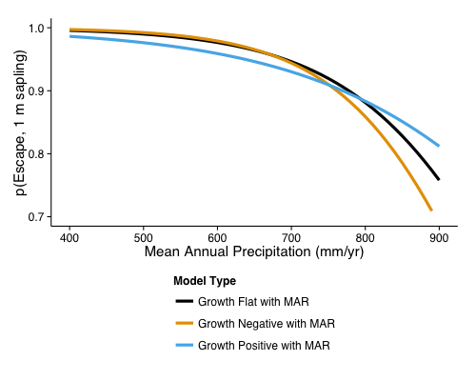

Figure 7. Variation in probability of topkill as a function of rainfall with three different growth-responses relative to rainfall. All other variables (MFRI and intensity) also vary with rainfall.

# Works Cited