https://github.com/danielgabor99/FLCD/tree/master/Lab2

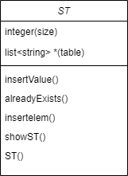

My ST is represented by a hash table with chaining. The hash table is an array of linked lists, each index has its own linked list.

void insertItem(string value):

Inserts a non existent element in the st

Pre: the element to be inserted

Post: the st with the inserted item

bool alreadyexists(string value):

Boolean that returns if a element is present already in the st

Pre: the element to be inserted

Post: true or false

int hashFun(string value):

The hash function that returns the index in st of the value

Pre: the value

Post: the index in the st

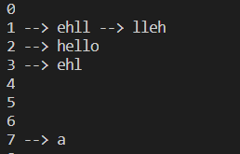void showST():

The print of the st

Pre:

Post: the st