https://github.com/danielgabor99/FLCD/blob/master/Lab3/scanner.cpp

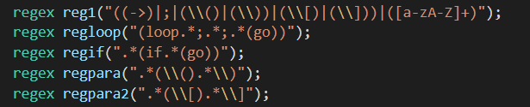

For lab3, to match my tokens I used regular expressions (regex).

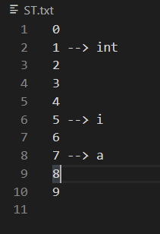

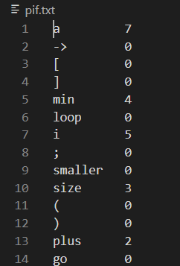

If the tokens exists in token.txt, it will be added in pif.txt, if not, it will be added in the st.txt (lab2) and pif.txt, as a identifier, with the index from the ST.

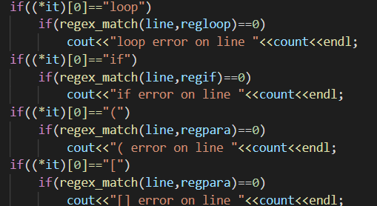

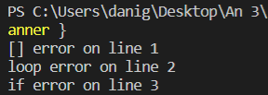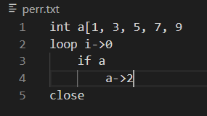For the lexicals errors I used regex_match.