|  |
| --- |
| Automata |
| Vector<string>(states)  Vector<string>(alphabet)  String (initialState)  Vector<string>(finalStates)  Vector<Transition>(transitions) |
| + void readFa()  + bool isDeterministic()  +void checkSequence() |

My Automata consists in a list of states, alphabets, final states and transitions;

https://github.com/danielgabor99/FLCD/tree/master/Lab4

bool isDeterministic():

Checks if it is deterministic of not, if yes, will return true, false otherwise.

Pre: the fa.

Post: true or false depending if it is deterministic or not.

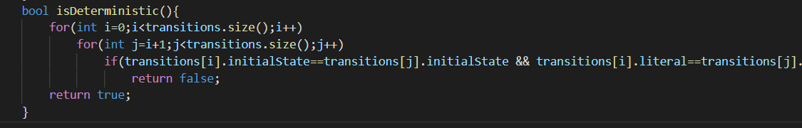

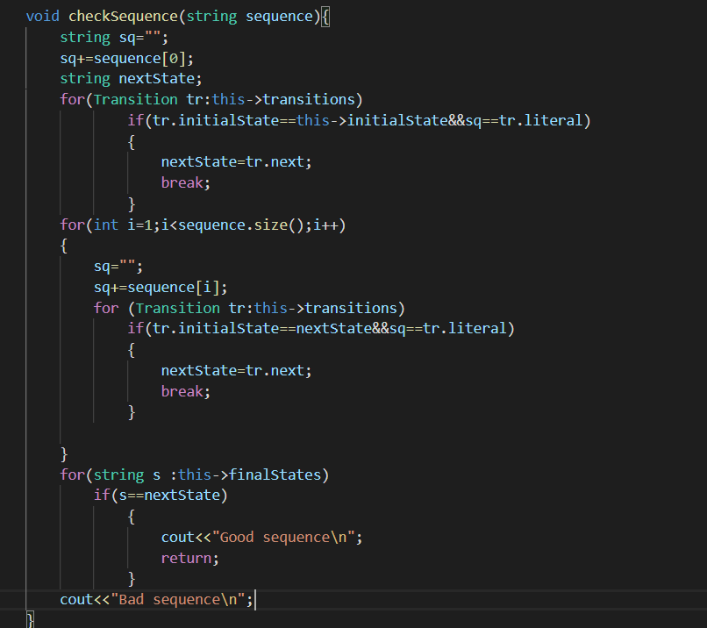

void checkSequence(sequence):

Checks if the sequence is valid

Pre: the sequence

Post: the validity of the sequence

q0,q1,q2,q3,q4

a,b,c

q0

q3

q0,a,q1

q1,b,q2

q2,c,q3

q3,a,q4