How The Upcoming Fed Interest Rate Hike Will Move Stock Prices - What You Need To Know

While having little economic effect in the short term, fear and anticipation of rising interest rates contribute to fear and volatility in the stock market.

The long term effects will be a reduction of price to earnings ratios. Stock market PE levels will drop by 6%-8% for every single point increase of interest rates.

The Federal reserve is planning to raise interest rates either in a few weeks time in September or possibly December. Either way, interest rates will begin to rise before the end of 2015. Recent market volatility may be influenced by anticipation of these events. Looking at historic valuations of the S&P500 stock market index, as well as previous interest rate hikes, can be helpful in establishing expectations of how interest rates levels will affect the stock market in the months and years to come. In this article, I will try to share some historical data, as well as how this information may be helpful.
The Summary
Rising interest rates create a downward drag on stock prices by reducing price to earnings (PE) ratios. This relationship is relatively predictable over the long term (years). Historically, PE ratios are reduced roughly by 6%-8% for each point of interest rate gained. In the short term (months) small changes in the federal funds rate do not seem to have a significant effect on stock prices. Upwards shifts in the Federal reserves management of interest rates can reduce stock price levels a little (e.g. by -5%-7%) as the market assimilates this new information. After a few months however, earnings again take over as the predominant force in determining stock prices, along with the previously mentioned change in market PE ratios.
The upcoming Fed rate hike is notable in a few ways; it follows a tremendous bull market, as well as an unprecedented low period of near zero interest rates. As such, anticipation of the upcoming Fed announcement of raising the interest rate target is greater than ever. This elevated anticipation may lead to more significant volatility in the short term.
Investors can choose to take advantage of these unfolding events by either going long on the S&P500 index (SPY,IVV) if they believe that corporate earnings are likely to grow over the long term. Such investors should keep in mind that price growth may be slowed due to rising interest rates. Conversely, if investors believe that interest rates will push prices down (and corporate earnings are likely to stay stagnant or drop), they may look to short SPY or IVV.

The Details
By far the most important determinant of stock prices are corporate earnings. Looking over the past century, stock market prices tend to trade at a multiple of around 15 times earnings. This multiple will be pushed higher or lower depending on many variables. One such example is the growth rate of earnings. During times of earnings growth, market PE gets pushed up. Another variable that can edge market PE ratios higher or lower are interest rates. Low interest rates can push market PE ratios up to 20 or above (as we have seen over the past few years), and high interest rates can push market PE ratios down to 10-12 times earnings, or even lower.
The following graph shows the S&P 500 PE ratio over the 30 year span 1980-2010 compared to the effective federal funds rate at the time. This allows to observe the inverse relation between PE ratios and interest rates. When the federal funds rate goes up, market PE ratios tend to go down, and vice versa.
(click to enlarge)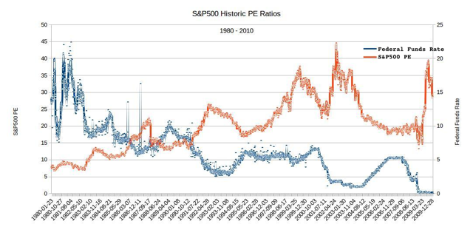
(Historical federal funds rate from the Federal Reserve Bank of St. Louis, S&P500 earnings from S&P Dow Jones Indices)
There are multiple reasons for this. One way that stock prices are affected by higher interest rates, is that higher interest rates translate into more expensive loans, making the recycling of debt, as well as new debt, more expensive. Another reason is that government bonds become a more attractive investment, and therefore divert money away from other investments. Higher interest rates can therefore result in less money flowing into the stock market, resulting in lower demand for stocks, and lower prices.
Since the most important determinant of stock prices are corporate earnings, if corporate earnings continue to grow, so will stock prices. However, in a higher interest rate environment, the growth in stock prices will be dampened. The price damping effect of interest rates develops over time. With a prolonged period of rising interest rates ahead of us, this damping effect will grow more the longer interest rates will rise, as well as the higher they go. Looking at the S&P 500 index, we can expect PE ratios to go down as interest rates go up. The Fed has indicated that they will raise interest rates gradually, at about one percentage point a year over the next three years. If we assume that earnings growth will continue at a mild pace, we might still expect to see PE ratios drop to by one earnings multiple per year.
While the long term market will be affected by future earnings and future interest rates, there is one market event that will have a strong effect in the short term; a drop in prices due to anticipation of the Federal Open Market Committee's (FOMC) announcement of a rate hike. Many money managers are eagerly awaiting the Fed's announcement, and looking to avoid the foreseeable price decline it will create. In the short term (until the end of 2015), this anticipation of the Fed's announcement, as well as the announcement itself, will be the most significant influence interest rates will have on the stock market.
To get a better idea of what this effect might look like, we can look at past rate hikes. One of the first things to notice when inspecting historical interest rates, is the limited relevance they have. The Fed has made some changes in the way it operates over the past few decades. The Fed has become a lot more communicative about its intentions, as well as placing a lot more importance on consistency and predictability of its actions. Thirty years ago, the Fed did not lay out such long term plans for interest rates. Over time, the FMOC has moved from an almost weekly tinkering of interest rate targets, to a clearer, more consistent long term announcement of its policies. In recent decades, we have seen more and more long term periods of stable interest rates. The most recent 7 year consistent zero rate (officially a federal funds rate target range of 0.0% to 0.25%, and effectively around 0.13%) is unprecedented. Therefore, the upcoming rate hike is perhaps the most anticipated rake hike ever, as well as following the longest period of consistently low rates.
Historic stock prices following previous interest rate hikes roughly follow a similar pattern: A drop of 5%-7% in market price around two months following the rate hike, and a market PE reduction of 6%-8% for every interest rate point raised within a year. Over the long term, corporate earnings predominantly determined price levels with interest rates weighing on PE ratios as described.
A closer look at the last rate hike, 2004
Keeping in mind that the upcoming rate hike is different compared to previous ones, we can look at previous announcements from the Fed regarding raising interest rates. The last time that this happened was over a decade ago, when on June 30th 2004, the FMOC announced it was raising the federal funds rate target by a quarter of a percent to 1.25%. Since then, the Fed eventually raised its rate target to just over 5% in mid 2006 followed by at first slow, and then rapid, reductions. The last, and most dramatic rate reduction was on December 16th 2008, when the current zero rate was announced.
(click to enlarge)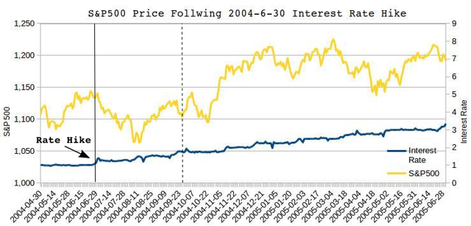
The above graph shows the S&P500 index price from two months prior, to a year after the most recent rate hike in June 2004. The vertical black line indicates the date of the rate hike (June 30th) and the vertical dashed line indicates September 30th, three months after the rate hike.
It is worth noting that in 2004, the stock market had just started turning bullish following a turn around from a market bottom in 2003. This period of rising interest rates was accompanied by rising corporate earnings. Market PE on June 30th 2004 was 23.4. Two months after the Fed's announcement, the S&P 500 index price reached a low of 1060, a drop of 7%. After one year, the previous high PE of 23.4 went down to 20.3, a 13% drop, or -6% for every interest rate point raised during the year. Rising corporate earnings resulted in eventual price gains, but prices then remained stagnant for a year at around 1,200 points, or 5% above price levels prior to raising interest rates.
Other historical rate hikes
The last rate hike before 2004 was a relatively brief period of rising interest rates in 1999, towards the end of the great bull market of the dot com boom of the late 1990s. This brief period at the end of the greatest bull market in history may not be very indicative of the current stock market environment. The S&P 500 first rose from a price of 1,372 points to 1,400 before dropping to 1,300, or 5% lower, two months after interest rates began to rise. In one year the S&P500 PE dropped from a very high 34 to (a still high) 29, or -8% less for each point of interest rate gained.
Other rate hikes in 1994, 1988, as well as farther back, follow a similar patter as well.
However, the upcoming rate hike is different. The federal funds rates, has been at around 0.1% for seven years, a historicity low level, and a historically long duration. Over this same time, the Fed also embarked on the “Quantitative easing” programs, fueling markets with money (at least 2.5 trillion of which are still held in excess reserves). Finally, the upcoming rate hike is follows a very strong bull market. The anticipation of this upcoming rate hike is arguably equally unprecedented. In such, the anticipation alone may be fueling much market volatility even before rates are actually elevated. It is also possible that this mounting anticipation will contribute to a greater price drop following the announcement, compared to the historic rate changes mentioned.
The Bottom Line
If we take the historical rate hikes as predictors of the upcoming rate hike, we should expect a slight reduction in market prices within 3 months of the Federal Reserve announcement of higher interest rates. It can be argued however that the upcoming rake hike will have a more severe influence on market prices. In the long term, a reduction in PE ratios of about 6%-8% a year can be expected, as the long term increase of interest rates is expected to be at, or just above, one percentage point a year. Over time, corporate earnings will determine price levels, but PE's can be expected to be lower due to rising interest rates.

