Django Tutorial

# Introduction

This is a tutorial that follows Corey Schafer’s Django series videos.

Video series: <https://www.youtube.com/watch?v=UmljXZIypDc&list=PL-osiE80TeTtoQCKZ03TU5fNfx2UY6U4p>

Youtube Channel : <https://www.youtube.com/channel/UCCezIgC97PvUuR4_gbFUs5g>

Code snippets : <https://github.com/CoreyMSchafer/code_snippets/tree/master/Django_Blog/snippets>

# Basics

## Basic Django start commands:

django-admin startproject projectname # creates new project

python manage.py runserver # runs the server

python manage.py migrate # creates a a SQlite3 database for your project.

This will create a new django project.

Making a new app within our django project.

A app basically means a part of our site . For eg. I created a blog app that represent the blog part of our website:

We create a new app with the following way:

We navigate to our project root folder and type in:

**python manage.py startapp blog**



## How do we add paths to our website :

We navigate to our newly created app ‘views.py’ module and add the following:

Think of views as a module that represents what will be shown when you use the functions from it.

from django.shortcuts import render  
from django.http import HttpResponse

def home(request):  
 return HttpResponse('<h1>Blog Home Page</h1>')  
  
def about(request):  
 return HttpResponse('<h1>About Page</

These are functions that will run when we got on home and about page (if we assign those functions to them)

Next step is making a new .py module called ‘urls’ which will contain the path and the functions to the pages.

from django.urls import path # path function from django.urls  
from . import views # '.' means from current folder  
  
urlpatterns = [  
 path('', views.home, name='blog-home'),  
 path('about/', views.about, name='home-about')  
]

The upper code basically makes our website have two more ‘pages’:

/blog/ # when it’s on blog homepage it will execute views.home function

/blog/about # when it’s on the about page it will execute views.about function

To make it work we have to add this path to the main project URL Module:

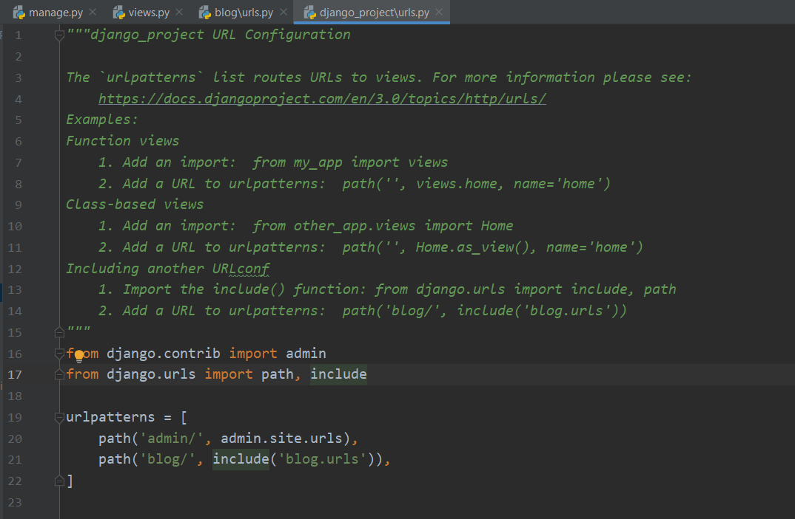

from django.contrib import admin  
from django.urls import path, include  
# The include() function basically references a python module in our case called blogs.url or in other words it MAPS it to our blogs.urls  
urlpatterns = [  
 path('admin/', admin.site.urls),  
 path('blog/', include('blog.urls')),  
]

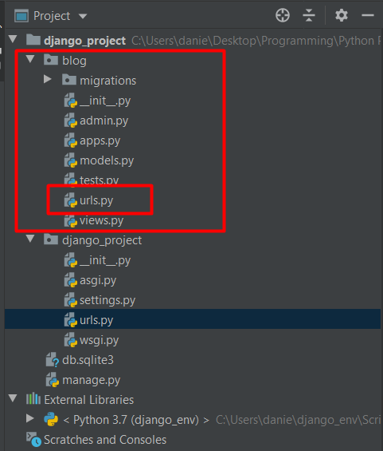

# Templates

## Adding our app config class to the main projects settings module

First we need to add our apps config class to the main project settings.py module.

myapp/apps.py , down below is our class config file

*class* BlogConfig(AppConfig):  
 name = 'blog'

Now we add this to our main project settings.py module

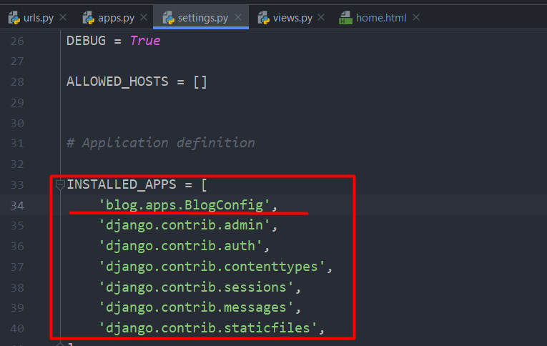

## Making templates

In order to make templates work , we have to add a templates folder inside the app we want to use the templates in our case ‘Blog’ and it should look something like this

eg. desiredapp/templates/desiredapp/

# Note : We have to make another folder in there with our apps name.

Here we are going to add the templates we want to use

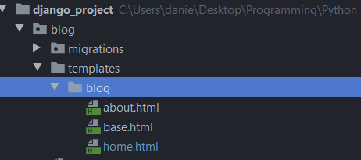

Next we go to our views.py folder and make sure that we use render() on these templates

## Django render() function:

*from* django.shortcuts *import* render

*from* django.http *import* HttpResponse

*def* about(request):  
 *return* render(request, 'blog/about.html')

# Render includes HttpResponse in it’s function

# Basically here when we the user navigates to our blog page this function will handle the request and load about.html file

## Adding dummy data and using it in our templates:

Below we add some dummy data and use it in our blog/templates/blog/home.html file

*from* django.shortcuts *import* render  
*from* django.http *import* HttpResponse  
  
posts=[  
 {  
 'author': 'Ghirasim Daniel',  
 'title': 'Blog Post 1',  
 'content': 'First post content',  
 'date_posted': '31 December, 2019'  
 },  
 {  
 'author': 'Jane Doe',  
 'title': 'Blog Post 2',  
 'content': 'Second post content',  
 'date_posted': '01 January, 2020'  
 },  
  
]  
  
*def* home(request):  
 context = {  
 'posts': posts  
 }  
 *return* render(request, 'blog/home.html', context)

Breaking it down in steps:

1. We make a list of dictionaries containing some dummy data
2. We go into our home function and make a new dictionary called context where we make a key called ‘posts’ and the value we assign to it is our posts list of dictionaries
3. Then we add the context dict as an argument to our return statement

## Accessing data in our templates .html files:

This is how our home.html file looks:

<!DOCTYPE html>  
<html>  
<head>  
 <title>Title</title>  
</head>  
<body>  
 {% for post in posts%}  
 <h1>{{post.title}}</h1>  
 <p>By {{post.author}} on {{post.date_posted}}</p>  
 <p>{{post.content}}</p>  
 {% endfor %}  
</body>  
</html>

### Code blocks in Django:

Code blocks in Django are represented like this :

{% %} – This means we are writing a code in the HTML file

### FOR LOOP in Django:

A Django for loop looks like this:

{% for post in posts%}

{% endfor %}

### VARIABLES in Django:

<h1>{{post.title}}</h1>

The double curly braces means that we want to access a variable

### IF ELSE statements in Django:

<head>  
 {% if title %}  
 <title>Django blog - {{ title }}</title>  
 {% else %}  
 <title>Django Blog</title>  
 {% endif %}  
</head>

We define title in our views.py:

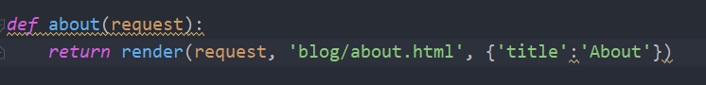

With the IF ELSE statement we say:

If we have a title print ‘Django Blog – {title}’ else print ‘Django Blog’

And it will look like this if we have a title:



and if we don’t have one:



## Template Inheritance - Base Template – Making our life easier

Making a base template helps us reduce the amount of code we have to write . We can make a base.html file from which our other .html **will inherit from** so if we modify the base.html file the other ones will automatically get modified.

We add to this base.html file all the things that are going to be constant troughout all of our .html files for eg:

<head>  
 {% if title %}  
 <title>Django blog - {{ title }}</title>  
 {% else %}  
 <title>Django Blog</title>  
 {% endif %}  
</head>

We want this if statement for all of our website.

### How does a base template work

This is how our base.html looks after some editing:

<!DOCTYPE HTML PUBLIC "-//W3C//DTD HTML 4.01 Transitional//EN"  
 "http://www.w3.org/TR/html4/loose.dtd">  
<html>  
<head>  
 {% if title %}  
 <title>Django blog - {{ title }}</title>  
 {% else %}  
 <title>Django Blog</title>  
 {% endif %}  
</head>  
<body>  
 {% block content %}{% endblock %}  
</body>  
</html>

Between the block content code we are going to set each or .html files information.

for eg. home.html will look like this:

{% extends 'blog/base.html' %}   
{% block content %}  
 {% for post in posts%}  
 <h1>{{post.title}}</h1>  
 <p>By {{post.author}} on {{post.date_posted}}</p>  
 <p>{{post.content}}</p>  
 {% endfor %}  
{% endblock content %}

We deleted everything that is found in base.html and are that we are left with is the actual code we want to run on the page.

{% extends 'blog/base.html' %}

This tells our home.html file that it **extends** base.html and after that we add:

{% block content %}  
 # We add our home.html code here  
{% endblock content

{% block content %} this refers to the CONTENT BLOCK we can have several blocks in a template file.

like {% block posts %} {% block pictures %} (have to verify this).

This is how our about page looks.

{% extends 'blog/base.html' %}  
{% block content %}  
 <h1>About Page!</h1>  
{% endblock content %}

Notice we reduced the code drastically by using template inheritance.

## Bootstrap

Bootstrap is a extremely popular library which makes it easy to add some nice styles to your website.

Basically we drag and drop the Bootstrap starter template into our base.html file . (It does some magic and it works).

#### Starter template:

<!doctype html>

<html lang="en">

<head>

<!-- Required meta tags -->

<meta charset="utf-8">

<meta name="viewport" content="width=device-width, initial-scale=1, shrink-to-fit=no">

<!-- Bootstrap CSS -->

<link rel="stylesheet" href="https://stackpath.bootstrapcdn.com/bootstrap/4.3.1/css/bootstrap.min.css" integrity="sha384-ggOyR0iXCbMQv3Xipma34MD+dH/1fQ784/j6cY/iJTQUOhcWr7x9JvoRxT2MZw1T" crossorigin="anonymous">

<title>Hello, world!</title>

</head>

<body>

<h1>Hello, world!</h1>

<!-- Optional JavaScript -->

<!-- jQuery first, then Popper.js, then Bootstrap JS -->

<script src="https://code.jquery.com/jquery-3.3.1.slim.min.js" integrity="sha384-q8i/X+965DzO0rT7abK41JStQIAqVgRVzpbzo5smXKp4YfRvH+8abtTE1Pi6jizo" crossorigin="anonymous"></script>

<script src="https://cdnjs.cloudflare.com/ajax/libs/popper.js/1.14.7/umd/popper.min.js" integrity="sha384-UO2eT0CpHqdSJQ6hJty5KVphtPhzWj9WO1clHTMGa3JDZwrnQq4sF86dIHNDz0W1" crossorigin="anonymous"></script>

<script src="https://stackpath.bootstrapcdn.com/bootstrap/4.3.1/js/bootstrap.min.js" integrity="sha384-JjSmVgyd0p3pXB1rRibZUAYoIIy6OrQ6VrjIEaFf/nJGzIxFDsf4x0xIM+B07jRM" crossorigin="anonymous"></script>

</body>

</html>

#### Adding bootstrap to our base.html

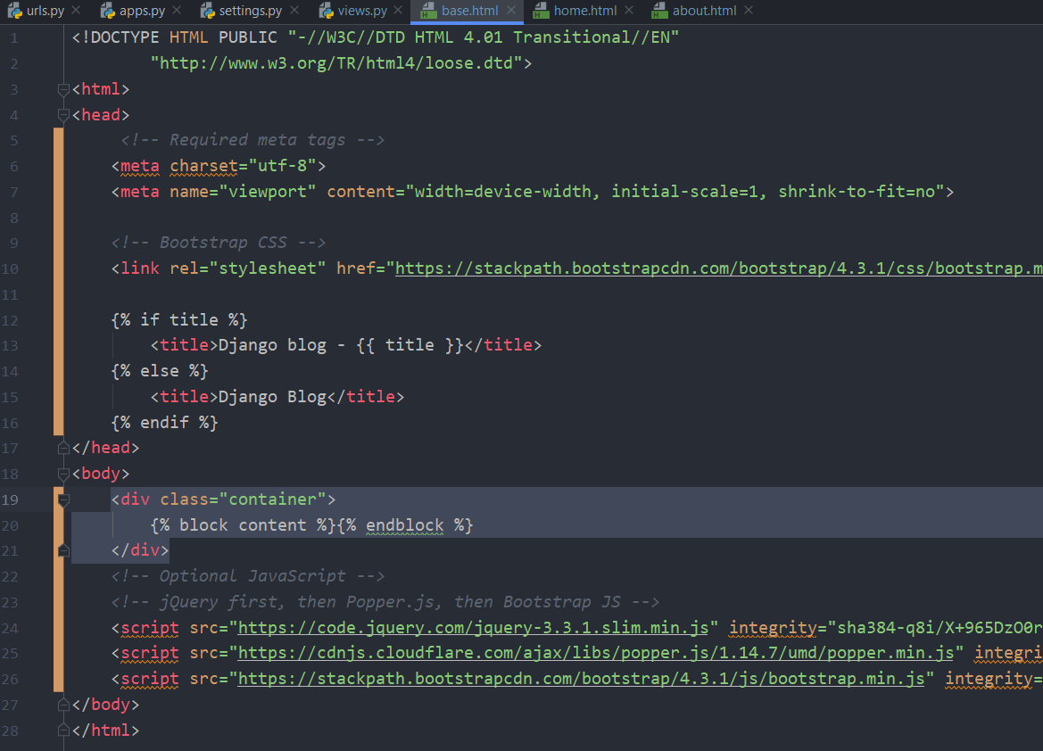

Notice we added our block content between <div> tags . I don’t really know the magic behind this but after the first div tag we add a class called ‘class=”container”’ (This gives our content some good padding and spacing)

After adding this I noticed the text moves slightly to the right.

## Adding a navigation bar

This is the template for a navigation bar:Top of Form

Bottom of Form

Top of Form

Bottom of Form

|  |  |
| --- | --- |
|  | <header class="site-header"> |
|  | <nav class="navbar navbar-expand-md navbar-dark bg-steel fixed-top"> |
|  | <div class="container"> |
|  | <a class="navbar-brand mr-4" href="/">Django Blog</a> |
|  | <button class="navbar-toggler" type="button" data-toggle="collapse" data-target="#navbarToggle" aria-controls="navbarToggle" aria-expanded="false" aria-label="Toggle navigation"> |
|  | <span class="navbar-toggler-icon"></span> |
|  | </button> |
|  | <div class="collapse navbar-collapse" id="navbarToggle"> |
|  | <div class="navbar-nav mr-auto"> |
|  | <a class="nav-item nav-link" href="/">Home</a> |
|  | <a class="nav-item nav-link" href="/about">About</a> |
|  | </div> |
|  | <!-- Navbar Right Side --> |
|  | <div class="navbar-nav"> |
|  | <a class="nav-item nav-link" href="#">Login</a> |
|  | <a class="nav-item nav-link" href="#">Register</a> |
|  | </div> |
|  | </div> |
|  | </div> |
|  | </nav> |
|  | </header> |

We are going to add this to the base.html file , we are going this between the body tags of our base.html

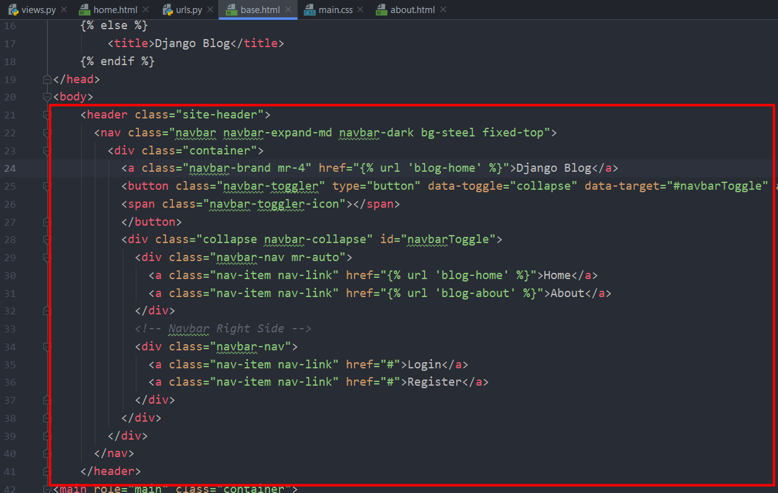

## Content Block Styling – Adding a main section for content block styling.

We are going to replace our content block section of base.html with some prewritten code to make it look nicer :

|  |
| --- |
| <main role="main" class="container"> |
|  | <div class="row"> |
|  | <div class="col-md-8"> |
|  | {% block content %}{% endblock %} |
|  | </div> |
|  | <div class="col-md-4"> |
|  | <div class="content-section"> |
|  | <h3>Our Sidebar</h3> |
|  | <p class='text-muted'>You can put any information here you'd like. |
|  | <ul class="list-group"> |
|  | <li class="list-group-item list-group-item-light">Latest Posts</li> |
|  | <li class="list-group-item list-group-item-light">Announcements</li> |
|  | <li class="list-group-item list-group-item-light">Calendars</li> |
|  | <li class="list-group-item list-group-item-light">etc</li> |
|  | </ul> |
|  | </p> |
|  | </div> |
|  | </div> |
|  | </div> |
|  | </main> |

Our newly modified base.html should look something like this

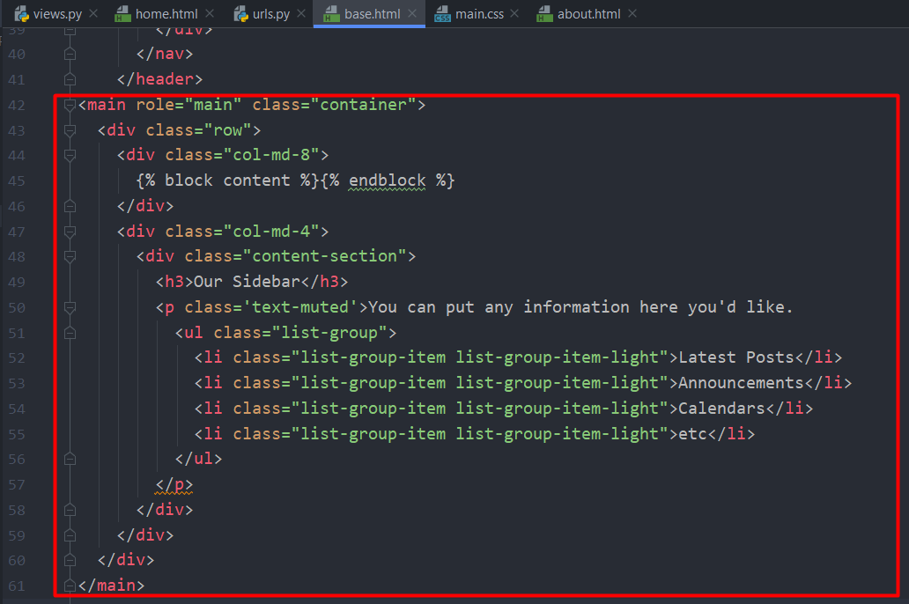

Notice we added {% block content %} {% endblock %} in a <div> tag

## Adding CSS files

In django , static files like .CSS and .JAVASCRIPT have to be located in a static directory within our app

eg. myapp/static/myapp/

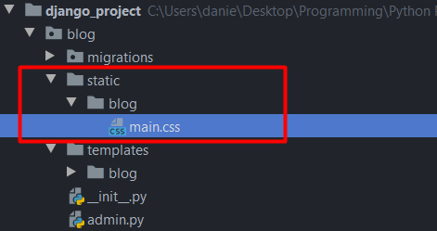

The main.css file looks like this:

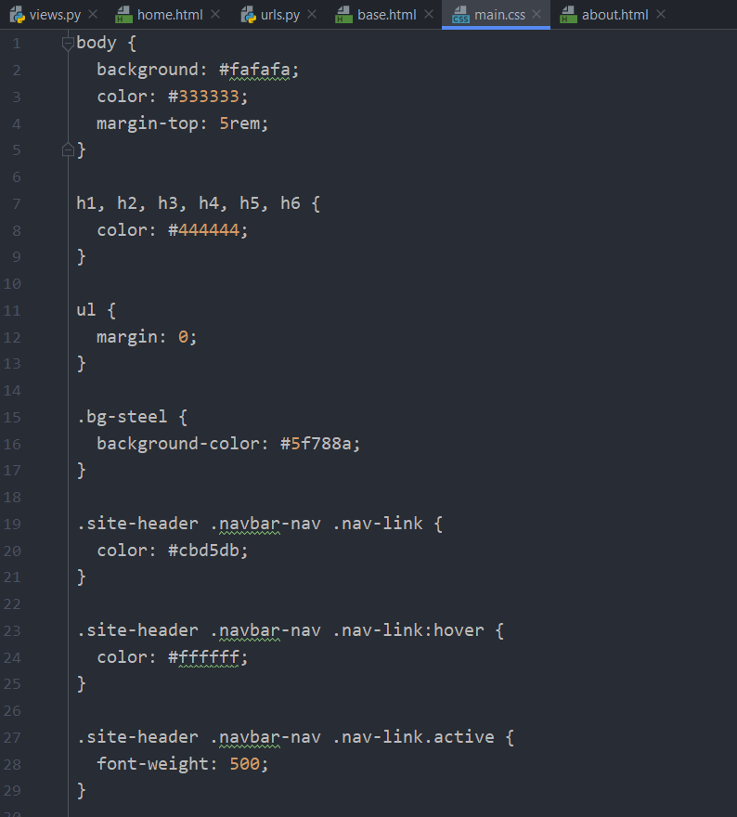

### How to include .CSS file

1. We load in our .CSS file from our static directory by adding

{% load static %} to the top of our base.HTML file.

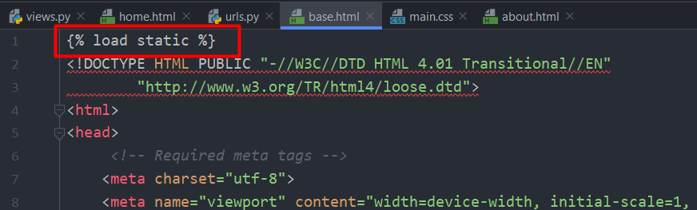

1. We add the next line of code:

<link rel="stylesheet" type="text/css" href="{% static 'blog/main.css' %}">

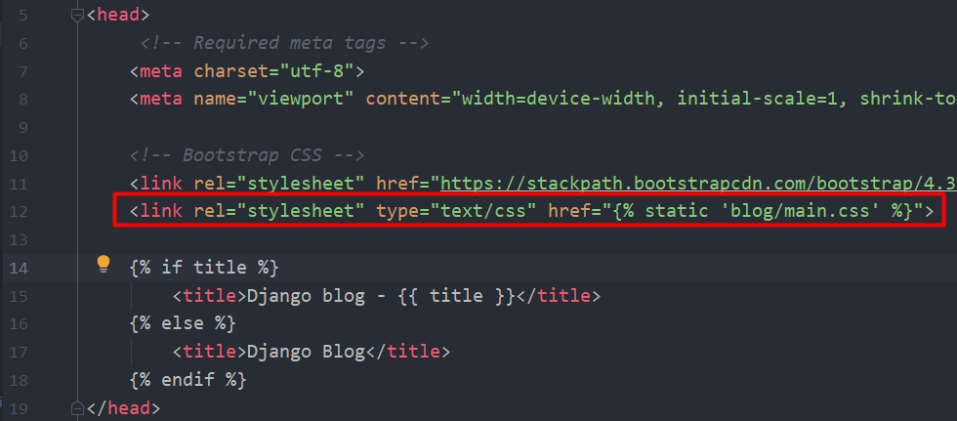

This basically gives style to our base.html file

### Styling the articles with our new .CSS file

Our new .CSS file has styling for each article posted on our blog we just need to add the functionality to our page.

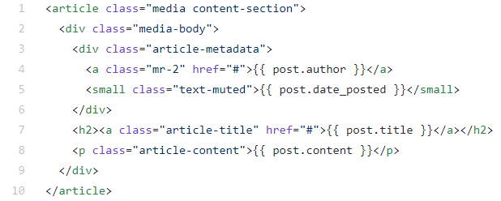

We are going to add this line within our for loop. Note that it has the second part of our for loop code already inserted

{% extends 'blog/base.html' %}  
{% block content %}  
 {% for post in posts%}  
 <article class="media content-section">  
 <div class="media-body">  
 <div class="article-metadata">  
 <a class="mr-2" href="#">{{ post.author }}</a>  
 <small class="text-muted">{{ post.date_posted }}</small>  
 </div>  
 <h2><a class="article-title" href="#">{{ post.title }}</a></h2>  
 <p class="article-content">{{ post.content }}</p>  
 </div>  
 </article>  
 {% endfor %}  
{% endblock content %}

## Making our templates more flexible

We are going to edit some “href=” variables in the navigation part of our base.html code in order to make site navigation much easer if we change the paths of our website in the future.

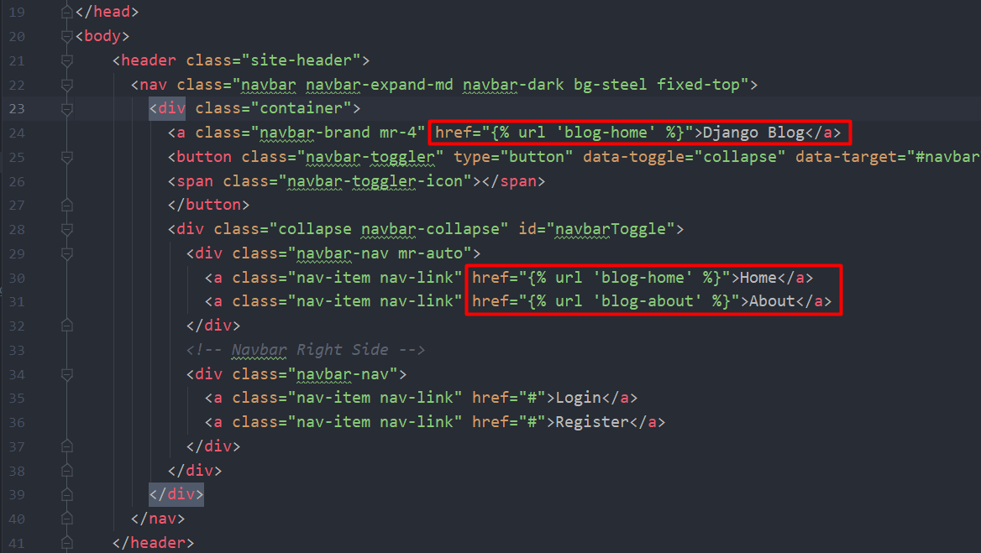

We modified the “href” to link us to the page name not the page path so in the future if we want to move Django blog to a different path we won’t have to manually modify the path because we give it it’s name. Example below:

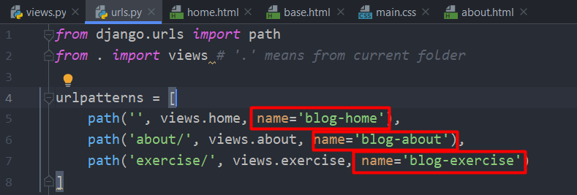

So basically we are referecing the name of the page not the path. Django will handle the hardwork.

## Adding a HYPER-LINK (Clickable thingie magic)

So if you want to add a new Hyperlink to your website like : Login , Register etc. Just do the following.

<a class="nav-item nav-link" href="#">Login</a>  
<a class="nav-item nav-link" href="#">Register</a>  
<a class="nav-item nav-link" href="https://www.youtube.com/watch?v=dQw4w9WgXcQ">Magic</a>

I don’t know exactly how it works , it might be some Bootstrap or CSS magic. But basically you add another <a> </a> tag (which is a hyperlink tag according to the interwebs) and add your stuff.

On the HREF I added a link to a very special youtube video.

# Creating the database

In order to advance we have to create a database by writing the following commands into the CMD prompt or terminal.

python manage.py migrate

This command basically creates an SQlite3 database for us (more on that later)

# Admin Page

## Creating an admin user

First we have to create an admin user using CMD prompt or terminal.

python manage.py createsuperuser

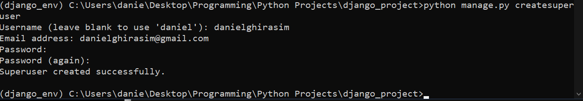

After this you can access the admin page by going to:

localhost:8000/admin/ - And typing in the admin account you just created

# Working with Databases in Django

## Some information

Django has it’s own built in ORM (Object Relational Mapper) which basically allows you to access the database data in an object oriented manner.

What’s cool about this is that it allows you to use different databases without changing your code

Django supported databases:

* [PostgreSQL](https://docs.djangoproject.com/en/3.0/ref/databases/#postgresql-notes)
* [MariaDB](https://docs.djangoproject.com/en/3.0/ref/databases/#mariadb-notes)
* [MySQL](https://docs.djangoproject.com/en/3.0/ref/databases/#mysql-notes)
* [Oracle](https://docs.djangoproject.com/en/3.0/ref/databases/#oracle-notes)
* [SQLite](https://docs.djangoproject.com/en/3.0/ref/databases/#sqlite-notes)

We can represent our databases as classes but in Django we call the **models .** We can have a look at our models.py module here :

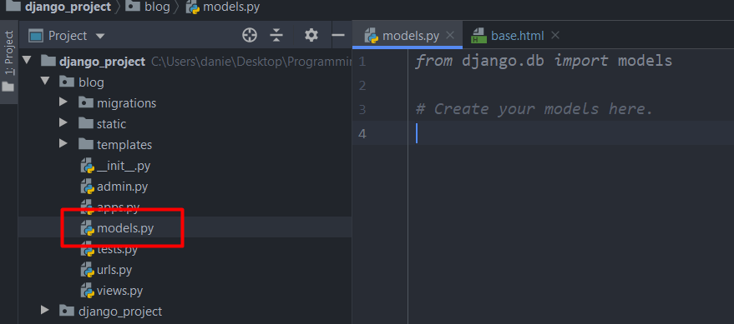

Here we are going to make a post model (basically a post class) which will inherit from django.Model class

**Each class is going to be it’s own table in the DATABASE and each attribute will be a different field in the database.**

## Adding databases

We refer to databases as models in Django .

Creating a database is as easy as adding a new class in models.py that inherits from django.models and it should look something like this

*from* django.db *import* models  
*from* django.utils *import* timezone  
  
*# Create your models here.*"""Each class is going to be a table in our database"""  
*class* Post(models.Model):  
 *"""Each attribute is a field in the database"""* title = models.CharField(max_length=100)

content = models.TextField()  
 date_posted = models.DateTimeField(default=timezone.now)

#max_lenght = length of charfield

# date_posted = models.DateTimeField(auto_now=*True*) auto_now = True sets our date_posted to the time it was posted but we are going to use the upper example because we want to store the timezone aswell . timezone.now is a function but we didn’t put () yet because we don’t want to execute it just yet.

We are also going to create a user attribute but since we already have a user database we are going to import that in this file.

Users and Posts are going to have a relationship , specifically this **will be called a 1 to many relationship** because a User can have multiple post and a post can’t have multiple users (here atleast) and to do this in django we use a **Foreign Key**

We are going to import Users since it already has a database created by django . The import location is :

*from* django.contrib.auth.models *import* User

After that we are going to add:

author = models.ForeignKey(User, on_delete=models.CASCADE())

# on_delete = models.CASCADE() means that when you delete a USER it will delete all his posts.

In the end our models.py should look something like this” *from* django.db *import* models  
*from* django.utils *import* timezone  
*from* django.contrib.auth.models *import* User  
  
*# Create your models here.*"""Each class is going to be a table in our database"""  
*class* Post(models.Model):  
 *"""Each attribute is a field in the database"""* title = models.CharField(max_length=100)  
 content = models.TextField()  
 date_posted = models.DateTimeField(default=timezone.now)  
 author = models.ForeignKey(User, on_delete=models.CASCADE)

After all this to make the changes we have to make migrations (Update the database).

We do this by entering python manage.py makemigrations into the terminal or command prompt and it should look something like this :

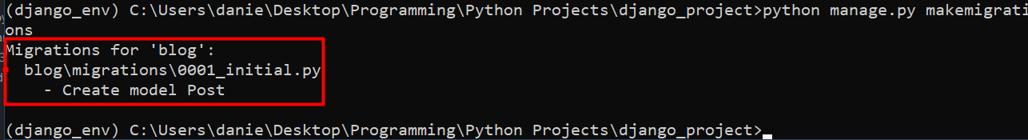

## SQL Code command (views the actualy SQL CODE)

To view the actual SQL code that is run we have to type :

python manage.py sqlmigrate blog 0001

It should look something like this:

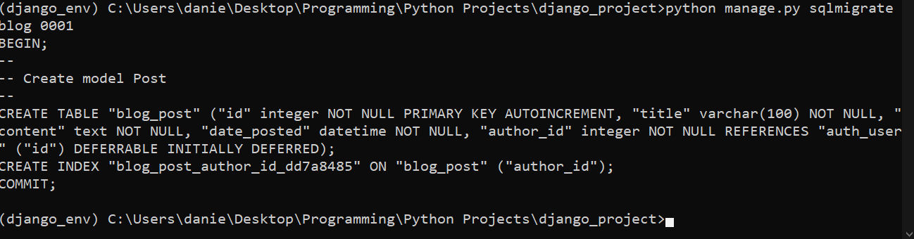

Django actually takes the information we entered and runs the command in SQlite 3 to make a table and field for our class , which makes our life much easier.

## Using CMD prompt to access databases

To access various information about our databases we can enter the next line into the command prompt:

**python manage.py shell**

**to exit the shell type : exit()**

This will open a python shell in our command prompt where we can enter commands:

from djang.contrib.auth.models import User (this imports our user database)

**User.objects.all() – Will list the contents of our User database**

**User.objects.first() – or last() will list the first or last entry in our database**

**User.objects.filter(username=’user’) – will filter for entered username**

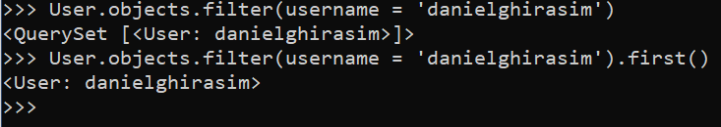

We can also use:

User.objects.filter(username=’danielghirasim) and it will give us a querry set . If we add first() to the end of the function it will give us the first username

We can set the upper mentioned function to a variable and then we can access more information from it ex:



Some commands we can run on this:

user.id – shows id

user.pk – shows primary key (id)

## Creating a post from Terminal

First we import our Post class that we just made .

from blog.models import Post

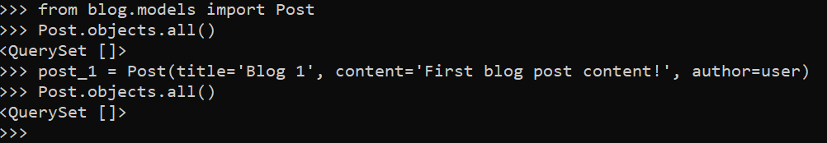

So in the picture above we created a post . Notice that we haven’t filled anything to our date_created field but since we set it to timezone.now, this should automatically get the time we created post_1.

After that we querry the Post database again and we can see we that the querry is still empty, this is because we have to migrate our post_1 to the database by using the following command.



After that we querry the DB again and we should see that it was added.



### Getting more descriptive querries

To get more descriptive querries we have to add some code to our Post class we created before.

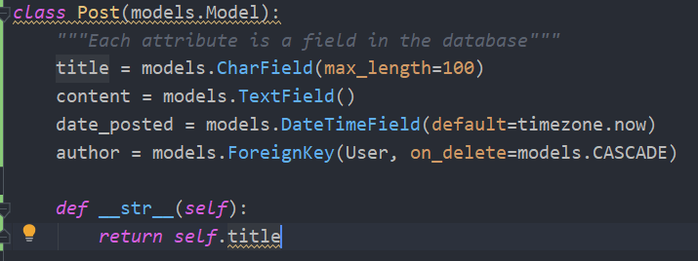

This dunder method basically applies the __str__ method to the Post class (self = Post class) and returns self.title

So it basically returns a string of Post.title.

After that we have to restart the shell by using exit() and reentering the imports and the commands and the querry should look like this

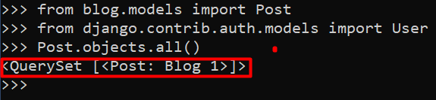

To acess all of our Post content we are going to set the post to a variable:

**post = Post.objects.first() – gives us the first post**

**post.content – prints content**

**post.title – prints title**

**post.author – prints author**

We can even access author data from here with the example below.

**post.author.email – this is gonna print the authors email so we don’t have to run a separate command for that aswell.**

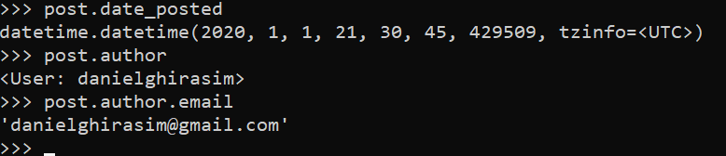

### Getting all USER posts with a simple command

We can get all the posts that a user posted by doing the following:

user = User.objects.get(username=’username’)

user.post_set.all() 🡪 This command will show all the posts created by the user we choose

We can also create posts while we have this user as a variable by using the following command line:



Using this method we don’t have to run the save function anymore and we don’t have to exit out of the shell. Also notice we didn’t enter the user in the function parameters since we already have the user defined.

## Connecting our Post database to our website

Here we are going to replace our dummy data with our data within our database.

We are going to do this the following way:

1. We are going to import our Post database into our views.py module

*from* .models *import* Post

*def* home(request):  
 context = {  
 'posts': Post.objects.all()  
 }  
 *return* render(request, 'blog/home.html', context)

As long as our dummy data’s dictionary keys were the same as our database fields everything should work fine without having to modify anything in our home.html file . If they are different we just have to go into our home.html and modify the FOR LOOP.

Aaaaaand it works !!!

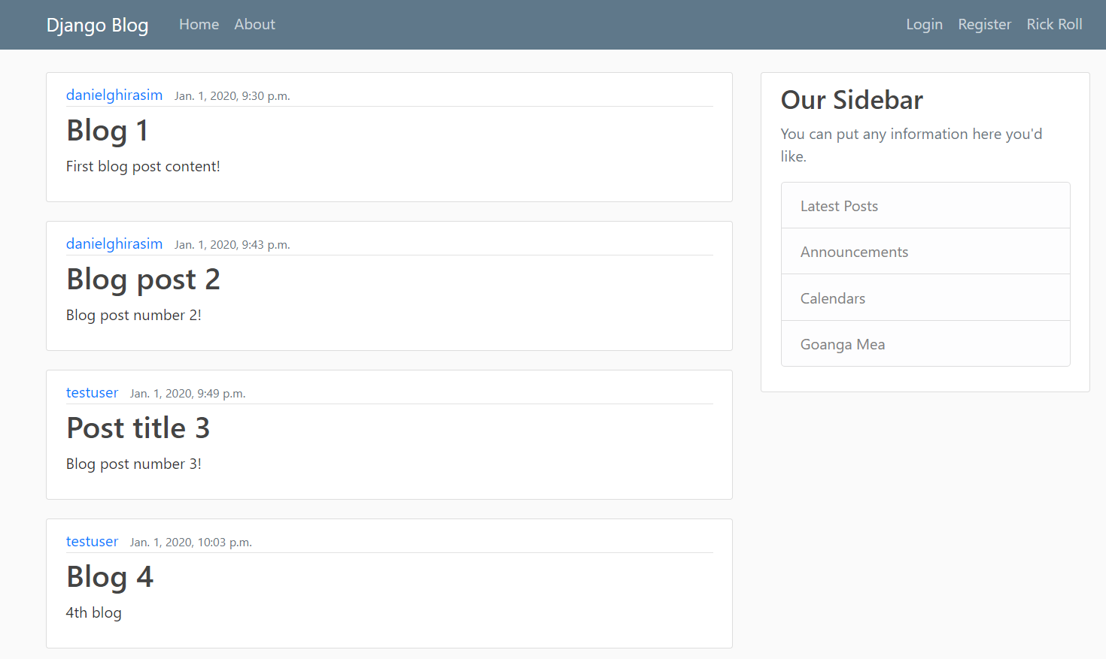

## Changing how our Date Time looks

We are going to change how our date time looks to make it a little bit neater.

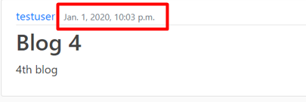

To do this we have to go to our home.html file and modify a bit of code by using Django documentation of dates as a reference (<https://docs.djangoproject.com/en/3.0/ref/templates/builtins/#date>):

The code should look like this:

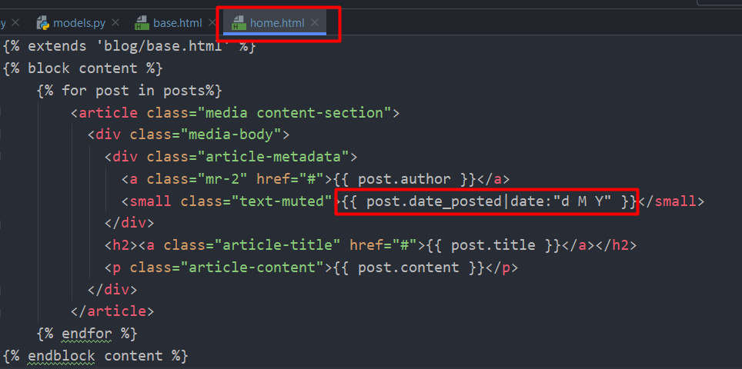

After we modified it , it should look something like this :

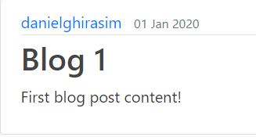

## Registering Databases (models) to the admin page

So when we enter the admin page we want to register our Post database in order to modify it . This is a very simple process thanks to Django is as easy as going into the admin.py module and entering a few lines of code.

*from* django.contrib *import* admin  
*from* .models *import* Post  
  
admin.site.register(Post)

This will add an editable Post section to our admin page and it’s freakin’ cool how easy it is.

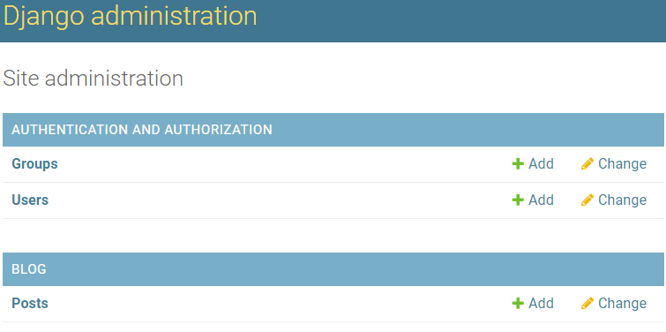

The editing section looks like this:

s