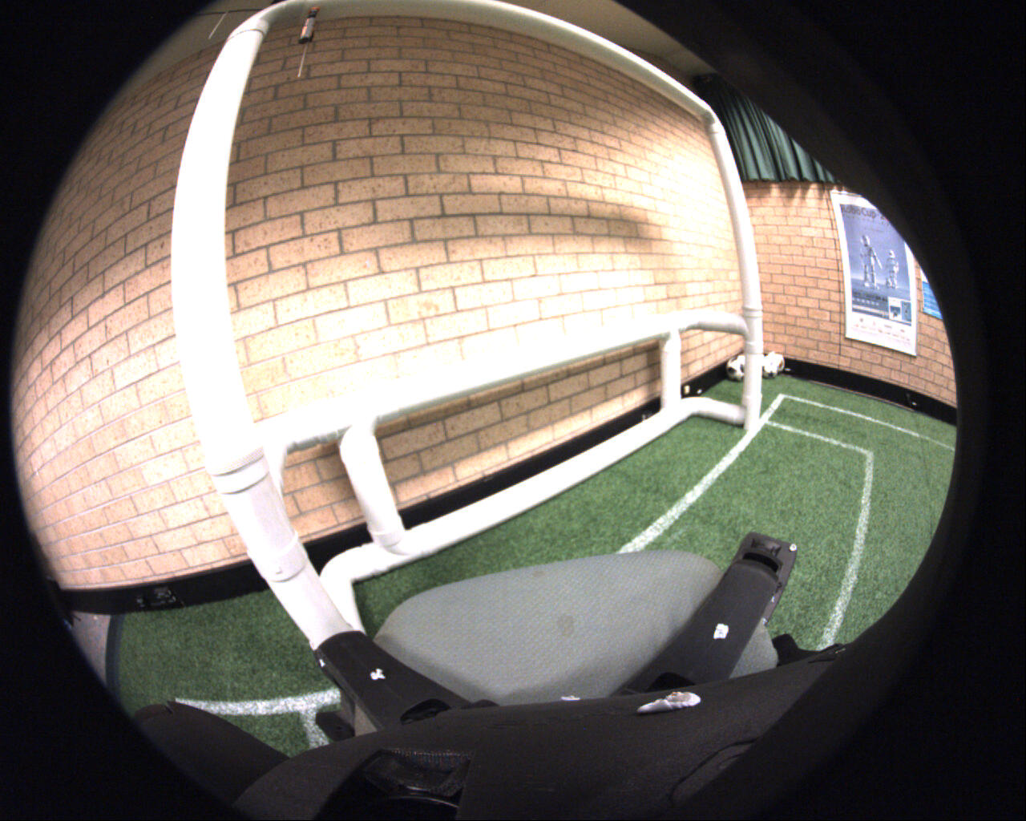

**50%**

Original Size: 1280 x 1024

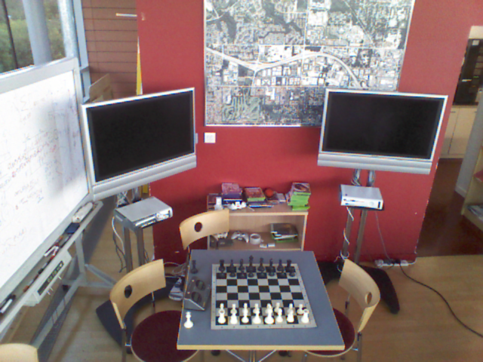

Original Size: 640 x 480