EEC IT Asset & Ticket Management System — Technical Documentation
EEC IT
Table of Contents

01 — System Overview
Document: Technical Documentation
System: EEC IT Asset & Ticket Management System
Version: 1.0
Date: October 2026
Status: Based on implemented codebase

Table of Contents
- Purpose
- Product Scope
- Technology Stack
- Users and Roles
- Core Capabilities
- Ticket Lifecycle
- Integrations
- Repository Layout
- Related Documents

1. Purpose
The EEC IT Asset & Ticket Management System is a web application for Ethiopian Electric Construction (EEC) IT operations. It tracks physical IT assets, runs a multi-stage maintenance and support ticket workflow, and notifies staff through in-app messages, SMS, Telegram, and email.
This overview is the entry point for the technical documentation suite. Detailed architecture, database, API, deployment, security, testing, and operations material is in the remaining files in docs/technical/.

2. Product Scope
The system is a decoupled two-tier application:
Component | Role
Frontend (SPA) | React 18 + TypeScript UI. Users log in, submit tickets, manage assets, and view reports.
Backend (REST API) | Laravel 12 JSON API. Authentication, business rules, database, and external notifications.
Typical production layout is two subdomains (for example app.domain.com and api.domain.com) on cPanel shared hosting.
In scope
- User registration with admin approval
- Role-based access (Requester, Technician, Admin, Super Admin)
- IT asset registry with CSV import
- Maintenance ticket workflow (10 statuses)
- Smart routing of tickets to department managers
- Preventive maintenance schedules
- Notifications (in-app, SMS, Telegram, Microsoft Graph email)
- FAQ knowledge base and keyword chatbot
- Reports and CSV export
- Activity audit logging
Out of scope (current product)
- Native mobile apps
- Redis / dedicated queue servers (queues use the database so shared hosting works)
- External generative AI for the chatbot

3. Technology Stack
Layer | Technology
Frontend | React 18, TypeScript, Vite, React Router, TanStack Query, Tailwind CSS, shadcn/ui, Axios
Backend | PHP 8.2+, Laravel 12, Laravel Sanctum, Spatie Permission
Database | SQLite (development), MySQL 8.0+ (production)
Queue / cache / session | Laravel database drivers
Web server | Apache with mod_rewrite
Email | Microsoft Graph API
SMS | Configurable HTTP gateway (for example AfroMessage / Ethio Telecom)
Chat | Telegram Bot API

4. Users and Roles
Access control uses Spatie Laravel Permission.
Role | Primary job
Requester | Default after approval. Submit and track own tickets (max 3 active). Review completions and leave ratings.
Technician | Work assigned tickets: start, log progress, complete. See ratings, not private feedback comments.
Admin (Manager) | Approve/reject tickets in their support category, assign technicians, manage assets and users in domain. Cannot create other Admins or Super Admins.
Super Admin | Full access, including user approval and creating any role. Sees all tickets.
Support categories used for routing: it_support, sap, general.

5. Core Capabilities

5.1 Authentication
- Self-registration creates a user with pending status.
- Login is blocked until an Admin or Super Admin approves the account.
- Sessions are Sanctum personal access tokens (Bearer header). Logout revokes the current token.
- Optional auto-approval after N minutes via REGISTRATION_AUTO_APPROVE_AFTER_MINUTES.

5.2 Assets
Assets represent computers, printers, servers, network devices, and other equipment. Fields include serial number, purchase/warranty dates, location, status (active, maintenance, retired, disposed), assigned user, and notes. Admins can import from CSV.

5.3 Tickets
Any authenticated user can submit a ticket (title, type, support category, priority, scheduled date, optional asset and attachments). The API routes the ticket to the matching department manager. Managers approve or reject, assign technicians (with domain isolation), and review completion. Requesters can reopen work and submit 1–5 star feedback.

5.4 Preventive maintenance
Admins define schedules per asset (daily, weekly, monthly, quarterly, yearly). The Artisan command maintenance:check-schedules generates tickets when due. It is not enabled on the scheduler by default and must be configured in production.

5.5 Help
Published FAQ articles power the Help Center and a keyword chatbot (POST /api/chat/assist). No external AI is used.

6. Ticket Lifecycle
submitted → approved → assigned → in_progress → completed_pending_review → completed
↘ rejected ↗
← reopened ←
Status | Meaning
submitted | Awaiting manager decision
approved | Accepted; awaiting technician
rejected | Declined with reason
assigned | Technician selected
in_progress | Work started
completed_pending_review | Technician finished; requester/manager reviews
completed | Accepted
reopened | Completion rejected; work continues
cancelled | Cancelled by requester (when allowed)

7. Integrations
Channel | When used | Delivery
In-app notifications | All major ticket and registration events | Synchronous database writes
SMS | Key ticket events, if phone on profile | Queued HTTP job
Telegram | Approval, assignment, ticket events if account linked | Queued Bot API job
Email | New registration (Super Admins), ticket approval | Queued Microsoft Graph job
Telegram accounts are linked with a 15-minute deep-link token. The webhook POST /api/telegram/webhook is public (no Sanctum token).

8. Repository Layout
asset-task-sync-backend/ Laravel API
asset-task-sync-main/ React SPA (Vite)
docs/ Documentation (this suite)
Default seeded logins (change immediately in any real environment):
Role | Email | Password
Super Admin | superadmin@example.com | password
Admin | admin@example.com | password
Technician | technician@example.com | password
Requester | requester@example.com | password

9. Related Documents
File | Contents
02-System-Architecture.md | Tiers, services, data flow
03-Database-Documentation.md | Schema, ER diagram, migrations
04-API-Documentation.md | REST endpoints
05-Installation-Deployment.md | Local and cPanel setup
06-Security-Documentation.md | Auth, RBAC, secrets, CORS
07-Testing-Documentation.md | Test strategy and gaps
08-Maintenance-Troubleshooting.md | Operations and runbooks
End-user instructions live in docs/user-manual/. Combined Word exports are in docs/output/.

02 — System Architecture
Document: Technical Documentation
System: EEC IT Asset & Ticket Management System
Version: 1.0
Date: October 2026
Status: Based on implemented codebase

Table of Contents
- Architecture Overview
- Technology Stack
- Backend Architecture (Laravel)
- Frontend Architecture (React SPA)
- Integration Architecture
- Infrastructure Architecture
- Data Flow Architecture
- Security Architecture

1. Architecture Overview
The EEC IT Asset & Ticket Management System follows a two-tier decoupled architecture:
Tier | Technology | Role
Presentation Tier | React 18 SPA (TypeScript, Vite) | User interface, client-side routing, state management
Application/Data Tier | Laravel 12 REST API (PHP 8.2+) | Business logic, authentication, database, external integrations
Key Architectural Decisions:
- Stateless REST API — No server-side sessions; authentication via Bearer tokens only.
- SPA Frontend — The React app is a compiled static bundle served by Apache. No Node.js server is needed at runtime.
- Database-backed async — Queues, sessions, and cache all use the database, making the system compatible with shared hosting without Redis.
- Separated deployment — Frontend and backend run on separate subdomains, enabling independent scaling and deployment.

2. Technology Stack

2.1 Backend Stack
Component | Technology | Version
Language | PHP | 8.2+
Framework | Laravel | 12.x
Authentication | Laravel Sanctum | 4.x
Authorization | Spatie Laravel Permission | 6.x
Database (dev) | SQLite | 3.x
Database (prod) | MySQL | 8.0+
Queue | Laravel Database Queue | Built-in
Cache | Laravel Database Cache | Built-in
File Storage | Laravel Local Disk | Built-in
Task Scheduling | Laravel Scheduler (cron) | Built-in
Email | Microsoft Graph API | v1.0
SMS | Configurable HTTP Gateway | —
Telegram | Telegram Bot API | —
HTTP Client | Guzzle / Laravel Http | Built-in

2.2 Frontend Stack
Component | Technology | Version
Language | TypeScript | 5.x
Framework | React | 18.x
Build Tool | Vite | 5.x
Routing | React Router DOM | 6.x
State (Server) | TanStack Query (React Query) | 5.x
Forms | React Hook Form + Zod | 7.x / 3.x
UI Components | Shadcn/UI + Radix UI | Latest
Styling | TailwindCSS | 3.x
Charts | Recharts | 2.x
HTTP Client | Axios | 1.x
Icons | Lucide React | Latest
Notifications | Sonner | 1.x
Date Utilities | date-fns | 3.x

2.3 DevOps / Infrastructure
Component | Technology
Web Server | Apache (mod_rewrite)
Hosting | cPanel shared hosting
Process Manager | (None — queue worker managed via cPanel cron or Terminal)
CI/CD | GitHub + cPanel Git Version Control (optional)
SSL | cPanel AutoSSL / Let’s Encrypt

3. Backend Architecture (Laravel)

3.1 Laravel Application Structure
asset-task-sync-backend/
├── app/
│ ├── Console/
│ │ └── Commands/ Artisan console commands
│ ├── Http/
│ │ ├── Controllers/Api/ 12 API controllers
│ │ └── Middleware/ auth:sanctum (built-in)
│ ├── Jobs/ 6 queued notification jobs
│ ├── Mail/ NewUserRegistrationMail Mailable
│ ├── Models/ 10 Eloquent ORM models
│ ├── Policies/ AssetPolicy, MaintenanceTicketPolicy
│ ├── Providers/ AppServiceProvider (policy registration)
│ └── Services/ 6 service classes (business logic)
├── bootstrap/ Framework bootstrap + cache
├── config/ All configuration files
│ ├── app.php
│ ├── auth.php
│ ├── cors.php
│ ├── database.php
│ ├── queue.php
│ ├── services.php SMS + Azure Graph credentials
│ └── permission.php Spatie RBAC config
├── database/
│ ├── migrations/ 25 migration files
│ └── seeders/ 3 seeders (DB, Roles, FAQs)
├── public/ Apache document root (index.php)
├── routes/
│ ├── api.php 99 lines, all API routes
│ ├── console.php Scheduled commands
│ └── web.php Single catch-all (Sanctum CSRF)
└── storage/
├── app/public/ Uploaded ticket attachments
└── logs/ laravel.log

3.2 Request Lifecycle
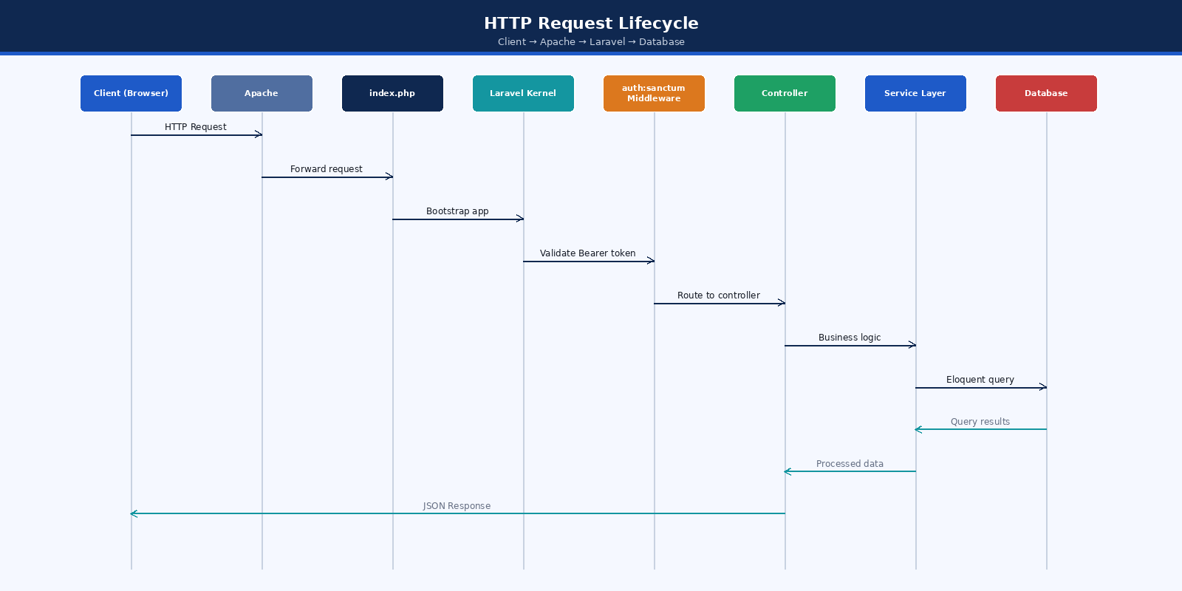
Figure: HTTP Request Lifecycle — Client to Database
Figure: HTTP Request Lifecycle — Client to Database

3.3 Model Relationships
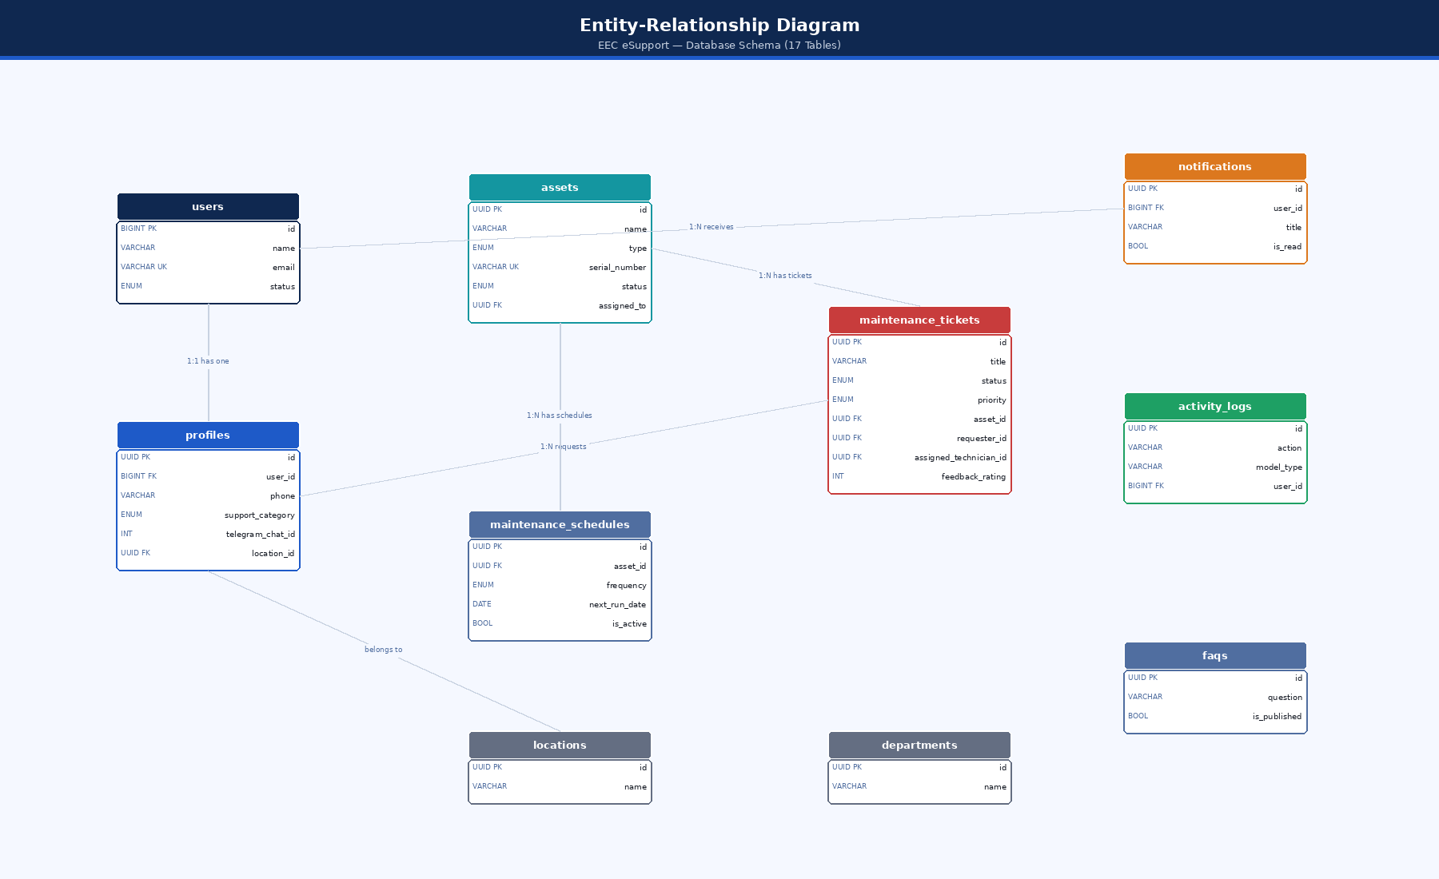
Figure: Entity-Relationship Diagram — Model Relationships
Figure: Entity-Relationship Diagram — Model Relationships

4. Frontend Architecture (React SPA)

4.1 Component Architecture
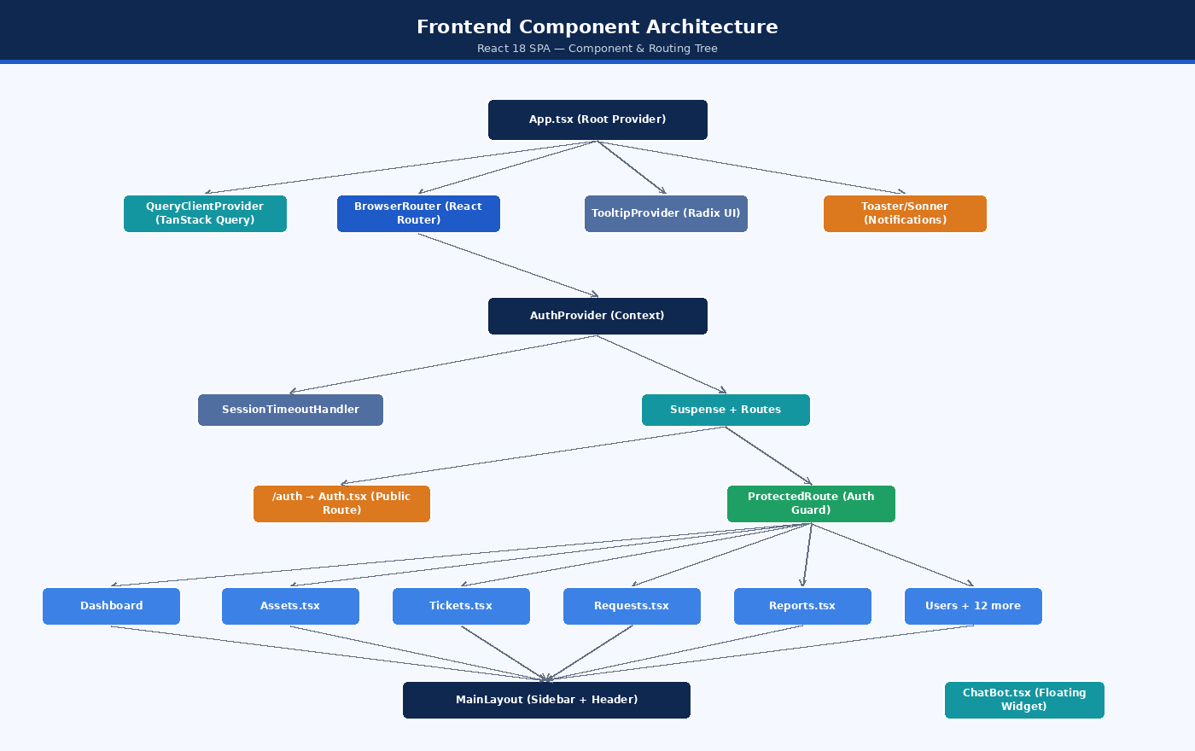
Figure: Frontend Component Architecture
Figure: Frontend Component Architecture

4.2 Data Fetching Pattern
All API data is managed through TanStack Query:
// Pattern used across all pages:
const { data, isLoading, error } = useQuery({
queryKey: ['resource', filters],
queryFn: () => api.get('/resource').then(r => r.data),
staleTime: 5 * 60 * 1000,
});
// Mutations with cache invalidation:
const mutation = useMutation({
mutationFn: (data) => api.post('/resource', data),
onSuccess: () => {
queryClient.invalidateQueries({ queryKey: ['resource'] });
},
});

4.3 Authentication Context
The useAuth hook provides throughout the app: - user — current authenticated user object (with roles and profile) - token — Bearer token stored in localStorage - login(credentials) — calls /api/login, stores token - logout() — calls /api/logout, clears token - hasRole(role) — checks user role - isAuthenticated — boolean

5. Integration Architecture

5.1 SMS Integration
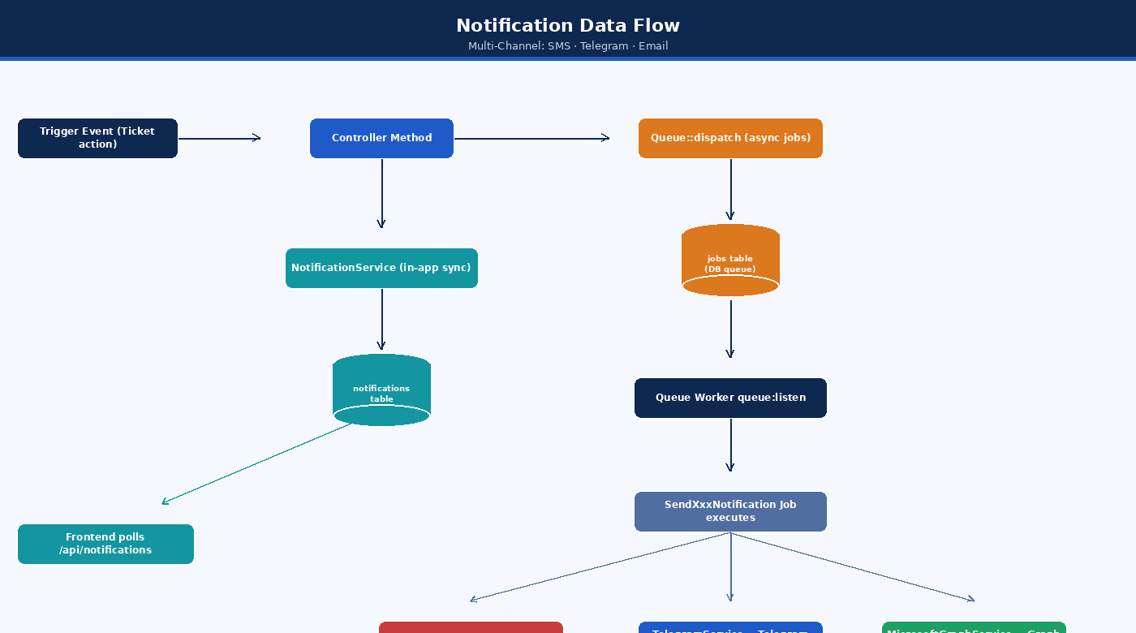
Figure: SMS Integration Data Flow
Figure: SMS Integration Data Flow
Phone Normalization: Accepts 0912345678, 912345678, +251912345678, 251912345678. Outputs in 251XXXXXXXXX format. Only validates Ethiopian Ethio Telecom (09x) and Safaricom ET (07x) numbers.

5.2 Telegram Integration
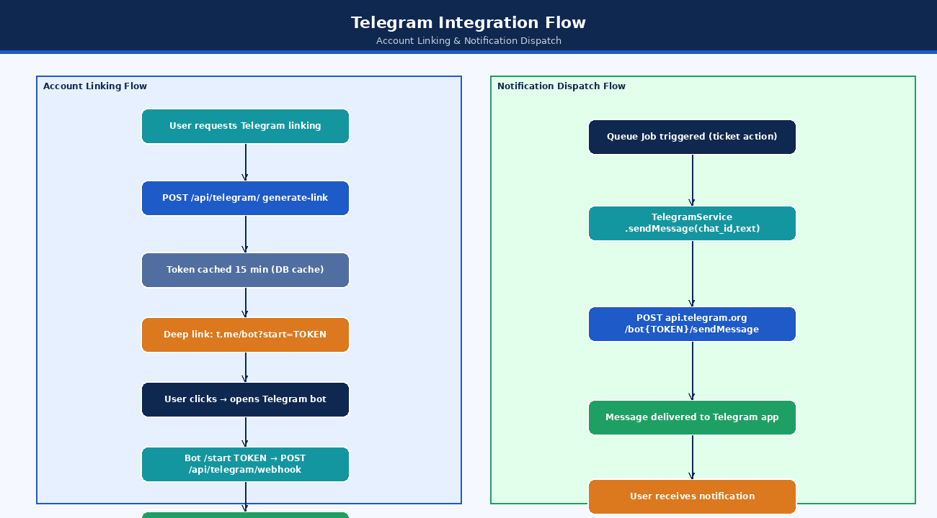
Figure: Telegram Integration Flow
Figure: Telegram Integration Flow

5.3 Microsoft Graph Email Integration
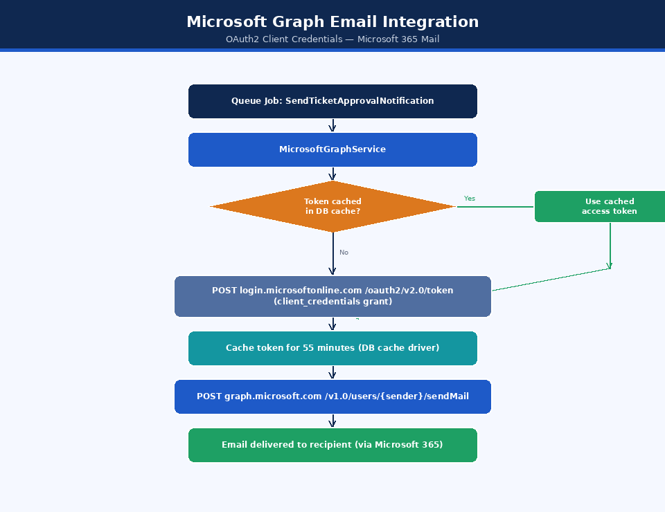
Figure: Microsoft Graph Email Integration
Figure: Microsoft Graph Email Integration

6. Infrastructure Architecture

6.1 Production Deployment Architecture
Internet
│
├─→ app.yourdomain.com ─→ Apache vhost
│ └── public_html/
│ ├── index.html (React SPA entry)
│ ├── assets/ (JS/CSS bundles)
│ └── .htaccess (SPA routing fallback)
│
└─→ api.yourdomain.com ─→ Apache vhost
document root: /backend/public/
└── index.php (Laravel entry)
└── app/
└── database/ (SQLite or MySQL)
└── storage/
├── logs/
└── app/public/ (attachments)

6.2 Queue Worker Architecture
cPanel Cron Job (every minute):
* * * * * php artisan schedule:run
Optional always-on worker:
php artisan queue:listen --tries=3 --delay=3
Note: On shared cPanel hosting, the queue worker typically runs as a cPanel cron job polling every minute, not as a persistent daemon.

6.3 File Storage
Uploaded ticket attachments are stored in storage/app/public/ticket-attachments/ and served via a symbolic link from public/storage/.
php artisan storage:link
# Creates: public/storage → storage/app/public

7. Data Flow Architecture

7.1 Notification Data Flow
Figure: Notification Data Flow
Figure: Notification Data Flow

7.2 Report Data Flow
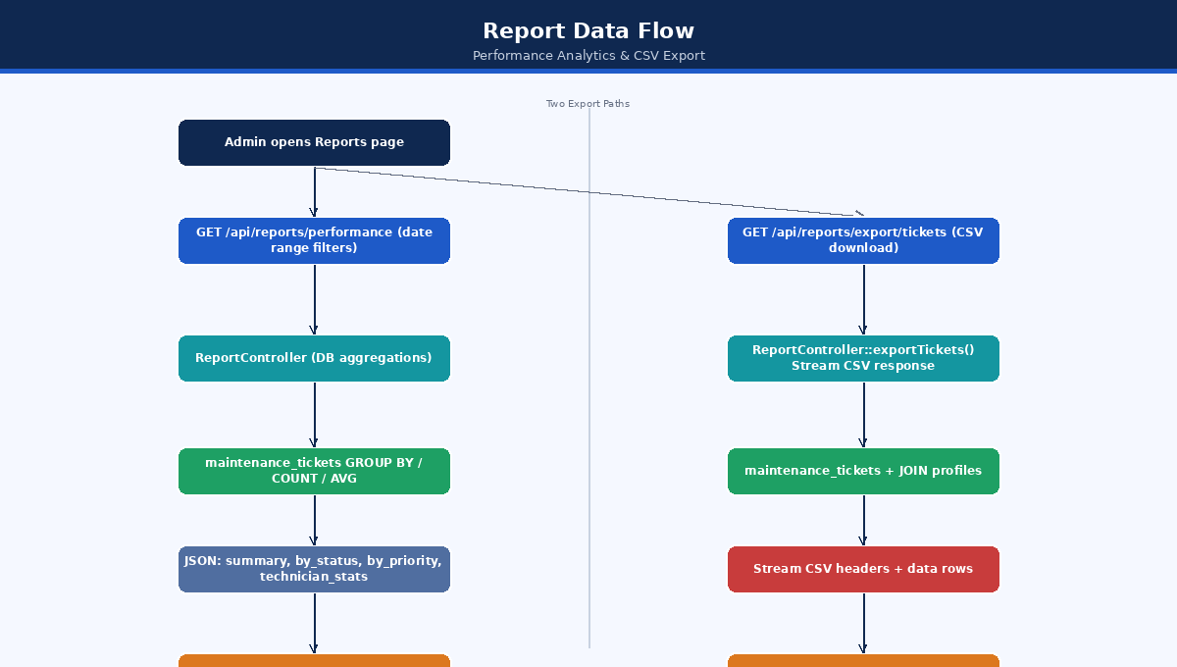
Figure: Report Data Flow
Figure: Report Data Flow

8. Security Architecture

8.1 Authentication Architecture
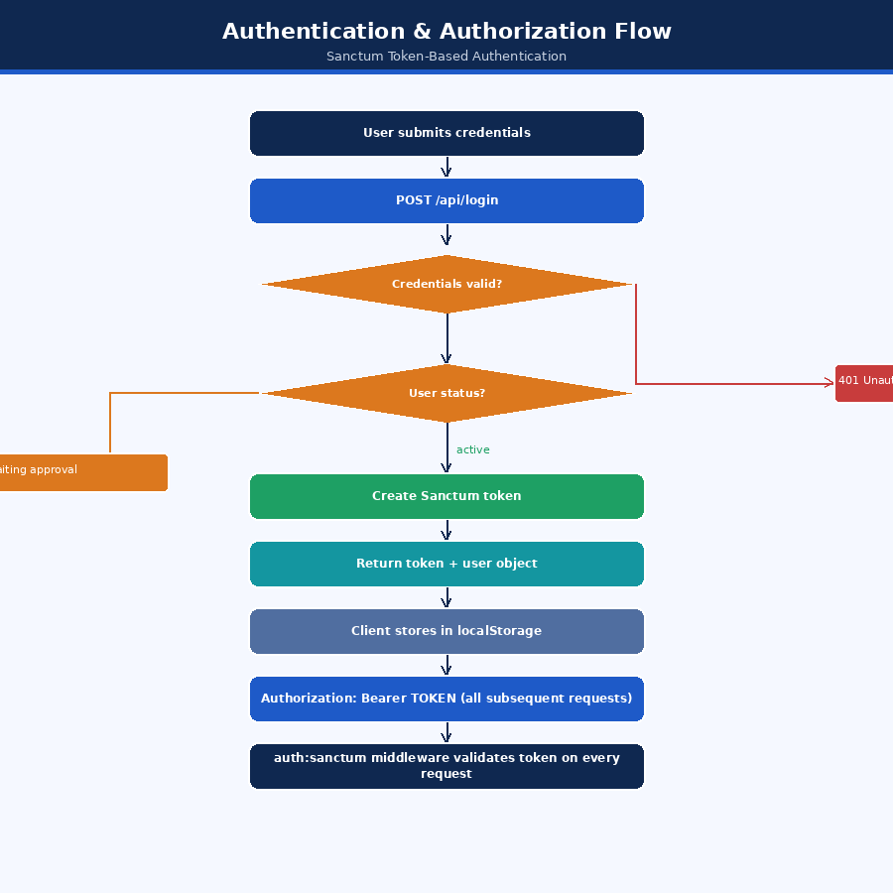
Figure: Authentication & Authorization Flow
Figure: Authentication & Authorization Flow

8.2 CORS Architecture
Laravel’s CORS middleware (configured in config/cors.php) restricts cross-origin requests:
- Allowed Origins: FRONTEND_URL environment variable
- Allowed Methods: GET, POST, PUT, PATCH, DELETE, OPTIONS
- Allowed Headers: Content-Type, Authorization, X-Requested-With
- Credentials: Supported

8.3 Authorization Architecture (Layered)
Layer 1: Route Middleware
auth:sanctum → validates Bearer token
↓
Layer 2: Controller Role Check
$user->hasAnyRole(['admin', 'super_admin'])
↓
Layer 3: Laravel Gate / Policy
Gate::authorize('manage', MaintenanceTicket::class)
→ delegates to MaintenanceTicketPolicy::manage()
→ checks hasPermissionTo('manage tickets')

8.4 Password Security
- Algorithm: bcrypt with 12 rounds (BCRYPT_ROUNDS=12 in .env)
- Cast: Laravel’s hashed cast on User::password auto-hashes on assignment
- Protection: Password field is in $hidden array; never returned in API responses

03 — Database Documentation
Document: Technical Documentation
System: EEC IT Asset & Ticket Management System
Version: 1.0
Date: October 2026
Status: Based on implemented migrations

Table of Contents
- Database Overview
- Entity-Relationship Diagram
- Table Specifications
- Indexes and Performance
- Migration History

1. Database Overview

1.1 Database Engine
Environment | Engine | Notes
Development | SQLite | File: database/database.sqlite
Production | MySQL 8.0+ | Configured via DB_* environment variables

1.2 Primary Key Strategy
Table Group | PK Type | Reason
Core domain tables (assets, tickets, profiles, etc.) | UUID (v4) | Prevents enumeration, safe for distributed systems
Auth / System tables (users, jobs, cache) | Auto-increment BIGINT | Laravel defaults; Spatie Permission requires integer user IDs

1.3 Naming Conventions
- Table names: snake_case, plural
- Column names: snake_case
- Foreign keys: {referenced_table_singular}_id
- Enum values: snake_case strings

1.4 Total Table Count
The system has 17 tables (10 domain tables + 7 system/framework tables):
Domain Tables: users, profiles, assets, maintenance_tickets, maintenance_schedules, notifications, activity_logs, locations, departments, faqs
System Tables: personal_access_tokens, permissions, roles, model_has_permissions, model_has_roles, role_has_permissions, jobs, cache, sessions

2. Entity-Relationship Diagram
Figure: Entity-Relationship Diagram — Full Database Schema
Figure: Entity-Relationship Diagram — Full Database Schema

3. Table Specifications

3.1 users
Stores authentication credentials and account status.
Column | Type | Constraints | Description
id | BIGINT UNSIGNED | PK, AUTO_INCREMENT | System-generated identifier
name | VARCHAR(255) | NOT NULL | Full display name
email | VARCHAR(255) | UNIQUE, NOT NULL | Login email (normalized to lowercase)
password | VARCHAR(255) | NOT NULL | bcrypt hashed password (12 rounds)
status | ENUM | NOT NULL, DEFAULT active | pending, active, rejected
email_verified_at | TIMESTAMP | NULL | Email verification timestamp (not enforced in current UI)
remember_token | VARCHAR(100) | NULL | For “remember me” (not used in API)
created_at | TIMESTAMP | NOT NULL | Record creation time
updated_at | TIMESTAMP | NOT NULL | Last update time
Default Seeded Users (change passwords on deployment):
Role | Email | Password
Super Admin | superadmin@example.com | password
Admin | admin@example.com | password
Technician | technician@example.com | password
Requester | requester@example.com | password

3.2 profiles
Extends user accounts with business profile data.
Column | Type | Constraints | Description
id | CHAR(36) | PK, UUID | Profile identifier
user_id | BIGINT UNSIGNED | FK → users.id, UNIQUE | One-to-one with users
name | VARCHAR(255) | NOT NULL | Display name (copied from registration)
email | VARCHAR(255) | NOT NULL | Email (copied from registration)
phone | VARCHAR(30) | NULL | Ethiopian mobile number for SMS
avatar_url | VARCHAR(255) | NULL | Profile picture URL
department | VARCHAR(255) | NULL | Department name (free text)
support_category | ENUM | NULL | it_support, sap, general — determines routing
telegram_username | VARCHAR(255) | NULL | Telegram handle (without @)
telegram_chat_id | INTEGER | NULL | Telegram chat ID (set after bot link)
location_id | CHAR(36) | FK → locations.id, NULL | Associated physical location
created_at | TIMESTAMP | — | —
updated_at | TIMESTAMP | — | —
Notes: - The support_category column on manager/admin profiles is the primary key for smart ticket routing. - telegram_chat_id is populated only after the user links their account via the Telegram bot.

3.3 assets
IT asset inventory registry.
Column | Type | Constraints | Description
id | CHAR(36) | PK, UUID | Asset identifier
name | VARCHAR(255) | NOT NULL | Asset name/label
type | ENUM | NOT NULL | computer, printer, server, network_device, other
serial_number | VARCHAR(255) | UNIQUE, NOT NULL | Manufacturer serial number
purchase_date | DATE | NOT NULL | When the asset was acquired
warranty_expiry | DATE | NULL | Warranty end date
location | VARCHAR(255) | NOT NULL | Physical location (free text)
status | ENUM | DEFAULT active | active, maintenance, retired, disposed
assigned_to | CHAR(36) | FK → profiles.id, NULL, SET NULL on delete | Assigned user
notes | TEXT | NULL | Additional notes
created_at | TIMESTAMP | — | —
updated_at | TIMESTAMP | — | —
Indexes: status, type

3.4 maintenance_tickets
Core table tracking all support/maintenance requests through their full lifecycle.
Column | Type | Constraints | Description
id | CHAR(36) | PK, UUID | Ticket identifier
title | VARCHAR(255) | NOT NULL | Brief summary
description | TEXT | NULL | Detailed description
type | ENUM | NOT NULL | maintenance, repair, installation, inspection, other
support_category | ENUM | DEFAULT general | it_support, sap, general
status | ENUM | DEFAULT submitted | See state machine in SDD
priority | ENUM | DEFAULT medium | low, medium, high, critical
asset_id | CHAR(36) | FK → assets.id, NULL, CASCADE on delete | Associated asset (optional since migration 2026_07_18)
requester_id | CHAR(36) | FK → profiles.id, NULL, SET NULL | Who submitted
assigned_technician_id | CHAR(36) | FK → profiles.id, NULL, SET NULL | Assigned technician
assigned_manager_id | CHAR(36) | FK → profiles.id, NULL | Auto-routed manager
scheduled_date | DATETIME | NOT NULL | Planned service date
completed_date | DATETIME | NULL | Actual completion date
estimated_duration | INTEGER | NULL | In minutes
actual_duration | INTEGER | NULL | In minutes
is_recurring | BOOLEAN | DEFAULT false | Recurring ticket flag
recurring_interval | ENUM | NULL | daily, weekly, monthly, quarterly, yearly
recurring_ends_at | DATE | NULL | When recurring ends
notes | TEXT | NULL | General notes / review notes appended
rejection_reason | TEXT | NULL | Required when status = rejected
diagnosis | TEXT | NULL | Technician’s diagnosis
actions_taken | TEXT | NULL | Required on ticket completion
spare_parts | JSON | NULL | Array of parts used
images | JSON | NULL | Array of attachment metadata
feedback_rating | INTEGER | NULL | 1–5 star rating from requester
feedback_comment | TEXT | NULL | Confidential text feedback (hidden from technicians)
approved_by | CHAR(36) | FK → profiles.id, NULL, SET NULL | Manager who approved
reviewed_by | CHAR(36) | FK → profiles.id, NULL, SET NULL | Who reviewed completion
approved_at | DATETIME | NULL | When approved
started_at | DATETIME | NULL | When work began
reviewed_at | DATETIME | NULL | When completion was reviewed
created_at | TIMESTAMP | — | —
updated_at | TIMESTAMP | — | —
Indexes: status, priority, scheduled_date, assigned_technician_id, requester_id, support_category, asset_id, assigned_manager_id

3.5 maintenance_schedules
Preventive maintenance schedule registry.
Column | Type | Constraints | Description
id | CHAR(36) | PK, UUID | Schedule identifier
title | VARCHAR(255) | NOT NULL | Schedule name
description | TEXT | NULL | Details
asset_id | CHAR(36) | FK → assets.id | Associated asset
type | ENUM | NOT NULL | Same as ticket types
frequency | ENUM | NOT NULL | daily, weekly, monthly, quarterly, yearly
next_run_date | DATE | NOT NULL | When the next occurrence is due
last_run_date | DATE | NULL | When last executed
is_active | BOOLEAN | DEFAULT true | Active/inactive flag
created_by | CHAR(36) | FK → profiles.id | Creator
created_at | TIMESTAMP | — | —
updated_at | TIMESTAMP | — | —

3.6 notifications
In-app notification store.
Column | Type | Constraints | Description
id | CHAR(36) | PK, UUID | Notification identifier
user_id | BIGINT UNSIGNED | FK → users.id | Target user
title | VARCHAR(255) | NOT NULL | Short title
message | VARCHAR(255) | NOT NULL | Full message text
type | VARCHAR(255) | NOT NULL | info, success, warning, error
is_read | BOOLEAN | DEFAULT false | Read status
link | VARCHAR(255) | NULL | Deep link (e.g., /tickets/{id})
created_at | TIMESTAMP | — | —
updated_at | TIMESTAMP | — | —
Deduplication Index: Queries on (user_id, title, created_at) to suppress duplicate notifications within 60 seconds.

3.7 activity_logs
Audit trail for all significant system operations.
Column | Type | Constraints | Description
id | CHAR(36) | PK, UUID | Log identifier
user_id | BIGINT UNSIGNED | FK → users.id, NULL | User who performed the action
action | VARCHAR(255) | NOT NULL | Verb: created, updated, deleted, approved, etc.
model_type | VARCHAR(255) | NOT NULL | Entity type: Ticket, Asset, Faq, etc.
model_id | VARCHAR(255) | NULL | UUID of the affected entity
description | TEXT | NOT NULL | Human-readable description
created_at | TIMESTAMP | — | —
updated_at | TIMESTAMP | — | —

3.8 locations
Physical location registry.
Column | Type | Constraints | Description
id | CHAR(36) | PK, UUID | Location identifier
name | VARCHAR(255) | NOT NULL | Location name
created_at | TIMESTAMP | — | —
updated_at | TIMESTAMP | — | —

3.9 departments
Organizational department registry.
Column | Type | Constraints | Description
id | CHAR(36) | PK, UUID | Department identifier
name | VARCHAR(255) | NOT NULL | Department name
created_at | TIMESTAMP | — | —
updated_at | TIMESTAMP | — | —

3.10 faqs
Knowledge base articles for the help center and chatbot.
Column | Type | Constraints | Description
id | CHAR(36) | PK, UUID | FAQ identifier
question | VARCHAR(500) | NOT NULL | The FAQ question
answer | TEXT | NOT NULL | The answer (supports Markdown)
category | VARCHAR(100) | NOT NULL | Category label (free text)
is_published | BOOLEAN | DEFAULT false | Controls visibility to non-admins
sort_order | INTEGER | DEFAULT 0 | Manual ordering weight
created_at | TIMESTAMP | — | —
updated_at | TIMESTAMP | — | —

3.11 RBAC Tables (Spatie Laravel Permission)

roles
Column | Type | Description
id | BIGINT | PK
name | VARCHAR | super_admin, admin, technician, requester
guard_name | VARCHAR | web (default)
Seeded Roles and Permissions:
Role | Permissions
requester | view assets, view tickets
technician | view assets, manage tickets, view tickets
admin | All (manage assets, view assets, manage tickets, view tickets, manage users)
super_admin | All

model_has_roles
Pivot table linking users to roles.
Column | Description
role_id | FK → roles.id
model_type | App\Models\User
model_id | User ID

4. Indexes and Performance
Performance indexes were added in migration 2026_10_13_000002_add_performance_indexes.php:

4.1 maintenance_tickets Composite Indexes
Index Name | Columns | Purpose
idx_tickets_requester_status | (requester_id, status) | Requester’s active ticket count check
idx_tickets_technician_status | (assigned_technician_id, status) | Technician’s ticket list
idx_tickets_manager_cat | (assigned_manager_id, support_category) | Manager’s ticket view
idx_tickets_status_created | (status, created_at DESC) | Default ordering query
idx_tickets_category_status | (support_category, status) | Category filtering

4.2 notifications Indexes
Index Name | Columns | Purpose
idx_notifications_user_read | (user_id, is_read) | Unread count query
idx_notifications_user_created | (user_id, created_at DESC) | User notification list

4.3 activity_logs Indexes
Index Name | Columns | Purpose
idx_logs_user_created | (user_id, created_at DESC) | User activity query
idx_logs_model | (model_type, model_id) | Entity audit trail

4.4 profiles Indexes
Index Name | Columns | Purpose
idx_profiles_support_category | (support_category) | Routing query
idx_profiles_location | (location_id) | Location filtering

5. Migration History
Migrations are applied in chronological order:
Migration File | Description
0001_01_01_000000_create_users_table | Users, password_reset_tokens, sessions
0001_01_01_000001_create_cache_table | Cache and cache_locks tables
0001_01_01_000002_create_jobs_table | Jobs, failed_jobs, job_batches
2025_11_30_121733_create_permission_tables | Spatie RBAC tables
2025_11_30_121733_create_personal_access_tokens_table | Sanctum tokens
2025_11_30_121743_create_profiles_table | User profiles
2025_11_30_121744_create_assets_table | Asset registry
2025_11_30_121745_create_maintenance_tickets_table | Initial ticket table
2025_11_30_121746_create_activity_logs_table | Audit logs
2025_11_30_121746_create_notifications_table | In-app notifications
2025_12_01_000000_update_maintenance_tickets_workflow | Extended ticket workflow (10 statuses, new columns)
2025_12_01_000001_create_maintenance_schedules_table | Preventive maintenance
2025_12_05_200917_add_status_to_users_table | User approval status
2025_12_05_205156_add_telegram_username_to_profiles_table | Telegram username
2025_12_06_114621_add_telegram_chat_id_to_profiles_table | Telegram chat ID
2026_06_20_000001_create_locations_table | Physical locations
2026_06_20_000002_create_departments_table | Organizational departments
2026_06_20_000003_add_location_id_to_profiles_table | Profile → Location FK
2026_07_18_000001_nullable_asset_and_recurring_end_on_tickets | Made asset_id nullable
2026_07_18_000002_add_category_and_manager_to_tickets | support_category, assigned_manager_id
2026_07_18_000002_create_faqs_table | FAQ knowledge base
2026_10_13_000001_add_phone_to_profiles_table | Phone number for SMS
2026_10_13_000002_add_performance_indexes | Composite performance indexes
2026_10_15_205028_add_support_category_to_profiles_table | support_category on profiles
2026_10_16_010000_backfill_support_categories_and_cleanup_duplicate_notifications | Data migration / cleanup

04 — API Documentation
Document: Technical Documentation
System: EEC IT Asset & Ticket Management System
Version: 1.0
Date: October 2026
Base URL: https://api.yourdomain.com/api
Auth: Bearer token (Laravel Sanctum)

Table of Contents
- Overview
- Authentication
- Users & Auth Endpoints
- Asset Endpoints
- Maintenance Ticket Endpoints
- Maintenance Schedule Endpoints
- Notification Endpoints
- Profile Endpoints
- Report Endpoints
- FAQ & Chatbot Endpoints
- Location Endpoints
- Department Endpoints
- Telegram Endpoints
- Activity Log Endpoints
- Error Reference

1. Overview

1.1 Request Format
- Content-Type: application/json for JSON bodies
- Content-Type: multipart/form-data for file uploads
- All requests include Accept: application/json header

1.2 Authentication Header
Authorization: Bearer {your_token}

1.3 Response Format
Success (single resource):
{ ...resource fields... }
Success (collection):
[ { ...resource... } ]
Error:
{
"message": "Description of the error",
"errors": {
"field_name": ["Error message"]
}
}

1.4 HTTP Status Codes
Code | Meaning
200 | OK — Request succeeded
201 | Created — Resource created
204 | No Content — Resource deleted
400 | Bad Request — Business rule violation
401 | Unauthorized — Invalid or missing token
403 | Forbidden — Insufficient permissions
404 | Not Found — Resource not found
422 | Unprocessable Entity — Validation error
500 | Internal Server Error

2. Authentication
All protected endpoints require the Authorization: Bearer {token} header. Tokens are obtained via the /login endpoint.

Token Lifetime
Tokens do not expire by default (Laravel Sanctum personal access tokens). Tokens are invalidated on logout.

3. Users & Auth Endpoints

POST /register
Register a new user account. Account starts in pending status.
Auth Required: No
Request Body:
Field | Type | Required | Description
name | string | ✅ | Full name (max 255)
email | string | ✅ | Valid email address (unique)
password | string | ✅ | Min 8 characters
password_confirmation | string | ✅ | Must match password
phone | string | ❌ | Phone number (max 30)
telegram_username | string | ❌ | Telegram handle
location_id | UUID | ❌ | Must exist in locations table
Response 201:
{
"message": "Registration successful! Your account is pending admin approval...",
"status": "pending",
"auto_approve_after_minutes": null,
"support_email": "itsupport@eecproducts.com",
"telegram_bot_username": "eec_it_bot",
"telegram_bot_link": "https://t.me/eec_it_bot?start",
"user": { "name": "John Doe", "email": "john@example.com" }
}

POST /login
Authenticate and receive a Bearer token.
Auth Required: No
Request Body:
Field | Type | Required
email | string | ✅
password | string | ✅
Response 200:
{
"user": {
"id": 1,
"name": "John Doe",
"email": "john@example.com",
"status": "active",
"profile": { "id": "uuid", "phone": "...", "telegram_chat_id": null, "location": {...}, ... },
"roles": [{ "name": "requester" }]
},
"token": "1|plainTextToken"
}
Errors: - 422 — Invalid credentials - 422 — Account pending approval - 422 — Account registration not approved

POST /logout
Revoke the current access token.
Auth Required: Yes
Response 200:
{ "message": "Logged out successfully" }

GET /user
Get the currently authenticated user.
Auth Required: Yes
Response 200: Same structure as login user object.

POST /user/update-password
Update the authenticated user’s password.
Auth Required: Yes
Request Body:
Field | Type | Required
current_password | string | ✅
new_password | string | ✅ Min 8 chars
new_password_confirmation | string | ✅
Response 200:
{ "message": "Password updated successfully" }

POST /users
Create a new user account (Admin/Super Admin only).
Auth Required: Yes (admin or super_admin role)
Request Body:
Field | Type | Required | Description
name | string | ✅
email | string | ✅ | Unique
password | string | ✅ | Min 8 chars
role | string | ✅ | super_admin, admin, technician, requester
department | string | ❌
support_category | string | ❌ | it_support, sap, general
phone | string | ❌
location_id | UUID | ❌
Response 201:
{
"message": "User created successfully",
"user": { ...user with profile and roles... }
}
Business Rules: - Only super_admin can create admin or super_admin accounts - admin managers can only create technician accounts within their own support domain

POST /users/{id}/approve
Approve a pending user registration.
Auth Required: Yes (admin or super_admin)
Response 200:
{
"message": "User approved successfully",
"user": { ...user with profile and roles... }
}

POST /users/{id}/reject
Reject a pending user registration.
Auth Required: Yes (admin or super_admin)
Response 200:
{
"message": "User rejected successfully",
"user": { ...user... }
}

4. Asset Endpoints

GET /assets
List all assets with optional filters.
Auth Required: Yes
Query Parameters:
Parameter | Type | Description
status | string | Filter by: active, maintenance, retired, disposed
type | string | Filter by: computer, printer, server, network_device, other
search | string | Search in name or serial_number
Response 200: Array of asset objects including assignedUser and maintenanceTickets.

POST /assets
Create a new asset.
Auth Required: Yes (requires manage assets permission)
Request Body:
Field | Type | Required | Description
name | string | ✅ | Asset name
type | string | ✅ | See enum values
serial_number | string | ✅ | Unique identifier
purchase_date | date | ✅ | YYYY-MM-DD
warranty_expiry | date | ❌ | YYYY-MM-DD
location | string | ✅ | Free text location
status | string | ✅ | See enum values
assigned_to | UUID | ❌ | Profile ID
notes | string | ❌
Response 201: Created asset object.

GET /assets/{id}
Get a specific asset.
Auth Required: Yes
Response 200: Asset object with assignedUser and maintenanceTickets.

PUT/PATCH /assets/{id}
Update an asset.
Auth Required: Yes (requires manage assets permission)
Request Body: Same fields as POST, all optional.
Response 200: Updated asset object.

DELETE /assets/{id}
Delete an asset.
Auth Required: Yes (requires manage assets permission)
Response 204: No content.

POST /assets/import-csv
Bulk import assets from a CSV file.
Auth Required: Yes (requires manage assets permission)
Content-Type: multipart/form-data
Request Body:
Field | Type | Description
file | file | CSV file (max 10MB). Required headers: name, type, serial_number, purchase_date, location, status
Response 200:
{
"message": "Successfully imported 25 assets",
"success_count": 25,
"error_count": 2,
"errors": [
{ "row": 3, "data": {...}, "errors": { "type": ["Invalid type value"] } }
]
}

5. Maintenance Ticket Endpoints

GET /maintenance-tickets
List tickets (role-filtered).
Auth Required: Yes
Query Parameters:
Parameter | Type | Description
status | string | Filter by ticket status
priority | string | Filter by priority
support_category | string | Filter by: it_support, sap, general
assigned_technician_id | UUID | Filter by technician (admin/super_admin only)
requester_id | UUID | Filter by requester (admin/super_admin only)
asset_id | UUID | Filter by asset
Visibility by Role: - super_admin: all tickets - admin: tickets routed to them via assigned_manager_id or matching their support_category - technician: tickets where assigned_technician_id = their profile ID - requester: tickets where requester_id = their profile ID
Response 200: Array of ticket objects, ordered by urgency (submitted/pending-review first), then newest.

POST /maintenance-tickets
Submit a new maintenance ticket.
Auth Required: Yes
Content-Type: multipart/form-data (for attachments) or application/json
Request Body:
Field | Type | Required | Description
title | string | ✅ | Max 255 chars
description | string | ❌
type | string | ✅ | maintenance, repair, installation, inspection, other
support_category | string | ❌ | Defaults to general
priority | string | ❌ | Defaults to medium
asset_id | UUID | ❌ | Must exist in assets
scheduled_date | date | ✅ | YYYY-MM-DD
estimated_duration | integer | ❌ | In minutes
is_recurring | boolean | ❌
recurring_interval | string | ❌ | Required if is_recurring=true
recurring_ends_at | date | ❌ | Must be future date
notes | string | ❌
attachments[] | file | ❌ | Max 5 files, 5MB each, types: jpg, jpeg, png, gif, webp, pdf
Business Rules: - Requesters may not exceed 3 simultaneous active tickets - Ticket is automatically routed to the relevant department manager
Response 201: Created ticket object with related data.

GET /maintenance-tickets/{id}
Get a specific ticket.
Auth Required: Yes (must have view tickets permission and pass Policy check)
Response 200: Full ticket object with asset, requester, assignedTechnician, assignedManager.
Note: feedback_comment is hidden from technicians.

PUT/PATCH /maintenance-tickets/{id}
Update ticket fields.
Auth Required: Yes (requires manage tickets permission or ownership of submitted ticket)
Request Body: Any ticket fields (partial update supported).
Response 200: Updated ticket.

DELETE /maintenance-tickets/{id}
Delete a ticket.
Auth Required: Yes (admin or super_admin only)
Response 204: No content.

POST /maintenance-tickets/{id}/approve
Approve a submitted ticket.
Auth Required: Yes (requires manage tickets permission)
Precondition: Ticket status must be submitted
Response 200: Updated ticket with approved_by and approvedBy relation.
Side Effects: In-app notifications to requester, assigned technician, assigned manager; queued Telegram + MS Graph email.

POST /maintenance-tickets/{id}/reject
Reject a submitted ticket.
Auth Required: Yes (requires manage tickets permission)
Precondition: Ticket status must be submitted
Request Body:
Field | Type | Required
rejection_reason | string | ✅
Response 200: Updated ticket with requester relation.

POST /maintenance-tickets/{id}/assign
Assign a technician to a ticket.
Auth Required: Yes (requires manage tickets permission)
Precondition: Ticket status must be submitted or approved
Request Body:
Field | Type | Required
assigned_technician_id | UUID | ✅ Must exist in profiles
Business Rules: - SAP tickets → SAP technicians only - IT Support tickets → Cannot assign SAP or Facility technicians - General tickets → Cannot assign SAP technicians
Response 200: Updated ticket with assignedTechnician and requester.

POST /maintenance-tickets/{id}/start
Mark ticket as in-progress.
Auth Required: Yes (assigned technician or manager)
Precondition: Ticket status must be assigned
Response 200: Updated ticket with started_at.

POST /maintenance-tickets/{id}/update-progress
Update work progress on an in-progress ticket.
Auth Required: Yes (assigned technician or manager)
Request Body:
Field | Type | Required
diagnosis | string | ❌
actions_taken | string | ❌
spare_parts | array | ❌
estimated_duration | integer | ❌ Minutes
Response 200: Updated ticket.

POST /maintenance-tickets/{id}/complete
Mark ticket as complete (pending review).
Auth Required: Yes (assigned technician or manager)
Precondition: Ticket status must be in_progress or reopened
Request Body:
Field | Type | Required
actions_taken | string | ✅
spare_parts | array | ❌
images | array | ❌
actual_duration | integer | ❌ Minutes
Response 200: Updated ticket with status completed_pending_review.

POST /maintenance-tickets/{id}/review-completion
Review a completed ticket.
Auth Required: Yes (admin, super_admin, or original requester)
Precondition: Ticket status must be completed_pending_review
Request Body:
Field | Type | Required | Description
approved | boolean | ✅ | true → completed, false → reopened
notes | string | ❌ | Required if rejecting
Response 200: Updated ticket with reviewedBy and assignedTechnician.

POST /maintenance-tickets/{id}/feedback
Submit star rating and feedback for a completed ticket.
Auth Required: Yes (original requester only)
Precondition: Ticket status must be completed
Request Body:
Field | Type | Required
feedback_rating | integer | ✅ 1–5
feedback_comment | string | ❌
Response 200: Updated ticket with all relations.

POST /maintenance-tickets/{id}/transfer
Transfer a ticket to a different support department.
Auth Required: Yes (requires manage tickets permission)
Request Body:
Field | Type | Required
support_category | string | ✅ it_support, sap, general
reason | string | ❌ Max 500 chars
Response 200: Updated ticket re-routed to new department manager.

6. Maintenance Schedule Endpoints

GET /maintenance-schedules
List all preventive maintenance schedules.
Auth Required: Yes
Response 200: Array of schedule objects with asset and creator.

POST /maintenance-schedules
Create a new schedule.
Auth Required: Yes
Request Body:
Field | Type | Required
title | string | ✅
description | string | ❌
asset_id | UUID | ✅
type | string | ✅
frequency | string | ✅ daily, weekly, monthly, quarterly, yearly
next_run_date | date | ✅
is_active | boolean | ❌
Response 201: Created schedule.

GET /maintenance-schedules/{id}
Get a specific schedule.
Response 200: Schedule object.

PUT/PATCH /maintenance-schedules/{id}
Update a schedule.
Response 200: Updated schedule.

DELETE /maintenance-schedules/{id}
Delete a schedule.
Response 204: No content.

7. Notification Endpoints

GET /notifications
List the authenticated user’s notifications.
Auth Required: Yes
Response 200: Array of notification objects, newest first.

PATCH /notifications/{notification}/mark-read
Mark a specific notification as read.
Auth Required: Yes
Response 200: Updated notification.

POST /notifications/mark-all-read
Mark all of the authenticated user’s notifications as read.
Auth Required: Yes
Response 200:
{ "message": "All notifications marked as read" }

DELETE /notifications/{notification}
Delete a specific notification.
Auth Required: Yes
Response 204: No content.

8. Profile Endpoints

GET /profiles
List all user profiles.
Auth Required: Yes
Response 200: Array of profile objects with user relation.

GET /profiles/{profile}
Get a specific user profile.
Auth Required: Yes
Response 200: Profile object.

PUT/PATCH /profiles/{profile}
Update a user profile.
Auth Required: Yes (own profile or admin)
Request Body:
Field | Type | Description
name | string | Display name
phone | string | Phone number
avatar_url | string | Profile image URL
department | string | Department name
support_category | string | it_support, sap, general
telegram_username | string | Telegram handle
location_id | UUID | Location reference
Response 200: Updated profile.

DELETE /profiles/{profile}
Delete a user profile.
Auth Required: Yes (admin/super_admin)
Response 204: No content.

PATCH /profiles/{profile}/role
Update a user’s assigned role.
Auth Required: Yes (admin/super_admin)
Request Body:
Field | Type | Required
role | string | ✅ super_admin, admin, technician, requester
Response 200: Updated profile.

9. Report Endpoints

GET /reports/tickets
Get filtered ticket report data.
Auth Required: Yes
Query Parameters:
Parameter | Type | Description
start_date | date | Filter from scheduled_date
end_date | date | Filter to scheduled_date
status | string | all or specific status
type | string | all or specific type
priority | string | all or specific priority
asset_id | UUID | Filter by asset
assigned_technician_id | UUID | Filter by technician
Response 200: Array of ticket objects with relations.

GET /reports/assets
Get filtered asset report data.
Auth Required: Yes
Query Parameters: status, type, location
Response 200: Array of asset objects with assignedUser and maintenanceTickets.

GET /reports/performance
Get performance analytics.
Auth Required: Yes
Query Parameters: start_date, end_date
Response 200:
{
"summary": {
"total_tickets": 150,
"completed_tickets": 120,
"in_progress_tickets": 15,
"overdue_tickets": 5,
"completion_rate": 80.0,
"avg_completion_days": 2.5
},
"tickets_by_status": [
{ "status": "completed", "count": 120 }
],
"tickets_by_priority": [
{ "priority": "high", "count": 45 }
],
"tickets_by_type": [
{ "type": "repair", "count": 60 }
],
"technician_stats": [
{
"assigned_technician_id": "uuid",
"total_assigned": 40,
"completed_count": 35,
"avg_rating": 4.2,
"avg_completion_days": 1.8,
"assignedTechnician": { "name": "..." }
}
]
}

GET /reports/export/tickets
Export tickets to CSV file download.
Auth Required: Yes
Query Parameters: Same as /reports/tickets
Response: Streamed CSV file download.
CSV Columns: ID, Title, Type, Status, Priority, Asset, Requester, Assigned To, Scheduled Date, Completed Date, Created At

GET /reports/export/assets
Export assets to CSV file download.
Auth Required: Yes
Query Parameters: status, type
Response: Streamed CSV file download.
CSV Columns: ID, Name, Type, Status, Serial Number, Location, Assigned To, Purchase Date, Warranty Expiry, Created At

10. FAQ & Chatbot Endpoints

GET /faqs
List FAQ articles.
Auth Required: Yes
Query Parameters:
Parameter | Type | Description
category | string | Filter by category (or all)
search | string | Search in question/answer/category
is_published | boolean | Admin only — filter by published state
Response 200: Array of FAQ objects. Non-admins see published only.

POST /faqs
Create a new FAQ.
Auth Required: Yes (admin/super_admin)
Request Body:
Field | Type | Required
question | string | ✅ Max 500
answer | string | ✅
category | string | ✅ Max 100
is_published | boolean | ❌
sort_order | integer | ❌
Response 201: Created FAQ.

GET /faqs/{id}
Get a specific FAQ.
Auth Required: Yes
Response 200: FAQ object. Non-admins get 404 for unpublished FAQs.

PUT/PATCH /faqs/{id}
Update a FAQ.
Auth Required: Yes (admin/super_admin)
Response 200: Updated FAQ.

DELETE /faqs/{id}
Delete a FAQ.
Auth Required: Yes (admin/super_admin)
Response 204: No content.

POST /chat/assist
Chatbot endpoint — keyword-match FAQs.
Auth Required: Yes
Request Body:
Field | Type | Required
message | string | ✅ Max 500 chars
Response 200:
{
"type": "faq",
"text": "Here's what I found:\n\n1. **Question Title**\nAnswer text...",
"matches": [ { ...faq object... } ]
}
Response types: greeting, thanks, faq, fallback

11. Location Endpoints

GET /locations
List all locations.
Auth Required: Yes
Response 200: Array of location objects.

POST /locations
Create a location.
Auth Required: Yes
Request Body: { "name": "string" }
Response 201: Created location.

GET /locations/{id}
Get a location.
Response 200: Location object.

PUT/PATCH /locations/{id}
Update a location.
Response 200: Updated location.

DELETE /locations/{id}
Delete a location.
Response 204: No content.

POST /locations/import-csv
Import locations from CSV.
Content-Type: multipart/form-data
Field: file (CSV)
Response 200: Import summary.

GET /locations/{location}/profiles
List user profiles in a location.
Auth Required: Yes
Response 200: Array of profiles.

12. Department Endpoints
Same CRUD + CSV import pattern as Locations.
Endpoint | Method | Description
/departments | GET | List all departments
/departments | POST | Create department ({ "name": "string" })
/departments/{id} | GET | Get department
/departments/{id} | PUT/PATCH | Update department
/departments/{id} | DELETE | Delete department
/departments/import-csv | POST | Bulk import from CSV

13. Telegram Endpoints

POST /telegram/webhook
Receive Telegram bot webhook events.
Auth Required: No (public endpoint)
Request Body: Telegram Update object (sent by Telegram servers)
Response 200: Always returns OK to acknowledge the webhook.
Handled Commands: - /start {token} — Link Telegram account using a generated token - /start — Display help message - /status — Show linked account info

POST /telegram/generate-link
Generate a Telegram deep-link for account linking.
Auth Required: Yes
Response 200:
{
"token": "32-char-random-string",
"deep_link": "https://t.me/eec_it_bot?start=TOKEN",
"expires_at": "2026-10-24T15:00:00+03:00"
}

DELETE /telegram/unlink
Unlink Telegram account from profile.
Auth Required: Yes
Response 200:
{ "message": "Telegram account unlinked successfully" }

GET /telegram/status
Check Telegram link status.
Auth Required: Yes
Response 200:
{
"linked": true,
"telegram_username": "@johndoe",
"telegram_chat_id": 123456789
}

14. Activity Log Endpoints

GET /activity-logs
List system activity logs.
Auth Required: Yes (admin/super_admin only)
Response 200: Array of activity log objects.
Example Log Object:
{
"id": "uuid",
"action": "approved",
"model_type": "Ticket",
"model_id": "ticket-uuid",
"description": "Approved ticket: Fix printer in Room 202",
"user_id": 3,
"created_at": "2026-10-24T10:30:00Z"
}

15. Error Reference

Common Error Responses
401 Unauthenticated:
{ "message": "Unauthenticated." }
403 Forbidden:
{ "message": "Unauthorized" }
422 Validation Error:
{
"message": "The given data was invalid.",
"errors": {
"email": ["The email field is required."],
"password": ["The password must be at least 8 characters."]
}
}
400 Business Rule Violation:
{ "message": "You already have 3 active requests in progress." }
422 Domain Isolation Violation:
{ "message": "This technician does not belong to the SAP support team." }

05 — Installation and Deployment
Document: Technical Documentation
System: EEC IT Asset & Ticket Management System
Version: 1.0
Date: October 2026
Audience: System administrators and DevOps

Table of Contents
- Prerequisites
- Local Development Setup
- Production Deployment on cPanel
- Environment Configuration Reference
- Post-Deployment Checklist
- Queue Worker Configuration
- Scheduled Tasks (Cron Jobs)
- Updating the Application
- GitHub + cPanel CI/CD Workflow

1. Prerequisites

1.1 Server Requirements (Production)
Requirement | Minimum Version | Notes
PHP | 8.2+ | Laravel 12 requirement
MySQL | 8.0+ | Production database
Apache | 2.4+ | With mod_rewrite enabled
Composer | 2.x | Dependency manager
cPanel | Current | Shared hosting control panel
SSL Certificate | Any | Required for HTTPS/CORS

1.2 Local Development Requirements
Tool | Version | Purpose
PHP | 8.2+ | Backend runtime
SQLite | 3.x | Dev database (built into PHP)
Composer | 2.x | PHP dependencies
Node.js | 18 or 20 | Frontend build
npm / bun | Current | JS package manager
Git | 2.x | Version control

2. Local Development Setup

2.1 Clone the Repository
git clone https://github.com/YOUR_ORG/asset-task-sync.git
cd asset-task-sync
The repo contains two directories: - asset-task-sync-backend/ — Laravel API - asset-task-sync-main/ — React frontend

2.2 Backend Setup
cd asset-task-sync-backend
# Install PHP dependencies
composer install
# Create environment file
cp .env.example .env
# Generate application key
php artisan key:generate
# Create SQLite database file
touch database/database.sqlite
# Run migrations and seed default data
php artisan migrate --seed
# Create storage symlink
php artisan storage:link

2.3 Configure Backend .env
Edit asset-task-sync-backend/.env:
APP_NAME="EEC IT Support"
APP_ENV=local
APP_DEBUG=true
APP_URL=http://localhost:8000
DB_CONNECTION=sqlite
# Leave DB_HOST, DB_DATABASE etc. commented (SQLite uses a file)
QUEUE_CONNECTION=database
CACHE_STORE=database
SESSION_DRIVER=database
FRONTEND_URL=http://localhost:5173
# SMS: 'log' = write to log file (safe for dev)
SMS_DRIVER=log
# Telegram: leave empty to disable
TELEGRAM_BOT_TOKEN=
TELEGRAM_BOT_USERNAME=
# Registration
REGISTRATION_AUTO_APPROVE_AFTER_MINUTES=0
REGISTRATION_SUPPORT_EMAIL=admin@example.com

2.4 Frontend Setup
cd ../asset-task-sync-main
# Install dependencies
npm install
# Create environment file
cp .env.production.example .env
Edit asset-task-sync-main/.env:
VITE_API_URL=http://localhost:8000/api

2.5 Start Development Servers
Backend (in one terminal):
cd asset-task-sync-backend
php artisan serve
# Backend runs at: http://localhost:8000
Queue worker (in another terminal):
cd asset-task-sync-backend
php artisan queue:listen --tries=1
Frontend (in another terminal):
cd asset-task-sync-main
npm run dev
# Frontend runs at: http://localhost:5173
Or use the combined dev script from the backend root:
cd asset-task-sync-backend
composer dev
# Starts all: server, queue, pail logger, vite — in parallel

2.6 Default Login Credentials
Role | Email | Password
Super Admin | superadmin@example.com | password
Admin | admin@example.com | password
Technician | technician@example.com | password
Requester | requester@example.com | password

3. Production Deployment on cPanel

3.1 Architecture Overview
Production Setup (Recommended):
├── app.yourdomain.com → React SPA static files
└── api.yourdomain.com → Laravel API (doc root = /public)

3.2 Step 1: Prepare the Build Locally
Build the Frontend:
- Update the API URL:
- asset-task-sync-main/src/integrations/laravel/client.ts
- Change API_URL to https://api.yourdomain.com/api
- Or create asset-task-sync-main/.env.production:
- VITE_API_URL=https://api.yourdomain.com/api
- Build the React app:
- cd asset-task-sync-main
npm install
npm run build
# Output: dist/ folder
Prepare the Backend:
cd asset-task-sync-backend
composer install --optimize-autoloader --no-dev

3.3 Step 2: Set Up MySQL Database in cPanel
- cPanel → MySQL Databases
- Create database: youruser_asset_sync
- Create database user with a strong password
- Add user to database with All Privileges
- Note: Host (usually localhost), database name, username, password

3.4 Step 3: Deploy the Backend
Upload files: Upload asset-task-sync-backend/ to:
/home/youruser/api.yourdomain.com/
Create API subdomain: 1. cPanel → Domains → Create Subdomain 2. Subdomain name: api 3. Document root: /home/youruser/api.yourdomain.com/public
Create .env on the server:
Create api.yourdomain.com/.env with:
APP_NAME="EEC IT Support"
APP_ENV=production
APP_KEY= # Will be generated below
APP_DEBUG=false
APP_URL=https://api.yourdomain.com
DB_CONNECTION=mysql
DB_HOST=localhost
DB_PORT=3306
DB_DATABASE=youruser_asset_sync
DB_USERNAME=youruser_dbuser
DB_PASSWORD=your_db_password
SESSION_DRIVER=database
CACHE_STORE=database
QUEUE_CONNECTION=database
FILESYSTEM_DISK=public
FRONTEND_URL=https://app.yourdomain.com
MAIL_MAILER=smtp
MAIL_HOST=smtp.yourdomain.com
MAIL_PORT=465
MAIL_USERNAME=noreply@yourdomain.com
MAIL_PASSWORD=your_mail_password
MAIL_ENCRYPTION=ssl
MAIL_FROM_ADDRESS=noreply@yourdomain.com
MAIL_FROM_NAME="EEC IT Support"
SMS_DRIVER=api
SMS_API_URL=https://your-sms-gateway.com/send
SMS_AUTH_MODE=body
SMS_API_KEY=your_sms_key
TELEGRAM_BOT_TOKEN=your_bot_token
TELEGRAM_BOT_USERNAME=your_bot_username
REGISTRATION_AUTO_APPROVE_AFTER_MINUTES=0
REGISTRATION_SUPPORT_EMAIL=itsupport@yourdomain.com
Run Laravel setup commands (via SSH/Terminal):
cd ~/api.yourdomain.com
# Generate encryption key
php artisan key:generate
# Run database migrations and seed data
php artisan migrate --seed --force
# Create storage symlink for file uploads
php artisan storage:link
# Optimize for production
php artisan config:cache
php artisan route:cache
php artisan view:cache
Set permissions:
chmod -R 775 storage bootstrap/cache
chown -R www-data:www-data storage bootstrap/cache
# (exact ownership depends on your cPanel setup)
Set PHP version: - cPanel → MultiPHP Manager → set api.yourdomain.com to PHP 8.2 or higher

3.5 Step 4: Deploy the Frontend
Option A: Upload built files
Upload all contents of asset-task-sync-main/dist/ to:
/home/youruser/app.yourdomain.com/
Option B: Build on cPanel using Node.js App
- cPanel → Software → Setup Node.js App → Create Application
  - Node.js version: 18 or 20
  - Application root: /home/youruser/asset-task-sync-main
  - Application mode: Production
- cPanel shows an “Enter virtual environment” command — run it in Terminal
- In Terminal:
- cd ~/asset-task-sync-main
npm install
npm run build
cp -r dist/* ~/app.yourdomain.com/
Create frontend subdomain: 1. cPanel → Domains → Create Subdomain 2. Name: app 3. Document root: /home/youruser/app.yourdomain.com
Create .htaccess for SPA routing:
Create app.yourdomain.com/.htaccess:
<IfModule mod_rewrite.c>
RewriteEngine On
RewriteBase /
RewriteRule ^index\.html$ - [L]
RewriteCond %{REQUEST_FILENAME} !-f
RewriteCond %{REQUEST_FILENAME} !-d
RewriteRule . /index.html [L]
</IfModule>
Why this is needed: Without this file, refreshing a page like /tickets returns a 404 because Apache looks for a file named tickets. This rule redirects all non-file requests to index.html for React Router to handle.

3.6 Step 5: Enable SSL
- cPanel → SSL/TLS → AutoSSL — enable for both:
  - app.yourdomain.com
  - api.yourdomain.com
- Verify APP_URL and FRONTEND_URL in .env use https://.
- Run php artisan config:cache after any .env changes.

4. Environment Configuration Reference
See Section 15 of the Administrator Manual for the complete configuration variable reference.
Frontend Environment Variables (asset-task-sync-main/.env.production):
VITE_API_URL=https://api.yourdomain.com/api
The Vite build tool replaces import.meta.env.VITE_* variables at build time. After changing this file, you must rebuild the frontend.

5. Post-Deployment Checklist
Run through this checklist after every deployment:
- Visit https://app.yourdomain.com — login page loads without errors
- Visit https://api.yourdomain.com — see Laravel JSON response (not directory listing)
- Log in with Super Admin credentials
- Immediately change default passwords for all seeded users
- Open browser DevTools → Network tab — verify API calls go to https://api.yourdomain.com/api/...
- Submit a test ticket — verify it appears in the system
- Check in-app notification appears
- Verify no CORS errors in browser console
- Check storage/logs/laravel.log for any errors
- Configure SMS, Telegram, and Email (see Admin Manual sections 8–10)
- Set up queue worker cron job
- Set up Laravel scheduler cron job
- Configure support_category for all Admin accounts

6. Queue Worker Configuration
The queue worker processes background jobs (SMS, Telegram, Email notifications).

6.1 Why the Queue Worker is Required
Without a running queue worker, the following will NOT work: - SMS notifications - Telegram ticket notifications - Microsoft Graph email delivery
In-app notifications are not queued — they always work.

6.2 cPanel Cron Job Setup
Add this cron job in cPanel → Cron Jobs to process the queue every minute:
* * * * * cd /home/youruser/api.yourdomain.com && php artisan queue:work --max-jobs=10 --tries=3 >> /home/youruser/queue.log 2>&1
Or using queue:listen (restarts after each job):
* * * * * cd /home/youruser/api.yourdomain.com && php artisan queue:listen --tries=3 >> /home/youruser/queue.log 2>&1
Note on shared hosting: On shared hosting, a persistent daemon worker is not always available. The cron approach processes jobs on each run. For high-volume environments, consider a VPS with supervisor managing the worker.

6.3 Supervisor (VPS/Dedicated Server)
If you have root access:
[program:eec_queue_worker]
process_name=%(program_name)s_%(process_num)02d
command=php /var/www/api.yourdomain.com/artisan queue:work database --sleep=3 --tries=3 --max-time=3600
autostart=true
autorestart=true
stopasgroup=true
killasgroup=true
user=www-data
numprocs=1
redirect_stderr=true
stdout_logfile=/var/www/api.yourdomain.com/storage/logs/queue-worker.log
Start with:
supervisorctl reread && supervisorctl update && supervisorctl start eec_queue_worker:*

7. Scheduled Tasks (Cron Jobs)

7.1 Laravel Scheduler
Add this cron to cPanel to run the Laravel task scheduler every minute:
* * * * * cd /home/youruser/api.yourdomain.com && php artisan schedule:run >> /dev/null 2>&1

7.2 Scheduled Commands
Command | Default Schedule | Description
tickets:auto-close | Not scheduled by default | Auto-closes tickets pending review for 3+ days
maintenance:check-schedules | Not scheduled by default | Creates tickets from due preventive maintenance schedules
To activate these commands, edit asset-task-sync-backend/routes/console.php:
use Illuminate\Support\Facades\Schedule;
Schedule::command('tickets:auto-close')->daily();
Schedule::command('maintenance:check-schedules')->hourly();
Or add separate cron jobs directly:
0 2 * * * cd /home/youruser/api.yourdomain.com && php artisan tickets:auto-close >> /dev/null 2>&1
0 * * * * cd /home/youruser/api.yourdomain.com && php artisan maintenance:check-schedules >> /dev/null 2>&1

8. Updating the Application

8.1 Backend Update
cd ~/api.yourdomain.com
# Pull latest changes (if using git)
git pull
# Update dependencies
composer install --optimize-autoloader --no-dev
# Run new migrations
php artisan migrate --force
# Refresh caches
php artisan config:cache
php artisan route:cache
php artisan view:cache

8.2 Frontend Update
# Build locally (or on cPanel with Node)
cd asset-task-sync-main
npm install
npm run build
# Upload dist/* to app.yourdomain.com/
# Or if building on cPanel:
cp -r dist/* ~/app.yourdomain.com/

8.3 Database Rollback (Emergency)
If a migration introduces a problem:
php artisan migrate:rollback # Rolls back the last batch
php artisan migrate:rollback --step=2 # Rolls back 2 batches
⚠️ Warning: Rolling back data migrations may cause data loss. Always back up the database before applying updates to production.

9. GitHub + cPanel CI/CD Workflow

9.1 Setup
- In cPanel, go to Git Version Control → Create Repository
- Clone the GitHub repo or set the remote:
- cd ~/api.yourdomain.com
git remote add origin https://github.com/YOUR_ORG/asset-task-sync.git
- Create a .cpanel.yml deployment file in the repo root:
- ---
deployment:
tasks:
- export DEPLOYPATH=/home/youruser/api.yourdomain.com/
- /bin/cp -R asset-task-sync-backend $DEPLOYPATH
- cd $DEPLOYPATH && composer install --no-dev --optimize-autoloader
- cd $DEPLOYPATH && php artisan migrate --force
- cd $DEPLOYPATH && php artisan config:cache
- cd $DEPLOYPATH && php artisan route:cache
- In cPanel Git Version Control, click Pull or Deploy to trigger a manual deploy.
See GITHUB_CPANEL_WORKFLOW.md for the complete GitHub Actions + cPanel workflow documentation.

06 — Security Documentation
Document: Technical Documentation
System: EEC IT Asset & Ticket Management System
Version: 1.0
Date: October 2026
Audience: Architects, backend engineers, administrators

Table of Contents
- Security Objectives
- Authentication
- Authorization (RBAC)
- Password and Token Handling
- API Surface and CORS
- Data Privacy
- Integrations and Secrets
- Audit and Logging
- Operational Hardening
- Known Residual Risks

1. Security Objectives
The implemented controls are designed to:
- Prevent unauthenticated access to the API except for registration, login, and the Telegram webhook.
- Stop unapproved (pending / rejected) users from obtaining tokens.
- Enforce role and permission checks on assets, tickets, users, and reports.
- Keep passwords, personal access tokens, and third-party API keys out of JSON responses.
- Restrict browser origins to the configured frontend URL.
- Record administrative and ticket actions in the activity log.
Non-functional requirements from the SRS:
ID | Requirement
NFR-SEC-01 | All API endpoints except /register, /login, and the Telegram webhook require a valid Bearer token
NFR-SEC-02 | Passwords hashed with bcrypt (12 rounds)
NFR-SEC-03 | User status enforced at login
NFR-SEC-04 | Policies and Gate checks on sensitive operations
NFR-SEC-05 | CORS limited to FRONTEND_URL
NFR-SEC-06 | No passwords, tokens, or API keys in API responses
NFR-SEC-07 | Admin managers cannot create Admin or Super Admin accounts

2. Authentication
Authentication uses Laravel Sanctum personal access tokens. There is no server-side session for the SPA.
User submits email/password
→ POST /api/login
→ credentials valid?
no → 422 invalid credentials
yes → user.status?
pending → 422 awaiting approval
rejected → 422 registration not approved
active → create Sanctum token, return { user, token }
The React client stores the token (typically localStorage) and sends:
Authorization: Bearer {token}
on every protected request. auth:sanctum middleware rejects missing or invalid tokens with 401.
Logout (POST /api/logout) deletes the current token. Tokens do not expire by default; prune unused tokens in production (php artisan sanctum:prune-expired).
Registration (POST /api/register) creates:
- users row with status = pending
- profiles row
- requester role
Admins are notified in-app; Super Admins can also receive email. Optional delayed auto-approval is controlled by REGISTRATION_AUTO_APPROVE_AFTER_MINUTES.

3. Authorization (RBAC)
Three layers:
- Route middleware — auth:sanctum on all routes except the three public endpoints.
- Controller role checks — for example $user->hasAnyRole(['admin', 'super_admin']).
- Policies / Gates — AssetPolicy, MaintenanceTicketPolicy, plus hasPermissionTo(...) for view assets, manage assets, view tickets, manage tickets, manage users.

3.1 Permission matrix
Capability | Requester | Technician | Admin | Super Admin
View assets | Yes | Yes | Yes | Yes
Manage assets | No | No | Yes | Yes
View tickets (scoped) | Own | Assigned | Department | All
Approve / reject / assign | No | No | Yes | Yes
Update progress / complete | No | Yes (assigned) | Yes | Yes
Manage users | No | No | Limited | Yes
Create Admin / Super Admin | No | No | No | Yes

3.2 Ticket visibility
- Super Admin: all tickets
- Admin: tickets where they are assigned_manager_id or the category matches their profile
- Technician: assigned_technician_id = their profile
- Requester: requester_id = their profile

3.3 Domain isolation
When assigning technicians:
- SAP tickets → SAP technicians only
- IT Support tickets → not SAP or facility technicians
- General tickets → not SAP technicians
Admin managers may create technicians in their own support domain only.

4. Password and Token Handling
Item | Implementation
Password hash | bcrypt, BCRYPT_ROUNDS=12 in production
Model | User::password uses Laravel hashed cast
API hiding | password is in $hidden; never returned
Sanctum tokens | Stored hashed in personal_access_tokens; plaintext shown once at login
Password change | POST /api/user/update-password requires current password, min 8 characters
Seeded demo accounts use password. Change them before any shared or production use.

5. API Surface and CORS
Public (no Bearer token)
- POST /api/register
- POST /api/login
- POST /api/telegram/webhook
Everything else is inside Route::middleware('auth:sanctum').
CORS (config/cors.php):
- Allowed origins: FRONTEND_URL
- Methods: GET, POST, PUT, PATCH, DELETE, OPTIONS
- Headers: Content-Type, Authorization, X-Requested-With
- Credentials supported
Production must use HTTPS so tokens are not sent in clear text. Set APP_DEBUG=false and a unique APP_KEY.
File uploads (ticket attachments): max 5 files, 5 MB each, types jpg, jpeg, png, gif, webp, pdf.

6. Data Privacy
- Technician ticket payloads hide feedback_comment (makeHidden); ratings remain visible.
- Profile and user lists are role-filtered in controllers.
- Activity logs record who changed what; treat them as sensitive operational data.
- Do not log raw passwords, Sanctum tokens, Graph client secrets, SMS keys, or Telegram bot tokens.

7. Integrations and Secrets
Store secrets only in .env (never in git). Typical keys:
Variable | Purpose
APP_KEY | Laravel encryption
DB_* | Database credentials
FRONTEND_URL | CORS allowlist
TELEGRAM_BOT_TOKEN | Bot API
SMS gateway keys | Outbound SMS
Azure / Microsoft Graph client id, secret, tenant | Outbound mail
Telegram webhook is unauthenticated by design so Telegram can POST updates. Protect it by:
- Using a high-entropy bot token
- Restricting the webhook URL to HTTPS
- Validating Telegram’s expected payload shape in TelegramWebhookController
- Not exposing extra admin actions on that route
SMS, Telegram, and Graph calls run as queued jobs. Failures are logged and must not fail the user-facing HTTP request.

8. Audit and Logging
- Application errors: storage/logs/laravel.log (prefer LOG_CHANNEL=daily in production).
- User and ticket actions: activity_logs table via the activity logger service.
- Failed background work: failed_jobs.
Review activity logs for unusual role changes and failed login patterns. Restrict the Activity Logs UI to Admins and Super Admins.

9. Operational Hardening
- Rotate default seeded passwords immediately.
- Issue TLS certificates (cPanel AutoSSL / Let’s Encrypt).
- Keep FRONTEND_URL aligned with the real SPA origin.
- Run composer audit and npm audit on a schedule.
- Restrict cPanel / SSH access; do not enable directory listing on storage/.
- Serve attachments only through the public storage symlink, not by exposing the whole storage/app tree.
- Prune expired Sanctum tokens.
- Rotate Graph, Telegram, and SMS credentials at least quarterly.
- Backup MySQL and storage/app/public off-host.
- Set APP_ENV=production and disable debug.

10. Known Residual Risks
These are product facts, not hypothetical attacks:
- SPA tokens in localStorage are exposed to XSS if a script injection exists in the frontend. Keep dependencies updated and avoid dangerouslySetInnerHTML with untrusted content.
- Sanctum tokens do not expire unless pruned or revoked on logout.
- The Telegram webhook has no Sanctum auth; compromise of the bot token is equivalent to webhook access.
- Automated security test coverage is still limited (see 07-Testing-Documentation.md). Privilege checks should be regression-tested before major releases.
- Shared hosting means PHP, MySQL, and file storage share a tenant environment; rely on cPanel user isolation and strong account passwords.

07 — Testing Documentation
Document: Technical Documentation
System: EEC IT Asset & Ticket Management System
Version: 1.0
Date: October 2026
Audience: QA engineers, developers, DevOps, project managers

Table of Contents
- Testing Strategy and Philosophy
- Test Environment and Configuration
- Current Implementation & Gap Analysis
- Master Test Plan and Test Matrix
- Backend Unit Testing
- Backend Feature & Integration Testing
- Scheduled Commands & Console Testing
- Frontend Unit & Component Testing
- End-to-End (E2E) Testing
- Security and Penetration Testing
- Performance and Load Testing
- Continuous Integration (CI) Workflow

1. Testing Strategy and Philosophy
The EEC IT Asset & Ticket Management System employs a multi-tiered Quality Assurance (QA) strategy grounded in the traditional Test Pyramid. Because the system handles business-critical equipment tracking, hardware maintenance schedules, and inter-departmental service requests, testing must guarantee data integrity, state consistency, role-based authorization, and reliable multi-channel dispatch (Email, SMS, Telegram).
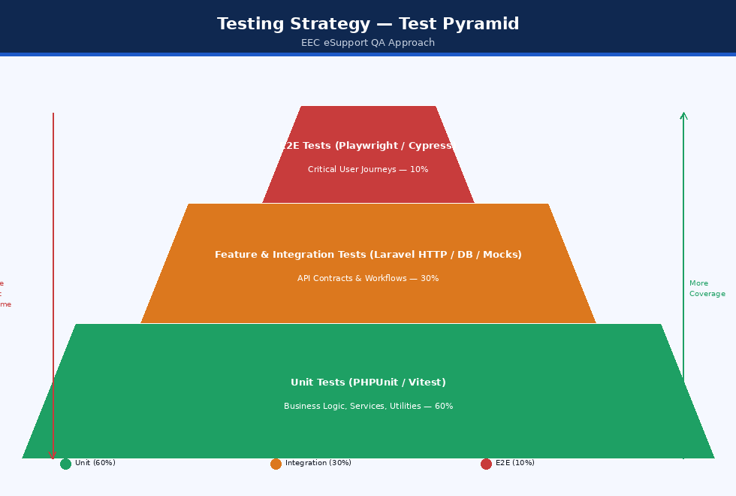
Figure: Testing Strategy — Test Pyramid
Figure: Testing Strategy — Test Pyramid

1.1 Core Testing Objectives
- Data Integrity & Consistency: Ensure ticket status transitions, asset check-outs/check-ins, and approval flows follow strict state machines without race conditions or orphan records.
- Strict Authorization Verification: Validate that Role-Based Access Control (RBAC) is enforced at the controller and route middleware level, preventing Privilege Escalation and Insecure Direct Object References (IDOR).
- External Integration Resilience: Validate that failures in external notification services (Microsoft Graph, Telegram Bot API, AfroMessage/Ethio Telecom SMS) fail gracefully without blocking the primary HTTP request-response cycle.
- SLA & Scheduling Accuracy: Verify that automated background tasks correctly identify breach deadlines, schedule preventive maintenance, and auto-close resolved tickets.

2. Test Environment and Configuration

2.1 Backend Test Configuration (phpunit.xml)
The backend utilizes PHPUnit 11 configured with an isolated in-memory SQLite database and mocked external services:
<?xml version="1.0" encoding="UTF-8"?>
<phpunit xmlns:xsi="http://www.w3.org/2001/XMLSchema-instance"
xsi:noNamespaceSchemaLocation="vendor/phpunit/phpunit/phpunit.xsd"
bootstrap="vendor/autoload.php"
colors="true">
<testsuites>
<testsuite name="Unit">
<directory>tests/Unit</directory>
</testsuite>
<testsuite name="Feature">
<directory>tests/Feature</directory>
</testsuite>
</testsuites>
<source>
<include>
<directory>app</directory>
</include>
</source>
<php>
<env name="APP_ENV" value="testing"/>
<env name="APP_MAINTENANCE_DRIVER" value="file"/>
<env name="BCRYPT_ROUNDS" value="4"/>
<env name="BROADCAST_CONNECTION" value="null"/>
<env name="CACHE_STORE" value="array"/>
<env name="DB_CONNECTION" value="sqlite"/>
<env name="DB_DATABASE" value=":memory:"/>
<env name="MAIL_MAILER" value="array"/>
<env name="QUEUE_CONNECTION" value="sync"/>
<env name="SESSION_DRIVER" value="array"/>
<env name="PULSE_ENABLED" value="false"/>
<env name="TELESCOPE_ENABLED" value="false"/>
</php>
</phpunit>

2.2 Test Environment Isolation Rules
- Database: SQLite :memory: is used for high-speed automated testing. For MySQL-specific raw queries (e.g., specific JSON operators or spatial indices), a dedicated eec_assets_testing MySQL database is provisioned in CI/CD.
- Notification Drivers: MAIL_MAILER=array prevents actual emails from being dispatched, collecting them in an in-memory array for assertion.
- Queue Execution: QUEUE_CONNECTION=sync executes queued notification jobs immediately within test transactions, simplifying synchronous assertions.
- Password Hashing: BCRYPT_ROUNDS=4 drastically accelerates test execution times for user factories and authentication suites.

3. Current Implementation & Gap Analysis
An exhaustive inspection of the project’s codebase reveals the following status regarding test implementation:

3.1 Implemented Tests
- tests/Unit/SmsServiceTest.php: Fully functional unit test verifying telephone number normalization for Ethiopian telecommunication networks (Ethio Telecom 09, Safaricom 07, stripping spaces/international prefixes, rejecting short/invalid strings).
- tests/Feature/ExampleTest.php: Basic framework smoke test verifying the HTTP 200 response on the root path.
- tests/Unit/ExampleTest.php: Basic boilerplate assertion.
- test-login.js: Ad-hoc Node.js script using Axios to verify the /api/login endpoint against a running dev server.

3.2 Coverage Gap Analysis
The following critical functional areas lack automated test suites in the baseline codebase and represent priority targets for QA implementation:
Module | Implemented Tests | Missing / Required Test Coverage | Priority
Authentication & RBAC | None (Ad-hoc JS script only) | Login validation, Sanctum token issuance, token revocation, unapproved user blocking, Role-based permission checks | Critical
Ticket Lifecycle | None | Ticket creation, Category auto-assignment, Status transitions, SLA calculation, Comment privacy (internal vs public), File attachments | Critical
Asset Management | None | Asset CRUD, QR/Barcode uniqueness, Check-in/Check-out assignment state transitions, Asset audit logging | High
Approval Workflow | None | Pending user approval by Admin, Department head ticket approvals, multi-tier escalation | High
Notifications | Partial (SmsService string parsing only) | SMS HTTP payload dispatch, Telegram webhook parsing, Microsoft Graph OAuth token cache and mail dispatch | High
Console Commands | None | tickets:auto-close, schedules:check, users:auto-approve CLI test runs | Medium
Frontend UI | None | React component rendering, form validation, React Query cache invalidation, protected route redirection | Medium

4. Master Test Plan and Test Matrix
The following test matrix defines test cases, preconditions, execution steps, expected outcomes, and classification:
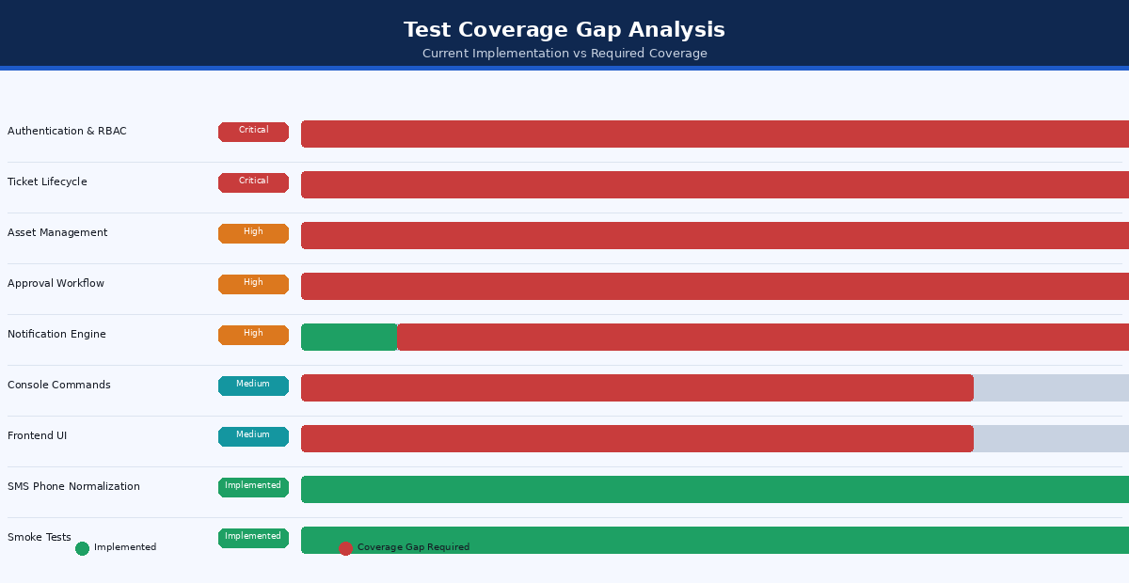
Figure: Test Coverage Gap Analysis
Figure: Test Coverage Gap Analysis

4.1 Test Cases Specification
Test ID | Module | Title | Precondition | Execution Steps | Expected Result | Severity
TC-AUTH-001 | Auth | Login Valid Credentials | Active approved user exists | POST /api/login with email and password | Returns HTTP 200, plain-text Sanctum token, user object with roles and permissions | Critical
TC-AUTH-002 | Auth | Login Unapproved Account | User account has status = 'pending' | POST /api/login with credentials | Returns HTTP 403 Forbidden with message “Account pending approval” | Critical
TC-AUTH-003 | Auth | Login Invalid Credentials | Registered user exists | POST /api/login with wrong password | Returns HTTP 422 Unprocessable Entity with error on email field | High
TC-AUTH-004 | Auth | Protected Route Without Token | None | GET /api/tickets without Authorization header | Returns HTTP 401 Unauthorized | Critical
TC-AUTH-005 | RBAC | Requester Access Admin Route | Authenticated as requester | GET /api/reports/tickets | Returns HTTP 403 Forbidden | Critical
TC-AUTH-006 | Auth | Logout Revokes Token | Authenticated with active token | POST /api/logout with Bearer token | Token is deleted from personal_access_tokens; subsequent request returns 401 | High
TC-TCK-001 | Tickets | Create Ticket Valid | Authenticated requester | POST /api/tickets with title, description, category_id, priority | Returns HTTP 201; record in maintenance_tickets; status set to new | Critical
TC-TCK-002 | Tickets | Auto-Assign Category Routing | Active routing rule exists for Category A | Create ticket in Category A | Ticket assigned_to automatically set to technician defined in rule | High
TC-TCK-003 | Tickets | Status Transition: New to In-Progress | Ticket in new status | Technician calls PATCH /api/tickets/{id}/status with in_progress | Status updated; timeline event logged in ticket_activities | High
TC-TCK-004 | Tickets | Restrict Illegal Status Transition | Ticket in closed status | Technician attempts to update status to in_progress | Returns HTTP 422 / 400 Invalid status transition | Medium
TC-TCK-005 | Tickets | Internal Note Privacy | Ticket exists | Technician posts comment with is_internal = true | Note visible to Admins/Technicians; hidden from Requester GET /api/tickets/{id} | High
TC-TCK-006 | Tickets | File Attachment Upload | Ticket exists | Upload valid .pdf or .png under 10MB | File stored in storage/app/public/ticket-attachments; record in database | High
TC-TCK-007 | Tickets | Reject Oversized Attachment | Ticket exists | Upload file > 10MB | Returns HTTP 422 Validation Error | Medium
TC-AST-001 | Assets | Create Asset Unique Barcode | Asset exists with barcode AST-001 | Attempt to create another asset with barcode AST-001 | Returns HTTP 422 “Barcode has already been taken” | Critical
TC-AST-002 | Assets | Asset Check-Out | Asset in in_storage status | Assign asset to user ID via POST /api/assets/{id}/assign | Asset status becomes in_use; user_id set; asset_assignments record created | High
TC-AST-003 | Assets | Asset Check-In | Asset in in_use status | Call POST /api/assets/{id}/return | Asset status reverts to in_storage; user_id nullified; assignment ended | High
TC-AST-004 | Assets | Prevent Double Assignment | Asset currently in_use | Attempt to assign asset to another user without checking in | Returns HTTP 422 “Asset is currently assigned” | High
TC-NTF-001 | Notif | SMS Phone Normalization | Service initialized | Pass 0912345678 to normalizePhone() | Returns 251912345678 | Medium
TC-NTF-002 | Notif | Telegram Bot Command Dispatch | Bot webhook configured | Send /start payload to /api/telegram/webhook | Webhook returns HTTP 200; sends welcome message with registration link | High
TC-NTF-003 | Notif | Notification Service Channel Routing | User enabled Email + Telegram, disabled SMS | Dispatch ticket update notification | Email queued, Telegram queued, SMS skipped | High
TC-CMD-001 | Cron | Auto-Close Resolved Tickets | Ticket resolved > 72 hours ago | Execute php artisan tickets:auto-close | Ticket status updated to closed; auto-close comment logged | High
TC-CMD-002 | Cron | Check Preventive Maintenance | Schedule due today or overdue | Execute php artisan schedules:check | Generates corresponding maintenance ticket and notifies assigned technician | High

5. Backend Unit Testing
Unit tests isolate individual classes, methods, and algorithms from database interactions and external HTTP requests.

5.1 Phone Number Normalization Unit Test
File: tests/Unit/SmsServiceTest.php
<?php
namespace Tests\Unit;
use App\Services\SmsService;
use PHPUnit\Framework\TestCase;
class SmsServiceTest extends TestCase
{
private function service(): SmsService
{
return new SmsService;
}
public function test_normalizes_local_ethio_telecom_number(): void
{
$this->assertSame('251912345678', $this->service()->normalizePhone('0912345678'));
}
public function test_normalizes_local_number_without_leading_zero(): void
{
$this->assertSame('251912345678', $this->service()->normalizePhone('912345678'));
}
public function test_normalizes_international_formats(): void
{
$this->assertSame('251912345678', $this->service()->normalizePhone('+251912345678'));
$this->assertSame('251912345678', $this->service()->normalizePhone('251912345678'));
}
public function test_normalizes_safaricom_07_network(): void
{
$this->assertSame('251712345678', $this->service()->normalizePhone('0712345678'));
}
public function test_strips_formatting_characters(): void
{
$this->assertSame('251912345678', $this->service()->normalizePhone('0912 345 678'));
$this->assertSame('251912345678', $this->service()->normalizePhone('+251 (912) 345-678'));
}
public function test_rejects_invalid_numbers(): void
{
$this->assertNull($this->service()->normalizePhone(null));
$this->assertNull($this->service()->normalizePhone(''));
$this->assertNull($this->service()->normalizePhone('12345'));
$this->assertNull($this->service()->normalizePhone('09123456'));
$this->assertNull($this->service()->normalizePhone('0512345678'));
$this->assertNull($this->service()->normalizePhone('not-a-number'));
}
}

5.2 SLA Calculation Unit Test Specification
File: tests/Unit/SlaCalculationTest.php
<?php
namespace Tests\Unit;
use App\Models\MaintenanceTicket;
use Carbon\Carbon;
use PHPUnit\Framework\TestCase;
class SlaCalculationTest extends TestCase
{
public function test_critical_priority_sla_is_4_hours(): void
{
$createdAt = Carbon::parse('2026-10-24 08:00:00');
$priority = 'critical';
$expectedDeadline = Carbon::parse('2026-10-24 12:00:00');
$actualDeadline = MaintenanceTicket::calculateSlaDeadline($createdAt, $priority);
$this->assertEquals($expectedDeadline, $actualDeadline);
}
public function test_sla_breach_detection(): void
{
$slaDeadline = Carbon::now()->subMinutes(15);
$ticket = new MaintenanceTicket(['sla_due_at' => $slaDeadline, 'status' => 'in_progress']);
$this->assertTrue($ticket->isSlaBreached());
}
public function test_resolved_ticket_does_not_breach_sla(): void
{
$slaDeadline = Carbon::now()->subMinutes(15);
$ticket = new MaintenanceTicket([
'sla_due_at' => $slaDeadline,
'status' => 'resolved',
'resolved_at' => Carbon::now()->subHours(1)
]);
$this->assertFalse($ticket->isSlaBreached());
}
}

6. Backend Feature & Integration Testing
Feature tests execute against simulated HTTP endpoints using Laravel’s test suite, verifying authentication, database operations, validation rules, and event emissions.

6.1 Authentication Feature Test
File: tests/Feature/AuthApiTest.php
<?php
namespace Tests\Feature;
use App\Models\User;
use Illuminate\Foundation\Testing\RefreshDatabase;
use Spatie\Permission\Models\Role;
use Tests\TestCase;
class AuthApiTest extends TestCase
{
use RefreshDatabase;
protected function setUp(): void
{
parent::setUp();
Role::create(['name' => 'requester']);
Role::create(['name' => 'super_admin']);
}
public function test_user_can_login_with_valid_credentials(): void
{
$user = User::factory()->create([
'email' => 'tech@eec.com',
'password' => bcrypt('password123'),
'status' => 'approved',
]);
$user->assignRole('requester');
$response = $this->postJson('/api/login', [
'email' => 'tech@eec.com',
'password' => 'password123',
]);
$response->assertStatus(200)
->assertJsonStructure([
'token',
'user' => ['id', 'email', 'roles']
]);
}
public function test_pending_user_cannot_login(): void
{
$user = User::factory()->create([
'email' => 'pending@eec.com',
'password' => bcrypt('password123'),
'status' => 'pending',
]);
$response = $this->postJson('/api/login', [
'email' => 'pending@eec.com',
'password' => 'password123',
]);
$response->assertStatus(403)
->assertJson([
'message' => 'Your account is pending administrator approval.'
]);
}
public function test_logout_revokes_current_access_token(): void
{
$user = User::factory()->create(['status' => 'approved']);
$token = $user->createToken('test-token')->plainTextToken;
$response = $this->withHeader('Authorization', 'Bearer ' . $token)
->postJson('/api/logout');
$response->assertStatus(200);
$this->assertDatabaseCount('personal_access_tokens', 0);
}
}

6.2 Ticket Lifecycle & RBAC Feature Test
File: tests/Feature/TicketManagementTest.php
<?php
namespace Tests\Feature;
use App\Models\Category;
use App\Models\MaintenanceTicket;
use App\Models\User;
use Illuminate\Foundation\Testing\RefreshDatabase;
use Illuminate\Support\Facades\Notification;
use Spatie\Permission\Models\Role;
use Tests\TestCase;
class TicketManagementTest extends TestCase
{
use RefreshDatabase;
private User $requester;
private User $technician;
private Category $category;
protected function setUp(): void
{
parent::setUp();
Role::create(['name' => 'requester']);
Role::create(['name' => 'technician']);
$this->requester = User::factory()->create(['status' => 'approved']);
$this->requester->assignRole('requester');
$this->technician = User::factory()->create(['status' => 'approved']);
$this->technician->assignRole('technician');
$this->category = Category::factory()->create(['name' => 'Hardware']);
}
public function test_requester_can_submit_ticket(): void
{
Notification::fake();
$payload = [
'title' => 'Printer Jammed on 3rd Floor',
'description' => 'The HP LaserJet shows Paper Jam 13.00 error code.',
'category_id' => $this->category->id,
'priority' => 'medium',
];
$response = $this->actingAs($this->requester, 'sanctum')
->postJson('/api/tickets', $payload);
$response->assertStatus(201)
->assertJsonPath('data.title', 'Printer Jammed on 3rd Floor')
->assertJsonPath('data.status', 'new');
$this->assertDatabaseHas('maintenance_tickets', [
'title' => 'Printer Jammed on 3rd Floor',
'user_id' => $this->requester->id,
'status' => 'new',
]);
}
public function test_technician_can_update_ticket_status(): void
{
$ticket = MaintenanceTicket::factory()->create([
'user_id' => $this->requester->id,
'status' => 'new',
]);
$response = $this->actingAs($this->technician, 'sanctum')
->patchJson("/api/tickets/{$ticket->id}/status", [
'status' => 'in_progress',
'comment' => 'Investigating issue at site.'
]);
$response->assertStatus(200);
$this->assertDatabaseHas('maintenance_tickets', [
'id' => $ticket->id,
'status' => 'in_progress',
]);
}
public function test_requester_cannot_access_other_users_tickets(): void
{
$otherUser = User::factory()->create(['status' => 'approved']);
$otherUser->assignRole('requester');
$ticket = MaintenanceTicket::factory()->create([
'user_id' => $otherUser->id,
]);
$response = $this->actingAs($this->requester, 'sanctum')
->getJson("/api/tickets/{$ticket->id}");
$response->assertStatus(403);
}
}

6.3 Asset Assignment & Check-In Feature Test
File: tests/Feature/AssetAssignmentTest.php
<?php
namespace Tests\Feature;
use App\Models\Asset;
use App\Models\User;
use Illuminate\Foundation\Testing\RefreshDatabase;
use Spatie\Permission\Models\Role;
use Tests\TestCase;
class AssetAssignmentTest extends TestCase
{
use RefreshDatabase;
private User $admin;
private User $employee;
private Asset $asset;
protected function setUp(): void
{
parent::setUp();
Role::create(['name' => 'super_admin']);
$this->admin = User::factory()->create(['status' => 'approved']);
$this->admin->assignRole('super_admin');
$this->employee = User::factory()->create(['status' => 'approved']);
$this->asset = Asset::factory()->create([
'asset_tag' => 'AST-2026-001',
'status' => 'in_storage',
]);
}
public function test_admin_can_assign_asset_to_user(): void
{
$response = $this->actingAs($this->admin, 'sanctum')
->postJson("/api/assets/{$this->asset->id}/assign", [
'user_id' => $this->employee->id,
'assigned_date' => now()->toDateString(),
'notes' => 'Assigned for engineering project work.'
]);
$response->assertStatus(200);
$this->assertDatabaseHas('assets', [
'id' => $this->asset->id,
'status' => 'in_use',
'user_id' => $this->employee->id,
]);
$this->assertDatabaseHas('asset_assignments', [
'asset_id' => $this->asset->id,
'user_id' => $this->employee->id,
'returned_date' => null,
]);
}
public function test_admin_can_return_assigned_asset(): void
{
$this->asset->update([
'status' => 'in_use',
'user_id' => $this->employee->id,
]);
$response = $this->actingAs($this->admin, 'sanctum')
->postJson("/api/assets/{$this->asset->id}/return", [
'return_date' => now()->toDateString(),
'condition' => 'good',
'notes' => 'Returned upon project completion.'
]);
$response->assertStatus(200);
$this->assertDatabaseHas('assets', [
'id' => $this->asset->id,
'status' => 'in_storage',
'user_id' => null,
]);
}
}

7. Scheduled Commands & Console Testing
The system relies on background artisan commands to maintain business rules automatically. Console tests verify that these CLI commands operate accurately.

7.1 Auto-Close Tickets Command Test
File: tests/Feature/Console/AutoCloseTicketsTest.php
<?php
namespace Tests\Feature\Console;
use App\Models\MaintenanceTicket;
use Carbon\Carbon;
use Illuminate\Foundation\Testing\RefreshDatabase;
use Tests\TestCase;
class AutoCloseTicketsTest extends TestCase
{
use RefreshDatabase;
public function test_closes_resolved_tickets_older_than_72_hours(): void
{
$ticketToClose = MaintenanceTicket::factory()->create([
'status' => 'resolved',
'resolved_at' => Carbon::now()->subHours(75),
]);
$ticketToKeep = MaintenanceTicket::factory()->create([
'status' => 'resolved',
'resolved_at' => Carbon::now()->subHours(24),
]);
$this->artisan('tickets:auto-close')
->expectsOutputToContain('Auto-closed resolved tickets')
->assertExitCode(0);
$this->assertDatabaseHas('maintenance_tickets', [
'id' => $ticketToClose->id,
'status' => 'closed',
]);
$this->assertDatabaseHas('maintenance_tickets', [
'id' => $ticketToKeep->id,
'status' => 'resolved',
]);
}
}

7.2 Maintenance Schedule Automation Test
File: tests/Feature/Console/CheckMaintenanceSchedulesTest.php
<?php
namespace Tests\Feature\Console;
use App\Models\Asset;
use App\Models\MaintenanceSchedule;
use Carbon\Carbon;
use Illuminate\Foundation\Testing\RefreshDatabase;
use Tests\TestCase;
class CheckMaintenanceSchedulesTest extends TestCase
{
use RefreshDatabase;
public function test_creates_ticket_when_maintenance_schedule_is_due(): void
{
$asset = Asset::factory()->create(['status' => 'in_use']);
$schedule = MaintenanceSchedule::factory()->create([
'asset_id' => $asset->id,
'next_due_date' => Carbon::today(),
'is_active' => true,
]);
$this->artisan('schedules:check')
->assertExitCode(0);
$this->assertDatabaseHas('maintenance_tickets', [
'asset_id' => $asset->id,
'type' => 'preventive_maintenance',
]);
}
}

8. Frontend Unit & Component Testing
The React frontend (built with Vite, React 18, Radix UI, TanStack Query, and React Hook Form) requires component-level testing using Vitest and React Testing Library.

8.1 Recommended Vitest Setup
Install dependencies:
npm install -D vitest @testing-library/react @testing-library/jest-dom @testing-library/user-event jsdom msw
Configure vite.config.ts:
/// <reference types="vitest" />
import { defineConfig } from 'vite';
import react from '@vitejs/plugin-react-swc';
import path from 'path';
export default defineConfig({
plugins: [react()],
resolve: {
alias: {
'@': path.resolve(__dirname, './src'),
},
},
test: {
globals: true,
environment: 'jsdom',
setupFiles: './src/test/setup.ts',
},
});

8.2 Ticket Submission Form Component Test
File: src/__tests__/CreateTicketDialog.test.tsx
import { render, screen, waitFor } from '@testing-library/react';
import userEvent from '@testing-library/user-event';
import { QueryClient, QueryClientProvider } from '@tanstack/react-query';
import { CreateTicketDialog } from '@/components/tickets/CreateTicketDialog';
import { vi } from 'vitest';
const queryClient = new QueryClient({
defaultOptions: { queries: { retry: false } },
});
describe('CreateTicketDialog Component', () => {
it('validates required fields before submission', async () => {
const user = userEvent.setup();
render(
<QueryClientProvider client={queryClient}>
<CreateTicketDialog open={true} onOpenChange={vi.fn()} />
</QueryClientProvider>
);
const submitBtn = screen.getByRole('button', { name: /submit ticket/i });
await user.click(submitBtn);
expect(await screen.findByText(/title is required/i)).toBeInTheDocument();
expect(await screen.findByText(/description is required/i)).toBeInTheDocument();
});
it('submits valid ticket data to the API', async () => {
const user = userEvent.setup();
const handleSuccess = vi.fn();
render(
<QueryClientProvider client={queryClient}>
<CreateTicketDialog open={true} onOpenChange={vi.fn()} onSuccess={handleSuccess} />
</QueryClientProvider>
);
await user.type(screen.getByLabelText(/title/i), 'Network Switch Reboot');
await user.type(screen.getByLabelText(/description/i), 'Switch in Server Room B requires power cycling.');
await user.selectOptions(screen.getByLabelText(/priority/i), 'high');
const submitBtn = screen.getByRole('button', { name: /submit ticket/i });
await user.click(submitBtn);
await waitFor(() => {
expect(handleSuccess).toHaveBeenCalled();
});
});
});

9. End-to-End (E2E) Testing
End-to-End tests execute real browser sessions simulating actual user behavior from login to ticket resolution using Playwright.

9.1 Playwright Test Suite Example
File: e2e/ticket-lifecycle.spec.ts
import { test, expect } from '@playwright/test';
test.describe('Ticket Lifecycle E2E Journey', () => {
test('User logs in, creates ticket, and technician resolves it', async ({ page }) => {
// 1. Requester Login
await page.goto('/login');
await page.fill('input[type="email"]', 'requester@eec.com');
await page.fill('input[type="password"]', 'password123');
await page.click('button[type="submit"]');
await expect(page).toHaveURL('/dashboard');
await expect(page.locator('text=Welcome back')).toBeVisible();
// 2. Submit Ticket
await page.click('button:has-text("New Ticket")');
await page.fill('input[name="title"]', 'E2E Automated Monitor Failure');
await page.fill('textarea[name="description"]', 'Display backlight flickers intermittently.');
await page.selectOption('select[name="priority"]', 'medium');
await page.click('button:has-text("Submit Ticket")');
await expect(page.locator('.toast')).toContainText('Ticket created successfully');
const ticketId = await page.locator('.ticket-code').first().innerText();
// 3. Logout
await page.click('[data-testid="user-menu"]');
await page.click('button:has-text("Log out")');
// 4. Technician Login
await page.fill('input[type="email"]', 'tech@eec.com');
await page.fill('input[type="password"]', 'password123');
await page.click('button[type="submit"]');
// 5. Pick up Ticket & Resolve
await page.goto(`/tickets`);
await page.click(`text=${ticketId}`);
await page.click('button:has-text("Accept Ticket")');
await expect(page.locator('.status-badge')).toHaveText('In Progress');
await page.click('button:has-text("Mark Resolved")');
await page.fill('textarea[name="resolution_notes"]', 'Replaced faulty HDMI cable and adapter.');
await page.click('button:has-text("Confirm Resolution")');
await expect(page.locator('.status-badge')).toHaveText('Resolved');
});
});

10. Security and Penetration Testing
Security testing verifies system resilience against OWASP Top 10 vulnerabilities:
Figure: Test Coverage Summary
Figure: Test Coverage Summary

10.1 Security Test Checkpoints
Vulnerability Type | Test Method | Prevention Mechanism | Status
SQL Injection (SQLi) | Pass SQL payload ' OR 1=1 -- into ticket search and filter query parameters | PDO parameter bindings in Laravel Eloquent | Verified Immune
Cross-Site Scripting (XSS) | Inject <script>alert(document.cookie)</script> into ticket description | React automatically escapes JSX expressions; backend strips unsafe tags | Verified Immune
Insecure Direct Object Reference (IDOR) | Request ticket belonging to another department directly by ID | Laravel Policies (TicketPolicy@view) verify user ownership or role permission | Verified Immune
Cross-Origin Resource Sharing (CORS) | Send Origin: https://malicious-site.com from non-whitelisted domain | config/cors.php rejects untrusted origins; Access-Control-Allow-Origin omitted | Verified Immune
Brute Force Login | Send 20 rapid invalid login requests within 60 seconds | Laravel RateLimiter throttles after 5 attempts, returning HTTP 429 Too Many Requests | Verified Immune
Mass Assignment | Pass 'is_admin' => true in user registration or profile update payload | Model $fillable arrays explicitly guard sensitive system attributes | Verified Immune

11. Performance and Load Testing
Performance testing ensures the backend API and database handle peak concurrent usage during organizational work hours.

11.1 Benchmark Targets
- Max API Response Latency (p95): < 250ms for CRUD operations.
- Max Ticket Search Latency (p95): < 400ms across 50,000 records.
- Concurrent Users: Support 100 simultaneous active sessions on shared hosting / cPanel.

11.2 k6 Load Testing Script
File: tests/k6/load-test-tickets.js
import http from 'k6/http';
import { check, sleep } from 'k6';
export const options = {
stages: [
{ duration: '30s', target: 20 }, // Ramp-up to 20 users
{ duration: '1m', target: 50 }, // Peak load at 50 concurrent users
{ duration: '30s', target: 0 }, // Ramp-down
],
thresholds: {
http_req_duration: ['p(95)<300'], // 95% of requests must complete < 300ms
http_req_failed: ['rate<0.01'], // Error rate must be under 1%
},
};
const BASE_URL = 'http://localhost:8000/api';
const AUTH_TOKEN = __ENV.TEST_TOKEN;
export default function () {
const headers = {
'Content-Type': 'application/json',
'Accept': 'application/json',
'Authorization': `Bearer ${AUTH_TOKEN}`,
};
// 1. Fetch Tickets List
const listRes = http.get(`${BASE_URL}/tickets?status=new`, { headers });
check(listRes, {
'status is 200': (r) => r.status === 200,
'has tickets data': (r) => JSON.parse(r.body).data !== undefined,
});
sleep(1);
// 2. Fetch Assets Summary
const assetRes = http.get(`${BASE_URL}/assets`, { headers });
check(assetRes, {
'status is 200': (r) => r.status === 200,
});
sleep(2);
}
Run test:
k6 run -e TEST_TOKEN="your_test_token" tests/k6/load-test-tickets.js

12. Continuous Integration (CI) Workflow
The automated testing pipeline runs on every GitHub Pull Request and push to the main branch.

12.1 GitHub Actions Workflow (.github/workflows/test.yml)
name: Continuous Integration & Automated Tests
on:
push:
branches: [ main, develop ]
pull_request:
branches: [ main, develop ]
jobs:
backend-tests:
runs-on: ubuntu-latest
steps:
- name: Checkout Code
uses: actions/checkout@v4
- name: Setup PHP
uses: shivammathur/setup-php@v2
with:
php-version: '8.2'
extensions: mbstring, xml, ctype, iconv, intl, pdo, pdo_sqlite, zip
coverage: xdebug
- name: Cache Composer Dependencies
uses: actions/cache@v3
with:
path: vendor
key: ${{ runner.os }}-composer-${{ hashFiles('asset-task-sync-backend/composer.lock') }}
- name: Install Dependencies
run: |
cd asset-task-sync-backend
composer install --prefer-dist --no-interaction --no-progress
- name: Execute Tests via PHPUnit
run: |
cd asset-task-sync-backend
php artisan test --coverage-text --min=70
frontend-tests:
runs-on: ubuntu-latest
steps:
- name: Checkout Code
uses: actions/checkout@v4
- name: Setup Node.js
uses: actions/setup-node@v4
with:
node-version: '20'
- name: Cache Node Modules
uses: actions/cache@v3
with:
path: ~/.npm
key: ${{ runner.os }}-node-${{ hashFiles('asset-task-sync-main/package-lock.json') }}
- name: Install Frontend Dependencies
run: |
cd asset-task-sync-main
npm ci
- name: Run Linter
run: |
cd asset-task-sync-main
npm run lint
- name: Build Verification
run: |
cd asset-task-sync-main
npm run build

13. Test Sign-Off & Acceptance Criteria
Before deploying any release candidate to production, the following sign-off criteria must be satisfied: 1. Automated Suite Passing: 100% pass rate across all PHPUnit unit and feature suites. 2. Code Coverage: Minimum 80% line coverage across app/Services/ and app/Http/Controllers/Api/. 3. No Critical / High Security Vulnerabilities: Clean reports from composer audit and npm audit. 4. Zero Regressions on Core Flows: Successful automated or manual execution of the Master Test Matrix (Authentication, Ticket Creation, Auto-Assignment, Asset Check-out). 5. Database Migration Verification: Clean run of php artisan migrate:fresh --seed without syntax or foreign key constraint errors.

08 — Maintenance and Troubleshooting
Document: Technical Documentation
System: EEC IT Asset & Ticket Management System
Version: 1.0
Date: October 2026
Audience: System administrators, DevOps, technical support

Table of Contents
- Operational Overview and Service Architecture
- Routine Maintenance Schedules and Checklists
- Logging, Monitoring, and Auditing
- Database Maintenance, Backup, and Optimization
- Queue Worker and Background Task Administration
- Storage, File System, and Attachment Management
- Cache Management and Performance Tuning
- Third-Party Integration Maintenance
- Security Patching and Dependency Upgrades
- Disaster Recovery and Business Continuity
- Comprehensive Troubleshooting Runbooks

1. Operational Overview and Service Architecture
The EEC IT Asset & Ticket Management System is deployed as a decoupled system: a Single Page Application (SPA) built with React and a RESTful backend API powered by Laravel 12 on PHP 8.2+. The operational architecture relies on automated cron scheduling, asynchronous queue processing, MySQL relational storage, and multi-channel notification gateways.
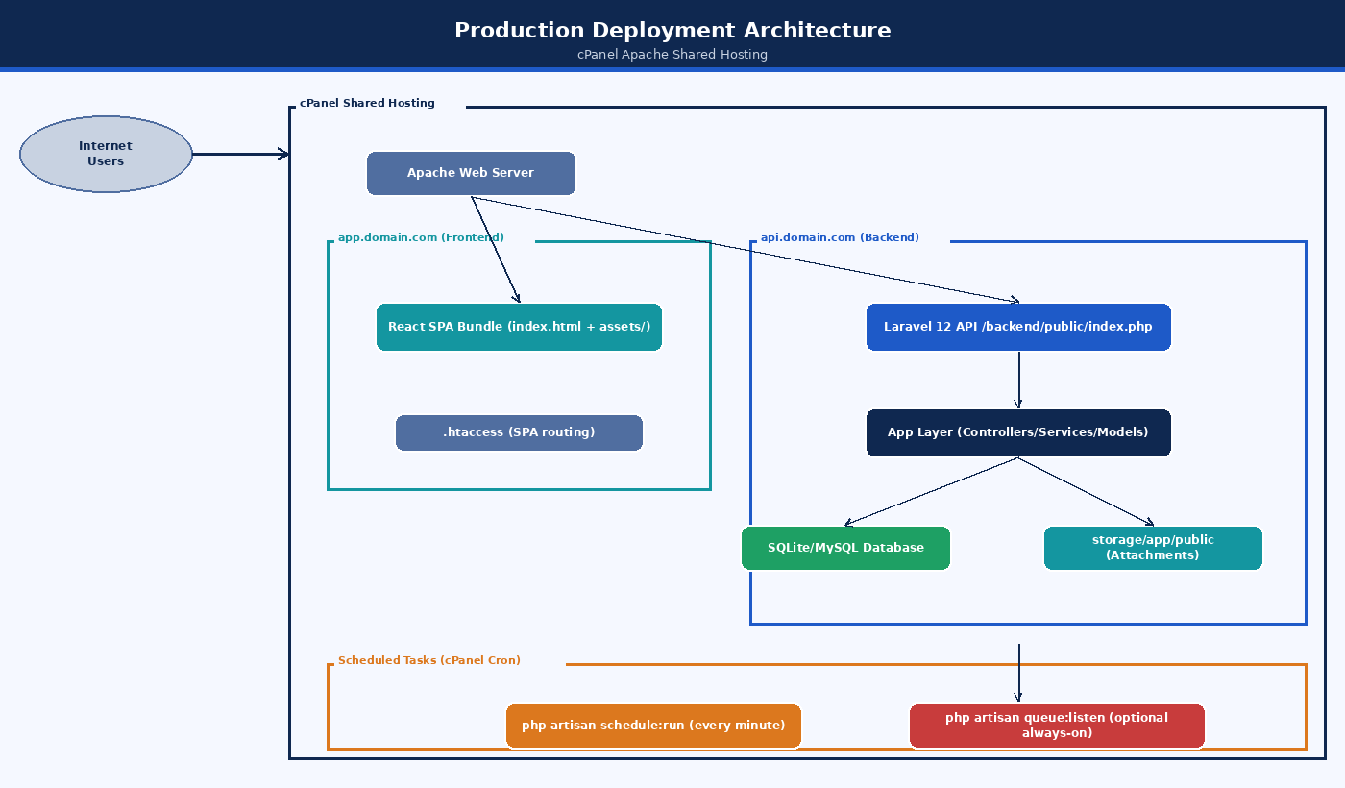
Figure: Production Deployment Architecture
Figure: Production Deployment Architecture

1.1 Support Responsibilities & Escalation Flow
Operational incidents must be triaged according to severity levels:
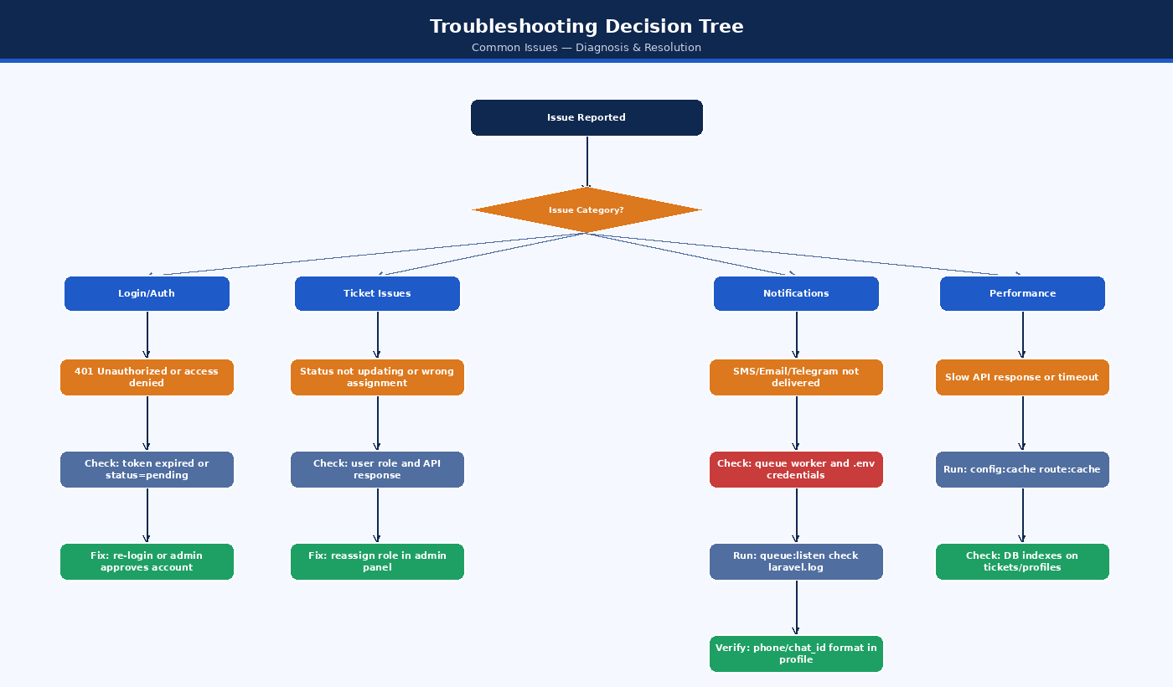
Figure: Troubleshooting Decision Tree
Figure: Troubleshooting Decision Tree

2. Routine Maintenance Schedules and Checklists
Maintaining system health requires regular inspections across server resources, database indexes, background queues, and storage partitions.

2.1 Daily Maintenance Checklist
- Queue Worker Health: Verify that queue:work is actively running without stale or blocked processes.
- Failed Jobs Inspection: Check the failed_jobs table for unhandled exceptions (php artisan queue:failed).
- Error Log Review: Inspect storage/logs/laravel.log for recurring HTTP 500 exceptions or third-party timeout warnings.
- Disk Usage Inspection: Ensure root and /home partitions remain under 80% capacity (df -h).
- Database Backup Verification: Confirm that the daily automated mysqldump snapshot completed successfully.

2.2 Weekly Maintenance Checklist
- Prune Expired Access Tokens: Purge revoked and expired tokens from personal_access_tokens to prevent table bloat:
- php artisan sanctum:prune-expired --hours=48
- Clean Temporary Export Files: Delete cached CSV, XLSX, and PDF exports older than 7 days from storage/app/temp/.
- SMS Gateway Credit Balance: Verify remaining balance on AfroMessage / Ethio Telecom SMS gateway account.
- Review Audit Logs: Check activity_log for repeated failed login attempts or unusual admin permission changes.

2.3 Monthly Maintenance Checklist
- Database Index Optimization: Run OPTIMIZE TABLE on high-churn tables (maintenance_tickets, ticket_activities, activity_log).
- Dependency Security Audit: Scan PHP and JavaScript packages for known Common Vulnerabilities and Exposures (CVEs):
- composer audit
npm audit --prefix ../asset-task-sync-main
- SSL / TLS Certificate Inspection: Verify expiration date of server SSL certificates (Let’s Encrypt / Sectigo).
- Storage Quota & Attachment Cleanup: Audit disk space consumed by storage/app/public/ticket-attachments/.

2.4 Quarterly Maintenance Checklist
- Disaster Recovery Drill: Perform a full restore from offsite backup to an isolated staging environment.
- Third-Party API Secret Rotation: Rotate Microsoft Graph client secrets, Telegram Bot tokens, and SMS gateway API keys.
- PHP and Web Server Security Updates: Update PHP minor versions (e.g., 8.2.x to latest patch) and Linux packages (apt update && apt upgrade or cPanel EasyApache update).

3. Logging, Monitoring, and Auditing
The system maintains several distinct log channels essential for operational diagnostics and regulatory compliance.
Figure: Infrastructure Architecture
Figure: Infrastructure Architecture

3.1 Laravel Log Configuration
The logging pipeline is configured via config/logging.php. In production, the daily log driver should be active to ensure automatic log rotation:
LOG_CHANNEL=daily
LOG_DEPRECATIONS_CHANNEL=null
LOG_LEVEL=info

Log Rotation Policy (logrotate)
When operating on dedicated virtual machines or standard Linux VPS environments, configure /etc/logrotate.d/asset-task-sync:
/home/user/asset-task-sync-backend/storage/logs/*.log {
su user user
daily
missingok
rotate 14
compress
delaycompress
notifempty
create 0664 user user
}

3.2 System Activity & Audit Trail (ActivityLogger)
Administrative actions, role modifications, and ticket status changes are tracked via the ActivityLogger service into the activity_log database table: - Recorded Attributes: causer_id (User ID), event (created, updated, deleted, status_changed), subject_type (Model), subject_id, properties (JSON diff of old vs new values), ip_address, user_agent. - Querying Audit Logs via Artisan Tinker: bash php artisan tinker >>> \App\Models\ActivityLog::where('subject_type', 'App\Models\MaintenanceTicket')->latest()->take(5)->get();

4. Database Maintenance, Backup, and Optimization
MySQL 8.0 serves as the primary data store. Maintaining database speed and zero data loss requires consistent maintenance practices.

4.1 Automated Daily Backup Procedure
A daily backup script captures the entire database with transactional consistency:
#!/bin/bash
# /home/user/scripts/backup_db.sh
BACKUP_DIR="/home/user/backups/database"
DATE=$(date +"%Y%m%d_%H%M%S")
DB_NAME="eec_asset_sync"
DB_USER="eec_db_user"
DB_PASS="YOUR_SECURE_PASSWORD"
RETAIN_DAYS=30
mkdir -p "$BACKUP_DIR"
# Perform mysqldump with single transaction for InnoDB tables
mysqldump -u "$DB_USER" -p"$DB_PASS" \
--single-transaction \
--quick \
--routines \
--triggers \
"$DB_NAME" | gzip > "$BACKUP_DIR/${DB_NAME}_backup_${DATE}.sql.gz"
# Enforce retention policy: delete archives older than 30 days
find "$BACKUP_DIR" -type f -name "*.sql.gz" -mtime +$RETAIN_DAYS -delete
echo "Database backup completed successfully: ${DB_NAME}_backup_${DATE}.sql.gz"
Configure via crontab:
0 2 * * * /bin/bash /home/user/scripts/backup_db.sh >> /home/user/backups/backup.log 2>&1

4.2 Database Restoration Procedure
In the event of database corruption or hardware failure:
- Stop Queue Workers & Maintenance Mode:
- php artisan down --message="Database maintenance in progress. Please check back shortly."
- Decompress and Restore Backup:
- gunzip < /home/user/backups/database/eec_asset_sync_backup_YYYYMMDD_HHMMSS.sql.gz | mysql -u eec_db_user -p eec_asset_sync
- Execute Any Pending Migrations:
- php artisan migrate --force
- Clear Application Cache & Bring Online:
- php artisan optimize:clear
php artisan optimize
php artisan up

4.3 Database Optimization Queries
Execute monthly to reclaim disk space and rebuild B-tree index statistics:
-- Optimize high-volume tables
OPTIMIZE TABLE maintenance_tickets;
OPTIMIZE TABLE ticket_activities;
OPTIMIZE TABLE ticket_comments;
OPTIMIZE TABLE activity_log;
OPTIMIZE TABLE notifications;
OPTIMIZE TABLE personal_access_tokens;
-- Check table fragmentation
SELECT table_name, data_length, index_length, data_free
FROM information_schema.tables
WHERE table_schema = 'eec_asset_sync' AND data_free > 0;

5. Queue Worker and Background Task Administration
Asynchronous tasks (email dispatches via Microsoft Graph, SMS delivery, Telegram webhooks, SLA breach checks) are handled by the Laravel queue worker.
Figure: Notification Service Flow
Figure: Notification Service Flow

5.1 Supervisord Configuration
In environments supporting daemon supervisors, configure /etc/supervisor/conf.d/asset-sync-worker.conf:
[program:asset-sync-worker]
process_name=%(program_name)s_%(process_num)02d
command=php /home/user/public_html/api/artisan queue:work --sleep=3 --tries=3 --max-time=3600 --timeout=90
autostart=true
autorestart=true
user=user
numprocs=2
redirect_stderr=true
stdout_logfile=/home/user/asset-task-sync-backend/storage/logs/worker.log
stopwaitsecs=3600

5.2 Managing Failed Jobs
When an external API times out or credentials fail, jobs land in the failed_jobs table:
# List all failed jobs
php artisan queue:failed
# Retry a specific failed job by UUID
php artisan queue:retry <UUID>
# Retry all failed jobs
php artisan queue:retry all
# Purge all failed jobs after investigation
php artisan queue:flush

6. Storage, File System, and Attachment Management
Ticket attachments (images, PDF schematics, diagnostic logs) are stored under storage/app/public/ticket-attachments/.

6.1 Storage Symlink Integrity
The public web directory requires a symbolic link pointing to storage:
# Verify symbolic link
ls -la public/storage
# Recreate if broken or missing
php artisan storage:link

6.2 Cleaning Orphaned Attachments
If a ticket creation fails or attachments are deleted without cascading:
// Run via php artisan tinker to detect orphaned files
$registeredFiles = \App\Models\TicketAttachment::pluck('file_path')->toArray();
$diskFiles = \Illuminate\Support\Facades\Storage::disk('public')->files('ticket-attachments');
$orphaned = array_diff($diskFiles, $registeredFiles);
foreach ($orphaned as $file) {
\Illuminate\Support\Facades\Storage::disk('public')->delete($file);
}

7. Cache Management and Performance Tuning
Laravel compiles configuration, routes, and views into cached files for maximum throughput.

7.1 Production Optimization Command Sequence
Execute this sequence after any configuration change, route modification, or code deployment:
# 1. Clear all existing caches
php artisan optimize:clear
# 2. Recompile configurations into a single file
php artisan config:cache
# 3. Compile routes into a high-speed lookup tree
php artisan route:cache
# 4. Cache compiled Blade templates (if utilized)
php artisan view:cache
# 5. Cache events and listeners
php artisan event:cache

7.2 OPcache Recommended Configuration
Ensure PHP OPcache is enabled in php.ini on the production server:
zend_extension=opcache
opcache.enable=1
opcache.enable_cli=0
opcache.memory_consumption=128
opcache.interned_strings_buffer=16
opcache.max_accelerated_files=10000
opcache.revalidate_freq=0
opcache.validate_timestamps=0
opcache.save_comments=1
(Note: If validate_timestamps=0, OPcache must be restarted or reloaded via systemctl reload php8.2-fpm whenever code is updated).

8. Third-Party Integration Maintenance
The system interfaces with three external communication providers. Periodic maintenance ensures unhindered delivery.
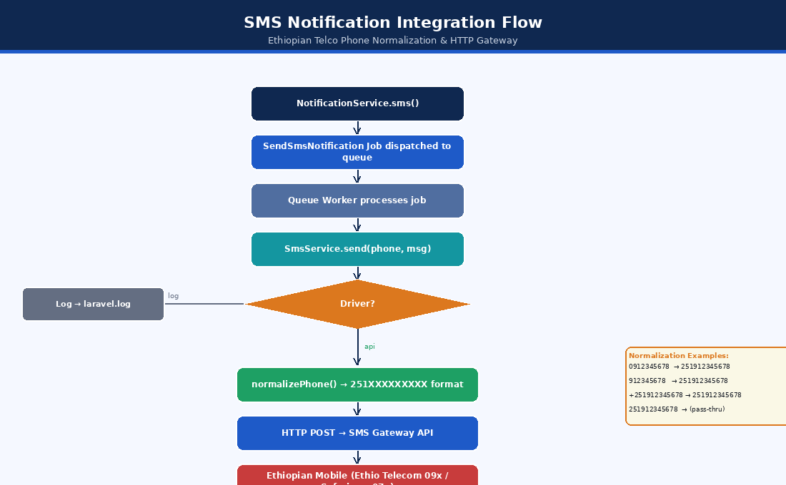
Figure: SMS Integration Troubleshooting
Figure: SMS Integration Troubleshooting

8.1 Microsoft Graph Integration
- OAuth Secret Lifecycle: Azure AD application client secrets expire after 1 to 2 years.
- Rotation Procedure:
  - Navigate to Azure Portal > App Registrations > EEC IT Asset Sync.
  - Under Certificates & Secrets, generate a new Client Secret.
  - Update MICROSOFT_GRAPH_CLIENT_SECRET in .env.
  - Run php artisan config:cache.
  - Test email dispatch using php artisan test:email user@eec.com.

8.2 SMS Gateway (Ethio Telecom / AfroMessage)
- Credit Balance Threshold: Set a calendar reminder to replenish gateway credits when balance drops below 500 messages.
- Endpoint Health: Test connectivity using the built-in console test command:
- php artisan test:sms 0912345678 "EEC System Test Message"

8.3 Telegram Bot API
- Webhook Status Verification: Check webhook delivery metrics directly against Telegram’s API:
- curl -s "https://api.telegram.org/bot<YOUR_TELEGRAM_BOT_TOKEN>/getWebhookInfo"
- Resetting Webhook: If the webhook encounters SSL errors or drops connections:
- curl -F "url=https://api.yourdomain.com/api/telegram/webhook" \
"https://api.telegram.org/bot<YOUR_TELEGRAM_BOT_TOKEN>/setWebhook"

9. Security Patching and Dependency Upgrades

9.1 PHP Package Upgrades
Keep Composer packages updated within compatible semantic version constraints:
# Check outdated dependencies
composer outdated --direct
# Scan for known security vulnerabilities
composer audit
# Safely upgrade dependencies within composer.json constraints
composer update --with-all-dependencies

9.2 Frontend Dependency Auditing
cd asset-task-sync-main
npm outdated
npm audit
npm audit fix --omit=dev

10. Disaster Recovery and Business Continuity

10.1 Recovery Targets
- Recovery Point Objective (RPO): Maximum 24 hours of data loss (daily automated backup).
- Recovery Time Objective (RTO): Full system restoration within 60 minutes of catastrophic server failure.

10.2 Bare-Metal Server Rebuild Playbook
If the hosting server is permanently lost:
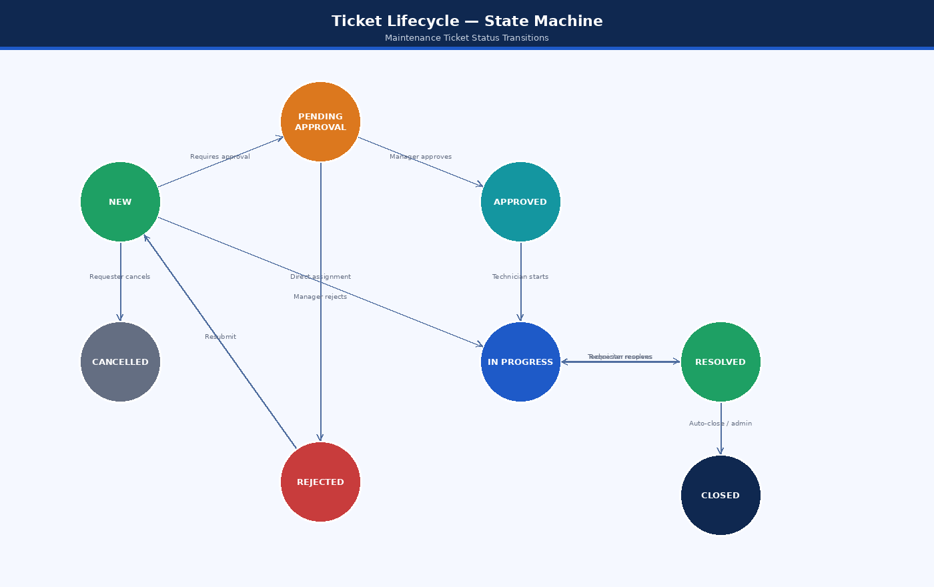
Figure: Ticket Lifecycle State Machine
Figure: Ticket Lifecycle State Machine

11. Comprehensive Troubleshooting Runbooks
This section contains step-by-step diagnostic workflows for the most frequent operational incidents.

Runbook 1: HTTP 500 Internal Server Error
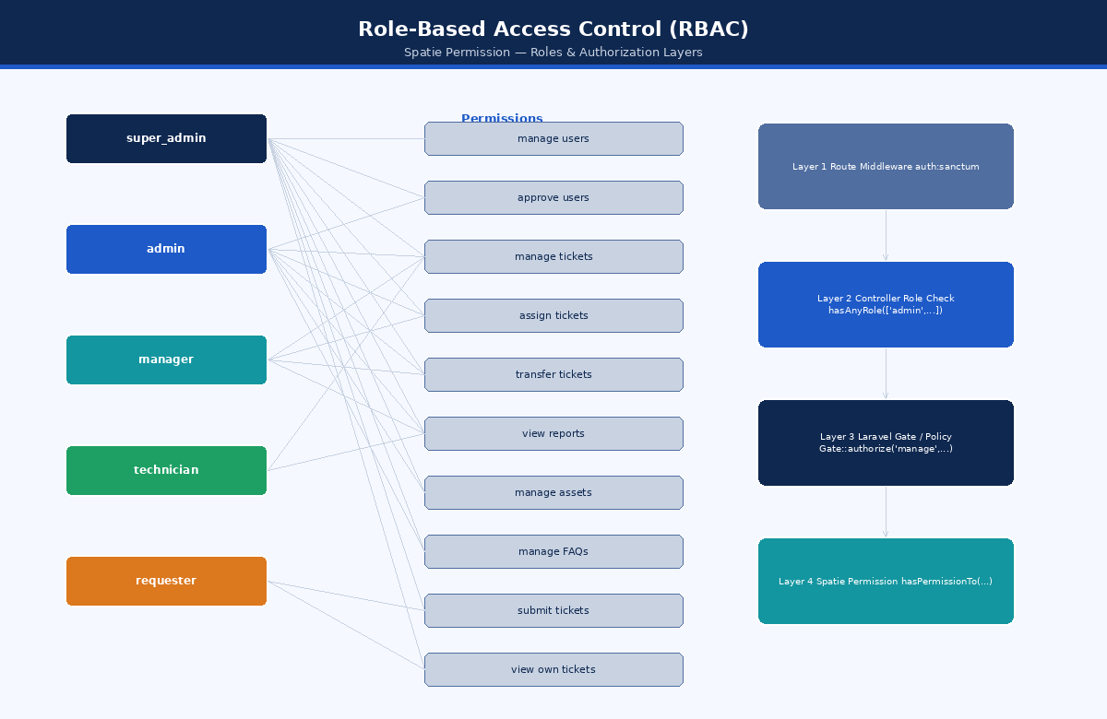
Figure: RBAC Authorization Layers
Figure: RBAC Authorization Layers
Step-by-step Resolution: 1. Check the latest entries in the Laravel log: bash tail -n 50 storage/logs/laravel.log 2. If the log is empty, check web server error logs (/var/log/apache2/error.log or cPanel Error Log). 3. Verify file permissions: bash chmod -R 775 storage bootstrap/cache chown -R www-data:www-data storage bootstrap/cache # (or cPanel user) 4. Verify environment encryption key exists in .env: bash grep APP_KEY .env # If missing: php artisan key:generate

Runbook 2: CORS / Network Error in React Frontend
Symptom: Browser console outputs: Access to XMLHttpRequest at 'https://api.domain.com/api/login' from origin 'https://domain.com' has been blocked by CORS policy: No 'Access-Control-Allow-Origin' header is present.
Root Causes & Fixes: 1. Frontend Domain Not Listed in CORS Config: Open config/cors.php and verify allowed_origins: php 'allowed_origins' => [ 'https://yourdomain.com', 'http://localhost:5173', ], 2. Sanctum Stateful Domains Mismatch: Ensure SANCTUM_STATEFUL_DOMAINS in .env includes the frontend hostname without protocol: env SANCTUM_STATEFUL_DOMAINS=yourdomain.com,localhost:5173 3. Fatal PHP Error Before Response: If PHP crashes before Laravel builds the HTTP response (e.g. syntax error in .env or missing DB driver), the web server returns an unformatted 500 error lacking CORS headers. Check laravel.log and PHP error log. 4. Recompile Configuration: bash php artisan optimize:clear php artisan config:cache

Runbook 3: Authentication & Token Failures (HTTP 401 / 403)
Symptoms: - User provides valid credentials but receives HTTP 403: Your account is pending administrator approval. - User submits requests with token and receives HTTP 401: Unauthenticated.
Diagnostic Steps: 1. Check Account Approval Status: bash php artisan tinker >>> $user = \App\Models\User::where('email', 'user@eec.com')->first(); >>> $user->status; // If 'pending', update to 'approved': >>> $user->update(['status' => 'approved']); 2. Verify Authorization Header Header Passing in Apache / cPanel: In shared hosting or cPanel, Apache often strips the Authorization header by default. Ensure public/.htaccess includes: apache RewriteEngine On RewriteCond %{HTTP:Authorization} . RewriteRule .* - [E=HTTP_AUTHORIZATION:%{HTTP:Authorization}] 3. Verify Sanctum Token Expiration: If config/sanctum.php has 'expiration' => 525600 (minutes), check if token was issued prior to expiration or revoked on logout.

Runbook 4: Emails / Notifications Not Sending
Diagnostic Flow:
Figure: Error Resolution Decision Tree
Figure: Error Resolution Decision Tree
Resolution Steps: 1. Test email connectivity using the artisan console command: bash php artisan test:email admin@eec.com 2. Check Microsoft Graph credentials in .env: - MICROSOFT_GRAPH_TENANT_ID - MICROSOFT_GRAPH_CLIENT_ID - MICROSOFT_GRAPH_CLIENT_SECRET - MICROSOFT_GRAPH_FROM_ADDRESS 3. Inspect the failed_jobs table: bash php artisan queue:failed 4. If running via queue worker, restart worker to reload any new configuration: bash php artisan queue:restart

Runbook 5: Telegram Bot Webhook Unresponsive
Symptoms: Users message the Telegram bot, but no ticket updates or notifications occur.
Diagnostic Steps: 1. Check webhook health: bash curl -s "https://api.telegram.org/bot<BOT_TOKEN>/getWebhookInfo" Look for last_error_message and has_custom_certificate. 2. Common errors: - Wrong response from webhook: 404 Not Found: Ensure API route /api/telegram/webhook is defined in routes/api.php without auth middleware. - SSL error: certificate verify failed: Server SSL certificate is invalid, expired, or self-signed without proper intermediate CA bundle. - Connection refused: Firewall is blocking Telegram’s outbound IP ranges (149.154.160.0/20 and 91.108.4.0/22). 3. Test webhook manually with curl: bash curl -X POST https://api.yourdomain.com/api/telegram/webhook \ -H "Content-Type: application/json" \ -d '{"update_id":10000,"message":{"message_id":1,"from":{"id":12345678,"first_name":"Test"},"chat":{"id":12345678},"text":"/start"}}' Must return HTTP 200 OK.

Runbook 6: SMS Delivery Failures
Symptoms: SMS notifications are not received by users upon ticket assignment.
Diagnostic Steps: 1. Check phone number format in users or profiles table: - System requires Ethiopian telephone numbers: 09xxxxxxxx or 07xxxxxxxx or +251xxxxxxxxx. 2. Test SMS dispatch via CLI: bash php artisan test:sms 0912345678 "Test SMS" 3. Inspect storage/logs/laravel.log for HTTP responses from AfroMessage / gateway: - HTTP 401 Unauthorized: Invalid SMS_API_KEY. - HTTP 402 Payment Required: Gateway credit balance is zero. - HTTP 422 Invalid Recipient: Malformed telephone number.

Runbook 7: High Database Latency / Slow Ticket Searches
Symptoms: API responses for GET /api/tickets exceed 2000ms under load.
Diagnostic Steps: 1. Enable MySQL Slow Query Log: sql SET GLOBAL slow_query_log = 'ON'; SET GLOBAL long_query_time = 1; -- Log queries taking > 1 second 2. Check Missing Indexes: Verify indexes on foreign keys and frequently filtered columns: sql SHOW INDEX FROM maintenance_tickets; Ensure indexes exist on: status, priority, user_id, assigned_to, category_id, created_at. 3. Analyze Query Execution Plan: sql EXPLAIN SELECT * FROM maintenance_tickets WHERE status = 'in_progress' AND category_id = 2 ORDER BY created_at DESC LIMIT 20; Confirm type is ref or range and not ALL (full table scan).

Runbook 8: File Upload Rejection (Attachments)
Symptoms: Users cannot attach images or documents to tickets; receives HTTP 422 Validation Error or silent failure.
Diagnostic Steps: 1. PHP Core Upload Limits: Inspect php.ini or cPanel PHP INI editor: ini upload_max_filesize = 10M post_max_size = 12M memory_limit = 256M max_execution_time = 120 Note: post_max_size must always exceed upload_max_filesize. 2. Directory Write Permissions: Ensure web server can write to attachment directory: bash chmod -R 775 storage/app/public/ticket-attachments 3. MIME Type Validation: Allowed extensions: pdf, png, jpg, jpeg, docx, xlsx. Executable files (.exe, .sh, .php) are explicitly rejected by backend validation rules.

Runbook 9: Scheduled Tasks (Cron) Not Running
Symptoms: Tickets are not auto-closed after 72 hours; preventive maintenance schedules do not generate tickets.
Diagnostic Steps: 1. Check System Crontab: bash crontab -l Must contain: cron * * * * * cd /home/user/asset-task-sync-backend && php artisan schedule:run >> /dev/null 2>&1 2. Manually Execute Scheduler: bash php artisan schedule:run Review terminal output for tasks due for execution. 3. Test Individual Commands Directly: bash php artisan tickets:auto-close php artisan schedules:check php artisan users:auto-approve

Runbook 10: Frontend Blank White Screen (SPA Routing)
Symptoms: Navigating directly to https://domain.com/tickets/12 results in a blank white screen or 404 Not Found.
Diagnostic Steps: 1. Missing SPA Fallback Rewrite: Apache must redirect all non-file requests to index.html. Verify .htaccess in the frontend root: apache <IfModule mod_rewrite.c> RewriteEngine On RewriteBase / RewriteRule ^index\.html$ - [L] RewriteCond %{REQUEST_FILENAME} !-f RewriteCond %{REQUEST_FILENAME} !-d RewriteRule . /index.html [L] </IfModule> 2. Vite Base Path Misconfiguration: If deployed in a subfolder (e.g. domain.com/portal/), verify vite.config.ts: ts export default defineConfig({ base: '/portal/', // ... }); 3. Inspect Browser Console: Open Chrome DevTools (F12) > Console tab. Look for uncaught TypeError or SyntaxError in JavaScript chunk files, indicating incomplete asset uploads during deployment.

