EEC IT Asset & Ticket Management System — User Manual
EEC IT
Table of Contents

01 — Introduction
Document: User Manual
System: EEC IT Asset & Ticket Management System
Version: 1.0
Date: October 2026
Audience: All users

What this system is
The EEC IT Asset & Ticket Management System is the web application staff use to:
- Report IT, SAP/ERP, and general maintenance problems
- Track request status from submission to completion
- See assigned work (technicians)
- Approve work and manage assets (managers)
- Receive alerts in the app, by SMS, and optionally on Telegram
Open the application in a modern browser (Chrome, Edge, Firefox, or Safari) at the address your IT team provides, for example https://app.yourdomain.com.

Who uses it
Role | You typically…
Requester | Submit requests, wait for approval, review completed work, rate the service.
Technician | Open tickets assigned to you, log diagnosis and parts, mark work complete.
Admin (Manager) | Approve or reject requests for your department, assign technicians, review completions, maintain assets and users.
Super Admin | Full system access, including approving new accounts and seeing every department.
Your menu on the left changes with your role. If you cannot see Users, Assets, or Reports, your account does not have those permissions.

What a ticket is
A ticket (also called a request) is one maintenance or support job. It has:
- A title and optional description
- A type (maintenance, repair, installation, inspection, other)
- A support category (IT Support, SAP/ERP, or General) so the right manager receives it
- A priority (low, medium, high, critical)
- A scheduled date
- Optional asset, attachments, and recurring settings
Statuses you will see:
Status | Meaning
Submitted | Waiting for a manager
Approved | Accepted; waiting for a technician
Rejected | Not approved (read the reason)
Assigned | A technician is named
In Progress | Work has started
Completed – Pending Review | Technician finished; you or a manager must confirm
Completed | Accepted as done
Reopened | Completion was not accepted
Cancelled | The request was cancelled

Notifications
- Bell icon in the header: in-app messages
- SMS: sent to the phone number on your profile when the gateway is configured
- Telegram: optional; link your account in Settings (see Feature Guides)

How this manual is organized
Guide | Contents
02-Login-Guide.md | Register, wait for approval, sign in, sign out, change password
03-Dashboard-Guide.md | Home screen, sidebar, calendar, notifications
04-Feature-Guides.md | Tickets, assets, users, reports, help, Telegram, settings — by role
05-FAQ.md | Common questions
If something in the live screens differs from this manual, follow the application and ask your Super Admin; labels can change with new releases.

02 — Login Guide
Document: User Manual
System: EEC IT Asset & Ticket Management System
Version: 1.0

1. Create an account
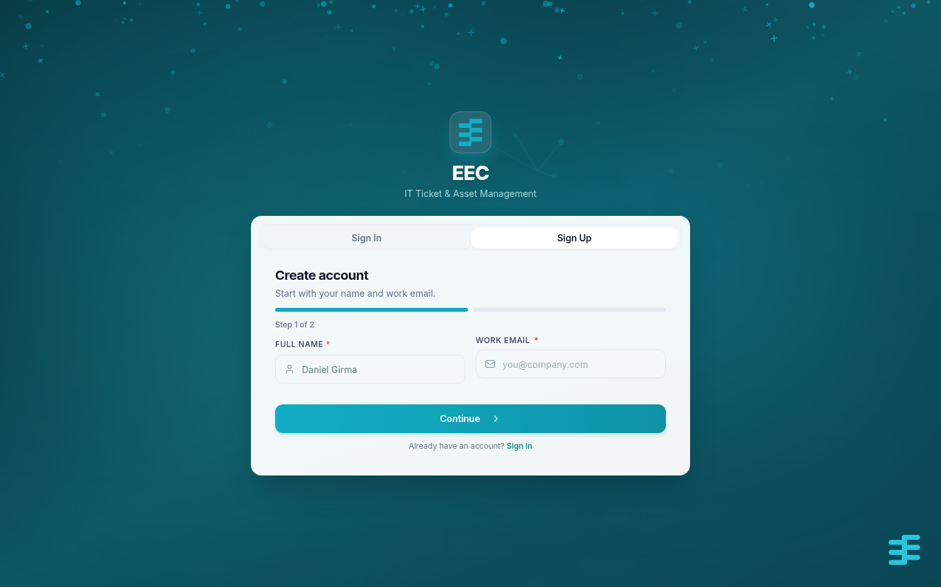
EEC eSupport Account Registration
- Open the application URL in your browser.
- Choose Register or Create an account.
- Fill in:
Field | Required | Notes
Full name | Yes | Shown on tickets and the user list
Email | Yes | This is your login
Password | Yes | At least 8 characters
Confirm password | Yes | Must match
Phone | No | Used for SMS
Telegram username | No | Used if you later link Telegram
Location | No | Building or branch, if listed
- Submit the form.
Your account is Pending Approval. You cannot sign in until a manager or Super Admin approves it. You should receive an in-app (and Telegram, if already linked later) notice when that happens.
If your organization created the account for you, skip registration and use the email and password they sent. Change the password after first login.

2. Sign in
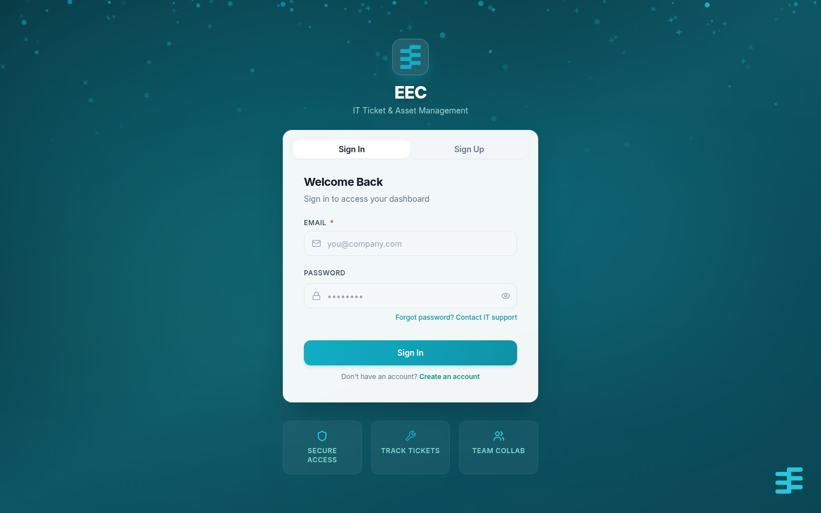
EEC eSupport Login Interface
- Open the login page.
- Enter email and password.
- Click Login.
Successful login takes you to the Dashboard.

Messages you may see
Message (wording may vary) | What to do
Account awaiting admin approval | Wait for approval; do not keep retrying with the same pending account
Registration not approved | The account was rejected; contact IT
Invalid credentials | Check email and password; use the same email you registered

3. Sign out
Open your profile avatar (top right) and choose Logout, or go to Settings and sign out.
Signing out revokes the current session token on the server. Always sign out on a shared computer.

4. Change password
After you are signed in:
- Go to Settings → Security.
- Enter current password.
- Enter new password (minimum 8 characters) and confirm it.
- Save.
There is no self-service “forgot password” email flow in the current product. If you cannot sign in, ask an Admin or Super Admin to reset or recreate access.

5. Session notes
- Keep one browser tab set as your main session; if you are signed out automatically, sign in again.
- Use HTTPS in production so your password and session token are encrypted in transit.
- Do not share your password. Managers should never ask you to send it by chat or email.

03 — Dashboard Guide
Document: User Manual
System: EEC IT Asset & Ticket Management System
Version: 1.0

1. After you sign in
The first screen is the Dashboard (/). It summarizes work that belongs to your role.
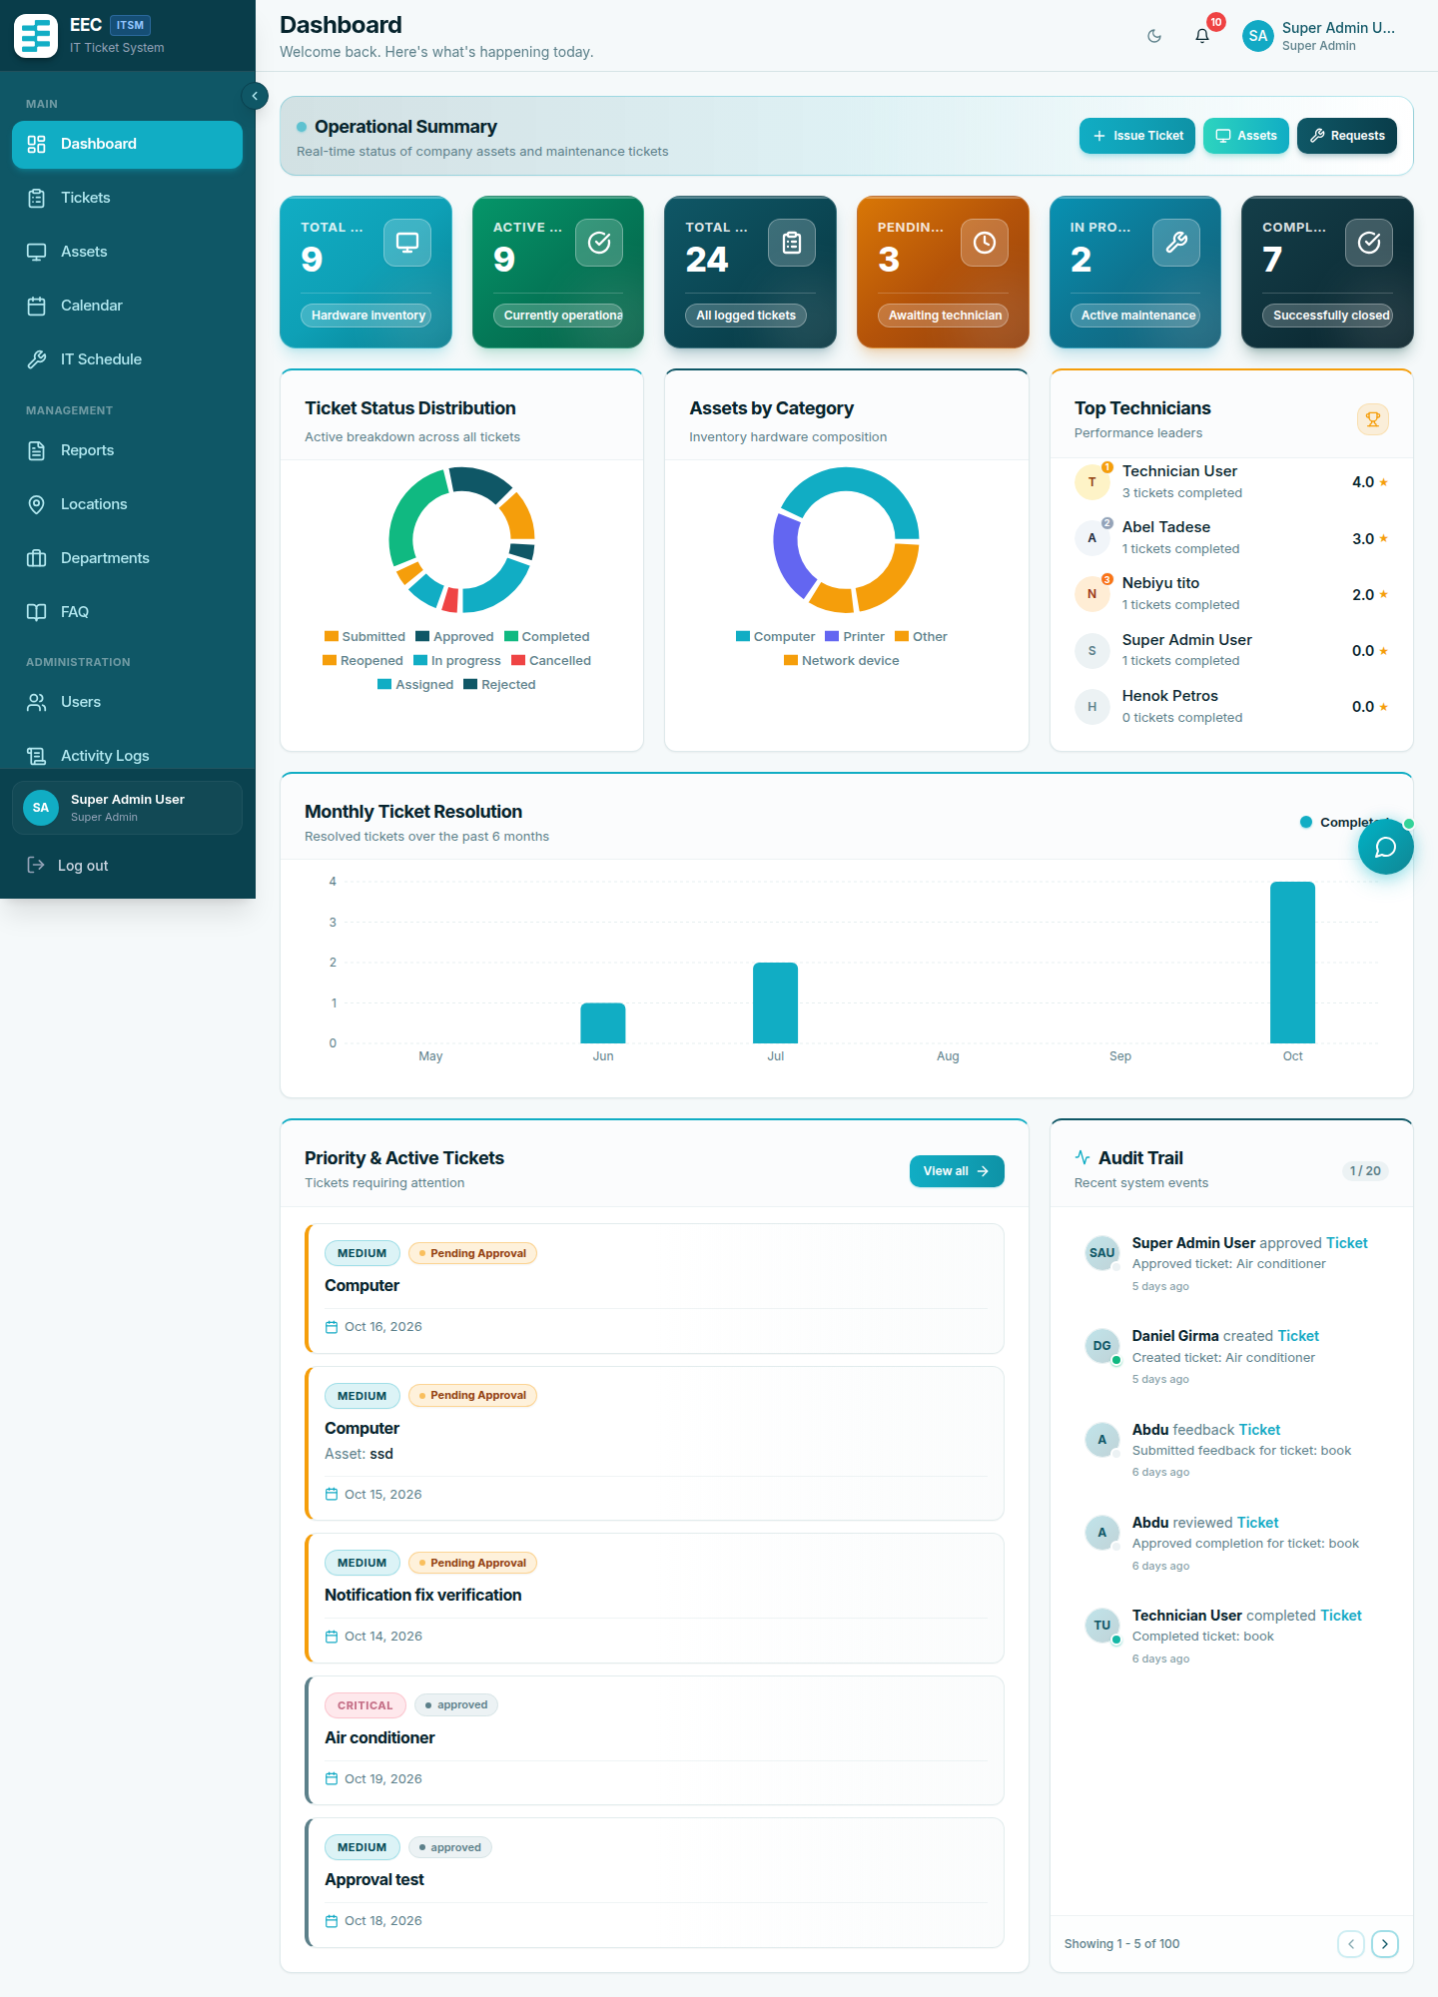
Admin & Manager Dashboard Overview
Figure 3.1: Super Admin and Manager Dashboard with active maintenance metrics, SLA compliance charts, and system status widgets.
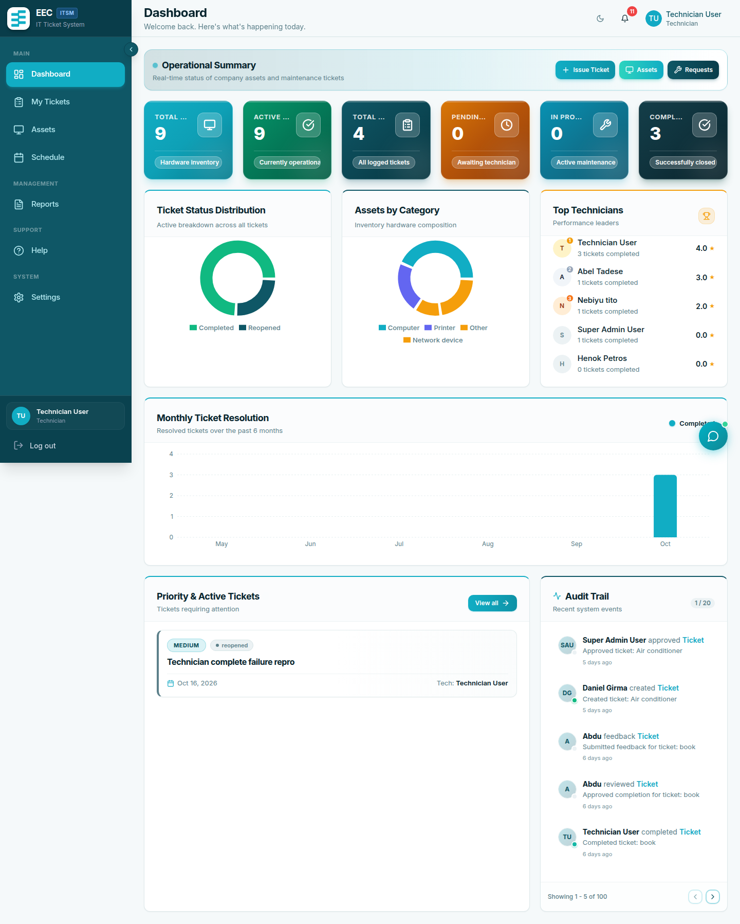
Technician Work Queue Dashboard
Figure 3.2: Technician Dashboard displaying assigned tickets, priority queues, and pending service tasks.
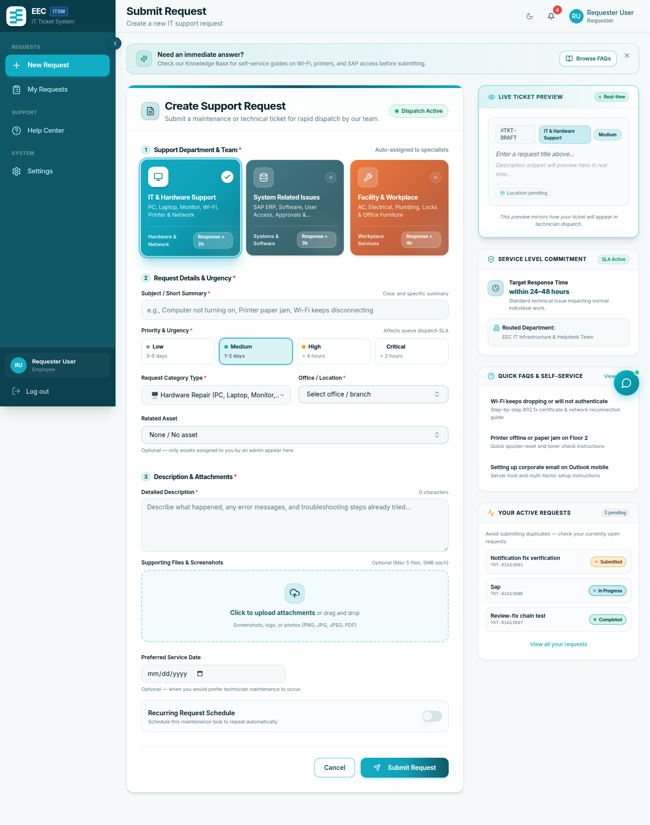
Requester Self-Service Dashboard
Figure 3.3: Requester Self-Service Portal displaying active requests, service status, and new request creation.
Typical widgets:
Widget | Who sees it | What it shows
Ticket summary | Most users | Counts of active, pending, and completed tickets you can see
Recent tickets | Most users | Latest activity
Quick actions | Most users | Shortcut to submit a request or open tickets
Asset overview | Managers | Distribution of asset statuses
Performance metrics | Technicians and managers | Completion rates and averages
Numbers depend on visibility rules: requesters see their own tickets, technicians see assigned work, managers see their department, Super Admins see everything.

2. Sidebar and header
Left sidebar — main navigation. Items appear only if your role is allowed to use them. Common entries:
Menu | Typical path | Purpose
Dashboard | / | Home
Requests / Tickets | /tickets or similar | List and open tickets
Assets | /assets | Asset register (managers)
Users | /users | Accounts (managers)
Locations | /locations | Sites
Departments | /departments | Organization units
Schedules | /schedules | Preventive maintenance
Calendar | /calendar | Scheduled work
FAQs | /faqs | Knowledge base editor (managers)
Help | /help | Published articles
Reports | /reports | Charts and CSV export
Activity Logs | /activity-logs | Audit trail
Notifications | /notifications | Full message list
Settings | /settings | Profile, password, Telegram, theme
Header
- Bell — unread in-app notifications. Click to open the panel; use Mark all as read when needed.
- Avatar — profile and logout.
- Theme — light or dark (also under Settings).
On a phone, the sidebar collapses; use the menu icon to open it.

3. Notifications page
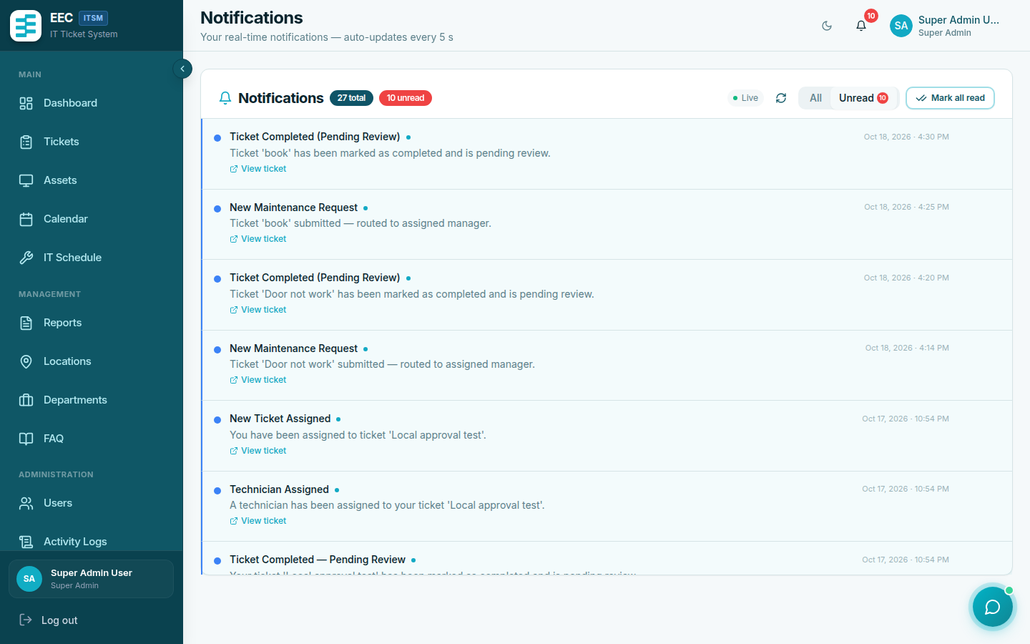
In-App Notifications Center
Figure 3.4: In-App Notifications Center displaying ticket state transitions and alert history.
Open Notifications for the full list. Click a row to open the related ticket or user (and mark it read). Events include:
- New registration (managers / Super Admins)
- Account approved (you)
- Ticket submitted, approved, rejected, assigned, completed, reopened
- Feedback received (managers; technicians get rating, not private comments)

4. Calendar
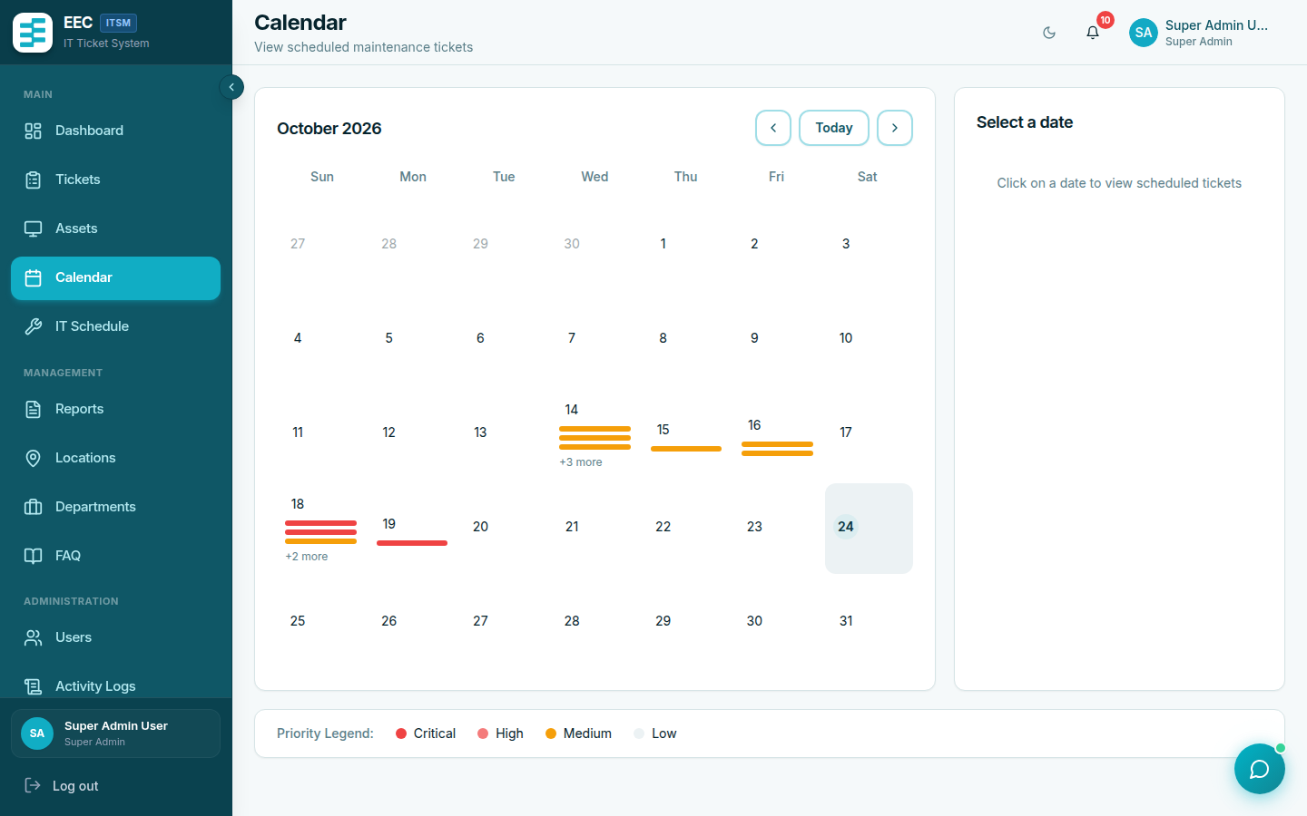
Maintenance & Service Schedule Calendar
Figure 3.5: Service Schedule Calendar with month/week views for planned preventive maintenance.
Calendar shows scheduled maintenance tickets and preventive schedules in month or week view. Use it to plan upcoming work; opening an event still happens from the ticket or schedule screens.

5. Empty and loading states
- While data loads you may see skeleton placeholders.
- If a list is empty, submit a request (requester) or wait for assignment (technician).
- If you open a URL you are not allowed to use, the app redirects or shows a forbidden message. Use the sidebar instead of typing admin URLs.

04 — Feature Guides
Document: User Manual
System: EEC IT Asset & Ticket Management System
Version: 1.0

Table of Contents
- Requester: tickets
- Technician: assigned work
- Manager: workflow
- Assets, locations, departments
- Users
- Schedules
- Reports and activity logs
- Help Center and chatbot
- Settings and Telegram
- Priority and category cheat sheet

1. Requester: tickets

Submit a request
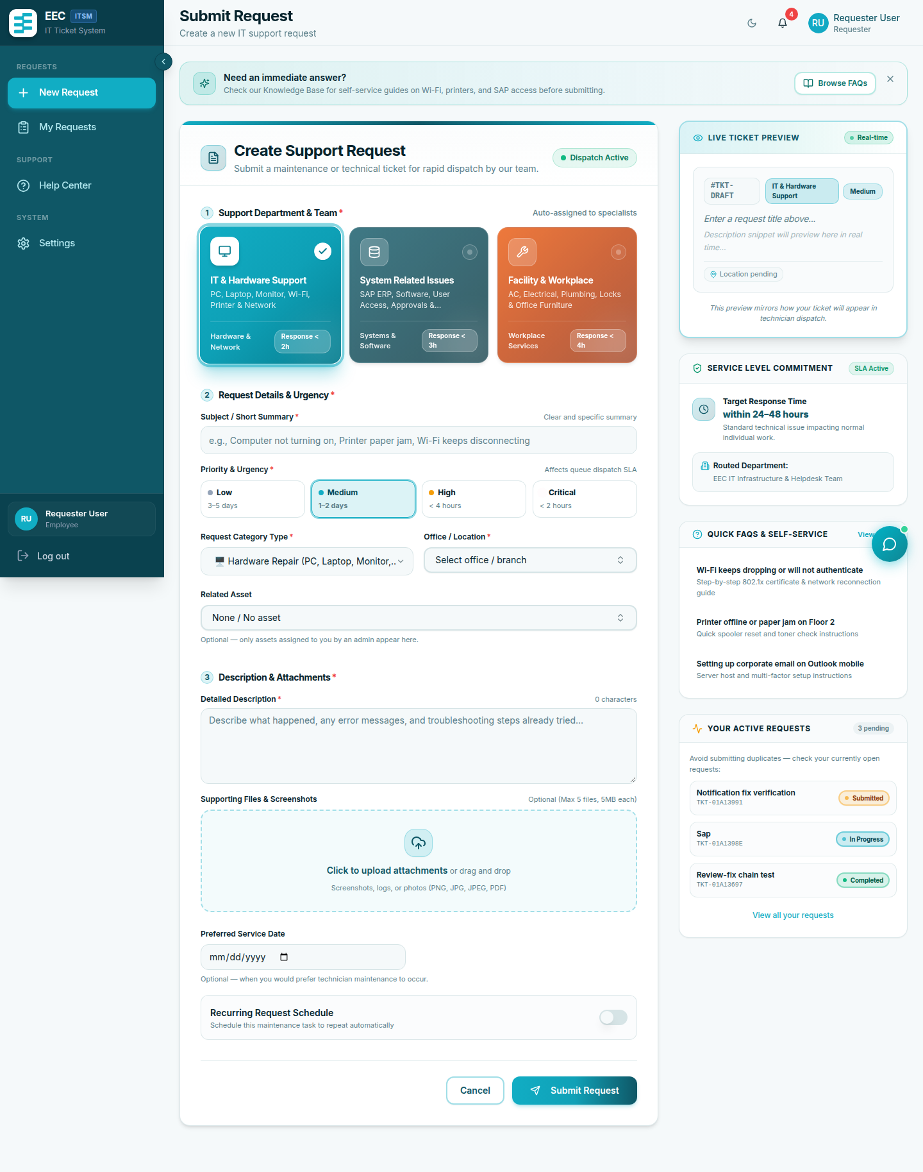
Requester Ticket Submission Portal
Figure 4.1: Requester ticket submission form and active requests tracking view.
- Open Requests (or New Request on the dashboard).
- Complete the form:
Field | Required | Notes
Title | Yes | Short summary
Type | Yes | Maintenance, Repair, Installation, Inspection, Other
Support category | No | IT Support, SAP/ERP, or General — routes to the right team (defaults to General)
Priority | No | Defaults to Medium
Scheduled date | Yes | When the work is needed
Description | No | Details
Asset | No | Affected equipment
Attachments | No | Up to 5 files, 5 MB each (images or PDF)
Recurring | No | Daily, weekly, monthly, quarterly, or yearly
- Submit.
Limit: at most 3 active requests at once. Finish or cancel existing ones before opening more.

Track status
Open Requests and click a row for diagnosis, actions taken, parts, and timeline.

Review completion
When status is Completed – Pending Review:
- Open the ticket.
- Choose Approve Completion if the issue is solved, or Request Rework with notes if not.

Feedback
After Completed, open the ticket → Submit Feedback → 1–5 stars and optional comment. Comments are visible to managers only, not to technicians.

Cancel
You can cancel your own tickets that are still submitted or reopened, when the button is shown.

2. Technician: assigned work
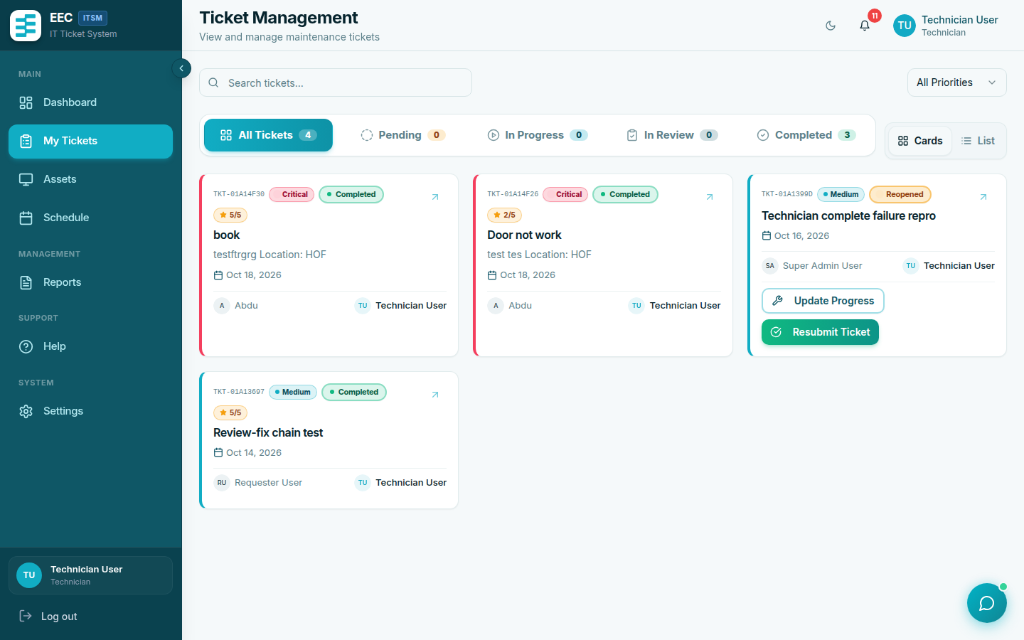
Technician Assigned Work Queue
Figure 4.2: Technician ticket queue with category filters, priority indicators, and action triggers.
- Open Tickets. You see work assigned to you. Filter by status, priority, or category.
- On an Assigned ticket, click Start Work. Status becomes In Progress and start time is stored.
- Use Update Progress for diagnosis, actions taken, spare parts, and estimated duration (minutes).
- Mark as Complete: required actions taken; optional spare parts and actual duration. Status becomes Completed – Pending Review.
- Open Reports for ticket and asset statistics you are allowed to see.
You cannot approve, reject, or assign tickets. If a ticket is reopened, continue work from In Progress / Reopened as the form allows.

3. Manager: workflow

Approve or reject
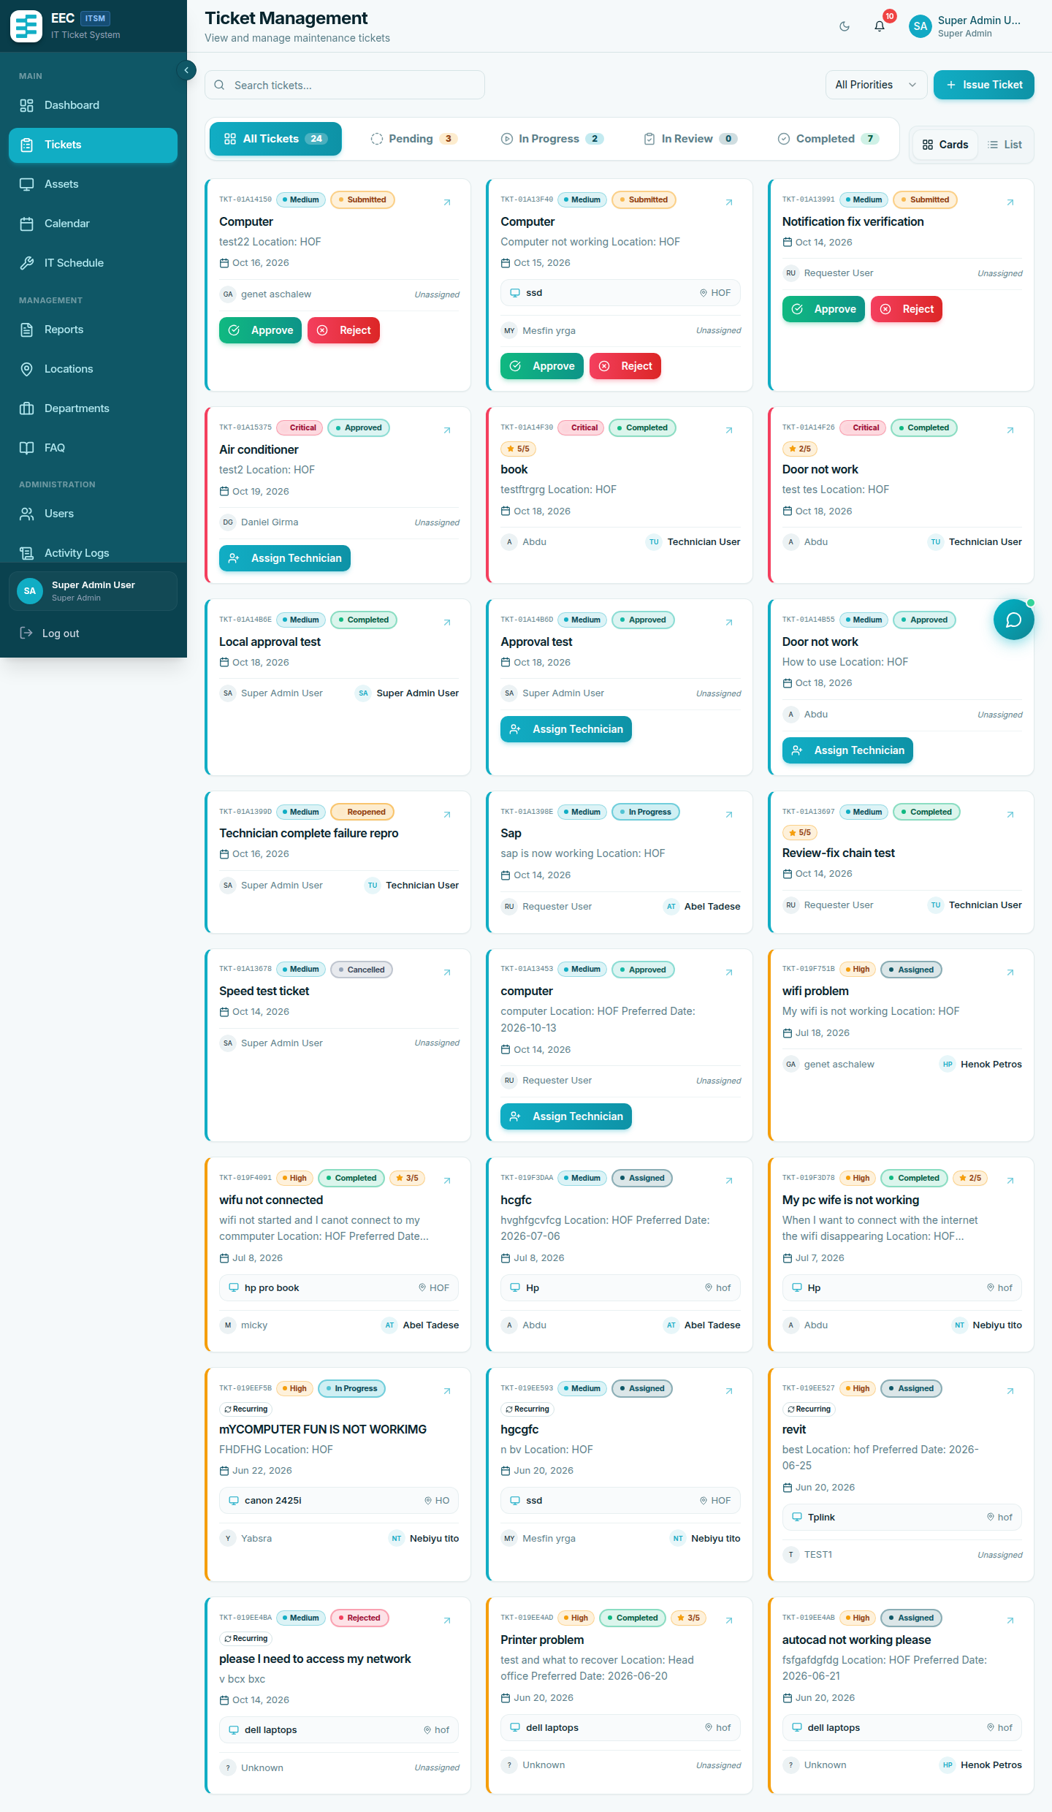
Ticket Management Directory
Figure 4.3: Comprehensive ticket listing with support categories, status chips, and technician assignments.
- Open Tickets and a Submitted item.
- Approve, or Reject with a required reason.
The requester is notified (in-app and SMS if configured).

Assign a technician
On Approved or Submitted tickets, Assign Technician. The list is limited by support category:
- SAP → SAP technicians
- IT Support → IT Support technicians
- General → general / facility technicians

Review completion and transfer
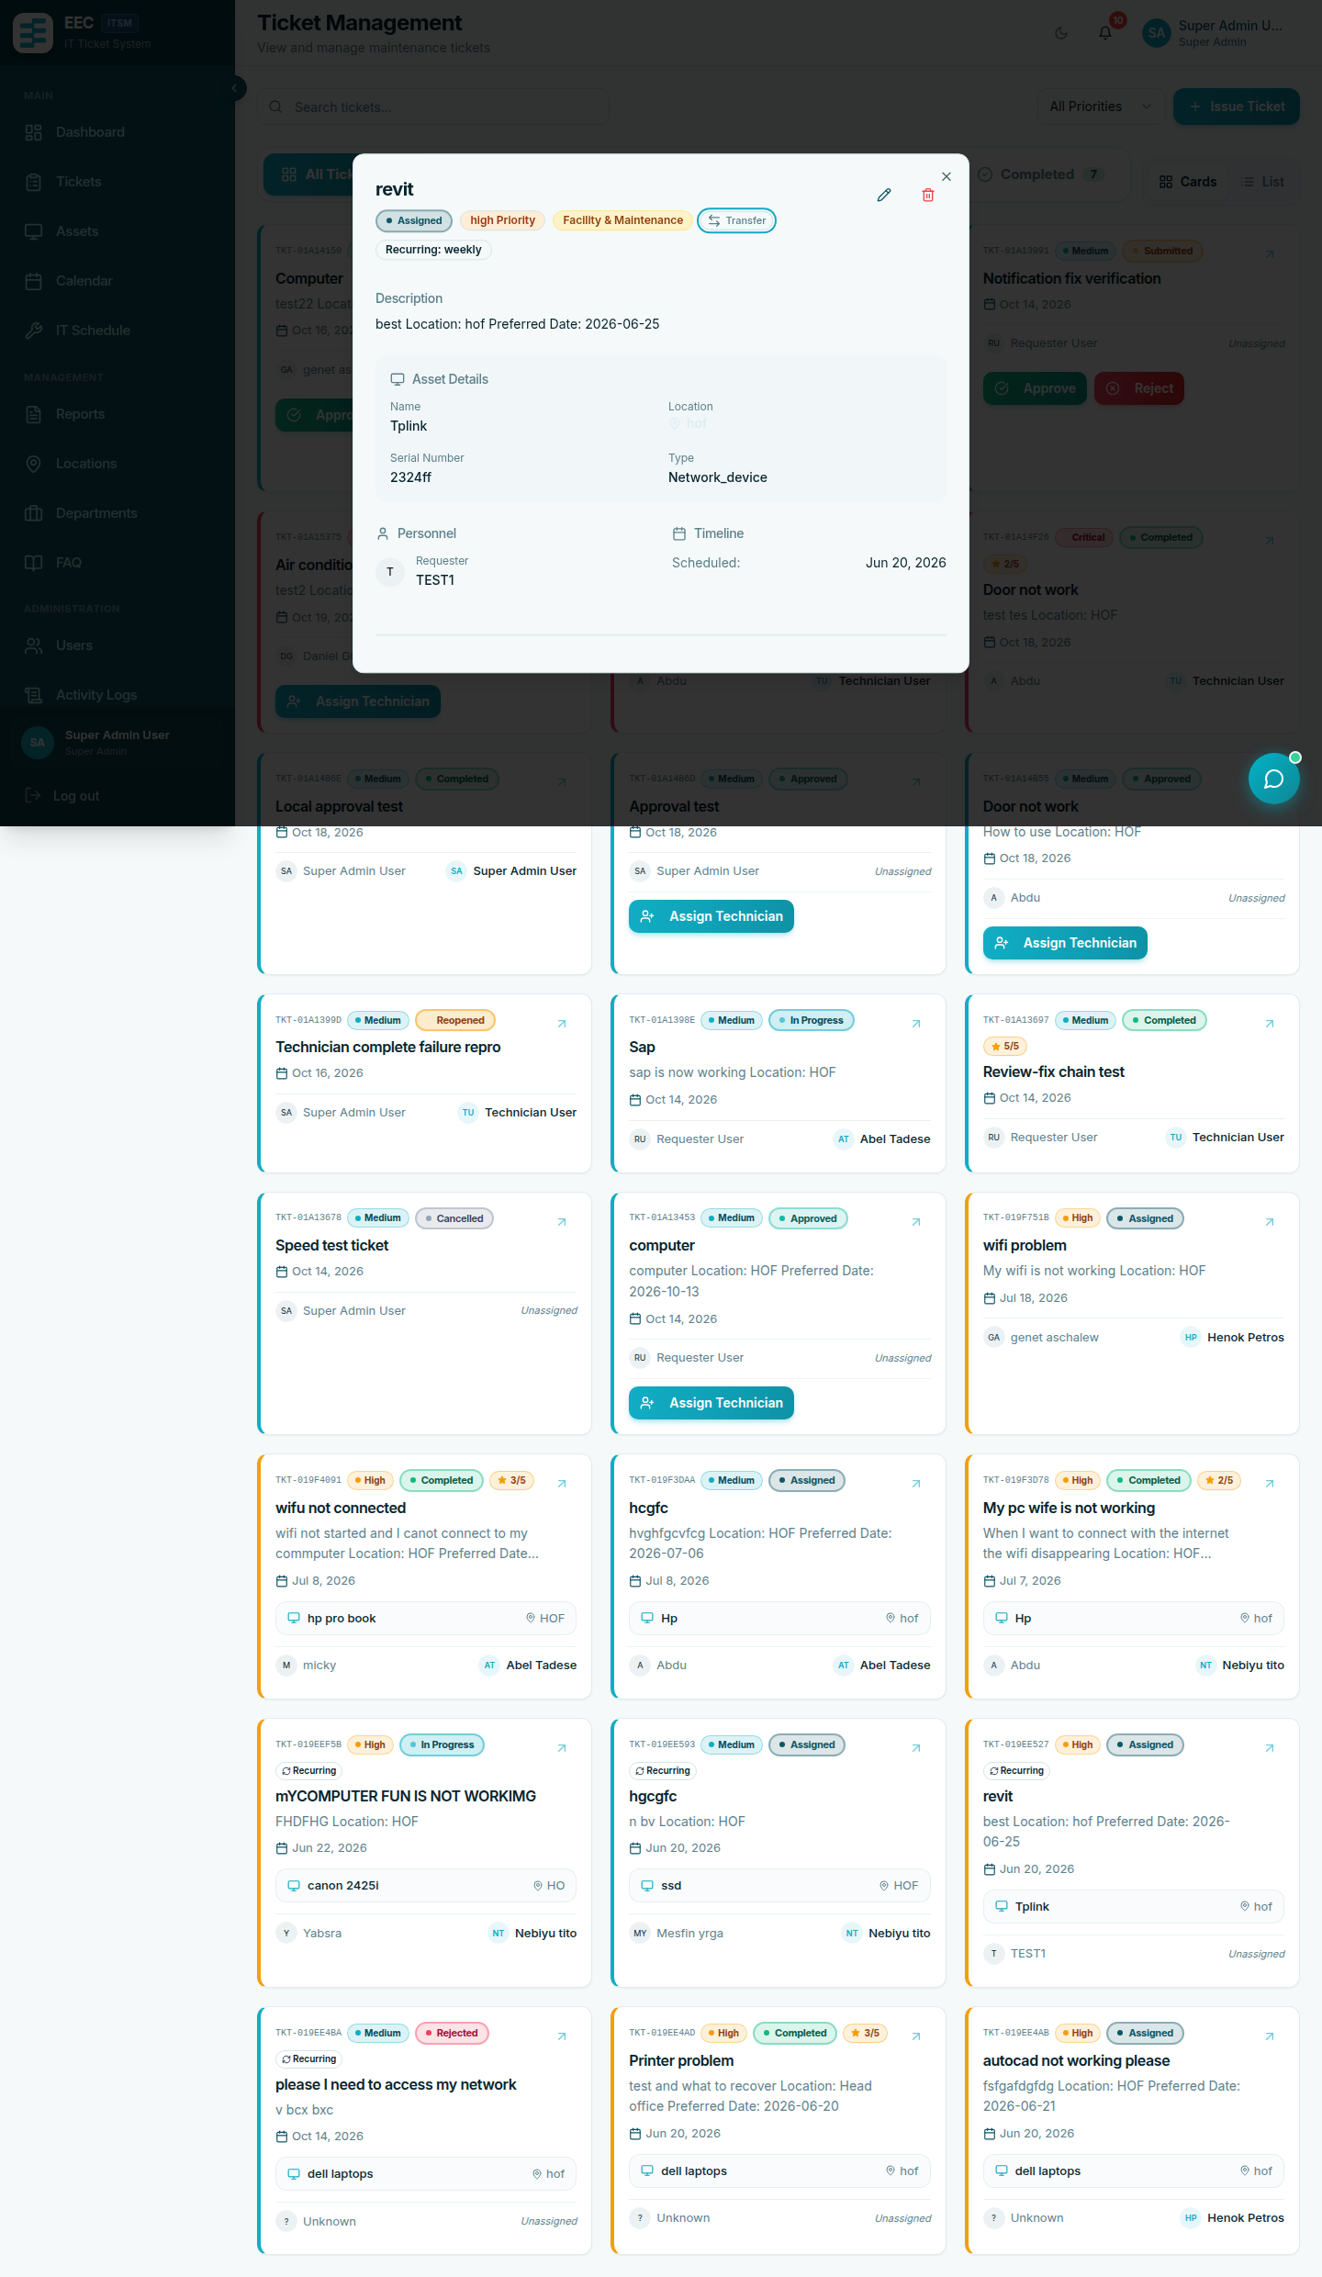
Ticket Detail & Workflow Actions
Figure 4.4: Ticket detail interface featuring technician assignment, status transitions, resolution notes, and activity timeline.
- Approve Completion or Reopen with notes on Completed – Pending Review.
- Transfer moves the ticket to another support category and re-routes it to that manager. Optional reason, max 500 characters.
Super Admins follow the same steps for every department.

4. Assets, locations, departments
Assets (/assets) — managers:
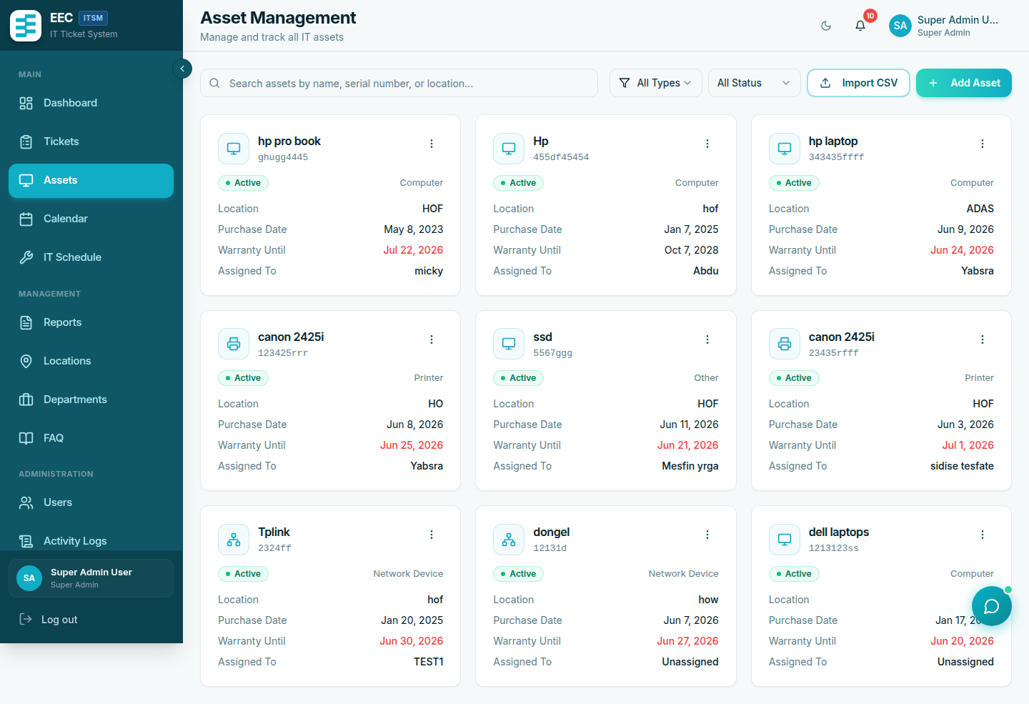
IT Asset Inventory Register
Figure 4.5: Centralized asset register showing serial numbers, equipment types, operational status, and assignment tracking.
- View, add, edit, delete
- Import CSV with columns: name, type, serial_number, purchase_date, location, status (optional warranty_expiry, notes)
- Types: computer, printer, server, network_device, other
- Statuses: active, maintenance, retired, disposed
Locations and Departments — create, edit, delete, or CSV import (name column). Profiles can be tied to a location.
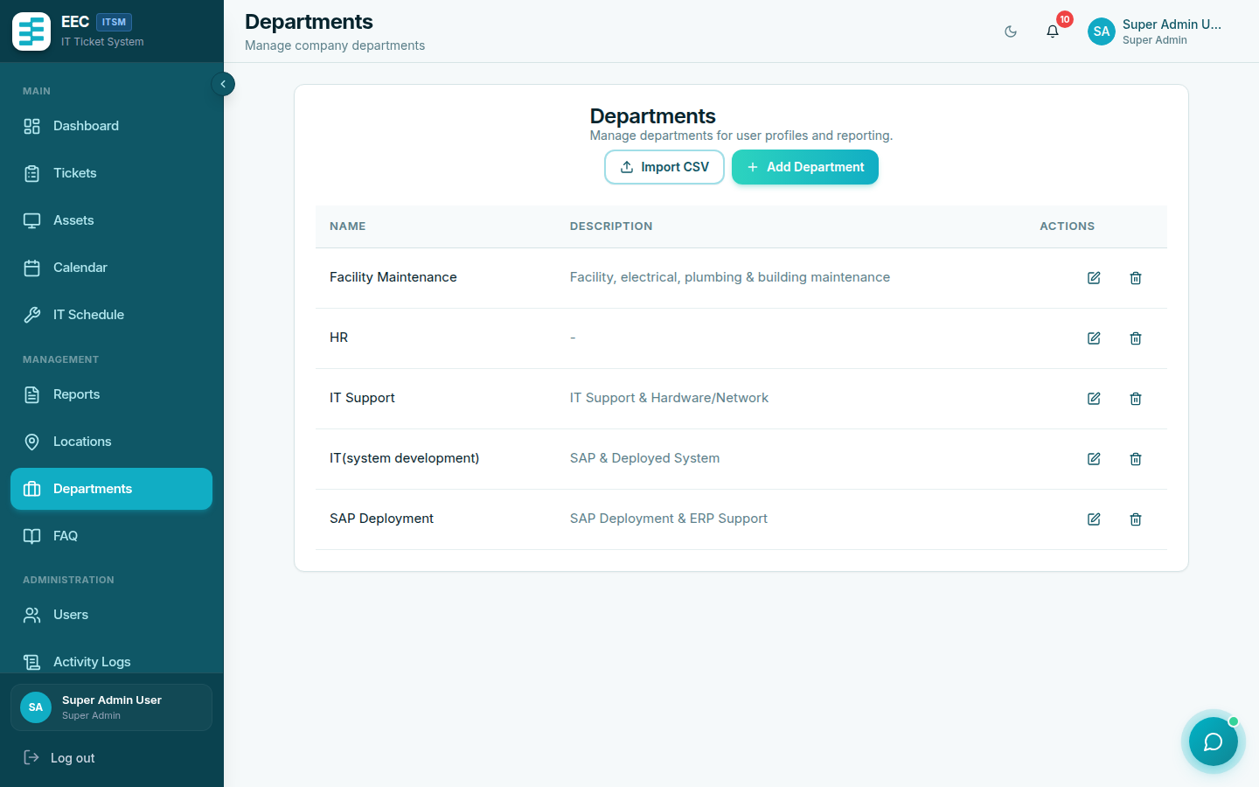
Department Organization Management
Figure 4.6: Organizational department configuration.
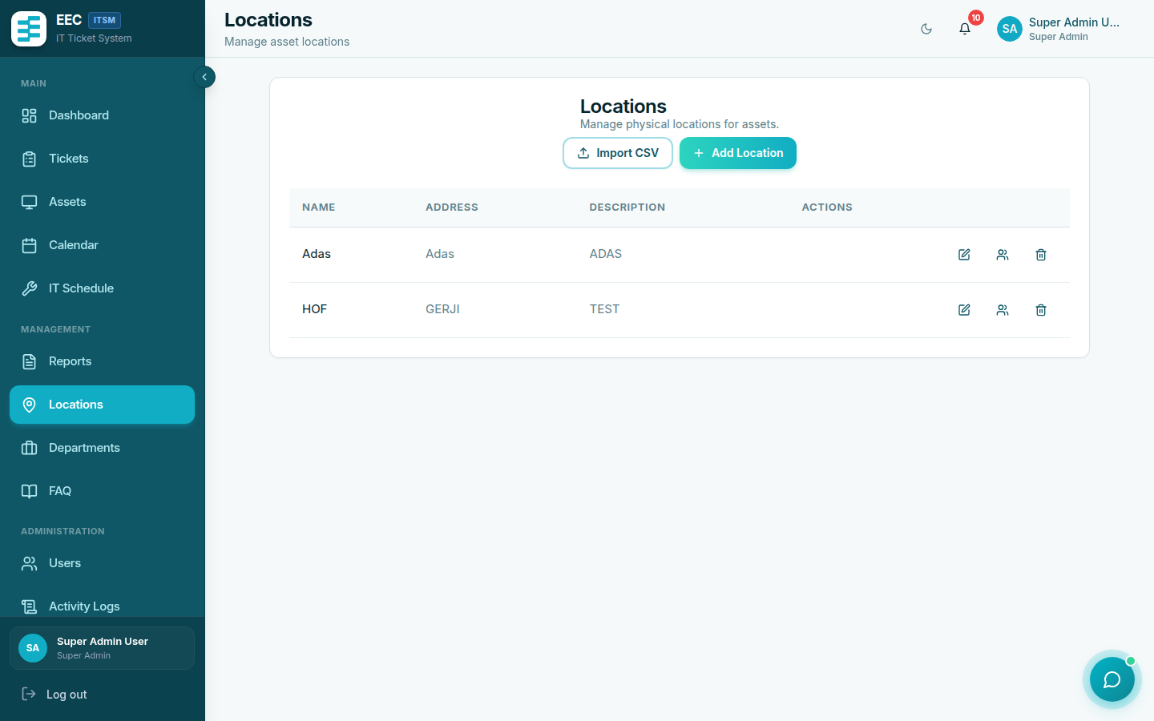
Locations Management
Figure 4.7: Facility and building location directory.

5. Users
Users (/users) — managers and Super Admins:
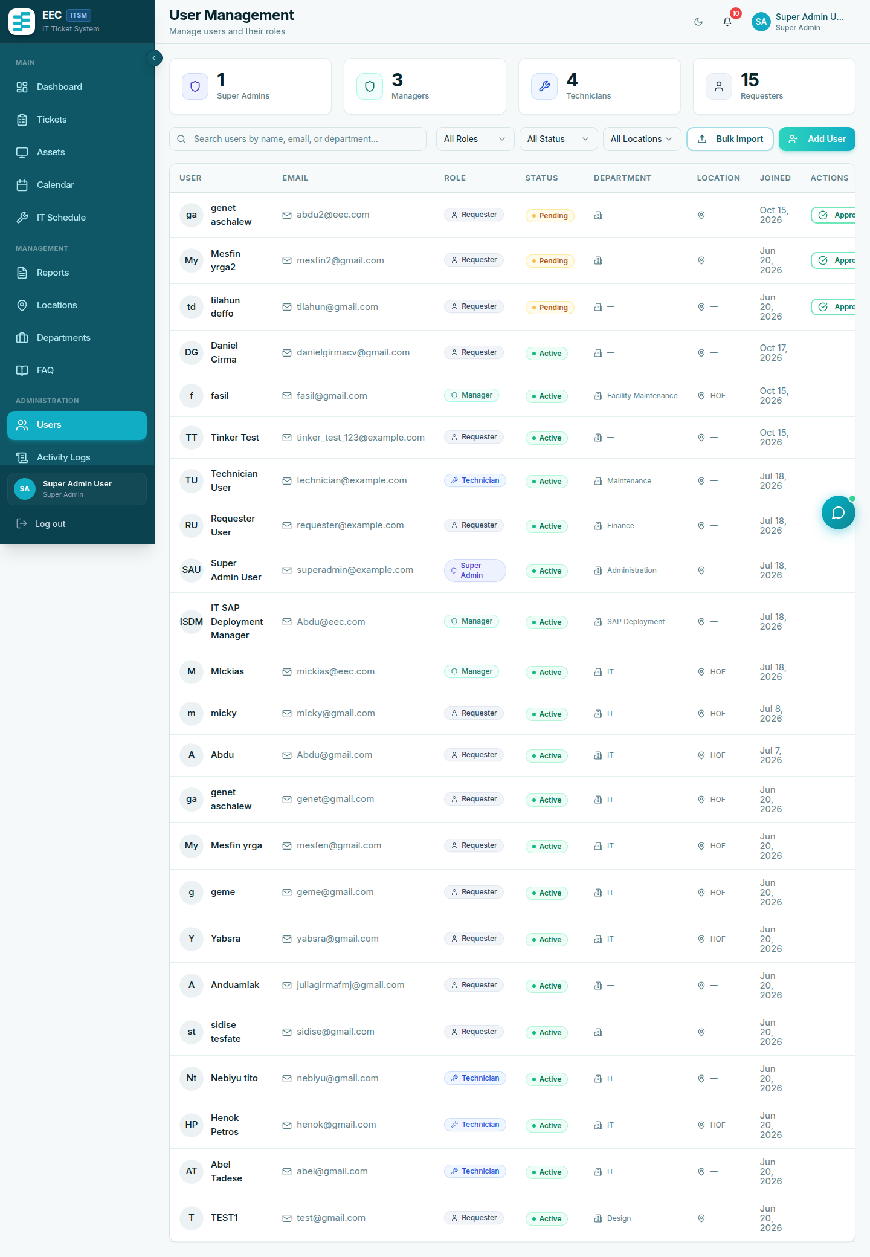
User Account Administration
Figure 4.8: User administration dashboard with pending approval queue, role assignments, and department filters.
- Filter Pending and Approve or Reject self-registered accounts
- Add User (admin-created accounts are active immediately)
- Admins create technicians in their own support domain only
- Only Super Admins create Admin or Super Admin accounts
- Change role and profile (including support category on manager accounts — required for correct ticket routing)
After a fresh install, change the default demo passwords (superadmin@example.com, admin@example.com, and others using password).

6. Schedules
Schedules (/schedules) — preventive maintenance on an asset:
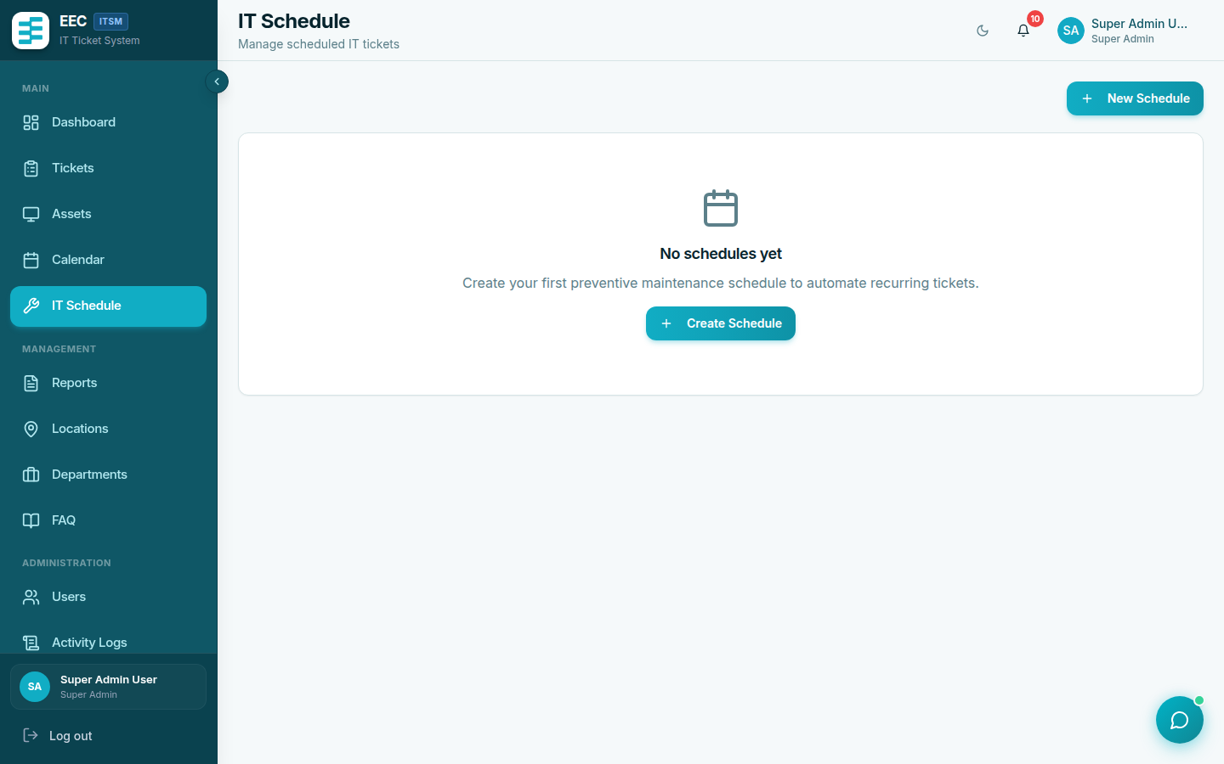
Preventive Maintenance Schedules
Figure 4.9: Recurring preventive maintenance schedules linked to registered assets.
- Title, description, type, frequency (daily, weekly, monthly, quarterly, yearly)
- Next / last run dates
- Active flag
Tickets are generated when the server command maintenance:check-schedules runs. Ask operations if schedules are not producing tickets.

7. Reports and activity logs
Reports (/reports):
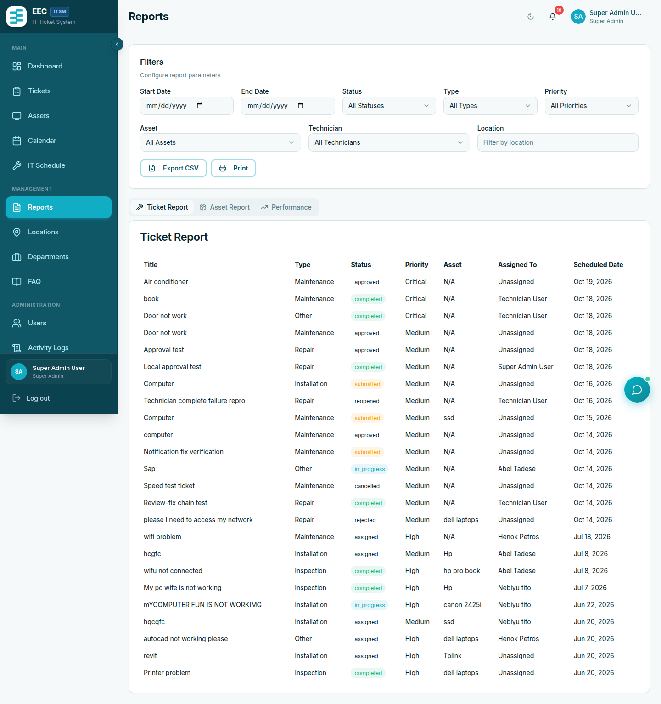
Operational Performance and Ticket Analytics
Figure 4.10: Service performance reports, resolution metrics, and CSV export utility.
- Ticket, asset, and performance views
- Filters: date range, status, type, priority, technician
- Export CSV for tickets and assets
Activity Logs (/activity-logs):
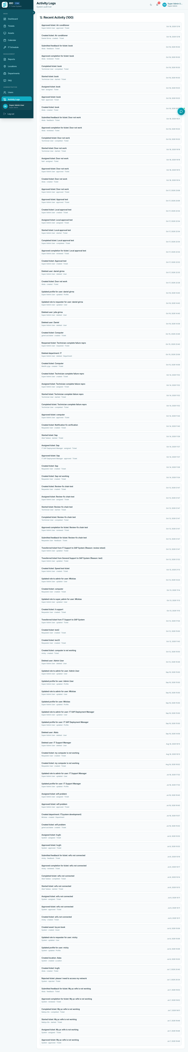
System Activity and Audit Logs
Figure 4.11: Audit log tracking user actions, entity updates, and security events.
Timestamped audit of create/update/delete and status changes. Super Admins should review after user or role changes.

8. Help Center and chatbot
Help (/help) lists published FAQ articles. Search by keyword.
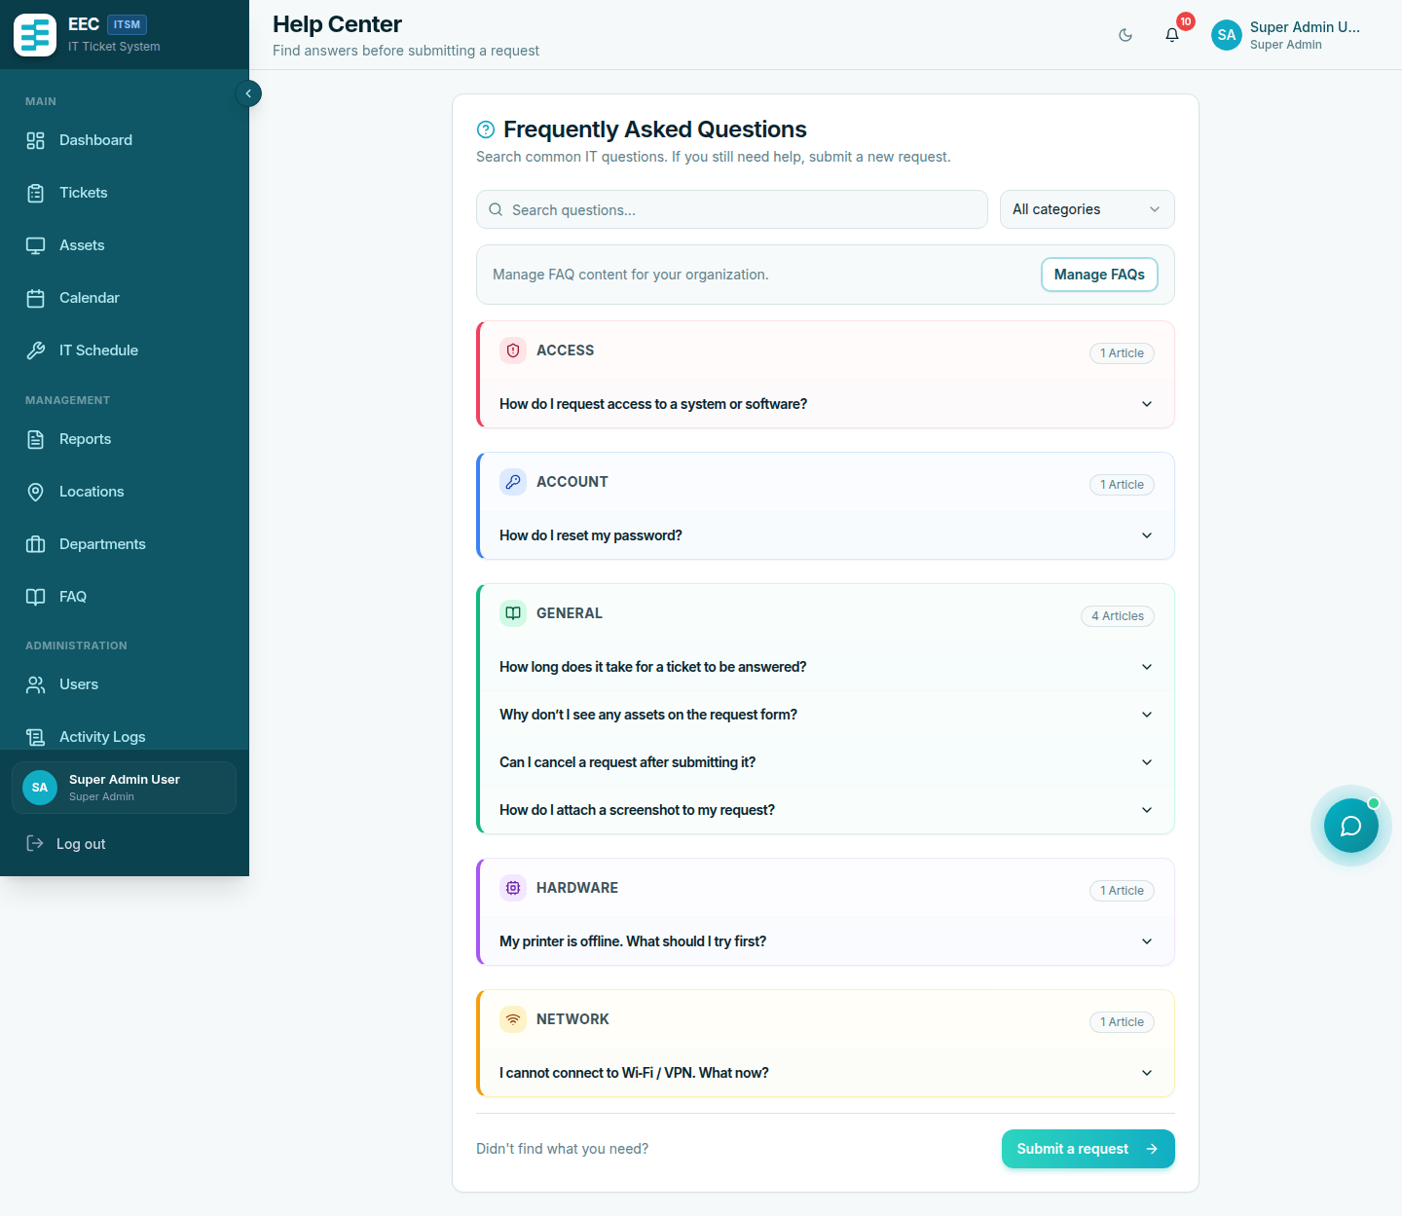
Help Center Knowledge Base
Figure 4.12: Staff self-service Help Center with keyword search and categorized support articles.
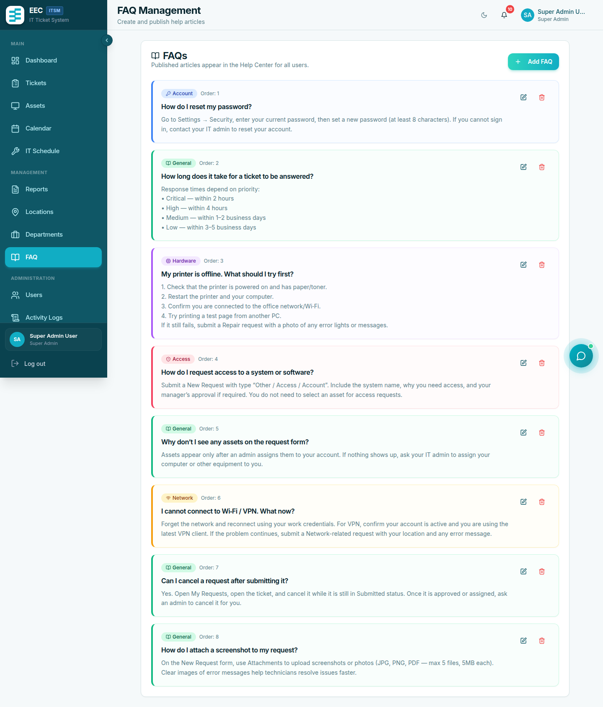
FAQ Article Administration
Figure 4.13: Knowledge base article editor for managers.
Managers maintain articles under FAQs (title, body, category, order, published flag). Unpublished articles are hidden from staff.
The chat bubble (bottom right) is a keyword search over published FAQs (up to three matches). It does not call an external AI. If nothing matches, submit a ticket.
Example questions: “How do I connect to the VPN?”, “Printer not working”, “Reset my password”.

9. Settings and Telegram
Settings (/settings):
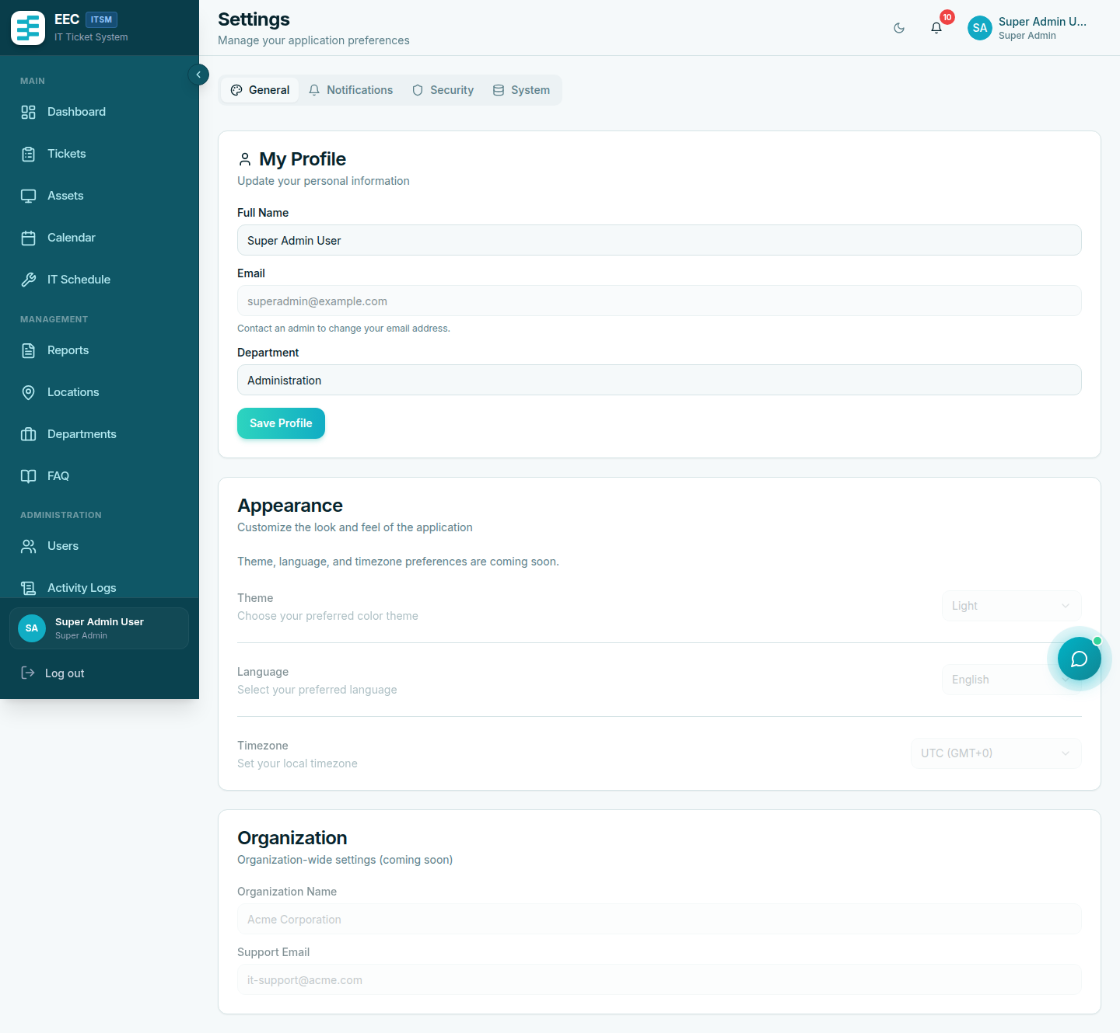
User Account and Integration Settings
Figure 4.14: User settings panel for profile updates, security password reset, theme selection, and Telegram linking.
- Profile: name, phone, department, location, avatar, Telegram username
- Security: password
- Theme: light / dark
- SMS uses the phone number on the profile

Link Telegram
- Settings → Telegram → Link Telegram Account.
- Open the deep link within 15 minutes.
- Send /start to the bot if prompted.
- Wait for confirmation.
Unlink from the same screen. Telegram messages cover approval, submission (managers), assignment, and completion events when the bot is configured.

10. Priority and category cheat sheet
Priority | Use when
Low | Can wait several days
Medium | Normal business impact
High | Significant productivity impact
Critical | Outage or halted operations

Category | Use when
IT Support | Hardware, network, OS, printers
SAP / ERP | SAP or other business applications
General | Facilities and non-IT workplace issues

05 — Frequently Asked Questions
Document: User Manual
System: EEC IT Asset & Ticket Management System
Version: 1.0

Accounts and login
Why can I not log in after registering?
New accounts stay pending until a manager or Super Admin approves them. If you still cannot log in after approval, confirm you are using the same email and that the account was not rejected.
I forgot my password.
The current system does not email a reset link. Ask an Admin or Super Admin to update your password or create a new account.
Can I use the same email as a colleague?
No. Email must be unique.

Tickets
Why is Submit disabled or why do I get an error about too many requests?
Requesters may have only three active tickets. Wait until one is completed or cancelled.
Who receives my ticket?
The system routes by support category (IT Support, SAP, General) to that department’s manager. If routing looks wrong, a manager can Transfer the ticket.
Can I attach photos?
Yes, on create: up to five files, 5 MB each, images or PDF.
The technician finished but the ticket is not Closed.
Status is Completed – Pending Review. The requester or a manager must approve completion. If the work is incomplete, choose rework / reopen.
Will the technician see my written feedback?
No. Technicians see the star rating only. Comments stay with managers.
Can I pick any technician?
Only managers assign technicians, and only within the matching support domain.

Notifications
I do not get SMS.
Add a valid phone number on your profile. SMS also depends on the organization gateway being configured and funded.
I do not get Telegram messages.
Link Telegram in Settings (the link expires in 15 minutes) and confirm the bot is enabled by IT. Unlink and link again if the chat id was never stored.
How do I clear the bell badge?
Open notifications or use Mark all as read.

Assets and admin
Who can add assets?
Users with manage assets (Admin and Super Admin). Requesters and technicians can usually view assets.
CSV import failed.
Check required headers: name, type, serial_number, purchase_date, location, status. Type and status must match the allowed lists. The import response lists row-level errors.
Schedules exist but no tickets appear.
Preventive tickets are created by a server command. Ask operations to confirm maintenance:check-schedules (and the Laravel scheduler) is running.
Why can I not create another manager?
Only a Super Admin can create Admin or Super Admin accounts. Department Admins create technicians in their own category.

Help chatbot
Is the chatbot ChatGPT?
No. It searches published FAQ articles by keywords. Add more FAQs (and publish them) to improve answers.
The chatbot found nothing.
Submit a ticket, or ask a manager to add an FAQ for that topic.

Technical (for IT)
Which browsers are supported?
Current Chrome, Edge, Firefox, and Safari with JavaScript enabled.
The page is blank after a release.
Hard-refresh (Ctrl+F5) or clear cache. Confirm the frontend build points at the correct VITE_API_URL.
Who do I contact for outages?
Your Super Admin or the operations contact in the deployment guide (docs/technical/05-Installation-Deployment.md).

