Installing Python

On the course page, download the Python installer by clicking on the Download button. Follow the instructions below for installing Python.
If you decide to you Visual Studio Code (optional), then click on the link to download and install that.
Be sure to download the installers based on whether you are using Windows or macOS.
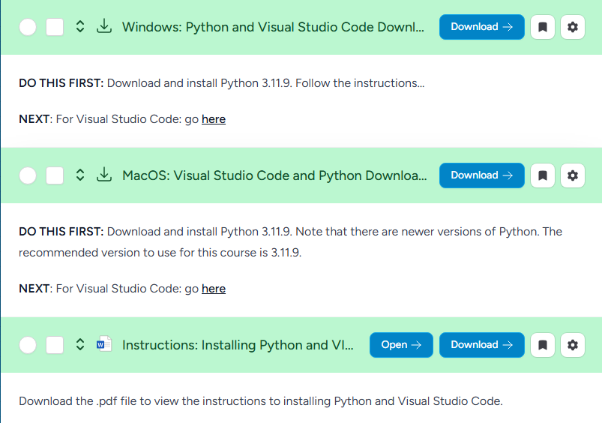
Save the appropriate file (Windows (64-bit) or macOS) to your Downloads directory. Then, double-click the file to launch the installer.
NOTE: These instructions show the installation of Python 3.11.8. You will be installing 3.11.9. The instructions are the same for both versions.

Windows 64-bit

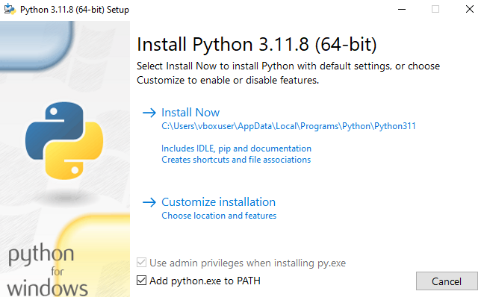

First, click on “Add python.exe to PATH.” Then, click on “Install Now.” There is no need to It is assumed that you have Administrator privileges to your computer. The installer will complete the installation.

macOS
The installation process begins:
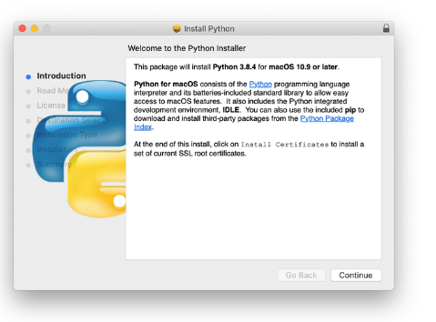
Follow these steps to complete the installation:
- Press Continue a few times until you’re asked to agree to the software license agreement. Then click Agree.
- You’ll be shown a window that tells you the installation destination and how much space it will take. You most likely don’t want to change the default location, so go ahead and click Install to start the installation.
- When the installer is finished copying files, double-click the Install Certificates command in the finder window to make sure your SSL root certificates are updated.
To create/modify a Python program, run Python IDLE:
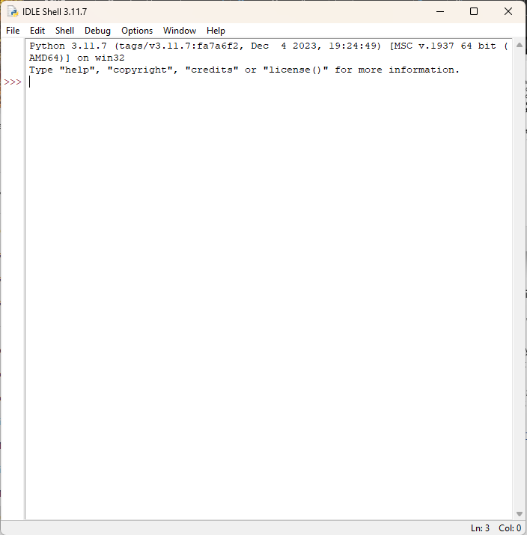
Then from the menu, select File/New File or File/Open. Once the file opens, from the menu in the code window, select Options/Show Line Numbers.

Installing Visual Studio Code (optional)

While installing Visual Studio Code is optional, most lessons will feature its use.
After downloading Visual Studio Code, double-click the file to launch the installer:
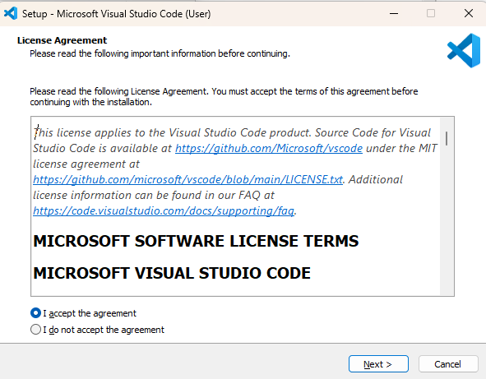
- Accept the agreement and click Next.
- On the next screen, click Next.
- On the “Ready to install” screen, click Install.

Configuring Visual Studio Code

Once Visual Code Studio is installed, open it and click on Extensions (it is the fifth icon down in the left pane:

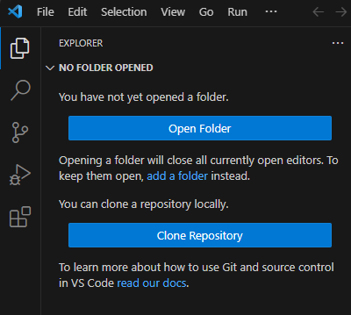
In the search bar, type “Python”:
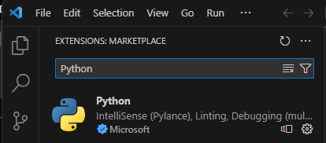
Install the Python Intellisense package by clicking on it.
Next, turn off file preview mode. Turning of preview mode will allow you to open a file in its own tab instead of overwriting the contents in a single tab.
To turn off preview mode, select File/Preferences/Settings:
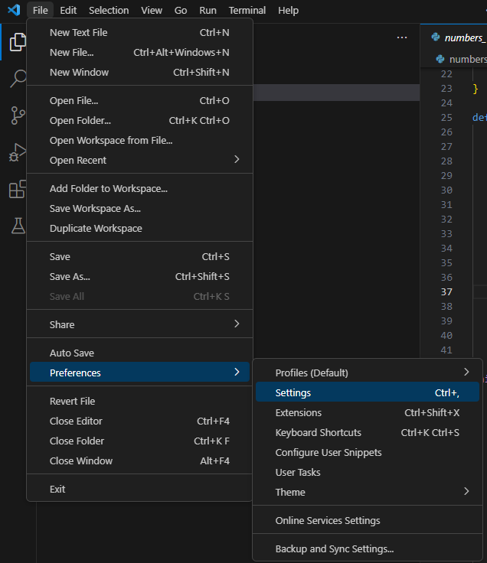
In the Settings search bar, type “preview”:
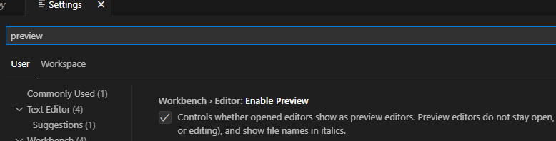
Uncheck the box so that it is blank. Then, close settings, close VSC, and reopen VSC. Now, when you open more than one file, it will open the file in a separate tab.
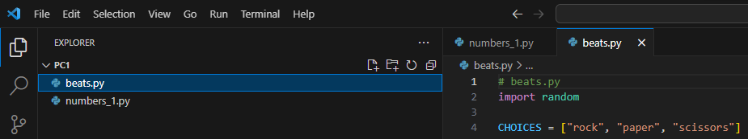

Installing git

Download the latest version from https://git-scm.com/install/. Launch the installer and accept the GNU license. If a previous version of git was installed, it will remove it and install the latest version.

