TestStudent

Daniel Gonzalez

2023-12-20

## R Markdown

This is an R Markdown document. Markdown is a simple formatting syntax for authoring HTML, PDF, and MS Word documents. For more details on using R Markdown see <http://rmarkdown.rstudio.com>.

When you click the **Knit** button a document will be generated that includes both content as well as the output of any embedded R code chunks within the document. You can embed an R code chunk like this:

## Loading required package: airports

## Loading required package: cherryblossom

## Loading required package: usdata

## ── Attaching core tidyverse packages ──────────────────────── tidyverse 2.0.0 ──  
## ✔ dplyr 1.1.4 ✔ readr 2.1.4  
## ✔ forcats 1.0.0 ✔ stringr 1.5.1  
## ✔ ggplot2 3.4.4 ✔ tibble 3.2.1  
## ✔ lubridate 1.9.3 ✔ tidyr 1.3.0  
## ✔ purrr 1.0.2   
## ── Conflicts ────────────────────────────────────────── tidyverse_conflicts() ──  
## ✖ dplyr::filter() masks stats::filter()  
## ✖ dplyr::lag() masks stats::lag()  
## ℹ Use the conflicted package (<http://conflicted.r-lib.org/>) to force all conflicts to become errors

## # A tibble: 4 × 9  
## f_age m_age weeks premature visits gained weight sex_baby smoke   
## <int> <int> <int> <fct> <int> <int> <dbl> <fct> <fct>   
## 1 31 30 39 full term 13 1 6.88 male smoker   
## 2 34 36 39 full term 5 35 7.69 male nonsmoker  
## 3 36 35 40 full term 12 29 8.88 male nonsmoker  
## 4 41 40 40 full term 13 30 9 female nonsmoker

## Filtering Data

You can also embed plots, for example:

## [1] 0.4005

# Plotting Chart

## Warning: The dot-dot notation (`..density..`) was deprecated in ggplot2 3.4.0.  
## ℹ Please use `after_stat(density)` instead.  
## This warning is displayed once every 8 hours.  
## Call `lifecycle::last_lifecycle_warnings()` to see where this warning was  
## generated.

## `stat_bin()` using `bins = 30`. Pick better value with `binwidth`.

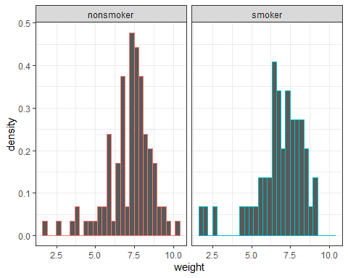

# **Testing normality:**

