Question 03
Create a view that can be used at screen level to show only the required fields.
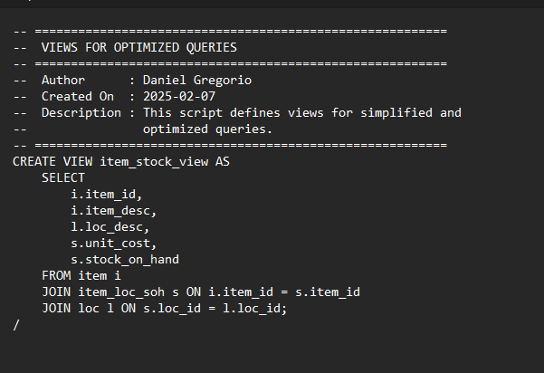
The file is available in the repository at the path \sql\ddl\views.

