Software Requirements Specification
for
Food Ordering App
Version 1.0 approved
Prepared by:
Grosu Daniel, Giurgiu Ana
Noname
10.03.2019
Table of Contents
Table of Contents ii
Revision History ii
1. Introduction 1
1.1 Purpose 1
1.2 Document Conventions 1
1.3 Intended Audience and Reading Suggestions 1
1.4 Product Scope 1
1.5 References 1
2. Overall Description 2
2.1 Product Perspective 2
2.2 Product Functions 2
2.3 User Classes and Characteristics 2
2.4 Operating Environment 2
2.5 Design and Implementation Constraints 2
2.6 User Documentation 2
2.7 Assumptions and Dependencies 3
3. External Interface Requirements 3
3.1 User Interfaces 3
3.2 Hardware Interfaces 3
3.3 Software Interfaces 3
3.4 Communications Interfaces 3
4. System Features 4
4.1 System Feature 1 4
4.2 System Feature 2 (and so on) 4
5. Other Nonfunctional Requirements 4
5.1 Performance Requirements 4
5.2 Safety Requirements 5
5.3 Security Requirements 5
5.4 Software Quality Attributes 5
5.5 Business Rules 5
6. Other Requirements 5
Appendix A: Glossary 5
Appendix B: Analysis Models 5
Appendix C: To Be Determined List 6

Revision History
Name | Date | Reason For Changes | Version

Introduction

Purpose
This documentation’s purpose is to present software requirements for a Food Ordering App with the scope of describing the features and usability of this application.

Document Conventions
There is not much to say about conventions found in this document, except for the fact that it is
separated into chapters and subchapters for a better understanding.

Intended Audience and Reading Suggestions
This document is intended for users, testers, marketing stuff, project managers, developers but
also for any interested reader, specialized or not.

Product Scope
This software is an Android mobile application, of type food ordering, for restaurants, fast-foods etc. It’s purpose is to help both the clients, by offering an easy way of choosing the products, and the restaurant or fast-food using the app, by managing the clients more efficient and simple.

References
https://github.com/

Overall Description

Product Perspective
Eating is something that everyone loves to do, and what’s better than sitting in the comfort of your home, reading your favorite book, watching some show or film or just idling with your family & friends and ordering food from your favorite restaurant at your fingertips.
Food delivery apps are a new rage, from restaurant owners making their own food ordering app for you to deliver food while sitting on your couch to services which act as a collaboration platform between the restaurants and clients.

Product Functions
The application has the following base functions:
- Login and registration section
- Menu category and menu items
- Order histoery, favourite and hot deals
- Cart, checkout, payment and order confirmation
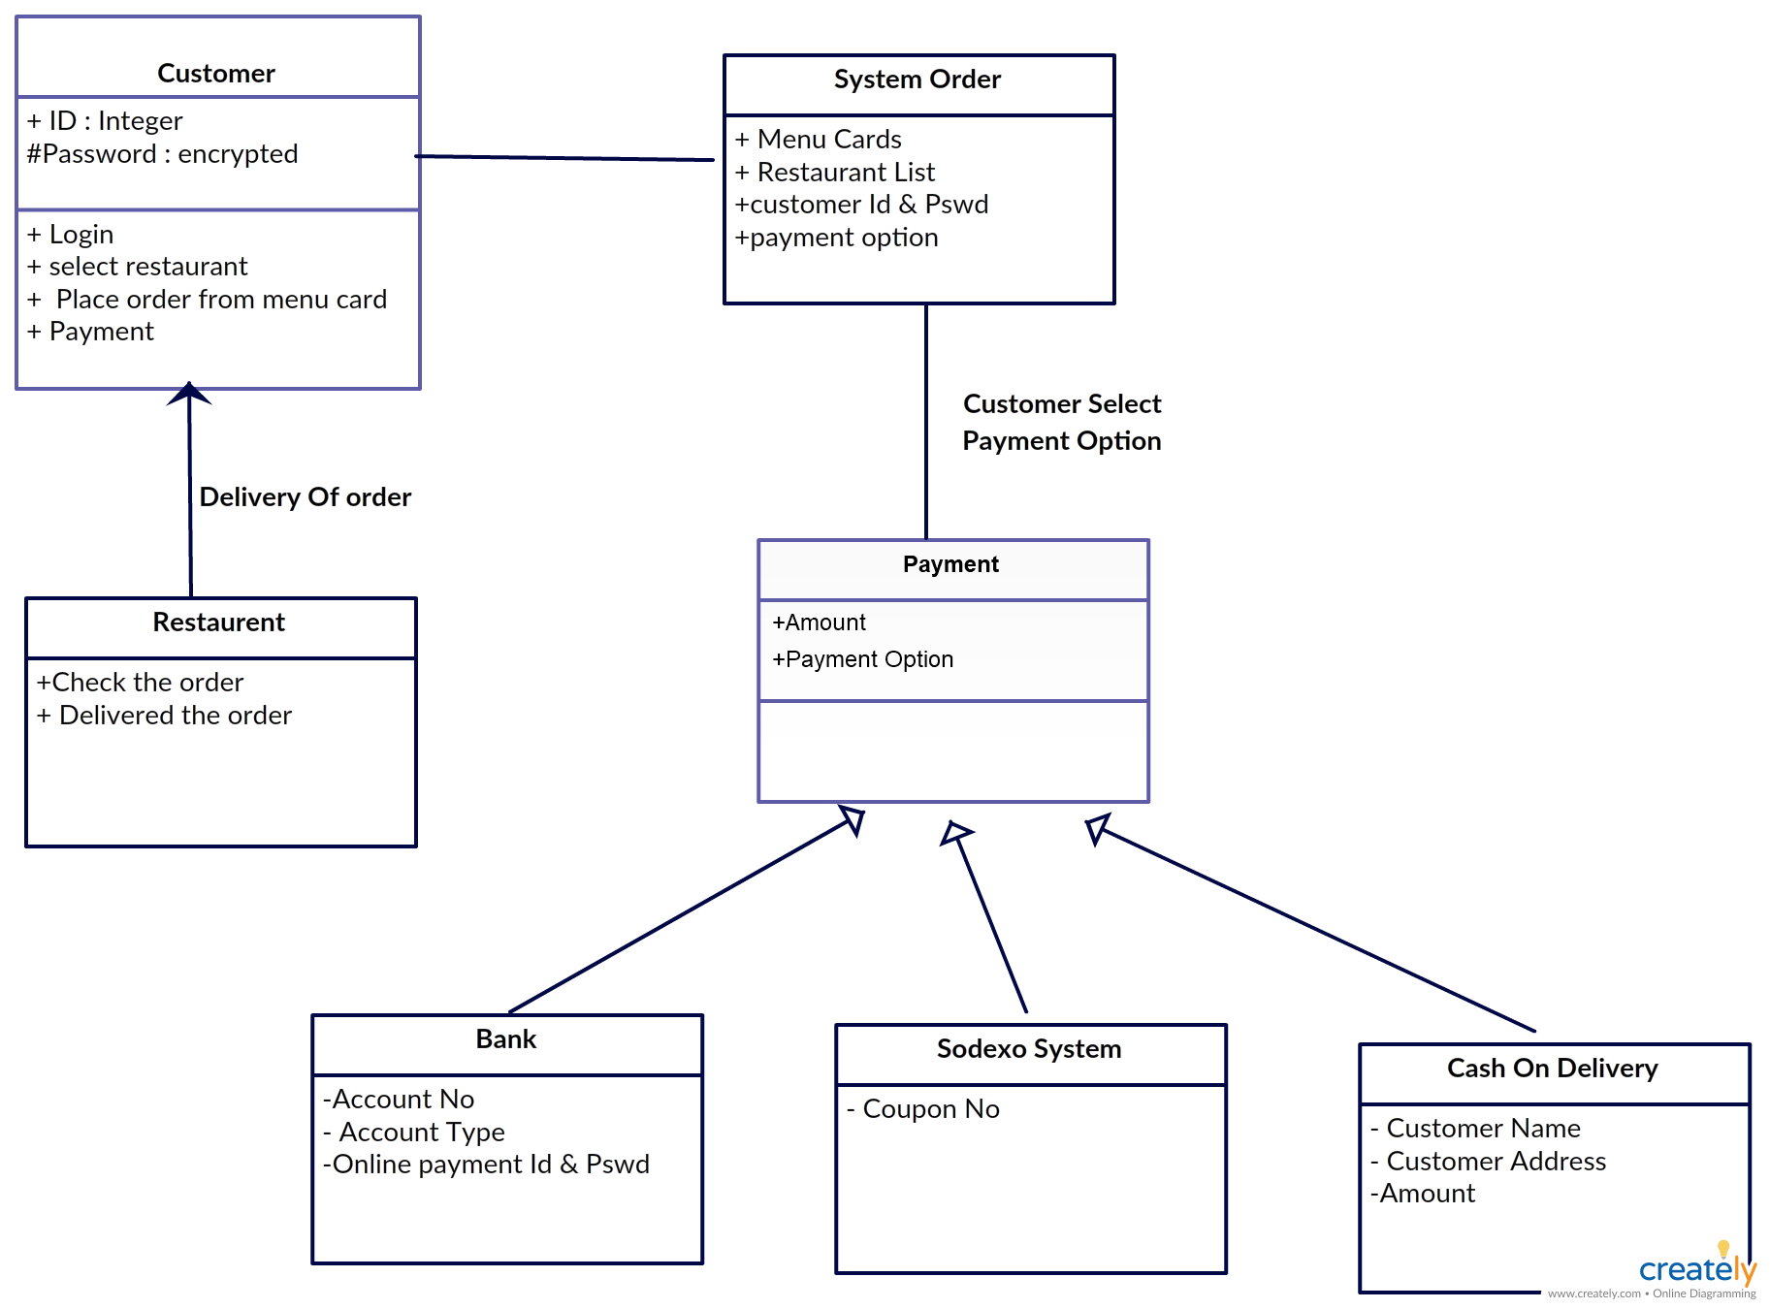

User Classes and Characteristics
Restaurant has a Menu (Menu class)
Menu has items (Item class)
User can order (Order class)
Order can have many selectedItems(SelectItem class)
User has to pay the Bill (Bill class)
There also be a Payment class(That must be thread safe)
Total - 8 classes: Restaurant, User, Menu, Item, Order, SelectItem, Bill, Payment

Operating Environment
Software is designed for smartphones/tablets with Android as OS.

Design and Implementation Constraints
One big hardware limitation is that the application will work only for Android devices not for IOS. There could be some options unavailable for this type of application, due to not having enough time to make it complete. Also, the application might not be able to: show a real-time delivery process, have a very efficient use of the database, perform multiple operations, have different languages or communications protocols. It will be a compact and simple application, without any unexpected or very unique features.

User Documentation
https://developer.android.com/studio
https://hackernoon.com/how-to-build-a-food-ordering-app-an-ultimate-guide-on-food-ordering-mobile-app-c19441826aca

Assumptions and Dependencies
Some of the major problems that could affect this project development could be both external and internal. This means that we might not be have all the knowledges to make it in time and with the highest standards. Also, we could have some technology difficulties while trying to make the app work on different versions of Android or different devices. All these factors probably might have a negative impact over the implementation but we can never know until time comes.

External Interface Requirements

User Interfaces
When opening the application, there will be a SIGN IN and a SING UP button. After this stage is complete, the menu and categories will be displayed and the customer will chose from it. Also, there will be a menu with a list of different functions such as: your orders, your favorites, hot deals, notifications, client’s profile, logout etc. There will also be a cart, like a place where orders will be stored before being completed. When the client considers that his choices a finale, there will be a button CHECKOUT which will show the orders and the final prices, which after will lead to a method of payment through another button.

Hardware Interfaces
The app will work on smartphones or tablets, basically devices that use Android as an operating system the same way a smartphone does.

Software Interfaces
App project will be developed in Android Studio 3.3.1.
The application will be able to run on Android OS, probably the latest versions only.
Through the use of Firebase, the log in part probably could also be done with user’s Google of Facebook account.

Communications Interfaces
The application could communicate with Google or Facebook, using Firebase, in order for the log in with these accounts to be done. Also, Google’s APIs could be used if we want to implement real location on maps.

System Features
Lets see classes one by one, understanding the main features:
Restuarant
-----------
- name : String
- location : string
- conatct : string
-----------
+ isOpen() : boolean
+ getName() : String
+ getLoaction() : String
+ getContact() : String
+ setContact()
+ displayMenu()
+ updateMenu)_
+ generateBill()
User
-----------
- uid : String
- contact : String
-----------
+ setContact()
+ getContact()
+ getUid()
+ searchRestauranr()
+ selectRestuarant()
+ newOrder()
+ cancelOrder()
+ trackOrder()
+ payBill()
Menu
---------
- menu : List<Item>
---------
+ displayMenu()
+ updateMenu()
+ addItem()
+ deleteItem()
Item
----------
- itemId : String
- price : float
- name : String
----------
+ setItemId(String)
+ setName(String)
+ setPrice(float)
+ getItemId()
+ getName()
+ getPrice()
Order
-----------
- orderId : String
-----------
+ getStatus() // To track the order
+ updateStatus() // Restaurant admin can update it
+ getOrderId()
+ selectItem()
+ removeItem()
+ updateItem()
SelectItem
-----------
- itemId
- quantity : int
-----------
+ getItem()
+ setItem()
+ getQuantity()
+ setQuantity()
Bill
------------
- billNum
- orderId
------------
+ getBillNum()
+ getTotalAmount()
+ displayBill()
Payment
------------
- pid : String
- pType : String
- billNum : String
-------------
+ successfulyPaid() : boolean

System Feature 1
<Don’t really say “System Feature 1.” State the feature name in just a few words.>
4.1.1 Description and Priority
<Provide a short description of the feature and indicate whether it is of High, Medium, or Low priority. You could also include specific priority component ratings, such as benefit, penalty, cost, and risk (each rated on a relative scale from a low of 1 to a high of 9).>
4.1.2 Stimulus/Response Sequences
<List the sequences of user actions and system responses that stimulate the behavior defined for this feature. These will correspond to the dialog elements associated with use cases.>
4.1.3 Functional Requirements
<Itemize the detailed functional requirements associated with this feature. These are the software capabilities that must be present in order for the user to carry out the services provided by the feature, or to execute the use case. Include how the product should respond to anticipated error conditions or invalid inputs. Requirements should be concise, complete, unambiguous, verifiable, and necessary. Use “TBD” as a placeholder to indicate when necessary information is not yet available.>

<Each requirement should be uniquely identified with a sequence number or a meaningful tag of some kind.>

REQ-1:
REQ-2:

System Feature 2 (and so on)

Other Nonfunctional Requirements

Performance Requirements
<If there are performance requirements for the product under various circumstances, state them here and explain their rationale, to help the developers understand the intent and make suitable design choices. Specify the timing relationships for real time systems. Make such requirements as specific as possible. You may need to state performance requirements for individual functional requirements or features.>

Safety Requirements
<Specify those requirements that are concerned with possible loss, damage, or harm that could result from the use of the product. Define any safeguards or actions that must be taken, as well as actions that must be prevented. Refer to any external policies or regulations that state safety issues that affect the product’s design or use. Define any safety certifications that must be satisfied.>

Security Requirements
<Specify any requirements regarding security or privacy issues surrounding use of the product or protection of the data used or created by the product. Define any user identity authentication requirements. Refer to any external policies or regulations containing security issues that affect the product. Define any security or privacy certifications that must be satisfied.>

Software Quality Attributes
<Specify any additional quality characteristics for the product that will be important to either the customers or the developers. Some to consider are: adaptability, availability, correctness, flexibility, interoperability, maintainability, portability, reliability, reusability, robustness, testability, and usability. Write these to be specific, quantitative, and verifiable when possible. At the least, clarify the relative preferences for various attributes, such as ease of use over ease of learning.>

Business Rules
<List any operating principles about the product, such as which individuals or roles can perform which functions under specific circumstances. These are not functional requirements in themselves, but they may imply certain functional requirements to enforce the rules.>

Other Requirements
<Define any other requirements not covered elsewhere in the SRS. This might include database requirements, internationalization requirements, legal requirements, reuse objectives for the project, and so on. Add any new sections that are pertinent to the project.>
Appendix A: Glossary
<Define all the terms necessary to properly interpret the SRS, including acronyms and abbreviations. You may wish to build a separate glossary that spans multiple projects or the entire organization, and just include terms specific to a single project in each SRS.>
Appendix B: Analysis Models
<Optionally, include any pertinent analysis models, such as data flow diagrams, class diagrams, state-transition diagrams, or entity-relationship diagrams.>
Appendix C: To Be Determined List
<Collect a numbered list of the TBD (to be determined) references that remain in the SRS so they can be tracked to closure.>

