2.1.

The film table is not a 1NF table. Even though it is a two-dimensional table and there are no repeating groups, it doesn’t have the problems that a 1NF table has. There are no insertion anomalies (data is not prevented from being added), deletion anomalies (groups can be easily deleted), and update anomalies (there is a primary key).

2.2

The film table is a 2NF table. There is a transitive dependency in the table and has three candidate keys (film_id, title, description).

2.3

The film table is not a 3NF table because of, in this case, the transitive dependency between film_id, title, and description.

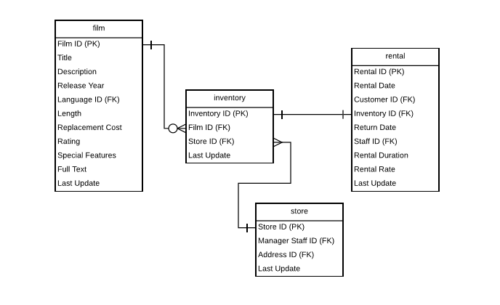

3.

The changes I made were to move rental_duration and rental_rate from the film table to the rental table. I did this because rental_duration and rental_rate are not functionally dependent on film_id. It made more sense to move them to the rental table because they are more functionally dependent on rental_id than film_id.