TABLE OF CONTENTS ENTRY
Title:
SMILES2Docking: an open-source desktop workflow for ligand ionization, stereochemistry-aware preparation and semi-empirical 3D refinement
Authors:
Daniel Andrés Grajales Ruiz, Bruna Flôres Negrisoli, Isabel Cristina Conceição Periquito, Nailton Monteiro do Nascimento Jr, and Adriano Marques Goncalves*
TOC Text:
SMILES2Docking converts SMILES-based compound libraries into docking-ready 3D ligands through a single configurable pipeline. It integrates salt removal, pH-dependent ionization, an explicit three-mode stereocenter policy, distance-geometry embedding, force-field optimization, and MOPAC semi-empirical refinement. The tool is freely available as a Python package, Windows executable, and Linux and MacOS bundle.
TOC Figure (Graphical abstract):
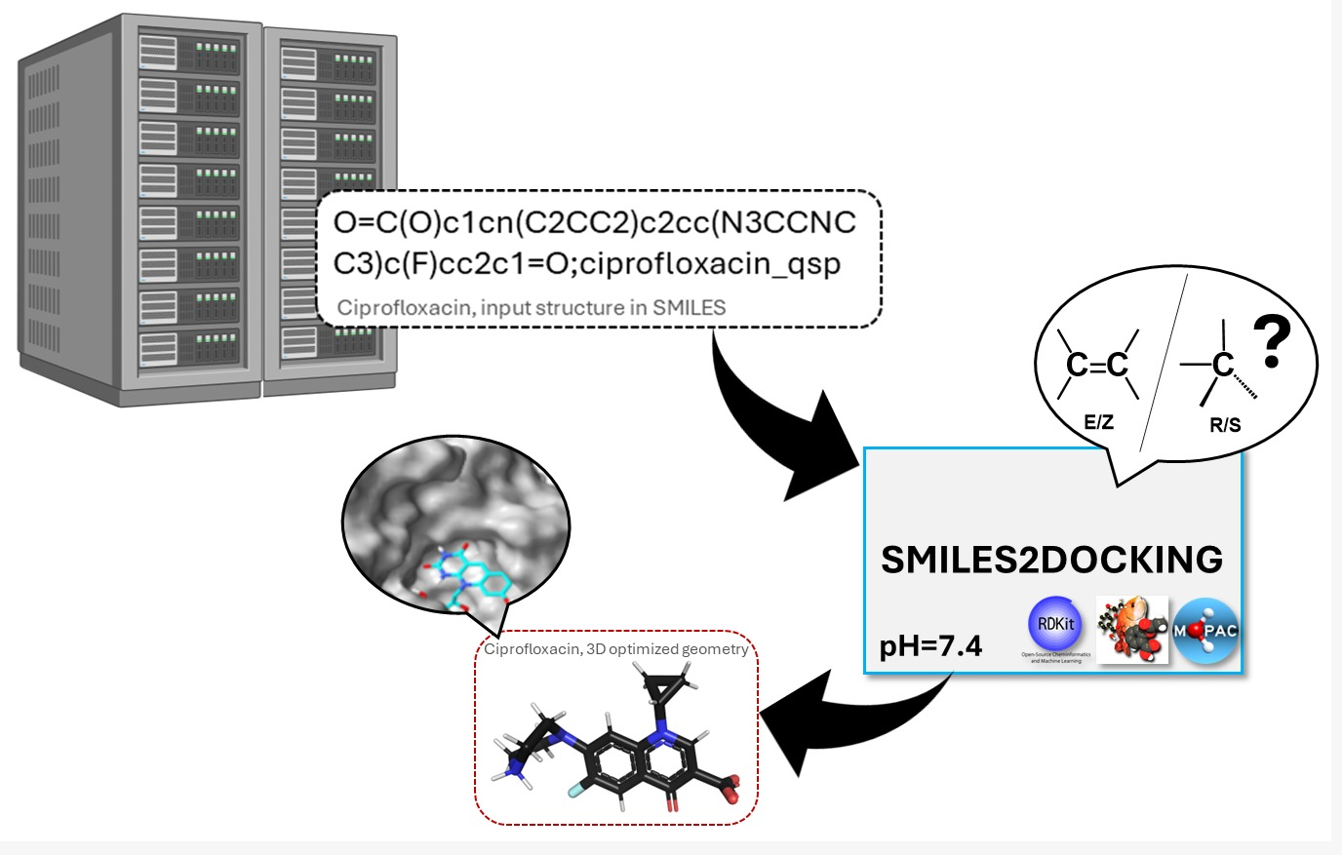

*corresponding author

