SMILES2Docking: an open-source desktop workflow for ligand ionization, stereochemistry-aware preparation and semi-empirical 3D refinement
Daniel Andrés Grajales Ruiz¹, Bruna Flôres Negrisoli², Isabel Cristina Conceição Periquito², Nailton Monteiro do Nascimento Jr¹ and Adriano Marques Goncalves^{2,3}
¹Instituto de Química, Universidade Estadual Paulista — IQ-Unesp, Araraquara, SP, Brazil
²Universidade de Araraquara — UNIARA, Araraquara, SP, Brazil
Correspondence: amgoncalves@uniara.edu.br

Abstract
SMILES2Docking converts spreadsheet-based SMILES libraries into docking-ready 3D ligands through a single pipeline. Salt and co-former removal, a three-mode stereocentre policy, pH-dependent ionization via Open Babel, distance-geometry embedding with RDKit, molecular mechanics optimization, and optional semi-empirical refinement under implicit solvation model are all handled in sequence. Users choose among permissive, strict, and enumerative stereocentre modes, allowing the same tool to serve broad exploratory screening and precision docking alike. A per-compound JSON audit report records ionization and stereocentre decisions throughout. The tool ships as a Python package, a Windows executable with bundled MOPAC, and a Linux portable bundle under GPL-2.0-or-later. SMILES2Docking is freely available to non-commercial users at https://github.com/amgoncalvesusp/Smiles2Docking (DOI: 10.5281/zenodo.19900622).
Keywords: SMILES; ligand preparation; molecular docking; stereochemistrydetection; protonation; ionziation state; 3D geometry optimization; semi-empirical methods; PM7; RDKit; Open Babel; MOPAC.

1. Introduction
Virtual screening campaigns routinely interrogate libraries of 10⁵ to 10⁹ compounds described as SMILES strings, drawn from public repositories such as ChEMBL, ZINC, ENAMINE and PubChem [1]. Molecular docking methodology, which has underpinned structure-based drug discovery since the 1970s, now extends well beyond the analysis of individual ligand–receptor complexes to include large-scale virtual screening, drug repositioning, polypharmacology and in silico toxicity profiling [2]. A recent bibliometric study reported an annual growth rate of 29.7 % in docking-related publications over the last decade, with a marked concentration in emerging research economies [3]. The integration of machine-learning scoring functions and hybrid computational strategies has further increased throughput, yet the reliability of any docking campaign remains bounded by the quality of the input structures themselves [4,5].
Converting a one-dimensional SMILES string into a docking-ready three-dimensional ligand requires several non-trivial transformations: removal of salts and disconnected co-formers, handling of unspecified stereocenters, prediction of the dominant ionization state at the biologically relevant pH, generation of reasonable initial three-dimensional coordinates, and geometry refinement to a level compatible with scoring functions [1,6]. Two of these steps are particularly error-prone. Undefined chirality, when silently ignored, produces arbitrary three-dimensional geometries whose docking poses lack physical meaning [7]. Additionally, neglecting the pH dependence of ionization systematically degrades the conformational search and the scoring accuracy [8]. Despite the availability of mature open-source toolkits, such as RDKit [6] for coordinate generation and stereochemistry detection, and Open Babel [9] for pH-dependent ionization, assembling a complete preparation pipeline still requires user-written orchestration across heterogeneous interfaces when available. Commercial alternatives such as LigPrep, OMEGA [10] and CORINA [11] integrate some of these steps but impose licensing costs that hinder reproducibility in academic and resource-limited settings, especially in development countries. In practice, both the stereochemistry policy and the ionization parameters are often buried inside scripting code rather than exposed as auditable, user-level decisions, and the gap extends further when a semi-empirical geometry refinement is desired, but no easy-to-use integration exists. Expanding the scientific reach of molecular docking fundamentally depends on reducing these operational barriers, allowing researchers to install, configure and audit each preparation step in a rigorous yet accessible manner [12].
This Application Note describes SMILES2Docking, an open-source workflow distributed under the GPL-2.0-or-later license that converts SMILES-based compound libraries into docking-ready ligands through a single, configurable pipeline. The workflow exposes a flexible stereochemistry policy as an explicit user choice: molecules with undefined tetrahedral centers and alkene stereochemistry may be processed without restriction for broad exploratory screening of large public databases, restricted to fully defined stereocentres only for rigorous precision docking, or expanded by enumerating all possible stereoisomers up to a configurable cap. Ionization is performed at a user-defined pH through Open Babel, and three-dimensional coordinates are generated via RDKit's distance-geometry algorithm followed by a force-field optimization cascade, with optional refinement by the MOPAC PM7, or other semi-empirical method distributed by MOPAC, under implicit solvation model [13]. A machine-readable audit report accompanies every run, recording per-structure stereochemistry decisions, ionization states, and any charge mismatches introduced during refinement. The application is distributed as a Python source tree, a Windows executable with a bundled MOPAC binary for zero-configuration use, and a Linux portable bundle. SMILES2Docking is freely available at https://github.com/amgoncalvesusp/Smiles2Docking (DOI: 10.5281/zenodo.19900622).

2. Implementation
2.1 Architecture and inputs
SMILES2Docking runs in Python 3.11, either as a PySide6 desktop application or from the command line, with both interfaces sharing the same configuration. As shown in Figure 1A, input is read from SMI, CSV, TSV, XLS or XLSX spreadsheets via pandas; column names are matched case-insensitively, so input files need no reformatting. Each record carries its original row index through the entire pipeline, preserving a direct link between the spreadsheet and the exported structure.

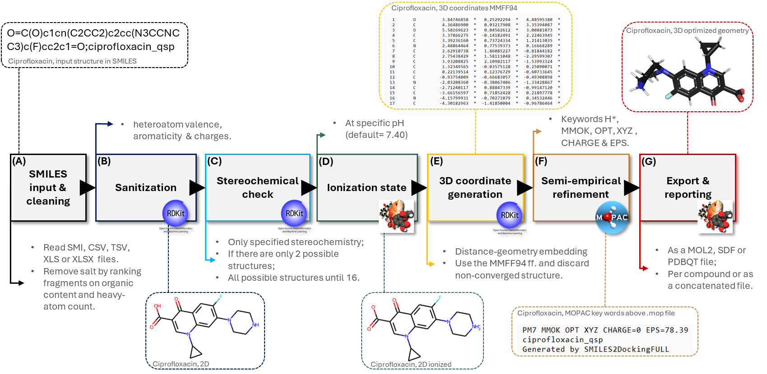
Figure 1. Step by step methodology of SMILES2Docking for three-dimensional structure generation and semi-empirical refinement. (ff), force field. Atoms of hydrogen are shown in white, carbon in black and oxygen in red for three-dimensional structures.
2.2 Salt, co-former handling and sanitization
Afterwards, SMILES strings encoding multiple disconnected fragments (typical for salts and co-crystallised counter-ions) are handled by ranking fragments on organic content and heavy-atom count, keeping the top-scoring one (see Figure 1A). When two fragments score identically and conservative mode is active, the run halts with an explicit error instead of guessing. In a large batch over a public library, a silent wrong choice would propagate unnoticed into every downstream step, so the failure is deliberate. In sequence, Figure1B summarizes the sanitization step for SMILES strings, where is applied the verification of the correct aromaticity assignments for all atoms and valence/charge on N and O atoms.
2.3 Stereochemistry validation
In sequence, the stereocenter policy can be decided, choosing among three modes of selection for setting up the run, as shown in Figure 1C. Permissive mode passes all molecules regardless of whether their tetrahedral and alkene stereocenters are assigned, the right default when working from databases like ChEMBL or PubChem, which contain many structures with incomplete stereo annotation. Strict mode rejects any compound with one or more undefined tetrahedral and/or alkene stereocenters, limiting the output to geometrically unambiguous structures. Enumerative mode generates all possible diastereomers up to a configurable cap (default = 16) and tags each variant with a unique identifier derived from the parent code, so all downstream files remain individually traceable.
2.4 Ionization state
Furthermore, as shown in Figure 1D, we use Open Babel to assign ionization state at a user-specified pH (default = 7.4). When the resulting SMILES cannot be re-parsed by RDKit, an SDF intermediate is used instead. The formal charge of the ionizated species is recorded and carried into the post-refinement charge audit (see Figure 1F).
2.5 3D coordinate generation
Herein, RDKit generates 3D coordinates from a distance-geometry algorithm [14]. The workflow summarized in Figure 1E, starts with a reproducible embedding at a fixed random seed; if that fails, it tries a random-seed variant, then a small-ring-adapted variant for strained or macrocyclic systems, with multiple attempts at each stage before moving on. The embedded geometry is then minimized through successive cycles of molecular mechanics force field MMFF94 [15,16] until convergence. If no force field converges, the record is rejected and the user is informed in the final log.
2.6 Semi-empirical refinement
When PM7 refinement is enabled, the converged geometry is submitted to MOPAC with a standard amide and peptide-bond correction (see Figure 1F). An implicit aqueous solvent model (ε = 78.4) [17] is available to better match physiological conditions. The keywords used for MOPAC run are MMOK, CHARGE=N (automatically determined for each molecule in the sanitization step, Figure 1 B), XYZ and OPT. For method-comparison work, seven additional Hamiltonians are accessible: PM6, PM6-D3H4X, PM6-ORG, RM1, PM3, AM1 and MNDO. The heat of formation is stored as a molecular property. After refinement, a charge audit compares the MOPAC formal charge against the pre-refinement value; a discrepancy triggers an automated rescue heuristic, and if that fails the record is rejected rather than passed on with a corrupted protonation state. On Windows and Linux distributions, MOPAC ships inside the executable and needs no separate installation.
2.7 Export and reporting
As seen in Figure 1G, structures are exported as MOL2, SDF or PDBQT, either per compound or as a concatenated file ready to dock. Every run also produces a JSON audit report with per-compound entries covering co-former removal, ionization, stereocenter outcomes, embedding and optimization results, and semi-empirical metadata. For anyone troubleshooting an unexpected result, the report will provide the possible problems.
3. Results and discussion
We ran more than ~2400 compounds from ECBD data base at pH 7.4 with PM7 refinement and implicit aqueous solvation model (see supplementary material), as well as 2 control compounds (acetaminophen and ibuprofen), 4 ionization susceptible compounds (captopril, metformin, ciprofloxacin and sulfamethoxazole) and 3 high structure complexity compounds (ritonavir, paclitaxel and cyclosporin). The workflow returned 9/9 cleaned drug structures; Ibuprofen, from controls, was excluded by the strict stereocenter policy, as seen in Figure 2A, and expanded by enumerative mode into two uniquely labelled stereoisomers (Figure 2B). Embedding succeeded on the first pass for all compounds. PM7 completed for all structures at average 0.25 s per atom on i7-10750H@ 16 GB RAM.
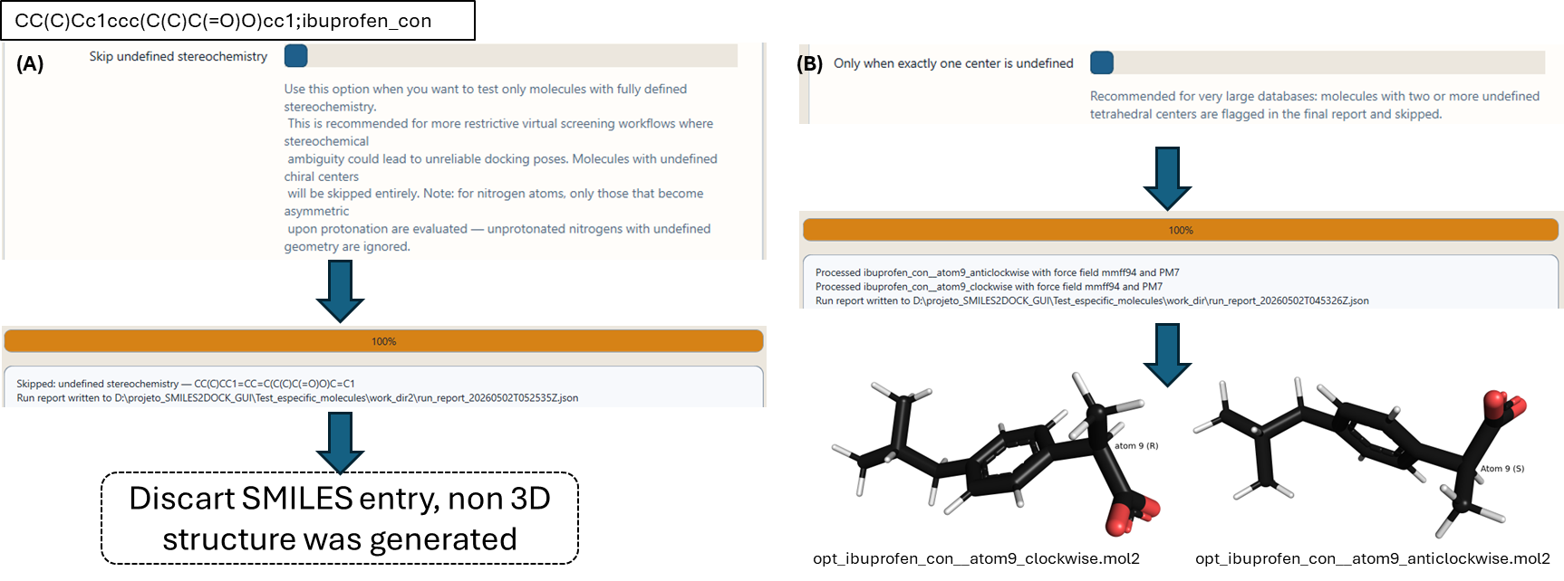
Figure 2. Stric (A) and flexible (B) functions for 3D structures generation with semi-empirical refinement, Ibuprofen example. Atoms of hydrogen are shown in white, carbon in black and oxygen in red for three-dimensional structures.
Compared to a minimal RDKit-plus-Open-Babel pipeline, SMILES2Docking adds two controls targeting known failure modes. The stereocenter policies make chirality handling explicit and per-compound auditable: standard RDKit embedding silently assigns an arbitrary configuration to an undefined stereocenter, whereas strict and enumerative modes filter or expand the compound. This matters because chirality errors propagate directly into binding-affinity predictions [7]. The post-refinement charge audit catches ionization changes that can occur during semi-empirical optimization and either rescues the structure or rejects it, since an incorrect charge reliably degrades docking scores [8].
The tool is also aimed at researchers who do not have the time or programming background to assemble a custom preparation pipeline. ChEMBL, ZINC and PubChem together hold hundreds of millions of compounds as SMILES strings, and the steps between a SMILES and a docked pose are genuinely non-trivial. The three stereocenter modes reflect decisions that come up in practice: permissive mode for exploratory campaigns where the database contains many structures with undefined stereochemistry; strict mode when every output must be geometrically unambiguous; enumerative mode when the scaffold is fixed and all diastereomers need docking. Figure 2 displays two from three cases: (i) strict restriction in undefined stereochemistry molecules such as SMILES representation of ibuprofen (Figure 2A) and (ii) permissive format where only one stereogenic center is not defined from the SMILES representation will be built (Figure 2B). There is also the flexible option when more than one stereogenic center are undefined, constructing up to 16 possibilities when applied. On Windows and Linux operating systems, MOPAC ships in the executable, so semi-empirical refinement works out of the box.
The current version retains only the dominant protonation state from Open Babel; tautomers are not enumerated. Processing is sequential, so throughput scales linearly with library size.
Acknowledgements

References
[1] Weininger D. SMILES, a chemical language and information system. 1. Introduction to methodology and encoding rules. J Chem Inf Comput Sci. 1988;28(1):31–36.
[2] Pinzi L, Rastelli G. Molecular Docking: Shifting Paradigms in Drug Discovery. Int J Mol Sci. 2019;20(18):4331. doi:10.3390/ijms20184331
[3] Bhatt A, Panda SK, Chaudhari SP, Pathak M, Satapathy A, Prasanna NK. Mapping of Global Research Performance on Molecular Docking: A Bibliometric Study. Curr Trends Biotechnol Pharm. 2024;18(2):1725–1735. doi:10.5530/ctbp.2024.2.21
[4] Gautam S, Pathak S, Dubey SH. The Role of Molecular Docking in Modern Drug Discovery and Development: A Comprehensive Review. J Drug Discov Health Sci. 2024;1(3):129–137. doi:10.21590/jddhs.01.03.02
[5] Neelam AK. Advancing drug discovery: the role of computer-aided design and development in modern pharmaceuticals. Discov Pharm Sci. 2025;1(1):8. doi:10.1007/s44395-025-00008-2
[6] Landrum G. RDKit: Open-source cheminformatics software. https://www.rdkit.org (accessed 2026).
[7] Brooks WH, Guida WC, Daniel KG. The significance of chirality in drug design and development. Curr Top Med Chem. 2011;11(7):760–770.
[8] ten Brink T, Exner TE. Influence of protonation, tautomeric, and stereoisomeric states on protein-ligand docking results. J Chem Inf Model. 2009;49(6):1535–1546.
[9] O’Boyle NM, Banck M, James CA, Morley C, Vandermeersch T, Hutchison GR. Open Babel: an open chemical toolbox. J Cheminform. 2011;3:33.
[10] Hawkins PCD, Skillman AG, Warren GL, Ellingson BA, Stahl MT. Conformer generation with OMEGA: algorithm and validation using high-quality structures from the Protein Data Bank and Cambridge Structural Database. J Chem Inf Model. 2010;50(4):572–584.
[11] Sadowski J, Gasteiger J. From atoms and bonds to three-dimensional atomic coordinates: automatic model builders. Chem Rev. 1993;93(7):2567–2581.
[12] Azam F, Almahmoud SA. Open-Source Molecular Docking and AI-Augmented Structure-Based Drug Design: Current Workflows, Challenges, and Opportunities. Int J Mol Sci. 2026;27(7):3302. doi:10.3390/ijms27073302
[13] Stewart JJP. Optimization of parameters for semiempirical methods VI: more modifications to the NDDO approximations and re-optimization of parameters. J Mol Model. 2013;19(1):1–32.
[14] Riniker S, Landrum GA. Better informed distance geometry: using what we know to improve conformation generation. J Chem Inf Model. 2015;55(12):2562–2574. doi:10.1021/acs.jcim.5b00654
[15] Halgren TA. Merck molecular force field. I. Basis, form, scope, parameterization, and performance of MMFF94. J Comput Chem. 1996;17(5–6):490–519.
[16] Rappé AK, Casewit CJ, Colwell KS, Goddard WA, Skiff WM. UFF, a full periodic table force field for molecular mechanics and molecular dynamics simulations. J Am Chem Soc. 1992;114(25):10024–10035.
[17] Klamt A, Schuurmann G. COSMO: a new approach to dielectric screening in solvents with explicit expressions for the screening energy and its gradient. J Chem Soc Perkin Trans 2. 1993;(5):799–805.

