A. State a hypothesis:

Will the site with more fishing pressure have a negative effect on predator size and population density? I predict that the site with more fishing pressure, even considering that is located within a regulated fishing area, is going to present less and smaller predators. I consider this hypothesis because the gulf of Nicoya has a high fishing pressure overall, while the other site is near a marine protected area (even though not inside, it could benefit from spillover effect). My predictive variable is the site (high-or-low fishing pressure) and my response variables are length and density.

B. Visualize the experimental design:

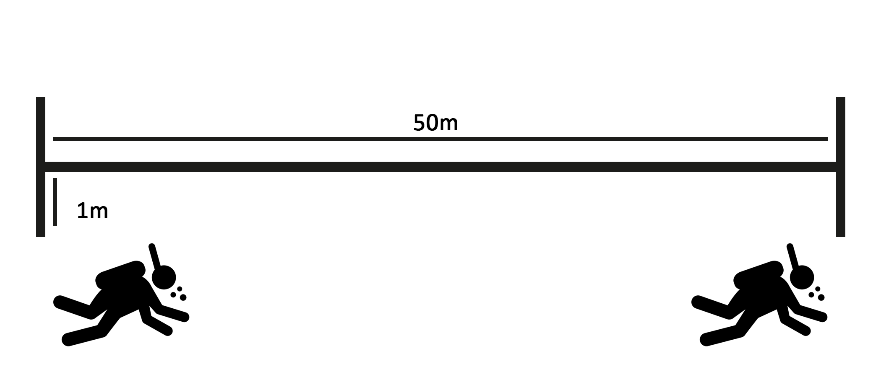

In two sites along the Pacific coast of Costa Rica, transects were done by triplicates in three different places within each site, in order to try to represent each site. Transects were placed randomly.

C. Data exploration.

First, I checked for outliers in my data using a boxplot. Looks like there are several outliers, but none of them are mistakes. Probably big fishes were measured in low abundance and smaller fishes were more abundant.

To see if there was homogeneity in data, I compared locations (two provinces/two sites with different fishing pressures) in function of length and density of organisms. There seems to be no heterogeneity.

Normal distribution was assessed by creating a histogram for length and for density. Data were skewed towards smaller sizes (to the left). For length and for density, no zeroes were found in the data that were affecting it.

Collinearity appears to be present within transects done in the two sites, for both length and density. By looking at the data, there are possibly some differences if one takes Locality instead of Province, but Province is the same as high-or-low fishing pressure, so it will not be excluded.

Regarding interactions, there seems to be none in Provinces, considering both Y variables.

Y variables are not totally independent of X because of fishing pressure that directly affects these parameters.