Domain-Aware Tuberculosis Screening via Foundation Model Ensembling and LoRA
Eunchan Hwang
Abstract
Tuberculosis (TB) still kills more people each year than any other single infectious disease, and automated chest X-ray (CXR) screening is one of the few ways to scale diagnosis where radiologists are scarce [2]. We build a TB/Normal classifier around two frozen, self-supervised CXR foundation models – RAD-DINO [3] and CheXFound [4] – adapted with low-rank adaptation (LoRA) [6] instead of full fine-tuning, and validated with leave-one-imaging-modality-out (LOMO) cross-validation, the correct proxy for cross-domain generalization once a real acquisition-domain signal (Modality_DICOM) sits inside the training pool. Of five backbones we trained, the two-model ensemble scores best on internal validation (F1=0.9929), beating the full five-model ensemble (F1=0.9890). We also run true external validation on the public Shenzhen and Montgomery TB cohorts, where F1 falls to 0.7707 and 0.8348 – a real generalization gap we report openly, since hiding it behind a flattering internal number would defeat the point of measuring it at all.
Domain-Aware Tuberculosis Screening via Foundation Model Ensembling and LoRA
Eunchan Hwang
MI2RL

Introduction
CXR classifiers routinely reach near-perfect accuracy on a held-out split from their own training hospital, then fail on a different hospital, scanner, or country. We saw this ourselves: a plain DenseNet-121, trained without any domain-generalization (DG) technique, scored only 66% accuracy on the external Shenzhen cohort in our earlier work [1], rising to 89% once MixStyle [7] and multi-level augmentation were added. Fig. 1 shows why: Grad-CAM on that un-augmented baseline fixates on a corner marker rather than any lung structure, for both a TB case and a Normal case, despite a high score on a plain stratified split. The model was not reading the X-ray – it was reading a sticker.
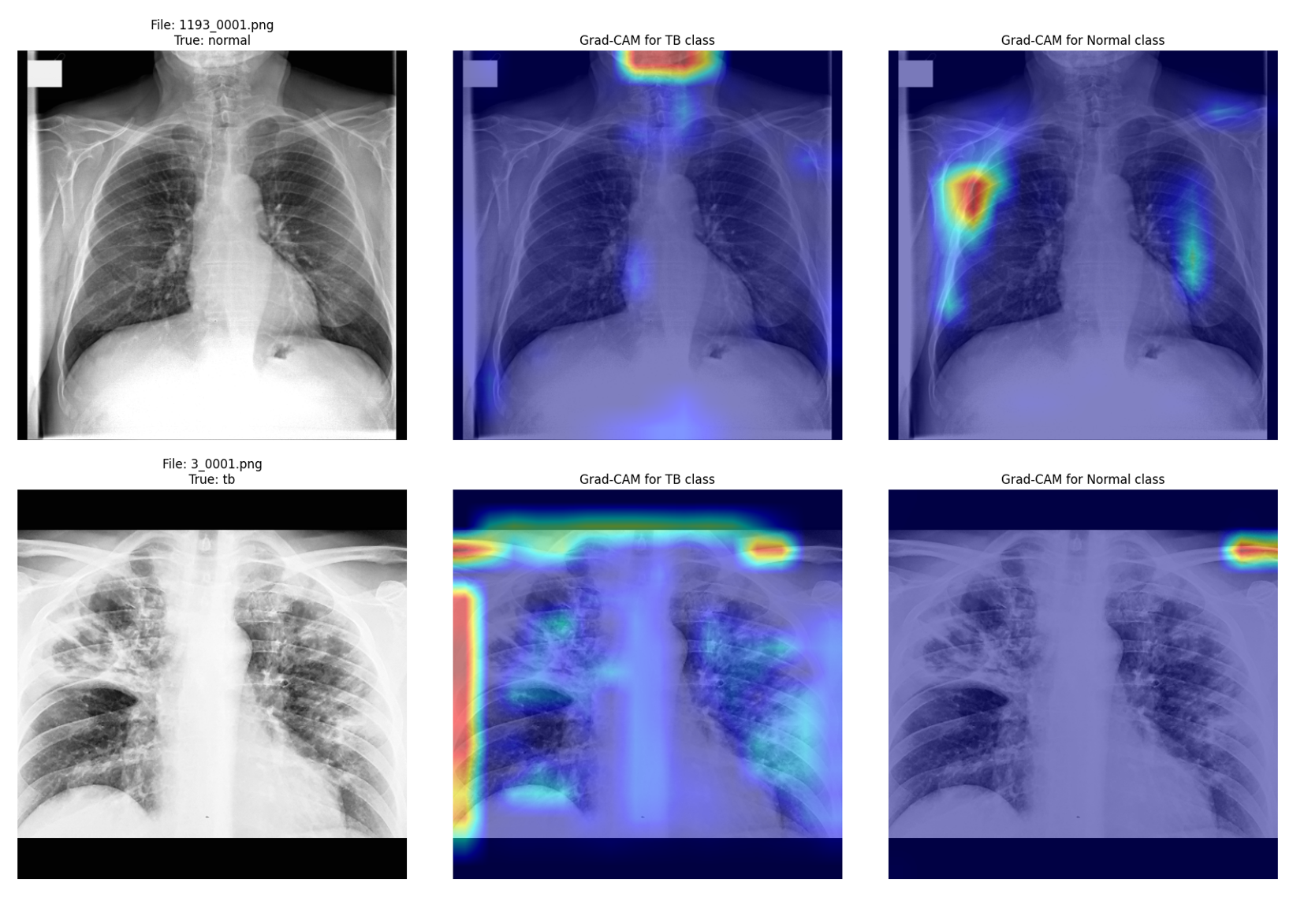
Grad-CAM on the un-augmented baseline, for a Normal case (top) and a TB case (bottom). Both classes’ attention fixates on a corner marker/border artifact, not lung anatomy – a shortcut a plain stratified split rewards even though it carries no diagnostic signal.
This paper extends that recipe two ways. First, we replace the single DenseNet-121 with two CXR-domain foundation models, RAD-DINO and CheXFound, each frozen and adapted with LoRA rather than fully fine-tuned – cheaper to train and, we find, harder for the model to overfit through. Second, we validate with leave-one-modality-out (LOMO) cross-validation rather than a plain stratified split: since Modality_DICOM is itself a domain signal present in the training data, a stratified split lets the model see every modality during training and rewards exploiting exactly the kind of shortcut Fig. 1 shows. LOMO instead holds out one whole modality per fold, so a fold’s validation score reflects generalization to an acquisition setting the model never saw – a much closer proxy for the external-hospital deployment this system is actually meant for.

Method
Overview of the inference pipeline (placeholder – see diagram_prompt.md).

Backbones
We train and compare five encoders: DenseNet-121 [10] (full fine-tune, our prior baseline architecture), Swin-Tiny [11] and ConvNeXt-Tiny [12] (added for architectural diversity at negligible extra cost, both ImageNet-pretrained at 224px), and two foundation models, each frozen and adapted with LoRA (rank 16, alpha 16, on the attention/MLP linear layers):
- RAD-DINO [3]: a DINOv2 [5] ViT-B/14 pretrained self-supervised on chest radiographs, 518px input.
- CheXFound [4]: a DINOv2 ViT-L/16 pretrained on a large CXR corpus, 512px input, register tokens, SwiGLU feed-forward.
All five share one lightweight head: LayerNorm, Dropout, then a single Linear layer over the pooled features.

Preprocessing and domain generalization
Every image is lung-cropped by a PSPNet segmenter [13] before classification, CLAHE-normalized, and clipped to its 1st/99th percentile intensity range. We apply DG at three levels, extending [1]:
- Feature-level: MixStyle [7] mixes low-level style statistics across a mini-batch. It is wired into the DenseNet-121 path only – the one backbone whose intermediate feature maps are cleanly hookable at the early layer MixStyle expects.
- Image-level: the multi-level augmentation of [1], plus RandConv [8] (a freshly re-initialized random convolution, blended with the original image, that scrambles texture while roughly preserving shape) and amplitude-spectrum perturbation (perturbing the Fourier amplitude, where scanner/contrast differences mostly live, while leaving the anatomy-carrying phase spectrum untouched).
- Batch-level: domain-aware mixup [9], pairing samples across different Modality_DICOM values rather than mixing uniformly at random, so synthesized samples interpolate along the domain axis this dataset actually has.
Modality_DICOM itself never enters the model as an input feature – it is only ever a domain label for the DG techniques and the LOMO split, never a shortcut for the classifier to key on.

Training and validation protocol
For each of the five encoders, we hold out one of the four imaging modalities in the training pool (CR, DX, XA, XC) and train on the remaining three, for 15 epochs per fold, repeating for all four modalities. This measures generalization to an unseen acquisition modality directly; a stratified split cannot, since it lets the model train on every modality and rewards Modality_DICOM-correlated shortcuts. At inference, each encoder’s four fold checkpoints are averaged into an implicit 4-way sub-ensemble, and encoder combinations are averaged the same way.

Experiments

Data
Training and internal-validation data comes from the challenge’s own TB/Normal pool across four modalities (CR, DX, XA, XC). For genuine external-domain validation, we additionally score the public Shenzhen (662 images) and Montgomery (138 images) TB cohorts [14] – the same two datasets our earlier work [1] used, giving a directly comparable external number.

Internal validation
Table 1 reports LOMO mean validation accuracy per encoder, and F1@0.5 on the organizer-provided internal validation set (test.csv, 1,940 samples), for individual encoders, the full five-encoder ensemble, and the best subset found by sweeping all 31 non-empty subsets of the five.
Internal results. LOMO accuracy is the mean over 4 held-out-modality folds; F1@0.5 is on the organizer-provided internal validation set, threshold fixed a priori at 0.5.
Model | LOMO mean val. acc. | Internal val. F1@0.5
DenseNet-121 | 0.9840–0.9871 | 0.9863
Swin-Tiny | 0.9877–0.9912 | 0.9879
ConvNeXt-Tiny | 0.9868–0.9896 | 0.9857
RAD-DINO | 0.9960 | 0.9890
CheXFound (ViT-L/16) | 0.9968–0.9972 | 0.9912
Full 5-encoder ensemble | – | 0.9890
RAD-DINO + CheXFound (ours) | – | 0.9929
The two-encoder foundation-model ensemble beats the full five-encoder ensemble: the three lighter backbones dilute rather than sharpen the combined estimate, despite reasonable standalone scores. LOMO accuracy is given as a range across two independent training runs (identical configuration, only ordinary floating-point nondeterminism differs) to show how stable it is; both runs agree that CheXFound is the strongest single encoder.

External validation and the generalization gap
Table 2 reports the full five-encoder ensemble on the two external cohorts, never seen during training. We report it plainly, gap and all: F1 drops from 0.9890 (internal, full ensemble) to 0.7707 (Shenzhen) and 0.8348 (Montgomery).
External validation (full 5-encoder ensemble), never seen during training. Threshold fixed a priori at 0.5.
Dataset | Accuracy@0.5 | AUC | F1@0.5
Shenzhen (662) | 0.7402 | 0.8711 | 0.7707
Montgomery (138) | 0.8623 | 0.9218 | 0.8348
That gap dwarfs the plain-split-vs-LOMO gap in [1]: even LOMO, our stricter protocol, still over-estimates cross-institution performance here. Worse, our foundation-model ensemble does not yet clearly beat [1]’s plain-DenseNet-121-plus-DG baseline once both are measured on the same external cohort, despite a much higher internal score. We treat closing this gap, not chasing a higher internal number, as the real open problem.
A post-hoc threshold sweep on these same predictions moves in opposite directions for the internal set (lower helps) and Shenzhen (higher helps), while Montgomery is already optimal at 0.5 – no single threshold helps everywhere, one more sign the internal number does not transfer cleanly.

Mask-guided attention (exploratory)
Separately, we trained a mask-guided attention variant of the three CNN backbones: a 1$×$1-conv gate on the last feature map, supervised with a Dice loss against the real lung mask, penalizing attention outside the lung silhouette rather than just handing the mask over as an extra channel. All three backbones improved slightly on LOMO validation (DenseNet-121: 0.9840$→$0.9871; Swin-Tiny: 0.9877$→$0.9889; ConvNeXt-Tiny: 0.9896$→$0.9900). Fig. 3 shows why on one held-out TB case: the baseline attends only to the left apex and misses the disease (P(TB)=0.357, wrong at threshold 0.5); the mask-guided model keeps that focus and recruits a second, correct hotspot on the right, landing at P(TB)=0.980. This gate is not yet implemented for RAD-DINO/CheXFound’s patch-token layout and is not part of our final submitted ensemble – we report it as a promising direction for future work.
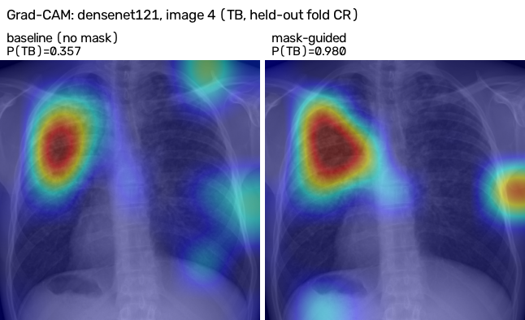
Grad-CAM for DenseNet-121 on the same held-out TB case, baseline (left) vs. mask-guided (right). The mask-guided model keeps the baseline’s left-apex focus and adds a second, correct hotspot on the right, flipping a misclassification (P(TB)=0.357) to a correct call (P(TB)=0.980).

Conclusion
A two-model ensemble of frozen, LoRA-adapted CXR foundation models – RAD-DINO and CheXFound – beats a larger five-backbone ensemble on internal, same-source-pool validation for TB/Normal classification (F1@0.5=0.9929), under the stricter leave-one-modality-out protocol rather than a plain stratified split. True external validation on public Shenzhen and Montgomery cohorts shows that strong internal score does not yet translate into a matching gain in cross-institution generalization over a simpler prior baseline. Internal validation numbers for CXR classifiers deserve caution, and closing the internal/external gap – through stronger domain generalization, mask-guided attention extended to the foundation-model branches, or larger and more diverse external-style training data – remains the central open problem for deployable TB screening.
14
[1] Anonymized for review: Domain Generalization of Tuberculosis Detection in Chest X-Rays through MixStyle and Multi-Level Augmentation. SSRN 5644210.
[2] World Health Organization: Global Tuberculosis Report 2023. WHO, Geneva (2023).
[3] Pérez-García, F., et al.: RAD-DINO: Exploring Scalable Medical Image Encoders Beyond Text Supervision. arXiv:2401.10815 (2024).
[4] CheXFound: A Chest X-Ray Foundation Model with Global and Local Representation Integration. (2024/2025).
[5] Oquab, M., et al.: DINOv2: Learning Robust Visual Features without Supervision. arXiv:2304.07193 (2023).
[6] Hu, E.J., et al.: LoRA: Low-Rank Adaptation of Large Language Models. ICLR (2022).
[7] Zhou, K., Yang, Y., Qiao, Y., Xiang, T.: Domain Generalization with MixStyle. ICLR (2021).
[8] Xu, Z., et al.: Robust and Generalizable Visual Representation Learning via Random Convolutions. ICLR (2021).
[9] Wang, Z., Xia, Y.: Domain-Aware Mixup for Robust Chest X-Ray Diagnosis Across Unseen Domains. (2022).
[10] Huang, G., Liu, Z., van der Maaten, L., Weinberger, K.Q.: Densely Connected Convolutional Networks. CVPR (2017).
[11] Liu, Z., et al.: Swin Transformer: Hierarchical Vision Transformer using Shifted Windows. ICCV (2021).
[12] Liu, Z., et al.: A ConvNet for the 2020s. CVPR (2022).
[13] Cohen, J.P., et al.: TorchXRayVision: A library of chest X-ray datasets and models. MIDL (2022).
[14] Jaeger, S., et al.: Two public chest X-ray datasets for computer-aided screening of pulmonary diseases. Quant. Imaging Med. Surg. 4(6), 475–477 (2014).

