Museum Management System
Harton Daniel
CSIE
Series: G-ENGL
Gr. 1073

Contents
Introduction 3
Database schema 4
Data Definition Language 5
1. Deleting tables created from previous runs of the script 5
2. Creating table structures 6
Data Manipulation Language 9
Full script 17

Introduction

The Museum Management System is designed to efficiently manage the financial and operational aspects of multiple museums. This system focuses on tracking and analyzing economic data related to museum operations, including revenues from ticket sales, donations, and exhibit rentals, as well as expenses such as staff salaries, utility costs, and exhibit maintenance. By implementing this system, the museum can optimize its financial performance by identifying profitable exhibits, managing costs effectively, and ensuring that donation and revenue streams are utilized efficiently. The database design supports the analysis of key metrics like cost-to-revenue ratios, donation trends, and visitor statistics, helping museum management make data-driven decisions.
The project leverages a relational database structure to store and manage various aspects of museum operations. Some primary components of the system are: “Ticket Sales Management” ( tracks daily ticket sales, visitor data, and revenue generated ) and “Exhibit Financial Tracking” ( records costs associated with exhibit maintenance and calculates their profitability) .
The project includes the design and implementation of a robust database using Oracle SQL, featuring tables, relationships, and constraints. It also incorporates SQL queries to manage and analyze the data, with a focus on financial metrics, ensuring that the system aligns with the economic theme.

Database schema
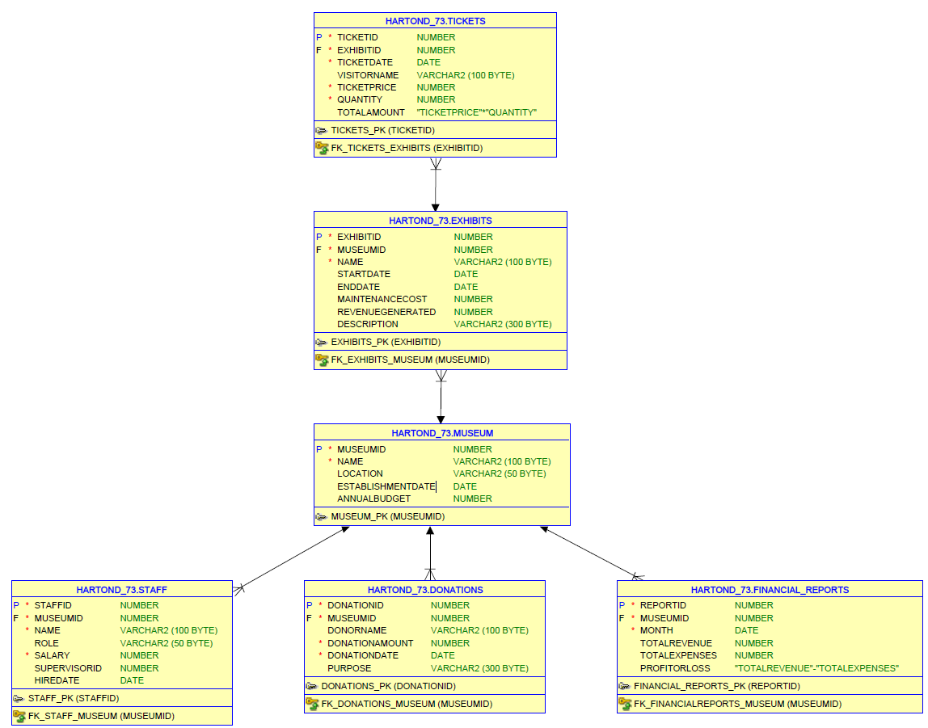

Data Definition Language

Deleting tables created from previous runs of the script
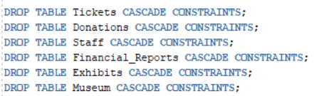
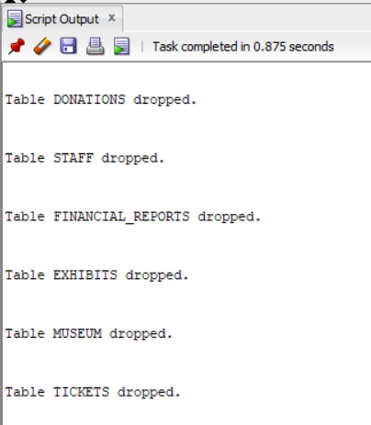

Creating table structures
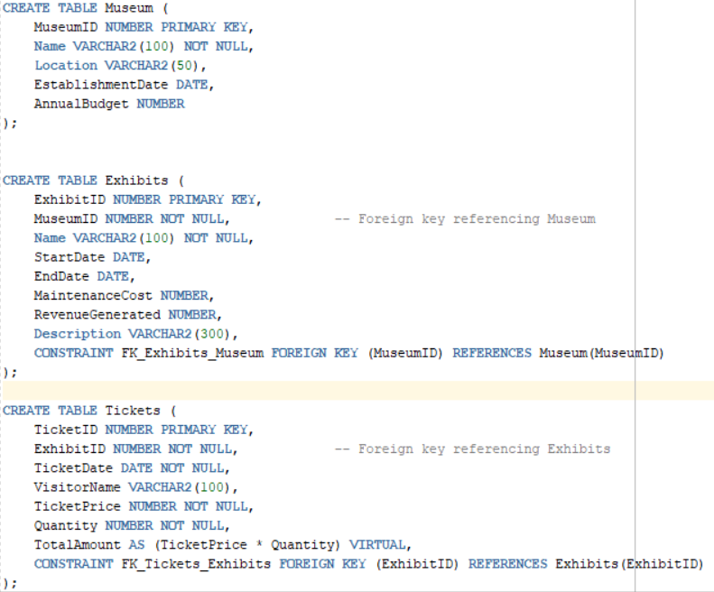
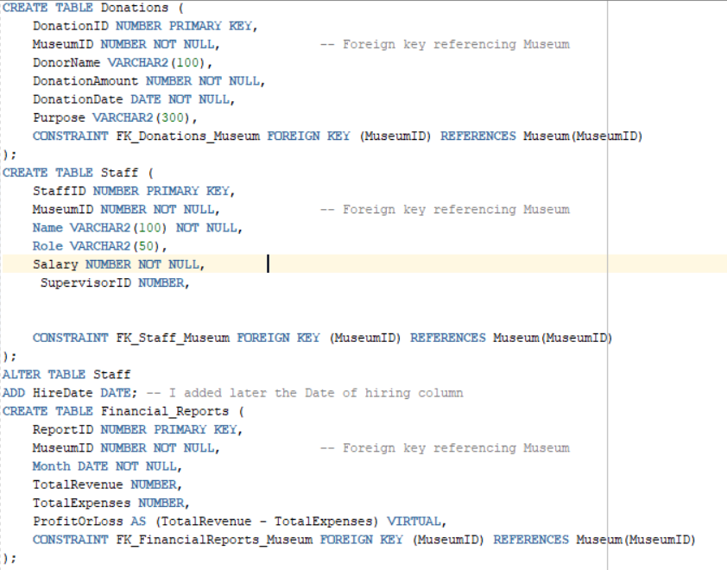

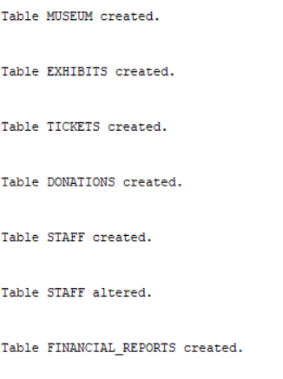

Data Manipulation Language
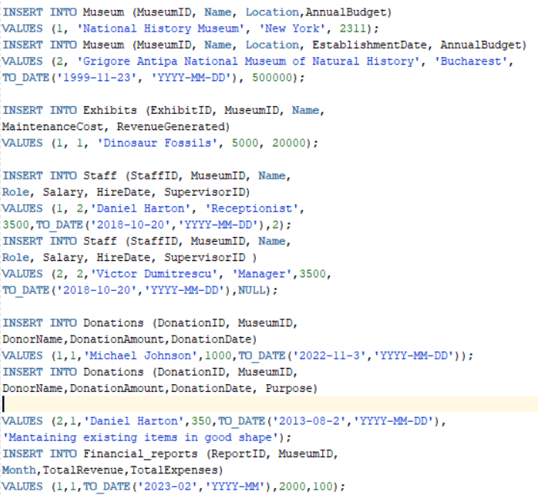
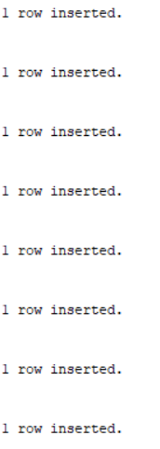
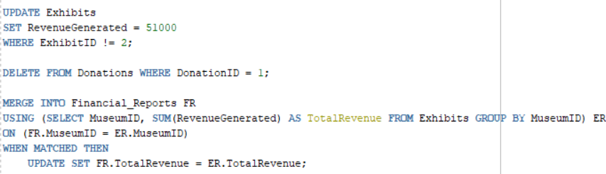
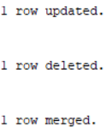
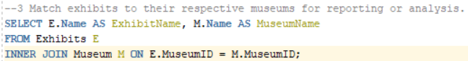
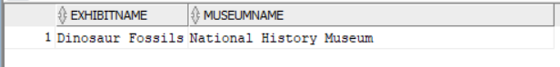
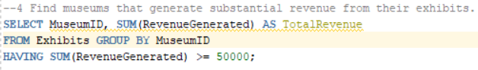
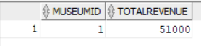
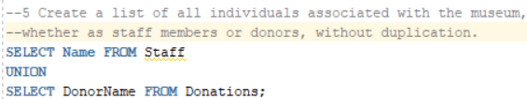
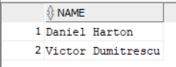
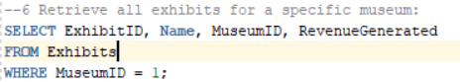
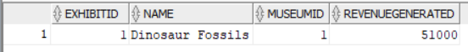
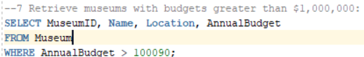
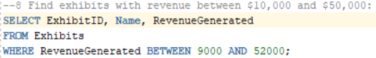
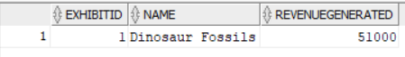
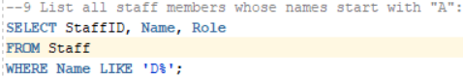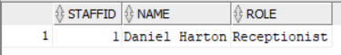
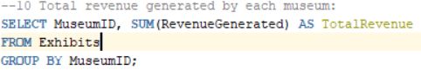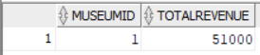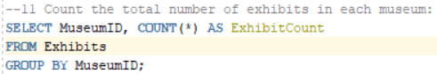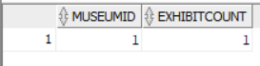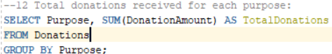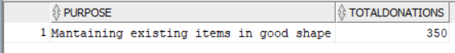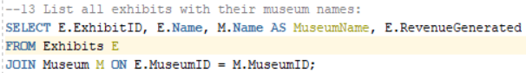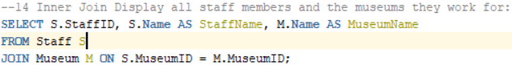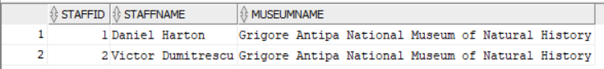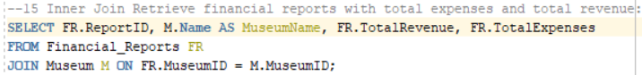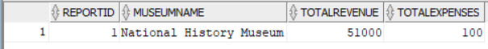
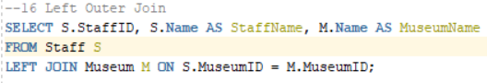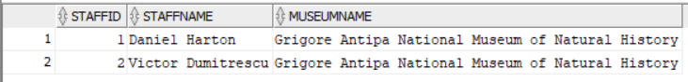
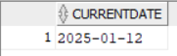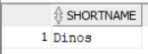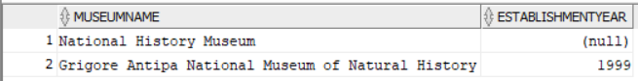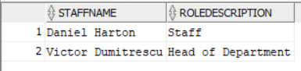
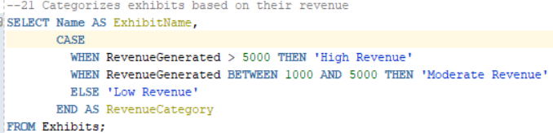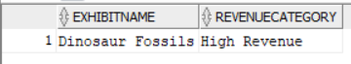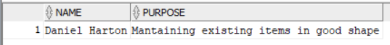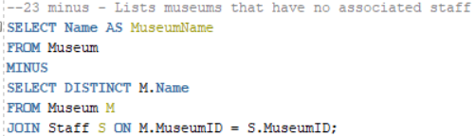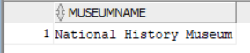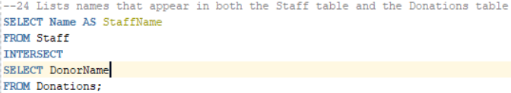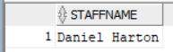
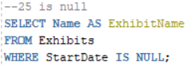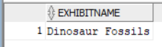
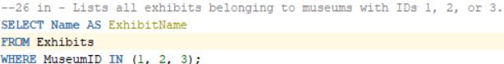
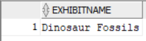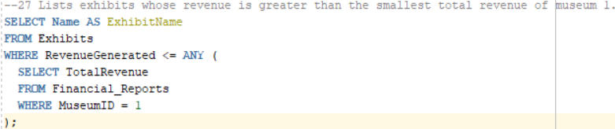
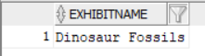
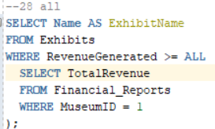
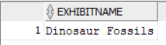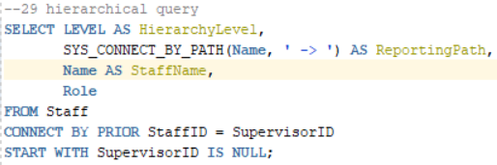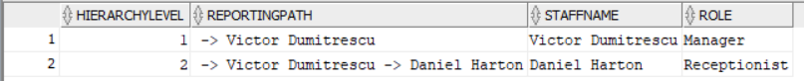

Full script
1. -- DDL
2.
3.
4. DROP TABLE Donations CASCADE CONSTRAINTS;
5. DROP TABLE Staff CASCADE CONSTRAINTS;
6. DROP TABLE Financial_Reports CASCADE CONSTRAINTS;
7. DROP TABLE Exhibits CASCADE CONSTRAINTS;
8. DROP TABLE Museum CASCADE CONSTRAINTS;
9. DROP TABLE Tickets CASCADE CONSTRAINTS;
10.
11.
12. CREATE TABLE Museum (
13. MuseumID NUMBER PRIMARY KEY,
14. Name VARCHAR2(100) NOT NULL,
15. Location VARCHAR2(50),
16. EstablishmentDate DATE,
17. AnnualBudget NUMBER
18. );
19.
20.
21. CREATE TABLE Exhibits (
22. ExhibitID NUMBER PRIMARY KEY,
23. MuseumID NUMBER NOT NULL, -- Foreign key referencing Museum
24. Name VARCHAR2(100) NOT NULL,
25. StartDate DATE,
26. EndDate DATE,
27. MaintenanceCost NUMBER,
28. RevenueGenerated NUMBER,
29. Description VARCHAR2(300),
30. CONSTRAINT FK_Exhibits_Museum FOREIGN KEY (MuseumID) REFERENCES Museum(MuseumID)
31. );
32.
33. CREATE TABLE Tickets (
34. TicketID NUMBER PRIMARY KEY,
35. ExhibitID NUMBER NOT NULL, -- Foreign key referencing Exhibits
36. TicketDate DATE NOT NULL,
37. VisitorName VARCHAR2(100),
38. TicketPrice NUMBER NOT NULL,
39. Quantity NUMBER NOT NULL,
40. TotalAmount AS (TicketPrice * Quantity) VIRTUAL,
41. CONSTRAINT FK_Tickets_Exhibits FOREIGN KEY (ExhibitID) REFERENCES Exhibits(ExhibitID)
42. );
43.
44.
45. CREATE TABLE Donations (
46. DonationID NUMBER PRIMARY KEY,
47. MuseumID NUMBER NOT NULL, -- Foreign key referencing Museum
48. DonorName VARCHAR2(100),
49. DonationAmount NUMBER NOT NULL,
50. DonationDate DATE NOT NULL,
51. Purpose VARCHAR2(300),
52. CONSTRAINT FK_Donations_Museum FOREIGN KEY (MuseumID) REFERENCES Museum(MuseumID)
53. );
54. CREATE TABLE Staff (
55. StaffID NUMBER PRIMARY KEY,
56. MuseumID NUMBER NOT NULL, -- Foreign key referencing Museum
57. Name VARCHAR2(100) NOT NULL,
58. Role VARCHAR2(50),
59. Salary NUMBER NOT NULL,
60. SupervisorID NUMBER,
61.
62.
63. CONSTRAINT FK_Staff_Museum FOREIGN KEY (MuseumID) REFERENCES Museum(MuseumID)
64. );
65. ALTER TABLE Staff
66. ADD HireDate DATE; -- I added later the Date of hiring column
67. CREATE TABLE Financial_Reports (
68. ReportID NUMBER PRIMARY KEY,
69. MuseumID NUMBER NOT NULL, -- Foreign key referencing Museum
70. Month DATE NOT NULL,
71. TotalRevenue NUMBER,
72. TotalExpenses NUMBER,
73. ProfitOrLoss AS (TotalRevenue - TotalExpenses) VIRTUAL,
74. CONSTRAINT FK_FinancialReports_Museum FOREIGN KEY (MuseumID) REFERENCES Museum(MuseumID)
75. );
76.
77. -- DML
78.
79. INSERT INTO Museum (MuseumID, Name, Location,AnnualBudget)
80. VALUES (1, 'National History Museum', 'New York', 2311);
81. INSERT INTO Museum (MuseumID, Name, Location, EstablishmentDate, AnnualBudget)
82. VALUES (2, 'Grigore Antipa National Museum of Natural History', 'Bucharest',
83. TO_DATE('1999-11-23', 'YYYY-MM-DD'), 500000);
84.
85. INSERT INTO Exhibits (ExhibitID, MuseumID, Name,
86. MaintenanceCost, RevenueGenerated)
87. VALUES (1, 1, 'Dinosaur Fossils', 5000, 20000);
88.
89. INSERT INTO Staff (StaffID, MuseumID, Name,
90. Role, Salary, HireDate, SupervisorID)
91. VALUES (1, 2,'Daniel Harton', 'Receptionist',
92. 3500,TO_DATE('2018-10-20','YYYY-MM-DD'),2);
93. INSERT INTO Staff (StaffID, MuseumID, Name,
94. Role, Salary, HireDate, SupervisorID )
95. VALUES (2, 2,'Victor Dumitrescu', 'Manager',3500,
96. TO_DATE('2018-10-20','YYYY-MM-DD'),NULL);
97.
98. INSERT INTO Donations (DonationID, MuseumID,
99. DonorName,DonationAmount,DonationDate)
100. VALUES (1,1,'Michael Johnson',1000,TO_DATE('2022-11-3','YYYY-MM-DD'));
101. INSERT INTO Donations (DonationID, MuseumID,
102. DonorName,DonationAmount,DonationDate, Purpose)
103.
104. VALUES (2,1,'Daniel Harton',350,TO_DATE('2013-08-2','YYYY-MM-DD'),
105. 'Mantaining existing items in good shape');
106. INSERT INTO Financial_reports (ReportID, MuseumID,
107. Month,TotalRevenue,TotalExpenses)
108. VALUES (1,1,TO_DATE('2023-02','YYYY-MM'),2000,100);
109.
110.
111.
112. UPDATE Exhibits
113. SET RevenueGenerated = 51000
114. WHERE ExhibitID != 2;
115.
116. DELETE FROM Donations WHERE DonationID = 1;
117.
118. MERGE INTO Financial_Reports FR
119. USING (SELECT MuseumID, SUM(RevenueGenerated) AS TotalRevenue FROM Exhibits GROUP BY MuseumID) ER
120. ON (FR.MuseumID = ER.MuseumID)
121. WHEN MATCHED THEN
122. UPDATE SET FR.TotalRevenue = ER.TotalRevenue;
123.
124.
125.
126. --1 Find exhibits that generate significant revenue
127. SELECT * FROM Exhibits WHERE RevenueGenerated > 10000;
128. --2 Identify moderate-level donations for analysis
129. SELECT * FROM Donations WHERE DonationAmount BETWEEN 100 AND 1000;
130. --3 Match exhibits to their respective museums for reporting or analysis.
131. SELECT E.Name AS ExhibitName, M.Name AS MuseumName
132. FROM Exhibits E
133. INNER JOIN Museum M ON E.MuseumID = M.MuseumID;
134. --4 Find museums that generate substantial revenue from their exhibits.
135. SELECT MuseumID, SUM(RevenueGenerated) AS TotalRevenue
136. FROM Exhibits GROUP BY MuseumID
137. HAVING SUM(RevenueGenerated) >= 50000;
138.
139. --5 Create a list of all individuals associated with the museum,
140. --whether as staff members or donors, without duplication.
141. SELECT Name FROM Staff
142. UNION
143. SELECT DonorName FROM Donations;
144. --6 Retrieve all exhibits for a specific museum:
145. SELECT ExhibitID, Name, MuseumID, RevenueGenerated
146. FROM Exhibits
147. WHERE MuseumID = 1;
148. --7 Retrieve museums with budgets greater than $1,000,000:
149. SELECT MuseumID, Name, Location, AnnualBudget
150. FROM Museum
151. WHERE AnnualBudget > 100090;
152. --8 Find exhibits with revenue between $10,000 and $50,000:
153. SELECT ExhibitID, Name, RevenueGenerated
154. FROM Exhibits
155. WHERE RevenueGenerated BETWEEN 9000 AND 52000;
156. --9 List all staff members whose names start with "A":
157. SELECT StaffID, Name, Role
158. FROM Staff
159. WHERE Name LIKE 'D%';
160. --10 Total revenue generated by each museum:
161. SELECT MuseumID, SUM(RevenueGenerated) AS TotalRevenue
162. FROM Exhibits
163. GROUP BY MuseumID;
164. --11 Count the total number of exhibits in each museum:
165. SELECT MuseumID, COUNT(*) AS ExhibitCount
166. FROM Exhibits
167. GROUP BY MuseumID;
168. --12 Total donations received for each purpose:
169. SELECT Purpose, SUM(DonationAmount) AS TotalDonations
170. FROM Donations
171. GROUP BY Purpose;
172. --13 List all exhibits with their museum names:
173. SELECT E.ExhibitID, E.Name, M.Name AS MuseumName, E.RevenueGenerated
174. FROM Exhibits E
175. JOIN Museum M ON E.MuseumID = M.MuseumID;
176. --14 Inner Join Display all staff members and the museums they work for:
177. SELECT S.StaffID, S.Name AS StaffName, M.Name AS MuseumName
178. FROM Staff S
179. JOIN Museum M ON S.MuseumID = M.MuseumID;
180. --15 Inner Join Retrieve financial reports with total expenses and total revenue:
181. SELECT FR.ReportID, M.Name AS MuseumName, FR.TotalRevenue, FR.TotalExpenses
182. FROM Financial_Reports FR
183. JOIN Museum M ON FR.MuseumID = M.MuseumID;
184. --16 Left Outer Join
185. SELECT S.StaffID, S.Name AS StaffName, M.Name AS MuseumName
186. FROM Staff S
187. LEFT JOIN Museum M ON S.MuseumID = M.MuseumID;
188.
189. --17 Show current date
190. SELECT TO_CHAR(SYSDATE, 'YYYY-MM-DD') AS CurrentDate FROM DUAL;
191. --18 Show the first 5 characters of every exhibit name
192. SELECT SUBSTR(Name, 1, 5) AS ShortName FROM Exhibits;
193. --19 Extracts the year from the DateEstablished column in the Museum table
194. SELECT Name AS MuseumName, EXTRACT(YEAR FROM EstablishmentDate) AS EstablishmentYear
195. FROM Museum;
196. --20 If Role = 'Manager', it outputs 'Head of Department', otherwise it outputs 'Staff'.
197. SELECT Name AS StaffName, DECODE(Role, 'Manager', 'Head of Department', 'Staff') AS RoleDescription
198. FROM Staff;
199. --21 Categorizes exhibits based on their revenue
200. SELECT Name AS ExhibitName,
201. CASE
202. WHEN RevenueGenerated > 5000 THEN 'High Revenue'
203. WHEN RevenueGenerated BETWEEN 1000 AND 5000 THEN 'Moderate Revenue'
204. ELSE 'Low Revenue'
205. END AS RevenueCategory
206. FROM Exhibits;
207. --22 nvl
208. SELECT DonorName AS Name, NVL(Purpose, 'No Purpose Provided') AS Purpose
209. FROM Donations;
210. --23 minus - Lists museums that have no associated staff
211. SELECT Name AS MuseumName
212. FROM Museum
213. MINUS
214. SELECT DISTINCT M.Name
215. FROM Museum M
216. JOIN Staff S ON M.MuseumID = S.MuseumID;
217. --24 Lists names that appear in both the Staff table and the Donations table
218. SELECT Name AS StaffName
219. FROM Staff
220. INTERSECT
221. SELECT DonorName
222. FROM Donations;
223. --25 is null
224. SELECT Name AS ExhibitName
225. FROM Exhibits
226. WHERE StartDate IS NULL;
227. --26 in - Lists all exhibits belonging to museums with IDs 1, 2, or 3.
228. SELECT Name AS ExhibitName
229. FROM Exhibits
230. WHERE MuseumID IN (1, 2, 3);
231. --27 Lists exhibits whose revenue is greater than the smallest total revenue of museum 1.
232. SELECT Name AS ExhibitName
233. FROM Exhibits
234. WHERE RevenueGenerated <= ANY (
235. SELECT TotalRevenue
236. FROM Financial_Reports
237. WHERE MuseumID = 1
238. );
239. --28 all
240. SELECT Name AS ExhibitName
241. FROM Exhibits
242. WHERE RevenueGenerated >= ALL (
243. SELECT TotalRevenue
244. FROM Financial_Reports
245. WHERE MuseumID = 1
246. );
247. --29 hierarchical query
248. SELECT LEVEL AS HierarchyLevel,
249. SYS_CONNECT_BY_PATH(Name, ' -> ') AS ReportingPath,
250. Name AS StaffName,
251. Role
252. FROM Staff
253. CONNECT BY PRIOR StaffID = SupervisorID
254. START WITH SupervisorID IS NULL;
255.

