BUCHAREST UNIVERSITY OF ECONOMIC STUDIES
CYBERNETICS, STATISTICS AND ECONOMIC INFORMATICS FACULTY

Museum Management System

Student: Coordinator:
Harton Daniel Prof. Univ. Dr. Diaconiţa V Vlad
Series: G-ENGL
Group: 1073

Contents
Introduction 3
Database schema 4
Storing business information in a database 5
Problems 10

Introduction

I designed a Museum Management System to handle the complexity of managing one or more museum locations through a cohesive relational framework that involves all aspects of operational and financial activity. The system's fundamental requirement is to reliably record the existence of various museums, the exhibits they display, tickets sold to visitors, donations acquired, and employees on staff; it must then integrate this information into accurate monthly financial reports. In the absence of such a framework, museum administrators frequently have to manage spreadsheets, records that are out of alignment, and reconciliations done by hand. This situation robs valuable time from administrative and educational work, which is hindered by usual data-entry tasks.
Each table is interconnected through well-defined one to many relationships that are recursive and ensure data integrity and simplify querying. At the highest level, the Museum table acts as the parent entity: a single museum record can have many related entries in both the Exhibits and Donations tables. Each exhibit belongs to exactly one museum. Similarly, every donation ties back to a single museum. Under each exhibit, the Tickets table records individual sales: a ticket row references exactly one exhibit, and an exhibit can generate many tickets over its lifespan. This one-to-many linkage ensures that ticket revenue can readily be aggregated per exhibit or per museum. The Staff table also connects to the Museum table, with each person assigned to exactly one museum, a museum can employ multiple staff members. Within the Staff table itself, a recursive one-to-many relationship exists: each staff row may reference another staff member as its direct supervisor, forming a hierarchy that allows managers to oversee multiple subordinates while each subordinate has at most one direct manager. Finally, the Financial_Reports table relates monthly snapshots back to a single museum, and only one report per museum per month is allowed.
Together, these relationships create a coherent, normalized schema: museums anchor exhibits, donations, staff and financial snapshots, exhibits anchor tickets, and staff supervise one another, enabling clear hierarchical and financial analyses across the entire system.
I’ve also made a business logic by defining and calling multiple functions and procedures, packaged and unpackaged, in PL/SQL, that give an insight about the current financial status of any area of each museum so it would allow managers to make good business decisions in the future. The project also includes five triggers that enforce business rules and audit all changes without altering the core schema.

Database schema

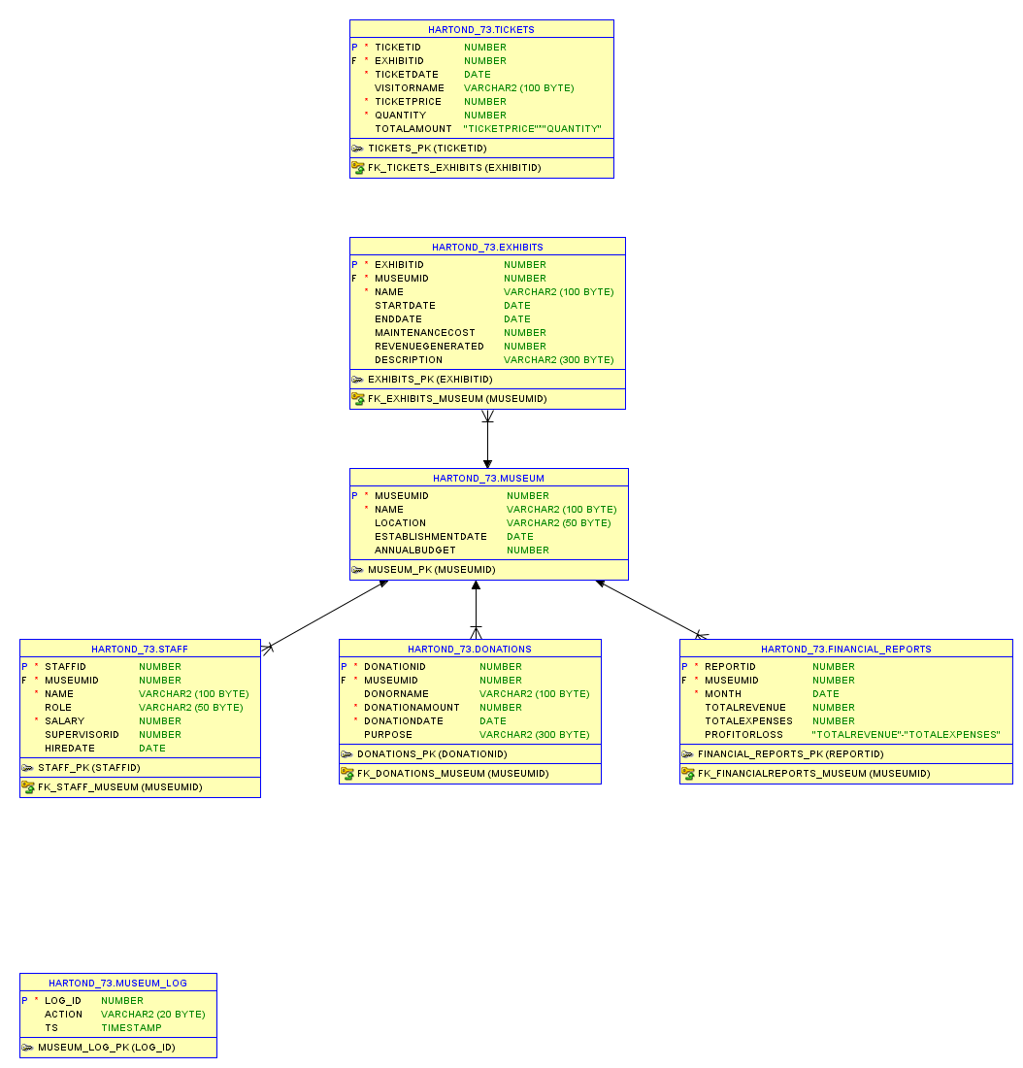
Modified database schema, added Museum_Log table

Storing business information in a database

Deleting tables created from previous runs of the script, creating table structures, and storing useful information respecting the constraints

DECLARE

v_count NUMBER;

BEGIN

-- If any table from the presented schema exists I will delete it

SELECT COUNT(*) INTO v_count FROM user_tables WHERE table_name= 'DONATIONS';

IF v_count >0 THEN

EXECUTE IMMEDIATE 'DROP TABLE Donations CASCADE CONSTRAINTS';

END IF;

SELECT COUNT(*) INTO v_count FROM user_tables WHERE table_name ='STAFF';

IF v_count> 0 THEN

EXECUTE IMMEDIATE 'DROP TABLE Staff CASCADE CONSTRAINTS';

END IF;

SELECT COUNT(*) INTO v_count FROM user_tables WHERE table_name ='FINANCIAL_REPORTS';

IF v_count >0 THEN

EXECUTE IMMEDIATE 'DROP TABLE Financial_Reports CASCADE CONSTRAINTS';

END IF;

SELECT COUNT(*) INTO v_count FROM user_tables WHERE table_name= 'EXHIBITS';

IF v_count> 0 THEN

EXECUTE IMMEDIATE 'DROP TABLE Exhibits CASCADE CONSTRAINTS';

END IF;

SELECT COUNT(*) INTO v_count FROM user_tables WHERE table_name= 'MUSEUM';

IF v_count>0 THEN

EXECUTE IMMEDIATE 'DROP TABLE Museum CASCADE CONSTRAINTS';

END IF;

SELECT COUNT(*) INTO v_count FROM user_tables WHERE table_name='TICKETS';

IF v_count>0 THEN

EXECUTE IMMEDIATE 'DROP TABLE Tickets CASCADE CONSTRAINTS';

END IF;

-- q'' allows multiple row strings

EXECUTE IMMEDIATE q'[CREATE TABLE Museum(

MuseumID NUMBER PRIMARY KEY,

Name VARCHAR2(100) NOT NULL,

Location VARCHAR2(50),

EstablishmentDate DATE,

AnnualBudget NUMBER)]';

EXECUTE IMMEDIATE q'[CREATE TABLE Exhibits(

ExhibitID NUMBER PRIMARY KEY,

MuseumID NUMBER NOT NULL,

Name VARCHAR2(100) NOT NULL,

StartDate DATE,

EndDate DATE,

MaintenanceCost NUMBER,

RevenueGenerated NUMBER,

Description VARCHAR2(300),

CONSTRAINT FK_Exhibits_Museum FOREIGN KEY (MuseumID) REFERENCES Museum(MuseumID))]';

EXECUTE IMMEDIATE q'[CREATE TABLE Tickets(

TicketID NUMBER PRIMARY KEY,

ExhibitID NUMBER NOT NULL,

TicketDate DATE NOT NULL,

VisitorName VARCHAR2(100),

TicketPrice NUMBER NOT NULL,

Quantity NUMBER NOT NULL,

TotalAmount AS (TicketPrice*Quantity) VIRTUAL,

CONSTRAINT FK_Tickets_Exhibits FOREIGN KEY (ExhibitID) REFERENCES Exhibits(ExhibitID))]';

EXECUTE IMMEDIATE q'[CREATE TABLE Donations(

DonationID NUMBER PRIMARY KEY,

MuseumID NUMBER NOT NULL,

DonorName VARCHAR2(100),

DonationAmount NUMBER NOT NULL,

DonationDate DATE NOT NULL,

Purpose VARCHAR2(300),

CONSTRAINT FK_Donations_Museum FOREIGN KEY (MuseumID) REFERENCES Museum(MuseumID))]';

EXECUTE IMMEDIATE q'[CREATE TABLE Staff(

StaffID NUMBER PRIMARY KEY,

MuseumID NUMBER NOT NULL,

Name VARCHAR2(100) NOT NULL,

Role VARCHAR2(50),

Salary NUMBER NOT NULL,

SupervisorID NUMBER,

CONSTRAINT FK_Staff_Museum FOREIGN KEY (MuseumID) REFERENCES Museum(MuseumID))]';

EXECUTE IMMEDIATE 'ALTER TABLE Staff ADD HireDate DATE';

EXECUTE IMMEDIATE q'[CREATE TABLE Financial_Reports (

ReportID NUMBER PRIMARY KEY,

MuseumID NUMBER NOT NULL,

Month DATE NOT NULL,

TotalRevenue NUMBER,

TotalExpenses NUMBER,

ProfitOrLoss AS (TotalRevenue-TotalExpenses) VIRTUAL,

CONSTRAINT FK_FinancialReports_Museum FOREIGN KEY (MuseumID) REFERENCES Museum(MuseumID))]';

EXECUTE IMMEDIATE q'[INSERT INTO Museum(MuseumID,Name,Location,AnnualBudget)

VALUES(1,'National History Museum','New York',2311)]';

EXECUTE IMMEDIATE q'[INSERT INTO Museum (MuseumID,Name,Location,EstablishmentDate,AnnualBudget)

VALUES (2,'Grigore Antipa National Museum of Natural History',

'Bucharest',TO_DATE('1999-11-23','YYYY-MM-DD'),500000)]';

EXECUTE IMMEDIATE q'[ INSERT INTO Exhibits (ExhibitID,MuseumID,Name,MaintenanceCost,RevenueGenerated)

VALUES (1,1,'Dinosaur Fossils',5000, 20000)]';

EXECUTE IMMEDIATE q'[INSERT INTO Staff(StaffID,MuseumID, Name,Role, Salary,HireDate, SupervisorID)

VALUES (2, 2,'Victor Dumitrescu','Manager',3500,

TO_DATE('2018-10-20','YYYY-MM-DD'), NULL)]';

EXECUTE IMMEDIATE q'[ INSERT INTO Staff(StaffID,MuseumID, Name,Role, Salary,HireDate,SupervisorID)

VALUES (1, 2,'Daniel Harton','Receptionist',

3500,TO_DATE('2018-10-20','YYYY-MM-DD'), 2)]';

EXECUTE IMMEDIATE q'[INSERT INTO Donations (DonationID,MuseumID, DonorName,DonationAmount, DonationDate)

VALUES (1,1, 'Michael Johnson',1000, TO_DATE('2022-11-03','YYYY-MM-DD'))]';

EXECUTE IMMEDIATE q'[ INSERT INTO Donations (DonationID,MuseumID,DonorName,DonationAmount,DonationDate,Purpose)

VALUES (2,1, 'Daniel Harton',350, TO_DATE('2013-08-02','YYYY-MM-DD'),

'Maintaining existing items in good shape')]';

EXECUTE IMMEDIATE q'[INSERT INTO Financial_Reports(ReportID,MuseumID, Month,TotalRevenue,TotalExpenses)

VALUES (1,1, TO_DATE('2023-02','YYYY-MM'),2000, 100)]';

EXECUTE IMMEDIATE q'[ UPDATE Exhibits SET RevenueGenerated = 51000

WHERE ExhibitID != 2]';

EXECUTE IMMEDIATE q'[

DELETE FROM Donations

WHERE DonationID = 1

]';

EXECUTE IMMEDIATE q'[MERGE INTO Financial_Reports FR

USING (SELECT MuseumID,SUM(RevenueGenerated) AS TotalRevenue

FROM Exhibits GROUP BY MuseumID) ER

ON (FR.MuseumID=ER.MuseumID) WHEN MATCHED THEN

UPDATE SET FR.TotalRevenue=ER.TotalRevenue]';

COMMIT;

EXCEPTION WHEN OTHERS THEN ROLLBACK;

END;

/

Problems
1. If an exhibit’s maintenance cost is below 1,000, add 200; if it is between 1,000 and 5,000, add 100; otherwise leave it unchanged.
set serveroutput on
DECLARE
v_cost EXHIBITS.maintenancecost%TYPE;
v_add NUMBER;
BEGIN
SELECT maintenancecost INTO v_cost FROM exhibits WHERE exhibitid = 1;
v_add :=CASE
WHEN v_cost < 1000 THEN 200
WHEN v_cost BETWEEN 1000 AND 5000 THEN 100
ELSE 0
END;
v_cost := v_cost + v_add;
DBMS_OUTPUT.PUT_LINE('Adjusted maintenance cost for Exhibit 1: ' || v_cost);
END;
/
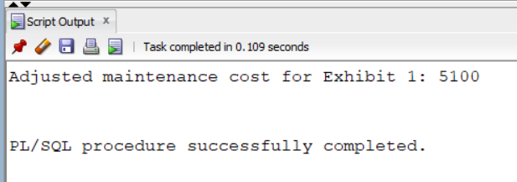
2. Define a function that displays the full name of a receptionist based on the id given as parameter
SET SERVEROUTPUT ON;
CREATE OR REPLACE FUNCTION get_receptionist_name (p_staffid IN NUMBER) RETURN VARCHAR2 IS
v_name Staff.Name%TYPE;
v_role Staff.Role%TYPE;
BEGIN
SELECT Name, Role INTO v_name, v_role FROM Staff
WHERE StaffID = p_staffid;
IF UPPER(v_role) = 'RECEPTIONIST' THEN
RETURN v_name;
ELSE
RETURN NULL;
END IF;
EXCEPTION
WHEN NO_DATA_FOUND THEN
RETURN NULL;
END get_receptionist_name;
/
DECLARE
v_recep_name VARCHAR2(100);
v_input_id NUMBER:=1;
BEGIN
v_recep_name := get_receptionist_name(v_input_id);
IF v_recep_name IS NOT NULL THEN
DBMS_OUTPUT.PUT_LINE('Receptionist (StaffID='|| v_input_id || '): '|| v_recep_name);
ELSE
DBMS_OUTPUT.PUT_LINE('No receptionist found for StaffID='|| v_input_id|| ' (either not a receptionist or does not exist).');
END IF;
END;
/
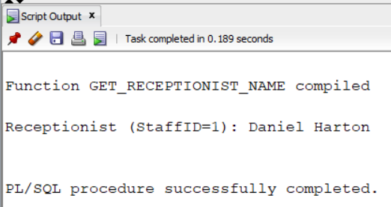
3. Loop through all donations for MUSEUMID = 1 and classify each as “Large”
SET serVerOutput on
DECLARE
CURSOR c IS
SELECT donationid, donationamount
FROM donations WHERE museumid = 1 ORDER BY donationid;
v_rec c%ROWTYPE;
v_category VARCHAR2(20);
BEGIN
OPEN c;
LOOP
FETCH c INTO v_rec;
EXIT WHEN c%NOTFOUND;
IF v_rec.donationamount>=10000 THEN
v_category:= 'Large';
ELSIF v_rec.donationamount BETWEEN 1031 AND 9963 THEN
v_category :='Medium';
ELSE
v_category:='Small';
END IF;
DBMS_OUTPUT.PUT_LINE('Donation '|| v_rec.donationid||' amount '|| v_rec.donationamount||' classified as '||v_category);
END LOOP;
CLOSE c;
EXCEPTION
WHEN OTHERS THEN
DBMS_OUTPUT.PUT_LINE('Error: '|| SQLERRM);
END;
/
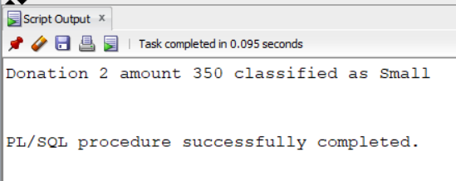
4. A cursor that fetches each exhibit for museum 1, prints its ID and name, and then updates its description using WHERE CURRENT OF before committing.
SET SERVEROUTPUT ON;
DECLARE
CURSOR c(p_mid NUMBER) IS SELECT exhibitid, name
FROM exhibits WHERE museumid = p_mid
FOR UPDATE;
v_rec c%ROWTYPE;
BEGIN
OPEN c(1);
LOOP
FETCH c INTO v_rec;
EXIT WHEN c%NOTFOUND;
DBMS_OUTPUT.PUT_LINE('ExhibitID=' || v_rec.exhibitid ||
', Name=' || v_rec.name);
UPDATE exhibits
SET description =NVL(description,'')|| ' (Reviewed)'
WHERE CURRENT OF c;
END LOOP;
CLOSE c;
COMMIT;
END;
/
5. Display the names of all exhibits whose ExhibitID is odd
SET SERVEROUTPUT ON
DECLARE
v_name VARCHAR2(100);
i PLS_INTEGER:=1;
BEGIN
DBMS_OUTPUT.PUT_LINE('Exhibits with odd IDs:');
WHILE i<=20 LOOP
BEGIN
SELECT name INTO v_name FROM exhibits
WHERE exhibitid = i;
DBMS_OUTPUT.PUT_LINE(i||' --> '||v_name);
EXCEPTION
WHEN NO_DATA_FOUND THEN
NULL;
END;
i:= i+2;
END LOOP;
END;
/
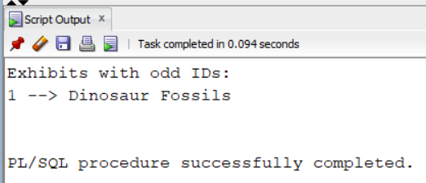
6. Fetch every staff member’s email into an index-by table, then print them.
SET SERVEROUTPUT ON
DECLARE
TYPE t_staff_email_tab IS TABLE OF STAFF%ROWTYPE INDEX BY PLS_INTEGER;
v_tab t_staff_email_tab;
v_index PLS_INTEGER:=0;
BEGIN
FOR r IN (SELECT staffid,name FROM staff ORDER BY staffid) LOOP
v_index:=v_index + 1;
v_tab(v_index).staffid:= r.staffid;
v_tab(v_index).name :=r.name;
END LOOP;

v_index :=v_tab.FIRST;
WHILE v_index IS NOT NULL LOOP
DBMS_OUTPUT.PUT_LINE( 'StaffID=' || v_tab(v_index).staffid ||
', Name=' || v_tab(v_index).name);
v_index:= v_tab.NEXT(v_index);
END LOOP;
END;
/
7. Load all donations for MUSEUMID = 1 into a nested-table variable, then loop and print each.
SET SERVEROUTPUT ON
DECLARE
TYPE t_don IS TABLE OF DONATIONS%ROWTYPE;
v_dons t_don;
idx PLS_INTEGER;
BEGIN
SELECT * BULK COLLECT INTO v_dons
FROM donations WHERE museumid=1
ORDER BY donationid;
idx:=v_dons.FIRST;
WHILE idx IS NOT NULL LOOP
DBMS_OUTPUT.PUT_LINE('DonationID='||v_dons(idx).donationid||
', Amount='|| v_dons(idx).donationamount||
', Date=' ||TO_CHAR(v_dons(idx).donationdate,'YYYY-MM-DD'));
idx :=v_dons.NEXT(idx);
END LOOP;
EXCEPTION
WHEN OTHERS THEN
DBMS_OUTPUT.PUT_LINE('Error: '||SQLERRM);
END;
/
8. Compute each museum’s total revenue, fetch the top 3 into a VARRAY, and print.
DECLARE
TYPE t_mv_rec IS RECORD(
museumid MUSEUM.museumid%TYPE,
total_revenue NUMBER
);
TYPE t_top3_mv IS VARRAY(3) OF t_mv_rec;
v_top t_top3_mv := t_top3_mv();
CURSOR c_rev IS
SELECT m.museumid, NVL(SUM(e.revenuegenerated),0) AS totrev
FROM museum m LEFT JOIN exhibits e ON m.museumid = e.museumid
GROUP BY m.museumid
ORDER BY totrev DESC
FETCH FIRST 3 ROWS ONLY;
v_rec t_mv_rec;
idx PLS_INTEGER := 0;
BEGIN
OPEN c_rev;
LOOP
FETCH c_rev INTO v_rec;
EXIT WHEN c_rev%NOTFOUND OR idx = 3;
idx := idx + 1;
v_top.EXTEND;
v_top(idx) := v_rec;
END LOOP;
CLOSE c_rev;

FOR i IN 1..v_top.COUNT LOOP
DBMS_OUTPUT.PUT_LINE(
'Rank ' || i || ': MuseumID=' || v_top(i).museumid ||
', Revenue=' || v_top(i).total_revenue
);
END LOOP;
EXCEPTION
WHEN OTHERS THEN
DBMS_OUTPUT.PUT_LINE('Error: ' || SQLERRM);
END;
/
9. Attempt to create table Museum_Log that logs information about currently and previously existing museums. If the table already exists, catch the exception, drop and re-create.
DECLARE
e_exists EXCEPTION;
PRAGMA EXCEPTION_INIT(e_exists,-955);
BEGIN
EXECUTE IMMEDIATE 'CREATE TABLE Museum_Log(log_id NUMBER PRIMARY KEY,action VARCHAR2(20),ts TIMESTAMP)';
EXCEPTION WHEN e_exists THEN
EXECUTE IMMEDIATE 'DROP TABLE Museum_Log';
EXECUTE IMMEDIATE 'CREATE TABLE Museum_Log(log_id NUMBER PRIMARY KEY,action VARCHAR2(20),ts TIMESTAMP)';
END;
/
10. Package MUSEUM_PKG contains three functions and three procedures:
- Public functions:
FUNC_EXHIBIT_PROFIT(p_eid) that returns RevenueGenerated – MaintenanceCost or 0.
FUNC_TOTAL_DONATIONS(p_mid,p_month) that returns sum of donation amounts for given museum+month.
FUNC_NEXT_STAFFID that returns next value from sequence STAFF_SEQ.
- Public procedures:
PROC_ADD_EXHIBIT() inserts new exhibit with basic validation.
PROC_RECORD_TICKET() inserts ticket if date in range and updates exhibit revenue.
PROC_GEN_MONTHLY_REPORT(p_month) upserts a row into FINANCIAL_REPORTS.
- Private subprogram:
PRIV_LOG(p_op,p_tbl) logs into Museum_Log.
SET SERVEROUTPUT ON;
CREATE OR REPLACE PACKAGE museum_pkg IS
FUNCTION func_exhibit_profit(p_eid EXHIBITS.exhibitid%TYPE) RETURN NUMBER;
FUNCTION func_total_donations(p_mid IN DONATIONS.museumid%TYPE,p_month DATE) RETURN NUMBER;
FUNCTION func_next_staffid RETURN NUMBER;
PROCEDURE proc_add_exhibit(p_eid EXHIBITS.exhibitid%TYPE,
p_mid EXHIBITS.museumid%TYPE,
p_name EXHIBITS.name%TYPE,
p_start EXHIBITS.startdate%TYPE,
p_end EXHIBITS.enddate%TYPE,
p_cost EXHIBITS.maintenancecost%TYPE,
p_desc EXHIBITS.description%TYPE);
PROCEDURE proc_record_ticket(p_tid TICKETS.ticketid%TYPE,
p_eid TICKETS.exhibitid%TYPE,
p_date TICKETS.ticketdate%TYPE,
p_price TICKETS.ticketprice%TYPE,
p_qty TICKETS.quantity%TYPE);
PROCEDURE proc_gen_monthly_report(p_month DATE);
END museum_pkg;
/

CREATE OR REPLACE PACKAGE BODY museum_pkg IS
PROCEDURE priv_log(p_op IN VARCHAR2,p_tbl VARCHAR2)
IS
v_next NUMBER;
BEGIN
SELECT NVL(MAX(log_id),0)+1 INTO v_next FROM Museum_Log;
INSERT INTO Museum_Log(log_id,action,ts) VALUES(v_next,p_op||' ON '||p_tbl,SYSTIMESTAMP);
COMMIT;
EXCEPTION WHEN OTHERS THEN NULL;
END priv_log;
FUNCTION func_exhibit_profit(p_eid IN EXHIBITS.exhibitid%TYPE) RETURN NUMBER
IS
v_cost EXHIBITS.maintenancecost%TYPE;
v_revenue EXHIBITS.revenuegenerated%TYPE;
BEGIN
SELECT maintenancecost,revenuegenerated INTO v_cost,v_revenue
FROM exhibits WHERE exhibitid=p_eid;
RETURN v_revenue-v_cost;
EXCEPTION
WHEN NO_DATA_FOUND THEN
RETURN 0;
WHEN OTHERS THEN
RAISE_APPLICATION_ERROR(-20001,'Error in func_exhibit_profit:'||SQLERRM);
END func_exhibit_profit;
FUNCTION func_total_donations(p_mid DONATIONS.museumid%TYPE,
p_month DATE) RETURN NUMBER
IS
v_sum NUMBER;
BEGIN
SELECT NVL(SUM(donationamount),0) INTO v_sum
FROM donations WHERE museumid=p_mid
AND TRUNC(donationdate,'MM')=TRUNC(p_month,'MM');
RETURN v_sum;
EXCEPTION
WHEN OTHERS THEN
RAISE_APPLICATION_ERROR(-20002,'Error in func_total_donations:'||SQLERRM);
END func_total_donations;
FUNCTION func_next_staffid RETURN NUMBER
IS
v_next NUMBER;
BEGIN
SELECT NVL(MAX(staffid),0)+1 INTO v_next FROM staff;
RETURN v_next;
EXCEPTION
WHEN OTHERS THEN
RAISE_APPLICATION_ERROR(-20003,'Error in func_next_staffid:'||SQLERRM);
END func_next_staffid;
PROCEDURE proc_add_exhibit(p_eid EXHIBITS.exhibitid%TYPE,
p_mid EXHIBITS.museumid%TYPE,
p_name IN EXHIBITS.name%TYPE,
p_start EXHIBITS.startdate%TYPE,
p_end EXHIBITS.enddate%TYPE,
p_cost EXHIBITS.maintenancecost%TYPE,
p_desc EXHIBITS.description%TYPE )
IS
e_no_museum EXCEPTION;
e_bad_dates EXCEPTION;
v_cnt NUMBER;
BEGIN
SELECT COUNT(*) INTO v_cnt FROM museum WHERE museumid=p_mid;
IF v_cnt=0 THEN
RAISE e_no_museum;
END IF;
IF p_start>p_end THEN
RAISE e_bad_dates;
END IF;
INSERT INTO exhibits(exhibitid,museumid,name,startdate,enddate,maintenancecost,revenuegenerated,description)
VALUES( p_eid,p_mid,p_name,p_start,p_end,p_cost,0,p_desc);
COMMIT;
priv_log('INSERT','EXHIBITS');
EXCEPTION
WHEN e_no_museum THEN
RAISE_APPLICATION_ERROR(-20011,'No such museum:'||p_mid);
WHEN e_bad_dates THEN
RAISE_APPLICATION_ERROR(-20012,'StartDate>EndDate');
WHEN DUP_VAL_ON_INDEX THEN
RAISE_APPLICATION_ERROR(-20014,'ExhibitID already exists:'||p_eid);
WHEN OTHERS THEN
RAISE_APPLICATION_ERROR(-20013,'Error in proc_add_exhibit:'||SQLERRM);
END proc_add_exhibit;
PROCEDURE proc_record_ticket( p_tid TICKETS.ticketid%TYPE,
p_eid TICKETS.exhibitid%TYPE,
p_date TICKETS.ticketdate%TYPE,
p_price TICKETS.ticketprice%TYPE,
p_qty TICKETS.quantity%TYPE )
IS
e_bad_date EXCEPTION;
v_start EXHIBITS.startdate%TYPE;
v_end EXHIBITS.enddate%TYPE;
v_rows NUMBER;
BEGIN
SELECT startdate,enddate INTO v_start,v_end
FROM exhibits WHERE exhibitid=p_eid;
IF p_date<v_start OR p_date>v_end THEN
RAISE e_bad_date;
END IF;
INSERT INTO tickets(ticketid,exhibitid,ticketdate,ticketprice,quantity)
VALUES(p_tid,p_eid,p_date,p_price,p_qty);
v_rows:=SQL%ROWCOUNT;
UPDATE exhibits SET revenuegenerated=NVL(revenuegenerated,0)+(p_price*p_qty)
WHERE exhibitid=p_eid;
COMMIT;
priv_log('INSERT TICKET','TICKETS');
EXCEPTION
WHEN NO_DATA_FOUND THEN
RAISE_APPLICATION_ERROR(-20021,'No such exhibit:'||p_eid);
WHEN e_bad_date THEN
RAISE_APPLICATION_ERROR(-20022,'Ticket date out of range');
WHEN DUP_VAL_ON_INDEX THEN
RAISE_APPLICATION_ERROR(-20024,'TicketID already exists:'||p_tid);
WHEN OTHERS THEN
RAISE_APPLICATION_ERROR(-20023,'Error in proc_record_ticket:'||SQLERRM);
END proc_record_ticket;

PROCEDURE proc_gen_monthly_report(p_month DATE)
IS
TYPE t_mid_tab IS TABLE OF MUSEUM.museumid%TYPE INDEX BY PLS_INTEGER;
v_mids t_mid_tab;
v_count PLS_INTEGER:=0;
v_rev NUMBER;
v_exp NUMBER;
v_next NUMBER;
BEGIN
FOR m IN (SELECT museumid FROM museum ORDER BY museumid) LOOP
v_count:=v_count+1;
v_mids(v_count):=m.museumid;
END LOOP;
FOR i IN 1..v_count LOOP
SELECT NVL(SUM(e.revenuegenerated),0) INTO v_rev
FROM exhibits e WHERE e.museumid=v_mids(i)
AND TRUNC(e.startdate,'MM')=TRUNC(p_month,'MM');
SELECT NVL(SUM(s.salary),0) INTO v_exp
FROM staff s WHERE s.museumid=v_mids(i)
AND TRUNC(s.hiredate,'MM')<=TRUNC(p_month,'MM');
BEGIN
UPDATE financial_reports
SET totalrevenue=v_rev,totalexpenses=v_exp
WHERE museumid=v_mids(i)
AND TRUNC(month,'MM')=TRUNC(p_month,'MM');
IF SQL%ROWCOUNT=0 THEN
SELECT NVL(MAX(reportid),0)+1 INTO v_next FROM financial_reports;
INSERT INTO financial_reports(reportid,museumid,month,totalrevenue,totalexpenses)
VALUES( v_next,v_mids(i),p_month,v_rev,v_exp);
END IF;
EXCEPTION
WHEN DUP_VAL_ON_INDEX THEN NULL;
END;
END LOOP;
COMMIT;
priv_log('EXECUTE','PROC_GEN_MONTHLY_REPORT');
EXCEPTION
WHEN OTHERS THEN
RAISE_APPLICATION_ERROR(-20031,'Error in proc_gen_monthly_report:'||SQLERRM);
END proc_gen_monthly_report;
END museum_pkg;
/
BEGIN
museum_pkg.proc_add_exhibit(p_eid =>10,
p_mid=>1,
p_name=> 'Modern Art Display',
p_start=> TO_DATE('2023-11-01','YYYY-MM-DD'),
p_end=>TO_DATE('2024-02-28','YYYY-MM-DD'),
p_cost =>2500,
p_desc=>'A rotating display of modern art pieces.');
DBMS_OUTPUT.PUT_LINE('proc_add_exhibit succeeded');
EXCEPTION
WHEN OTHERS THEN
DBMS_OUTPUT.PUT_LINE(SQLERRM);
END;
/

BEGIN
museum_pkg.proc_record_ticket(p_tid =>100,
p_eid=> 10,
p_date=>TO_DATE('2023-11-05','YYYY-MM-DD'),
p_price =>20,
p_qty=>3);
DBMS_OUTPUT.PUT_LINE('proc_record_ticket succeeded');
EXCEPTION
WHEN OTHERS THEN
DBMS_OUTPUT.PUT_LINE(SQLERRM);
END;
/
BEGIN
museum_pkg.proc_gen_monthly_report(TO_DATE('2024-03','YYYY-MM'));
DBMS_OUTPUT.PUT_LINE('proc_gen_monthly_report succeeded');
EXCEPTION
WHEN OTHERS THEN
DBMS_OUTPUT.PUT_LINE(SQLERRM);
END;
/

11. Before any DELETE on Museum check the old row’s ANNUALBUDGET. If it exceeds 1 000 000, it raises an error to block the delete.
CREATE OR REPLACE TRIGGER trg_prevent_delete_museum
BEFORE DELETE ON museum FOR EACH ROW
DECLARE
e_forbidden EXCEPTION;
BEGIN
IF :OLD.annualbudget > 1000000 THEN
RAISE_APPLICATION_ERROR(-20041,'Cannot delete Museum '
|| :OLD.museumid || ': budget ' ||
:OLD.annualbudget || ' > 1000000' );
END IF;
END;
/
12. Validate ticket date at row-level. Ensure each TICKETS.TICKETDATE falls within its exhibit’s STARTDATE..ENDDATE
CREATE OR REPLACE TRIGGER trg_validate_ticketdate
BEFORE INSERT OR UPDATE ON tickets
FOR EACH ROW
DECLARE
v_start DATE;
v_end DATE;
BEGIN
SELECT startdate, enddate INTO v_start, v_end
FROM exhibits WHERE exhibitid= :NEW.exhibitid;
IF :NEW.ticketdate < v_start OR :NEW.ticketdate>v_end THEN
RAISE_APPLICATION_ERROR(-20051,'Ticket date out of range for ExhibitID='|| :NEW.exhibitid);
END IF;
EXCEPTION
WHEN NO_DATA_FOUND THEN
RAISE_APPLICATION_ERROR(-20052,'No Exhibit '||:NEW.exhibitid);
END;
/
13. After any INSERT or UPDATE on Donations compute the next log_id, determine whether it was an insert or update, and write a single row to Museum_Log with that action and the current timestamp.
CREATE OR REPLACE TRIGGER trg_audit_donations
AFTER INSERT OR UPDATE ON donations
DECLARE
v_next NUMBER;
v_action VARCHAR2(30);
BEGIN
SELECT NVL(MAX(log_id),0)+1 INTO v_next FROM Museum_Log;
IF INSERTING THEN
v_action:= 'INSERT ON DONATIONS';
ELSIF UPDATING THEN
v_action :='UPDATE ON DONATIONS';
END IF;
INSERT INTO Museum_Log(log_id,action,ts)
VALUES(v_next,v_action,SYSTIMESTAMP);
END;
/
14. Prevent staff supervisor cross-museum if a new STAFF.SUPERVISORID does not belong to the same museum, raise an error.
CREATE OR REPLACE TRIGGER trg_validate_staff_supervisor
BEFORE INSERT OR UPDATE ON staff
FOR EACH ROW
DECLARE
v_sup_mid NUMBER;
BEGIN
IF :NEW.supervisorid IS NOT NULL THEN
SELECT museumid INTO v_sup_mid FROM staff WHERE staffid = :NEW.supervisorid;
IF v_sup_mid != :NEW.museumid THEN
RAISE_APPLICATION_ERROR(-20061,
'Supervisor ' || :NEW.supervisorid ||
' in Museum ' || v_sup_mid ||
' cannot supervise Staff in Museum ' || :NEW.museumid);
END IF;
END IF;
EXCEPTION
WHEN NO_DATA_FOUND THEN
RAISE_APPLICATION_ERROR(-20062,'No such Supervisor '||:NEW.supervisorid);
END;
/
15. After any INSERT, UPDATE, or DELETE on the Museum table, insert a log row with an auto-incremented log_id, fixed action text, timestamp into Museum_Log
CREATE OR REPLACE TRIGGER trg_stmt_log_museum_changes
AFTER INSERT OR UPDATE OR DELETE ON museum
BEGIN
INSERT INTO Museum_Log(log_id,action,ts)
VALUES((SELECT NVL(MAX(log_id),0)+1 FROM Museum_Log),
'STATEMENT CHANGE ON MUSEUM', SYSTIMESTAMP);
END;
/

