Daniel Hernandez CSCI-611
Summer 2025 Bo Shen

Assignment 2; Part 2

This is a report on the CNN model developed to classify images using the CIFAR-10 dataset. This model was built using PyTorch and tuning included multiple stages
Comparing 2 optimizers: Adam and SGD
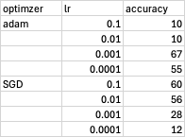
The best result from tuning the optimizer came from Adam optimizer with a learning rate of 0.001.

Kernel Tuning
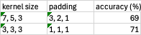
Initially, the kernel size decreased between layers. However, the best result came from adjusting all kernel sizes to 3x3 which increased the overall accuracy from 69% to 71%.

Layer Tuning

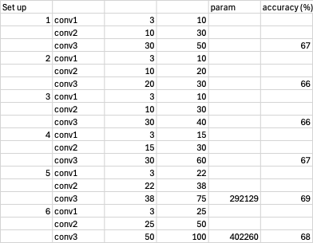
Testing 6 combinations of layer parameter inputs, the best result came from set up 5 with a 69% accuracy using 3 input parameters and 22 output parameters in the first layer, 22 and 38 in the second, and 38 and 75 in the third respectively. The number of parameters in this set up was 292,129. 2 fully connected linear layers were utilized, including 200 learned features in the first and 10 output classes in the second. This was a 2% increase from the previous accuracy.
Illustration
