Daniel Hernandez
CSCI-611
Summer 2025
Bo Shen

Assignment 2; Part 1

Sobel Operator Edge Detector
Using the Sobel operators defined in the assignment prompt, the images below reflect the changes to the image with highlighted vertical and horizontal edges
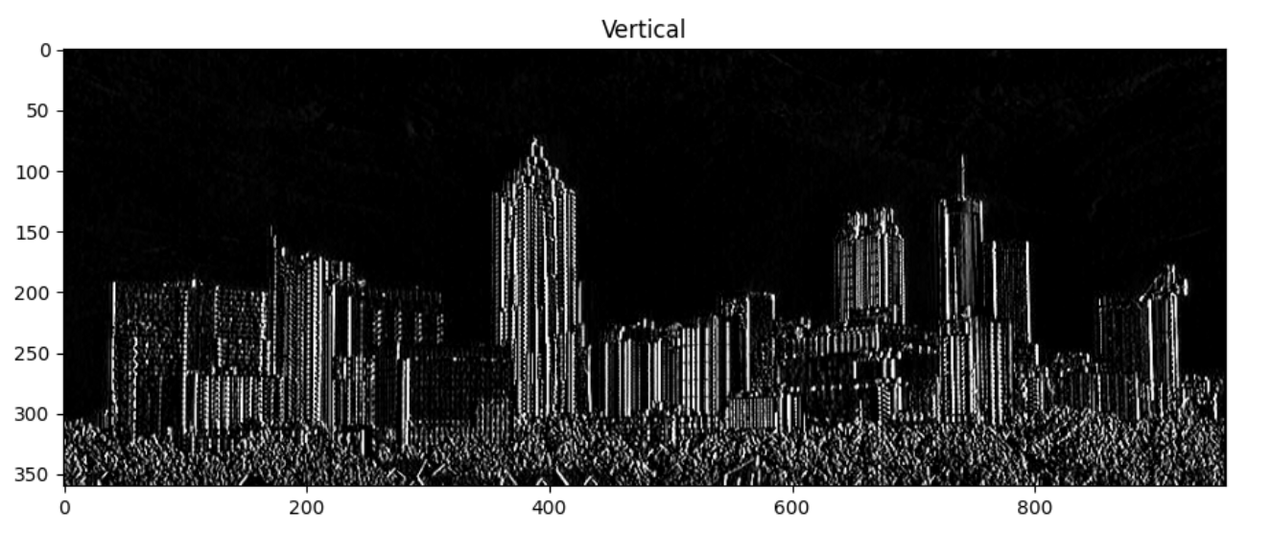
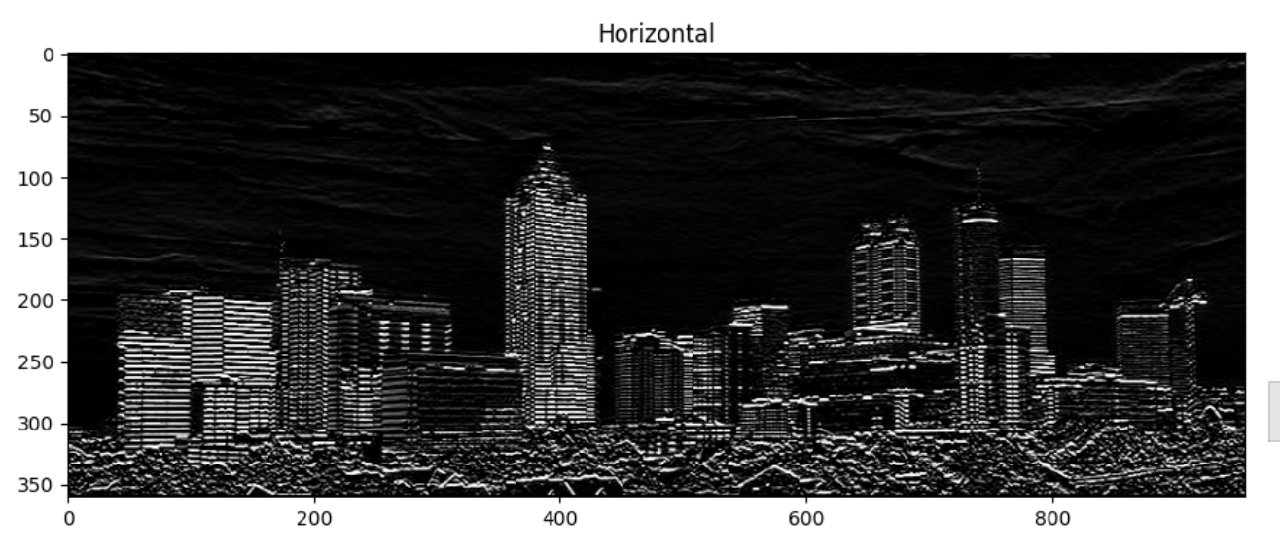
Corner Detection
Surprisingly, the effect of the following corner detection kernels, which were given in the lecture slides, did not produce visually significant changes to the image.
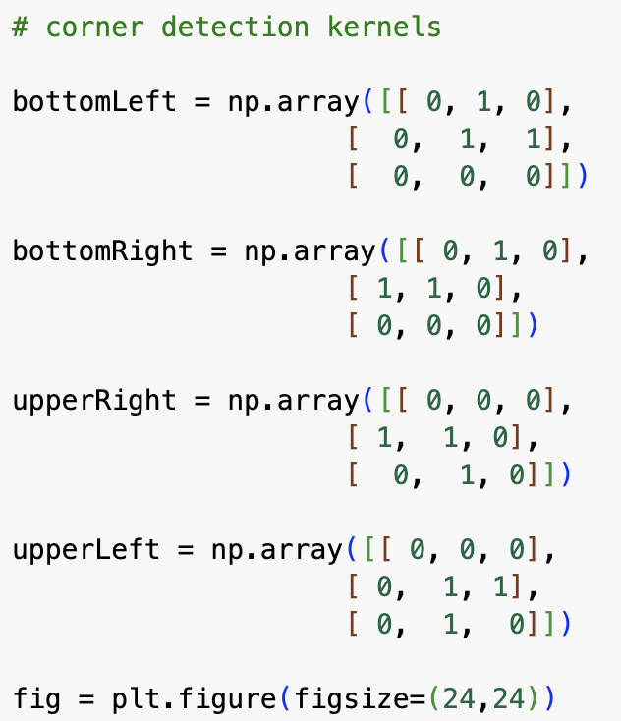
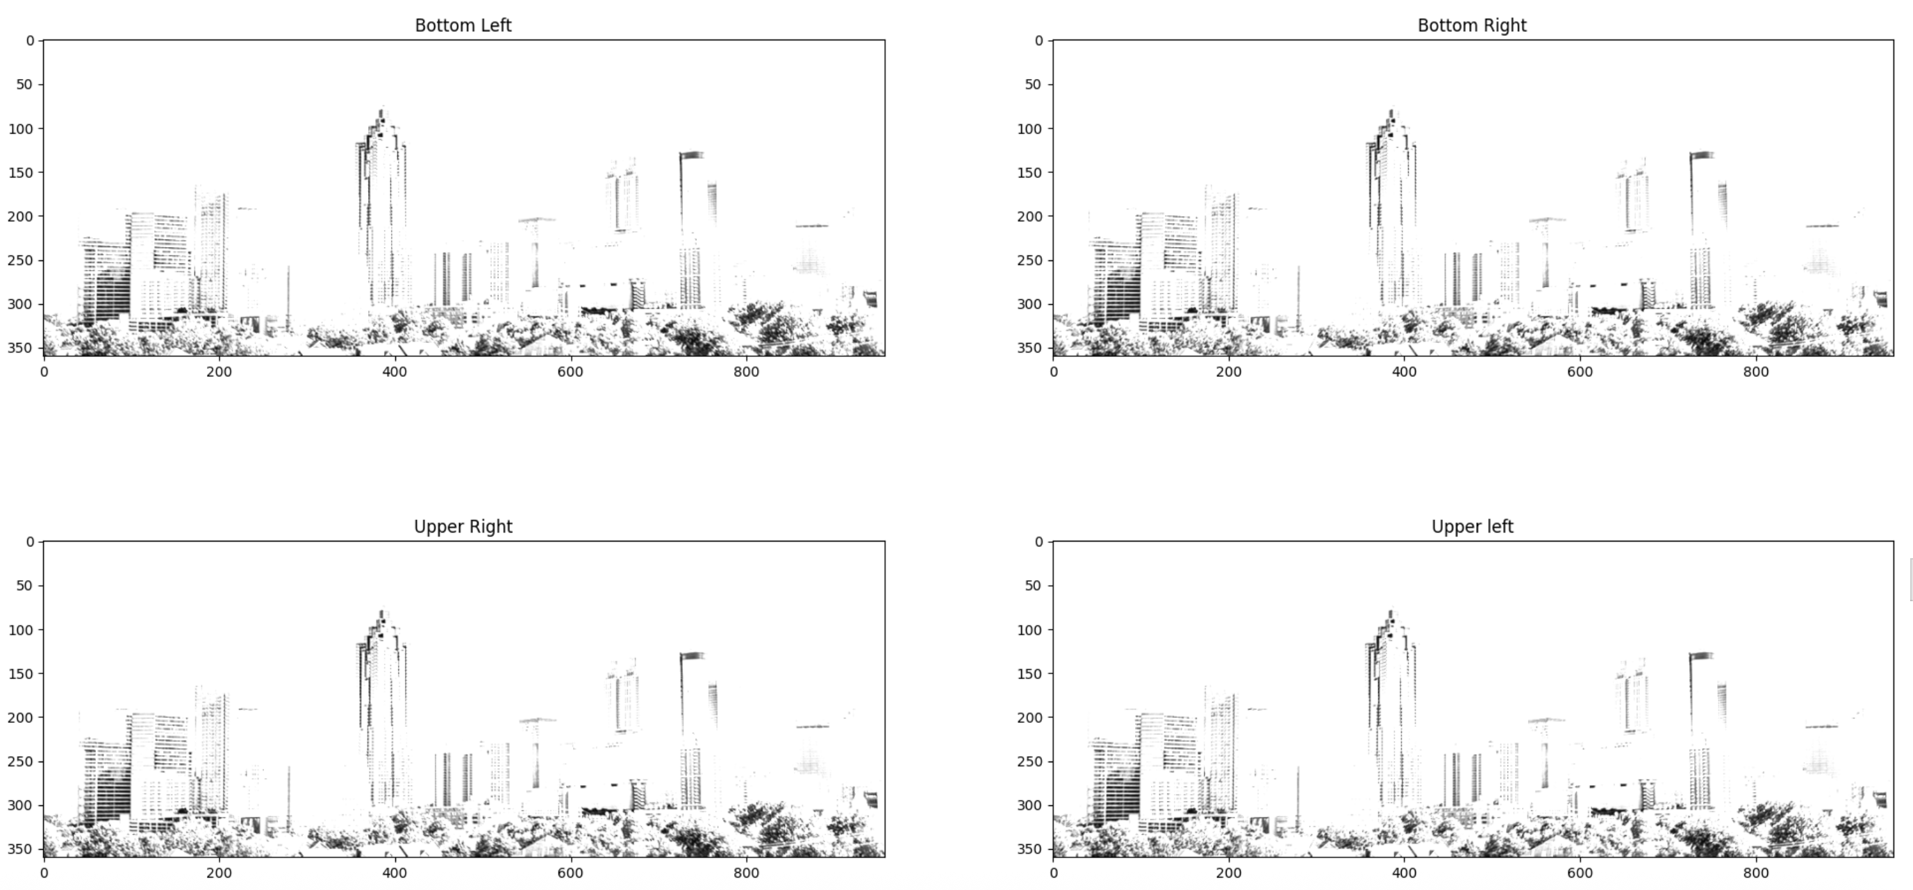
Scaling/Blurring
Here, I am dividing each neuron in the 2x2 kernel by the total amount of neurons in the kernel in order to average out each neuron in the image. This produces the blurring effect since the value of each pixel is changed to the average of the entire kernel. In the next line, we are producing the scaling effect by specifying that we only want every 50th column and every 50th row from the original image to appear in the scaled down version.
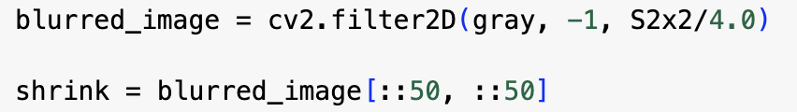
Challenge
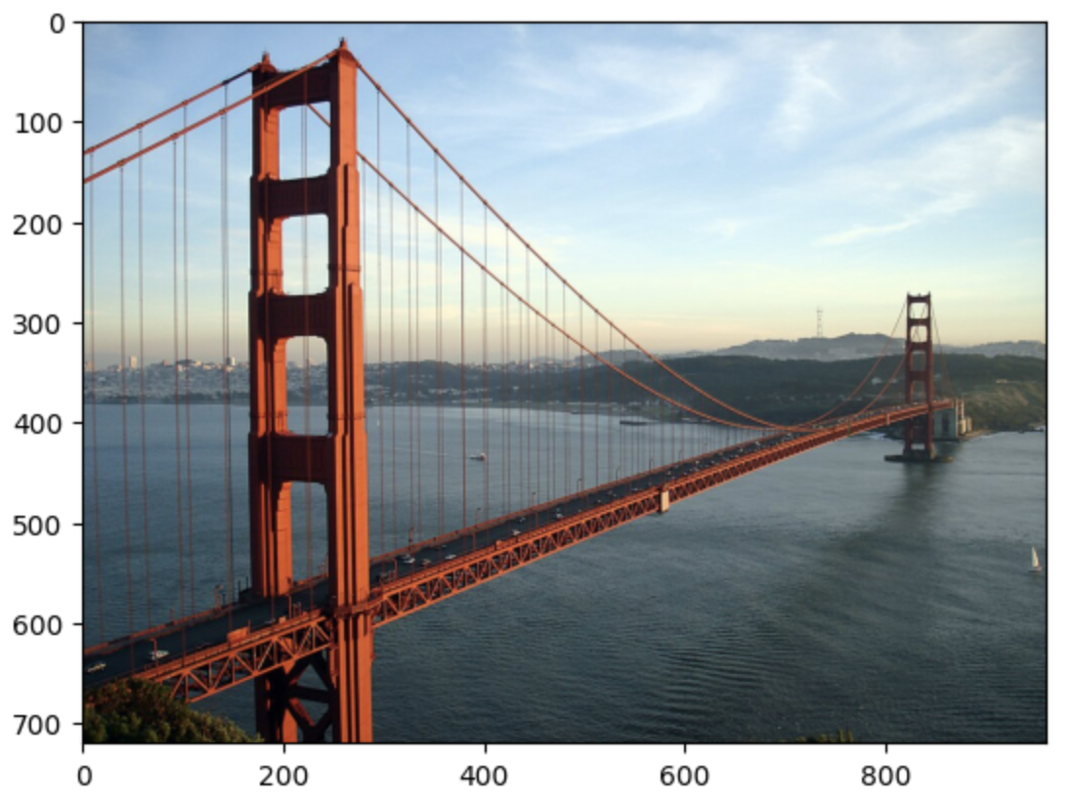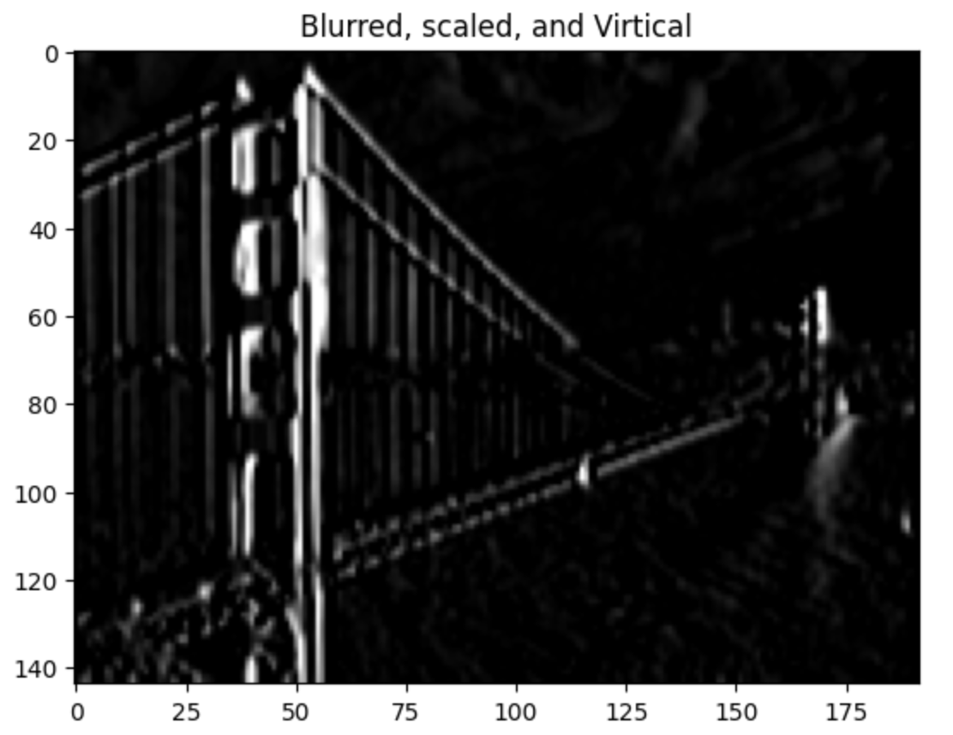
Here I demonstrate a blurred, scaled, and vertically filtered image. Using a 10x10 kernel to blur, choosing every 5 pixel to scale down, and applying the vertical Sobel operator edge detector (kx), I am able to transform my custom image.
