So multiple layers are used for style because style is much more than just position of different objects within the image. Its more nuanced. At certain levels, the style is very broad and can cover broad styles, but then at deeper layers, the style is much more refined where small little style qualities are pick up

When we compute the gram matrices we are getting rid of the space aspect of textures and patterns because before the gram matrices we still have spatial aspects of the layers that are being taken into consideration. With the gram matrices we want to measure the correlation between the style between different layers

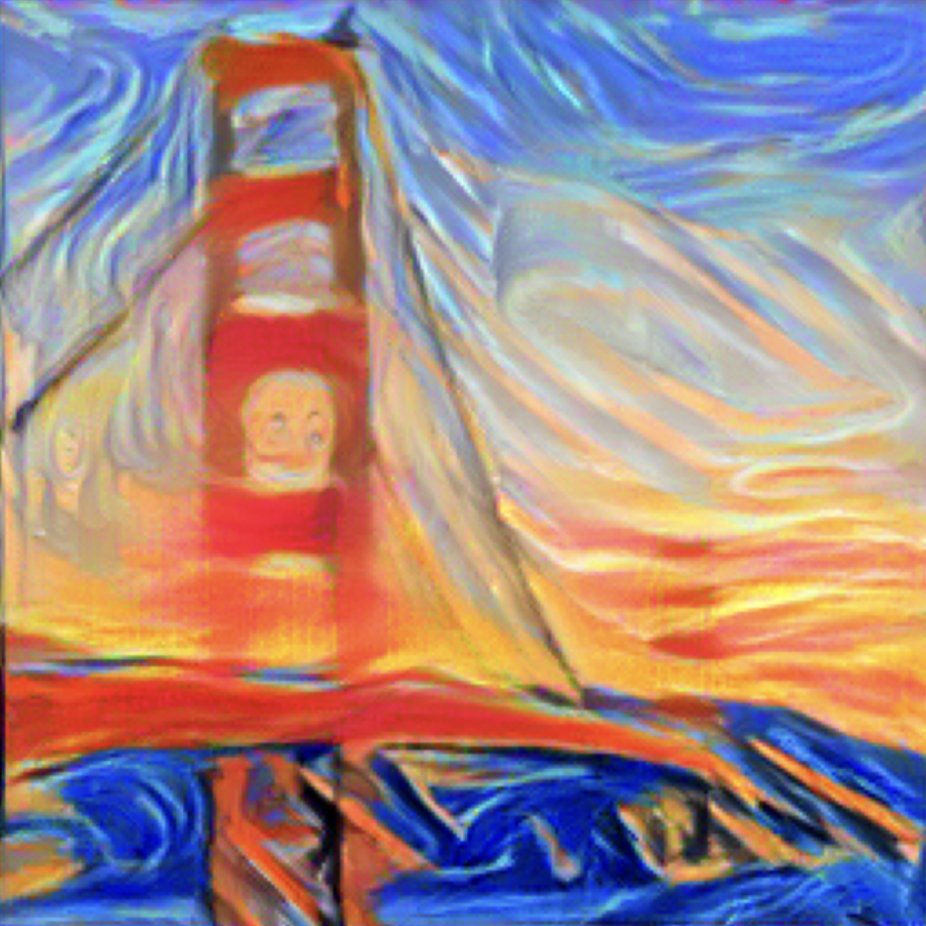

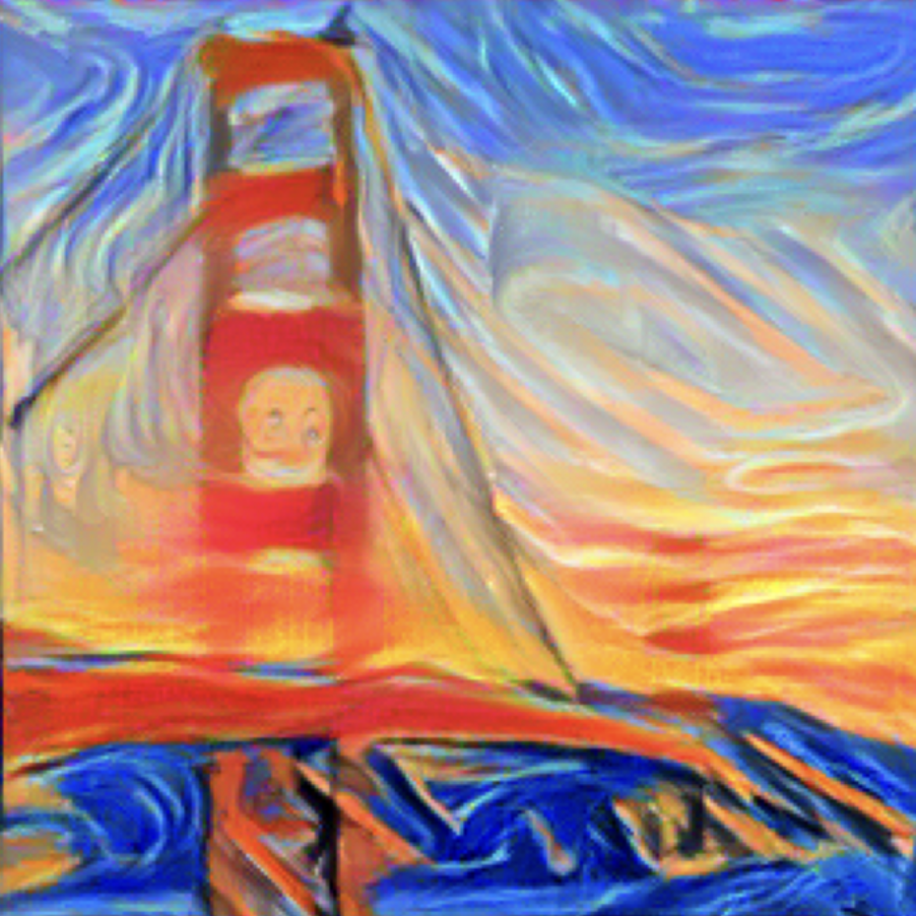

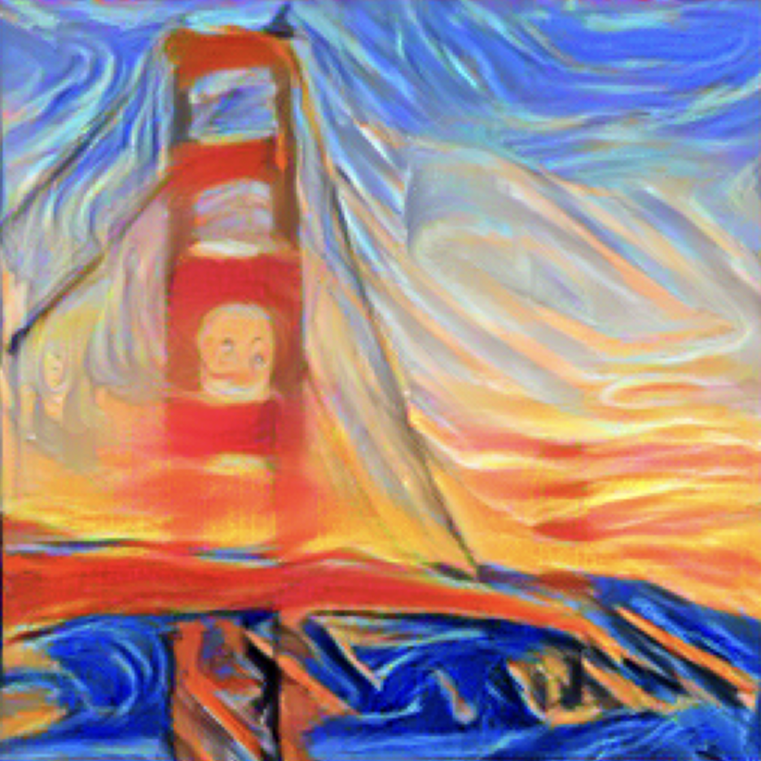

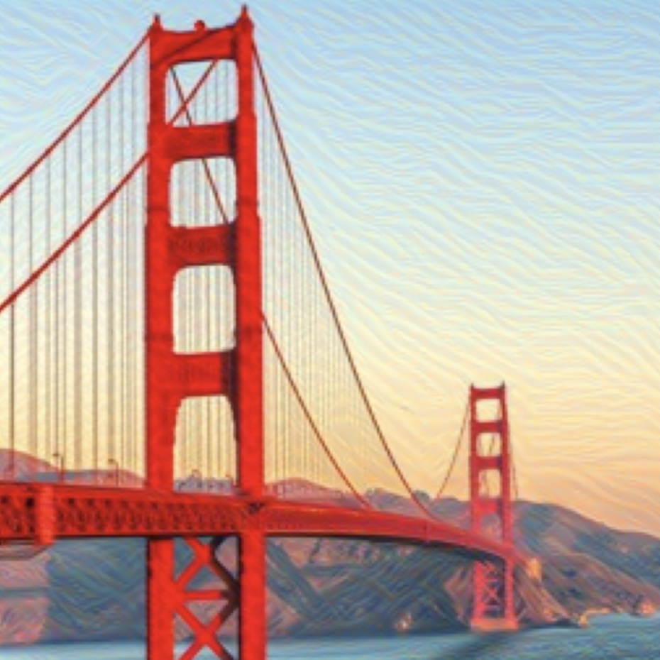

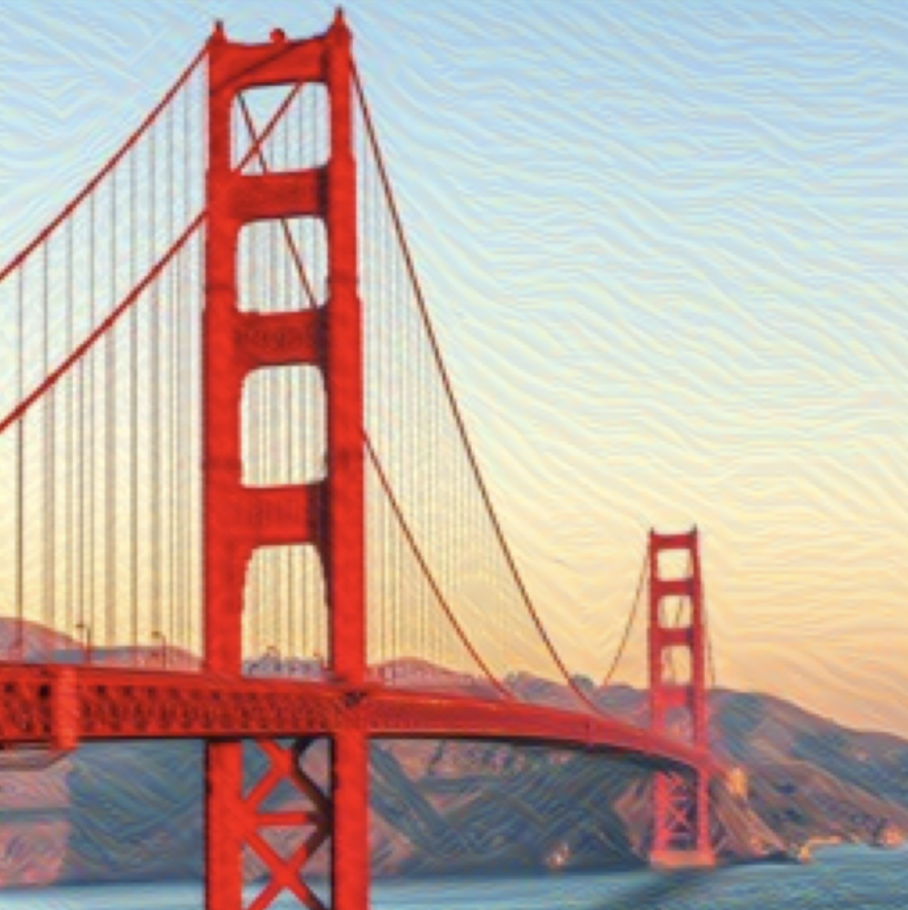

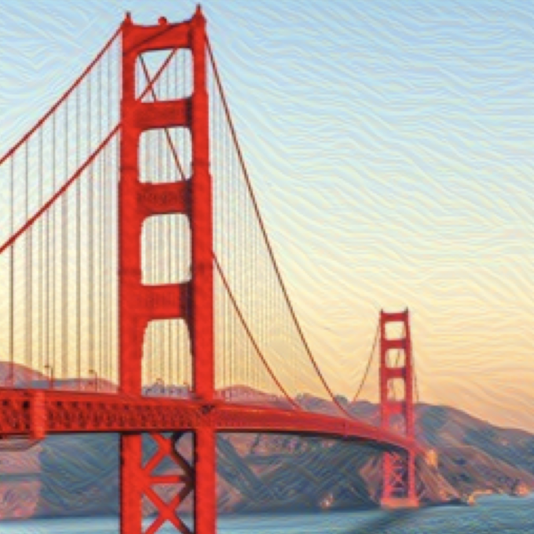

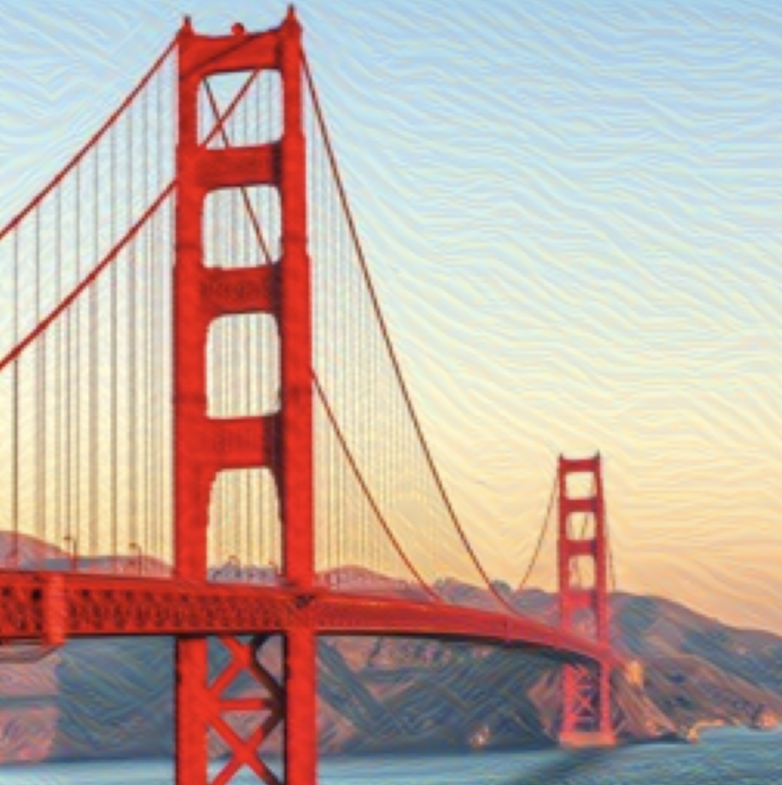

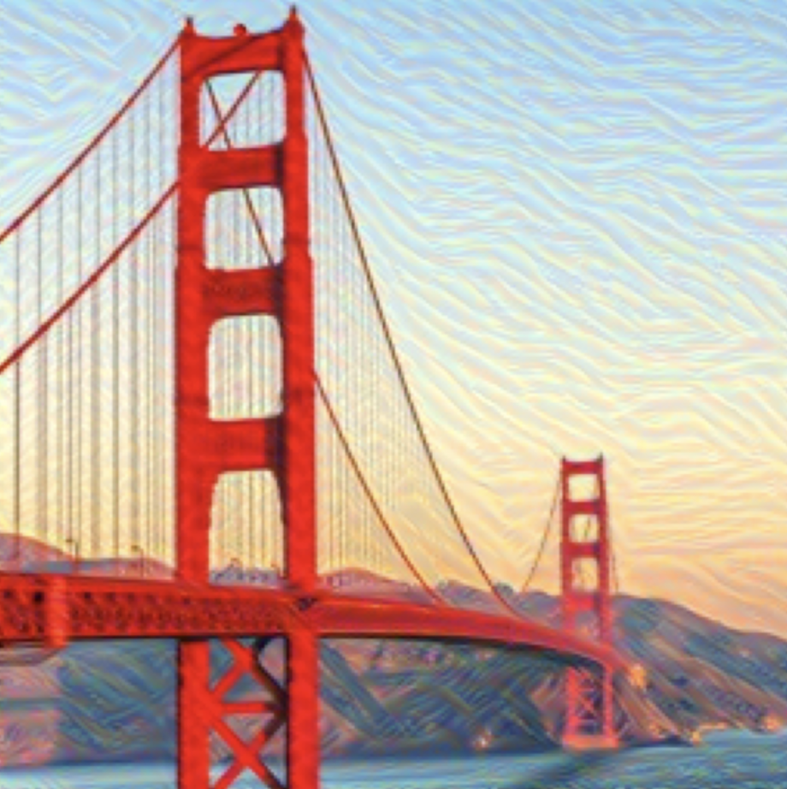
- s

