

**FallAlarm – Fall Detection and Alarm App**

## Daniel Hunegnaw | EE P 523 Mobile Applications for Sensing and Control| 07-10-21

**FallAlarm** – Fall Detector and Alarm system

In this project , I am proposing to design, and implement a fall-detector app, called FallAlarm. The main purpose of the FallAlarm app is to detect when a person falls* and to call or to text (with location information) an emergency contact that the user sets up in the App. The project will be implemented using Kotlin, Android Studio, Android Phone/Emulator. Since a fall involves an acceleration from a higher position to a lower position, the accelerometer sensor of an android device will be used a source of data for detecting a fall. In addition, the GPS will be used to get a location information , which is needed to alert an emergency contact in text (SMS).

The project will have two phases. In the first phase, a simple data collection app will be developed to gather accelerometer data to be used for modeling various states (or creating a threshold) of a person’s state such as normal activity, walking, falling etc .

In phase two, based on the model developed in phase one, an algorithm will be designed to detect a fall and will be implemented in the main app. In addition, a user’s settings, and a notification system to notify an emergency contact about the fall incident of the user will be implemented. The notification can be directly calling the emergency contact or just texting about the incident along with a location information.

Below are initial sketches or UI mocks showing how each page/view of the app looks like.

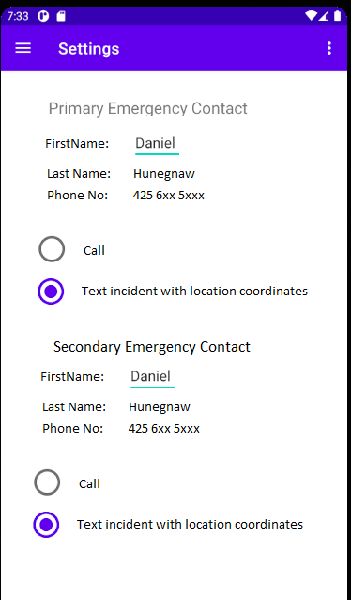

Fig 1. Settings View

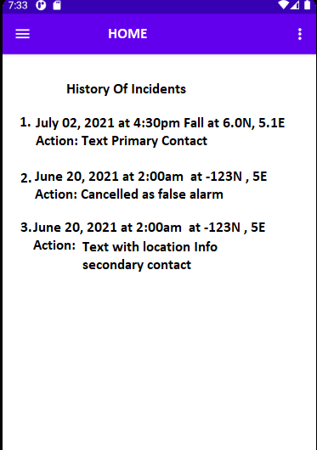

2. Home View

*Dictionary definition: move downward, typically rapidly and freely without control, from a higher to a lower level.