Alen Jose

Test plan

Football Management app

Contents

**No table of contents entries found.**

# Test Plan Identifier

FSMAP – 1013325 v1

# Introduction

This test plan lays out the different approaches in which the testing procedures will carried out to analyse the different aspects of the “FootballStatisticsManagementApp”. This document provides clear paths to efficiently evaluate different features and efficiently assess the integral parts. This test plan is following the IEEE 829-1998 format (Institute of Electrical and Electronics Engineers, 1998.)

The application that needs to be tested has already been developed therefore adequate testing needs to be done to make sure the core functionality of the application is working without any issues. The document needs to have specific areas that needs more focused testing as they are an integral part of this application.

# Test Items

There are 8 test conditions that have been filtered out of many options as the best suited for testing. These items are listed and explained in the table below.

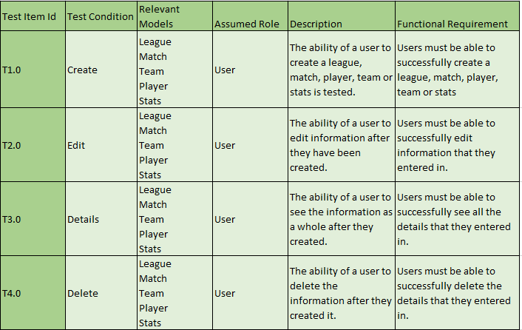

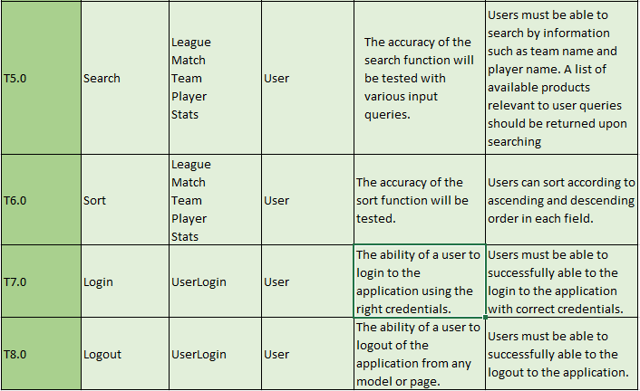

# Features to be Tested

The main focus of the test plan will be on the actual features that are included in the application. The focus of the test is on the functionality and usability of the aforementioned features. Quality characteristics defined in the ISO 9126 standard which includes performance testing is being taken upon.

# Features not to be Tested

Features excluded from testing:

* **Cross-platform suitability**
* **Recoverability**
* **Replaceability**
* **Security**
* **Efficient resource utilisation**

The above-mentioned features are not a part of testing for this application as they are irrelevant to the project objectives. The part that has