POLICY BRIEF
Minimum Wage vs. Unemployment: What 30 Years of State‑Level Data Show
Empirical Context for the Raise the Wage Act's $17 Federal Minimum Wage Proposal
Prepared for: A National News Outlet's Policy & Data Desk (illustrative exercise)
Prepared by: Daniel Igbokwe, Quantitative Analyst
October 2026

Executive Summary
Situation. The federal minimum wage has not risen since 2009. Thirty states now pay more. The Raise the Wage Act would lift the federal floor to $17 by 2030 [1].
Complication. Opponents warn that a higher floor will cost jobs. Advocates expect it to cut poverty. Simple comparisons cannot settle the question, because recessions and state wealth distort them.
Resolution. We analyzed 30 years of data from all 50 states and compared each state with its own history. We found no significant link between the minimum wage and unemployment, and no significant link with poverty. We did find a significant positive link with median household income: each $1 increase coincides with $1,266 more per household.
The evidence suggests that the job-loss fears behind opposition to the bill may be overstated. The income effect appears real and measurable. The poverty result is inconclusive, not proof of no effect. This analysis cannot capture cuts to hours, shifts in labor force participation, or cost-of-living differences, which limit any causal claim.

Background & Policy Context
The federal minimum wage has stayed at $7.25 per hour since 2009 [2]. That is the longest stretch without a raise since Congress created the wage floor in 1938.
States filled the gap. In 1995, seven states paid more than the federal minimum. By 2024, 30 states did. The gap between the highest and lowest state rate grew from $1.00 to $9.03 an hour. This patchwork turned the country into a natural laboratory for wage policy.
The Raise the Wage Act would raise the federal minimum wage to $17 per hour by 2030 [1]. The bill revives an old debate. Classical labor theory predicts that higher wage floors reduce employment [3]. A growing body of research, starting with Card and Krueger, finds little or no job loss [4].

The Debate
Opponents argue that raising the price of labor cuts demand for it. They expect layoffs, hiring freezes, and closures among firms with thin margins. They also argue that employers pass higher costs on to consumers and replace workers with technology sooner [5].
Advocates argue that higher wages lift low-income households out of poverty. Workers spend the extra income, which supports demand. Better pay also improves morale, reduces costly turnover, and lowers reliance on public assistance [6].
This brief tests only part of the debate. Its three outcomes, unemployment, poverty, and household income, can support or challenge the job-loss and poverty claims. They cannot test claims about prices, automation, productivity, or turnover. Those need different data, such as pricing records, capital investment, or employer surveys.
This brief does not take a position on the proposal. It brings decades of state-level evidence to the empirical parts of the debate, so that data, not priors, can ground the discussion.

Data & Methodology

Data Sources
We sourced all four variables from the Federal Reserve Economic Data (FRED) API. Using one source meant we only had to match state identifiers, not reconcile formats across agencies.
Variable | FRED series | Original source | Frequency
Unemployment rate | {STATE}UR | Bureau of Labor Statistics | Monthly, seasonally adjusted
State minimum wage | STTMINWG{STATE} | Department of Labor | Annual
Median household income | MEHOINUS{STATE}A646N | Census Bureau | Annual
Poverty rate | PPAA{STATE}{FIPS}A156NCEN | Census SAIPE program | Annual
Table 1. Panel variables and sources
FRED reports each state's own statutory wage. That rate can sit below the federal floor, and federal law requires employers to pay the higher of the two. We therefore use the effective minimum wage: the higher of the state and federal rate for each year. States without their own law, or with gaps in their series, take the federal rate for those years.
Unemployment arrives monthly. We averaged the 12 months into one calendar-year value to match the other three variables.

Panel Window: 1995-2024
The Census SAIPE program, which produces the poverty data, published no state estimates for 1990, 1991, 1992, or 1994. Only isolated estimates exist for 1989 and 1993. We start the panel in 1995, where all four variables run continuously through 2024.
This is a deliberate scope decision, and it costs little. The panel's two richest natural experiments both fall inside it: the federal freeze at $5.15 (1997-2007) and the freeze at $7.25 (2009-2024). States diverged most during these freezes.
The final panel covers 50 states over 30 years: 1,500 state-year observations, with no missing values and no duplicate keys.

Method
We use a panel regression with state and year fixed effects. State fixed effects remove differences that stay constant within a state, such as cost of living, industry mix, and labor market structure. Year fixed effects remove shocks that hit every state at once, such as recessions and national monetary policy. What remains is the within-state relationship between minimum wage changes and each outcome over time.
This design is far stronger than a national before-and-after comparison. We cluster standard errors by state, because each state's outcomes are correlated from year to year.
This is not a randomized experiment. It is an observational, quasi-experimental design that treats state wage increases as natural experiments. Labor economists use this approach widely, but it has real limits, which we discuss below.

Exploratory Data Analysis
We ran three checks before modeling.
First, state wage policies diverged sharply. A $1.00 gap in 1995 grew to $9.03 by 2024, and the divergence sped up after 2014 (Figure 01). This confirms that the data hold real variation for a fixed-effects design to use.
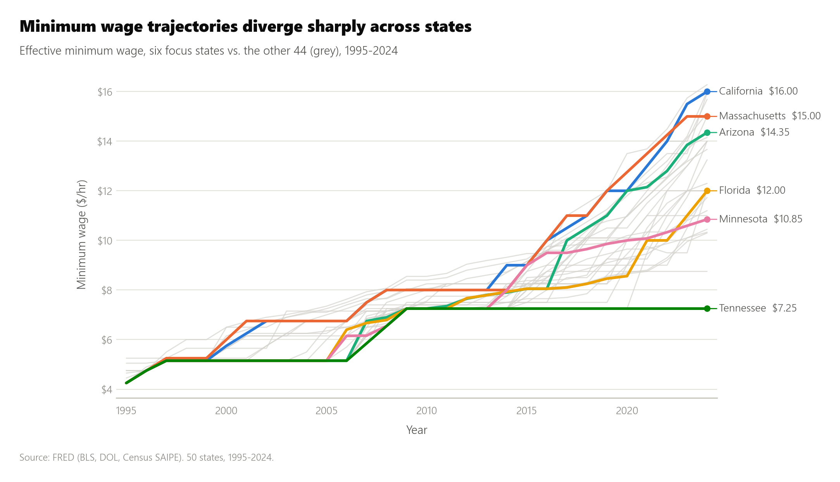
Figure 01. Minimum Wage Across States, 1995-2024
Second, unemployment moved together regardless of wage policy. States with very different wage paths rose and fell in the same shape and at the same time (Figure 02). All six spiked in 2001-03, 2008-09, and 2020. These shared national shocks are what year fixed effects absorb.
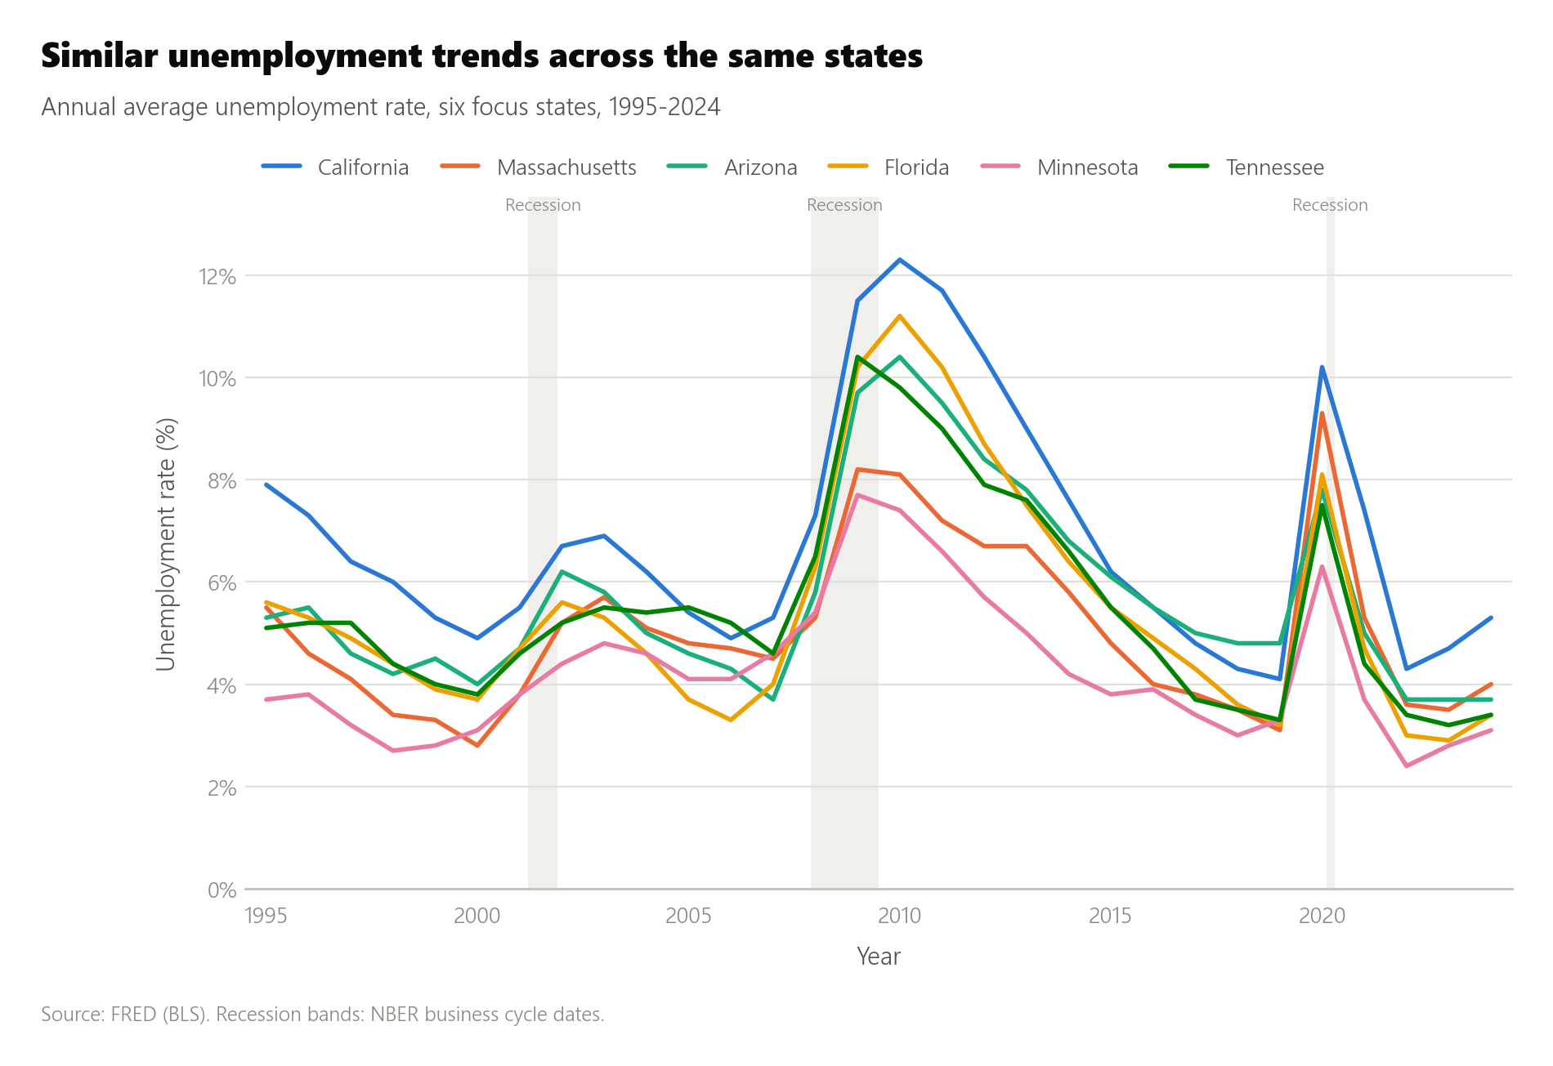
Figure 02. Unemployment Rate Across the Same Six States, 1995-2024
Third, raw correlations mix policy with place. The minimum wage shows almost no raw correlation with unemployment (r = 0.01) or poverty (r = -0.06). It shows a strong correlation with median income (r = 0.80) (Figure 03). We treat that income link with caution. High-wage states tend to be wealthier and more urban for reasons unrelated to wage policy. State fixed effects remove exactly this confound.
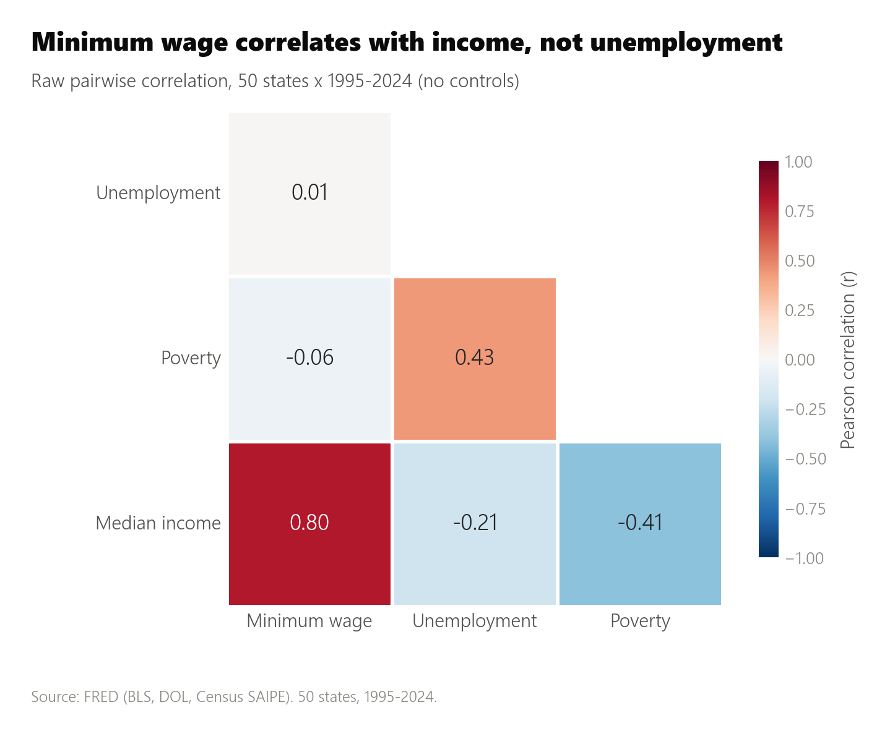
Figure 03. Correlation Matrix: Minimum Wage & Economic Indicators

Findings
Figure 04 and Table 2 summarize the three regressions. Each shows the estimated effect of a $1 higher minimum wage.
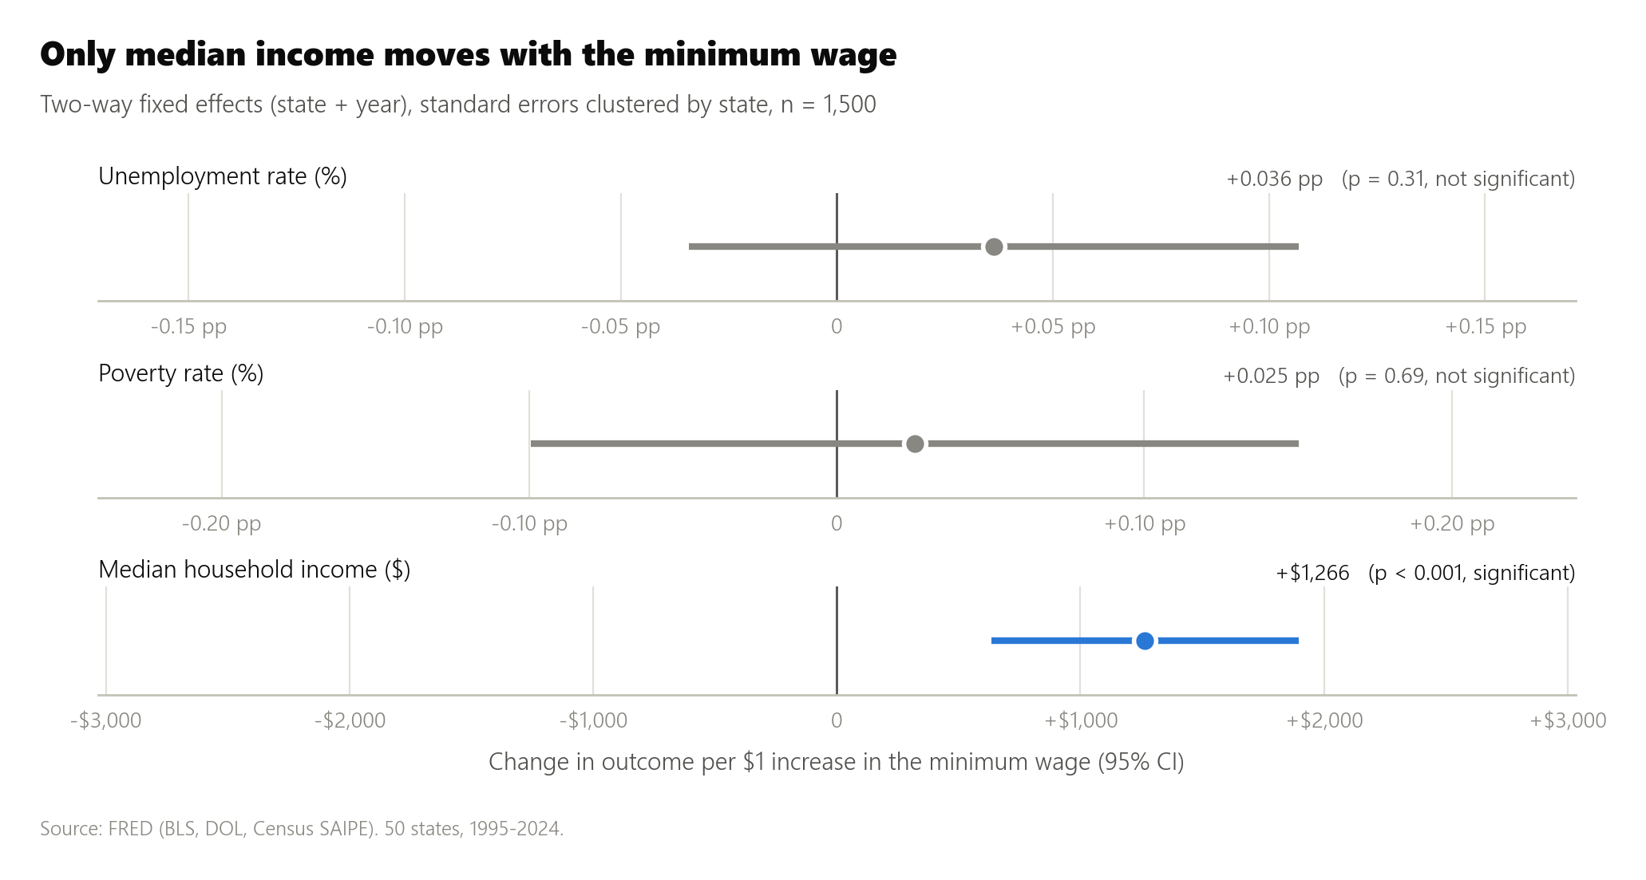
Figure 04. Fixed-Effects Regression Results with 95% Confidence Intervals
Outcome | Coefficient | P-value | 95% CI | Result
Unemployment rate (%) | 0.036 | 0.312 | -0.034 to 0.107 | Not significant
Poverty rate (%) | 0.025 | 0.690 | -0.099 to 0.150 | Not significant
Median household income ($) | 1,265.50 | 0.0001 | 635.53 to 1,895.50 | Significant, positive
Table 2. Effect of a $1 increase in the effective minimum wage (state and year fixed effects, n = 1,500)

Finding 1: Unemployment
We find no statistically significant link between minimum wage increases and state unemployment (coefficient: 0.036, p = 0.312). A $1 increase moves the unemployment rate by just 0.04 percentage points. Even the upper bound of the confidence interval is small, at 0.11 points. This null result matches the literature since Card and Krueger, which finds smaller job losses than classical models predict [4].

Finding 2: Poverty Rate
States that raised their minimum wage showed no significant change in poverty (coefficient: 0.025, p = 0.690). The confidence interval spans both negative and positive values. In this sample, the minimum wage does not clearly move poverty in either direction. We read this as inconclusive, not as proof of no effect.

Finding 3: Median Household Income
Median household income rose significantly with the minimum wage (coefficient: 1,265.50, p = 0.0001; 95% CI: 635.53 to 1,895.50). Each $1 increase coincides with about $1,266 more per household. This exceeds what one minimum-wage earner's raise could add to a household. The coefficient likely reflects broader wage growth that moves with minimum wage policy, not a purely mechanical pass-through.

The Combined Picture
The three results tell a consistent story. State minimum wage increases did not bring the unemployment that critics of the Raise the Wage Act predict. They did not significantly change poverty. They did coincide with measurably higher household income.
If state patterns hold at the federal level, a $17 floor would likely have limited effects on unemployment and poverty, and it could coincide with income gains. That is a significant caveat, discussed below. The income link is an association, not a guaranteed causal lever.

Limitations & What We Cannot Conclude
- Observational data. This design supports strong association claims, but it cannot prove causation.
- A narrow jobs measure. The unemployment rate misses cuts to hours, underemployment, and changes in labor force participation.
- State results may not scale. A business can move to a lower-wage state. It cannot escape a federal floor the same way.
- Nominal comparisons. Cost-of-living differences across states complicate comparisons of nominal wage effects.
- No recent federal variation. The federal floor has not moved since 2009 [2]. All federal-level inference here extrapolates from state variation.

Policy Implication
Thirty years of state natural experiments show no significant link between the minimum wage and unemployment or poverty. They do show a measurable link with household income. The job-loss concern at the center of opposition to the Raise the Wage Act finds little support in this evidence.
Policymakers should weigh this evidence alongside factors this analysis does not capture: regional cost of living, small-business margins, and the phase-in timeline.

Methodology, data sources, and full regression output: github.com/danieligbokwe/Minimum-Wage-vs-Unemployment. This brief is an illustrative student portfolio project.

References
[1] S.1332, Raise the Wage Act of 2025, 119th Congress. Congress.gov. https://www.congress.gov/bill/119th-congress/senate-bill/1332
[2] U.S. Department of Labor, Wage and Hour Division. “Minimum Wage.” https://www.dol.gov/agencies/whd/minimum-wage
[3] W.E. Upjohn Institute for Employment Research. Working paper on minimum wage and employment effects. https://research.upjohn.org/cgi/viewcontent.cgi?article=1250&context=up_workingpapers
[4] Card, David, and Alan B. Krueger. “Minimum Wages and Employment: A Case Study of the Fast-Food Industry in New Jersey and Pennsylvania.” American Economic Review 84, no. 4 (1994): 772-793. https://davidcard.berkeley.edu/papers/njmin-aer.pdf
[5] Brynjolfsson, Erik, J. Frank Li, Javier Miranda, Robert Seamans, and Andrew J. Wang. “Minimum Wages and Rise of the Robots.” NBER Working Paper 34895 (2026). https://www.nber.org/papers/w34895
[6] Peterson Institute for International Economics. “Higher Wages for Low-Income Workers Lead to Higher Productivity.” https://www.piie.com/blogs/realtime-economic-issues-watch/higher-wages-low-income-workers-lead-higher-productivity

