**Technical Support Manual**

1. Table of Contents

Overview of Program  
 Program Structure  
 Description of each function  
 Description of Data Structures  
 Global Variables  
 Cross References

2. Overview of Program

The PotatOS is an operating system simulator created for Professor Bowe’s operating systems class. It uses object-oriented programming and is easy to understand because of this.

3. Program Structure

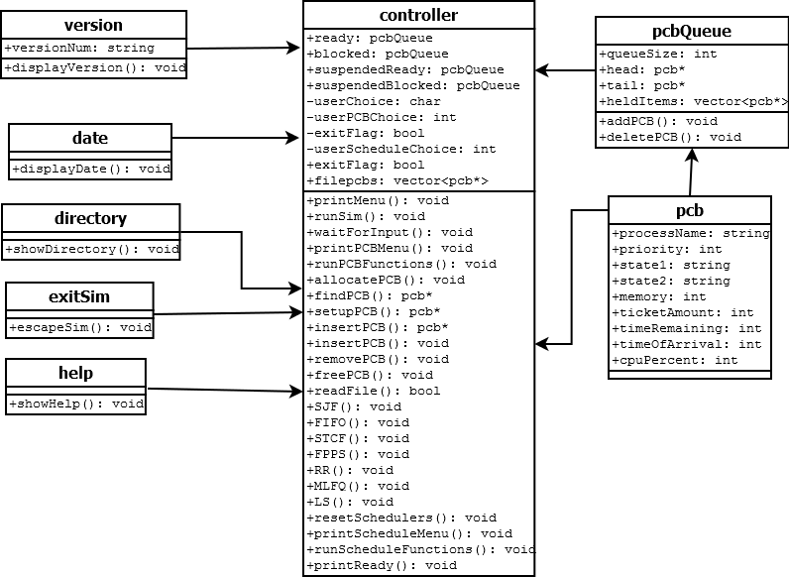

controller files:  
 controller class – controls all functions of the operating system simulator  
 printMenu – prints menu of choices for user  
 printPCBMenu – prints menu of choices relating to PCBs  
 waitForInput – waits for user input before continuing the program  
 runSim – runs the operating system simulator  
 runPCBFunctions – runs various PCB functions  
 allocatePCB – allocates memory for a new PCB  
 findPCB – searches PCB queue for PCB with same name as input  
 setupPCB – uses user input to create a new PCB  
 insertPCB – inserts PCP into appropriate queue  
 removePCB – removes PCB from queue  
 freePCB – deletes PCB and frees its memory  
 resetSchedulers – clears ready and blocked queues  
 readFile – reads in a file to create PCB’s based on its contents  
 SJF – runs a shortest job first scheduler  
 FIFO – runs a first in first out job scheduler  
 STCF – runs a shortest time to completion first job scheduler  
 FPPS - runs Fixed Priority Pre-Emptive Scheduling  
 RR – runs a round robin job scheduler  
 MLFQ – runs job scheduling using a multi-leveled feedback queue  
 LS – runs job scheduling using a lottery scheduler  
version files:  
 version class – used to display version of OS  
 displayVersion – displays version of the operating system  
date files:  
 date class – used to display current date  
 displayDate – displays current date   
directory files:  
 directory class – used to find files in a directory  
 showFiles – displays file names of all files in OS’s directory  
help files:  
 help class – used to give user help  
 showHelp – displays help messages for each command of the OS  
exitSim files:  
 exitSim class – used to exit the OS simulator  
 escapeSim – exits the OS simulator   
pcb files:  
 pcb class – makes PCBs that are used in various parts of the program  
pcbQueue files:  
 pcbQueue class – holds PCBs using vectors  
 addPCB – adds PCB to vector  
 removePCB – removes PCB from vector

4. Description of each function

-void printMenu() – prints menu of choices for user  
-void runSim() – runs the operating system simulator  
-void runPCBFunctions() – runs PCB functions based on user input  
-void printPCBMenu() – prints menu of choices relating to PCBs  
-void waitForInput() – waits for user input before continuing the program  
-void displayVersion() – displays version of the operating system  
-void displayDate() – displays current date   
-void showFiles() – displays file names of all files in OS’s directory  
-void showHelp() – displays help messages for each command of the OS  
-void escapeSim() – exits the OS simulator   
-void allocatePCB – allocates memory for a new PCB  
-pcb* findPCB(string) – searches PCB queue for PCB with same name as input  
-pcb* setupPCB(string, int, char) – uses user input to create a new PCB  
-void insertPCB(pcb*) – inserts PCP into appropriate queue  
-void removePCB(pcb*) – removes PCB from queue  
-void freePCB(pcb*) – deletes PCB and frees its memory  
-void readFile() – reads file to create PCBs based on its contents  
-void SJF() – runs a shortest job first scheduler  
-void FIFO() – runs a first in first out job scheduler  
-void STCF() – runs a shortest time to completion first job scheduler  
-void FPPS() - runs Fixed Priority Pre-Emptive Scheduling  
-void RR() – runs a round robin job scheduler  
-void MLFQ() – runs job scheduling using a multi-leveled feedback queue  
-void LS() – runs job scheduling using a lottery scheduler

5. Description of Data Structures

-controller class - controls all functions of the operating system simulator. It includes the variables userChoice, userPCBChoice, and userScheduleChoice that are used to indicate what actions the user wants to perform from vaious different menus.   
-version class – used to display current version of OS. The string versionNum holds the version number.  
-date class – used to display current date.   
-help class – used to give user help  
-directory class – used to find files in a directory  
-exitSim class – used to exit the OS simulator  
-pcb class – makes PCBs to use elsewhere in program  
-pcbQueue class – holds pcbs in a vector

6. Global Variables

N/A

7. Cross References

void printMenu() – called by runSim  
void runSim() – calls printMenu, displayVersion, displayDate, showFiles, showHelp, and escapeSim, and printPCBMenu  
void displayVersion() – called by runSim  
void displayDate() – called by runSim  
void showFiles() – called by runSim   
void showHelp() – called by runSim  
void escapeSim() – called by runSim  
void insertPCB() – calls addPCB and removePCB  
void setupPCB() – calls allocatePCB  
void runPCBFuntions() – calls insertPCB, searchPCB, removePCB, and freePCB  
void runScheduleFunctions() – calls SJF, FIFO, STCF, FPPS, RR, MLFQ, LS, and resetScheduler.  
SJF - calls readFile, addPCB, deletePCB  
FIFO - calls readFile, addPCB, deletePCB  
STCF - calls readFile, addPCB, deletePCB  
FPPS - calls readFile, addPCB, deletePCB  
RR - calls readFile, addPCB, deletePCB  
MLFQ - calls readFile, addPCB, deletePCB  
LS - calls readFile, addPCB, deletePCB