**Andy Lee**  
500163559  
Assignment 3

***Question 1a***

$$F\left(ABCD\right)=AC^{'}D+A^{'}C+ABC+AB^{'}C+A'C'D'$$

|  |  |  |  |  |
| --- | --- | --- | --- | --- |
| AB\CD | C’D’ | C’D | CD | CD’ |
| A’B’ | 1 |  | 1 | 1 |
| A’B | 1 |  | 1 | 1 |
| AB | 1 |  | 1 | 1 |
| AB’ | 1 |  | 1 | 1 |

$$F=D^{'}+C$$

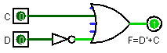

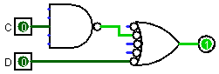

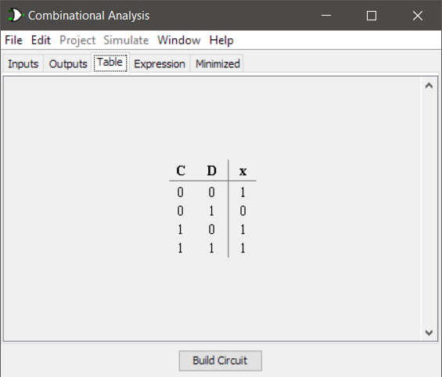

***Question 1b***

$F\left(ABC\right)=\left(A^{'}+C^{'}+D^{'}\right)\left(A^{'}+C^{'}\right)\left(C^{'}+D^{'}\right)$ $$F^{'}={\left[\left(A^{'}+C^{'}+D^{'}\right)\left(A^{'}+C^{'}\right)\left(C^{'}+D^{'}\right)\right]}^{'} \\ F^{'}={\left(A^{'}+C^{'}+D^{'}\right)}^{'}+{\left(A^{'}+C^{'}\right)}^{'}+{\left(C^{'}+D^{'}\right)}^{'} \\ F^{'}=ACD+AC+CD$$

|  |  |  |  |  |
| --- | --- | --- | --- | --- |
| A\CD | C’D’ | C’D | CD | CD’ |
| A’ | 1 | 1 | 0 | 1 |
| A | 1 | 1 | 0 | 0 |

$$F=C^{'}+A'D'$$

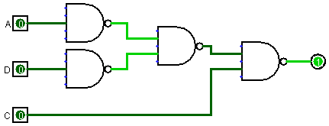

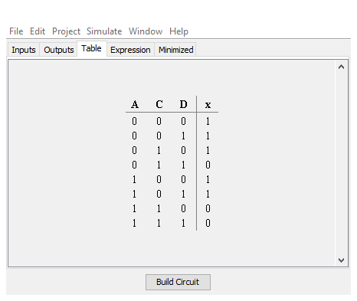

***Question 2. Build half adders (HA) using NOR gate; construct 4-bit adders using built HA.***

**Step 1.** Build carry and sum circuits with NOR gates base on the following truth table.

|  |  |  |  |
| --- | --- | --- | --- |
| X | Y | C | S |
| 0 | 0 | 0 | 0 |
| 0 | 1 | 0 | 1 |
| 1 | 0 | 0 | 1 |
| 1 | 1 | 1 | 0 |

|  |  |  |
| --- | --- | --- |
| x\y | $$y$$ | $$y'$$ |
| $$x'$$ | 0 | 0 |
| $$x$$ | 0 | 1 |

$${Collect 0s=C}^{'}=x^{'}+y^{'} \\ {\left(C^{'}\right)}^{'}={\left(x^{'}+y^{'}\right)}^{'}=xy={\left(xy\right)}^{''}=(x^{'}+y^{'})'$$

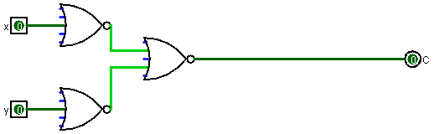

Figure 1 Diagram of **carry** circuit

$$S\left(x,y\right)=x^{'}y+xy^{'}$$

|  |  |  |
| --- | --- | --- |
| x\y |  |  |
|  | 0 | 0 |
|  | 0 | 1 |

Figure 2 Diagram for **sum** circuit

**Step 2.** Next construct half adder using C and S.

Figure 3 Diagram of half adder

**Step 3.** Construct full adder (FA) using on C and S and NOR gates were applicable. Design taken from lecture notes and modified to NOR gate only.

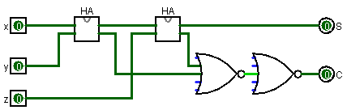

**Step 4.** Use FA as component and repeat 4 times to build a 4-bit adder.

Figure 4 diagram of 4bit adder

*Note: logicism randomly refuse to give an output and rebuilding the exact same circuitry or restarting the program fixes the program. So I’ve included samples below.*

Figure 5 demo of 1001+101

Figure 6 demo of 1+1011

***Q3 Build 4-bit binary to gray code converter from 0 to 9 using NAND gates only.***

|  |  |  |  |  |  |
| --- | --- | --- | --- | --- | --- |
|  | $$Binary(i_{3},i_{2},i_{1},i_{0})$$ | $$O_{3}$$ | $$O_{2}$$ | $$O_{1}$$ | $$O_{0}$$ |
| 0 | 0000 | 0 | 0 | 0 | 0 |
| 1 | 0001 | 0 | 0 | 0 | 1 |
| 2 | 0010 | 0 | 0 | 1 | 1 |
| 3 | 0011 | 0 | 0 | 1 | 0 |
| 4 | 0100 | 0 | 1 | 1 | 0 |
| 5 | 0101 | 0 | 1 | 1 | 1 |
| 6 | 0110 | 0 | 1 | 0 | 1 |
| 7 | 0111 | 0 | 1 | 0 | 0 |
| 8 | 1000 | 1 | 1 | 0 | 0 |
| 9 | 1001 | 1 | 1 | 0 | 1 |
| 10 | 1010 | X | X | X | X |
| 11 | 1011 | X | X | X | X |
| 12 | 1100 | X | X | X | X |
| 13 | 1101 | X | X | X | X |
| 14 | 1110 | X | X | X | X |
| 15 | 1111 | X | X | X | X |

|  |  |  |  |  |  |
| --- | --- | --- | --- | --- | --- |
| wx\yz |  |  | y | |  |
|  | 0 | 0 | 0 | 0 |  |
|  | 0 | 0 | 0 | 0 | x |
| w | x | x | x | X |
| 1 | 1 | x | x |  |
|  |  | z | |  |  |

Figure 7 k-map forOi_3

$$O_{3}=w$$

|  |  |  |  |  |  |
| --- | --- | --- | --- | --- | --- |
| wx\yz |  |  | y | |  |
|  | 0 | 0 | 0 | 0 |  |
|  | 1 | 1 | 1 | 1 | x |
| w | x | x | x | X |
| 1 | 1 | x | x |  |
|  |  | z | |  |  |

Figure 8 k-map for O_2

$$O_{2}=w+x$$

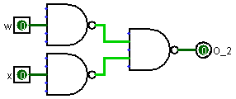

|  |  |  |  |  |  |
| --- | --- | --- | --- | --- | --- |
| wx\yz |  |  | y | |  |
|  | 0 | 0 | 1 | 1 |  |
|  | 1 | 1 | 0 | 0 | x |
| w | x | x | x | X |
| 0 | 0 | x | x |  |
|  |  | z | |  |  |

Figure 9 k-map for O_1

$$O_{1}=xy^{'}+x'y$$

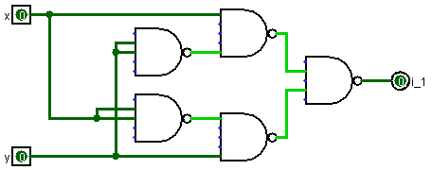

|  |  |  |  |  |  |
| --- | --- | --- | --- | --- | --- |
| wx\yz |  |  | y | |  |
|  | 0 | 1 | 0 | 1 |  |
|  | 0 | 1 | 0 | 1 | x |
| w | x | x | x | X |
| 0 | 1 | x | x |  |
|  |  | z | |  |  |

Figure 10 k-map for O_0

🡨 Boolean logic same as $O_{1}$, therefore will be reusing circuitry.

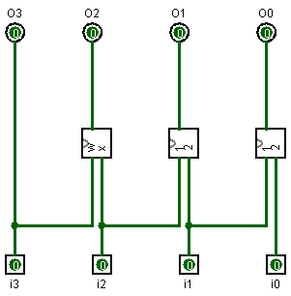

Figure 11 4bit to gray converter

Figure 12 gray converter demo 1

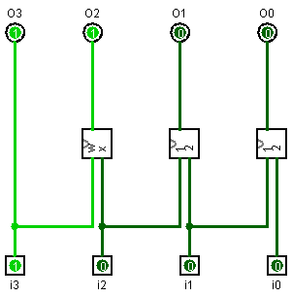

Figure 13 gray converter demo 2