Andy Lee – 500163559  
Lab 4

Part A

|  |  |  |  |  |  |  |  |  |
| --- | --- | --- | --- | --- | --- | --- | --- | --- |
|  | BCD(8421) | OUTPUTS | | | | | | |
| Dec. | ABCD | H | I | J | K | L | M | N |
| 0 | 0000 | 1 | 1 | 1 | 1 | 1 | 1 | 0 |
| 1 | 0001 | 0 | 1 | 1 | 0 | 0 | 0 | 0 |
| 2 | 0010 | 1 | 1 | 0 | 1 | 1 | 0 | 1 |
| 3 | 0011 | 1 | 1 | 1 | 1 | 0 | 0 | 1 |
| 4 | 0100 | 0 | 1 | 1 | 0 | 0 | 1 | 1 |
| 5 | 0101 | 1 | 0 | 1 | 1 | 0 | 1 | 1 |
| 6 | 0110 | 1 | 0 | 1 | 1 | 1 | 1 | 1 |
| 7 | 0111 | 1 | 1 | 1 | 0 | 0 | 0 | 0 |
| 8 | 1000 | 1 | 1 | 1 | 1 | 1 | 1 | 1 |
| 9 | 1001 | 1 | 1 | 1 | 1 | 0 | 1 | 1 |
| 10 | 1010 | x | x | x | x | x | x | x |
| 11 | 1011 | x | x | x | x | x | x | x |
| 12 | 1100 | x | x | x | x | x | x | x |
| 13 | 1101 | x | x | x | x | x | x | x |
| 14 | 1110 | x | x | x | x | x | x | x |
| 15 | 1111 | x | x | x | x | x | x | x |

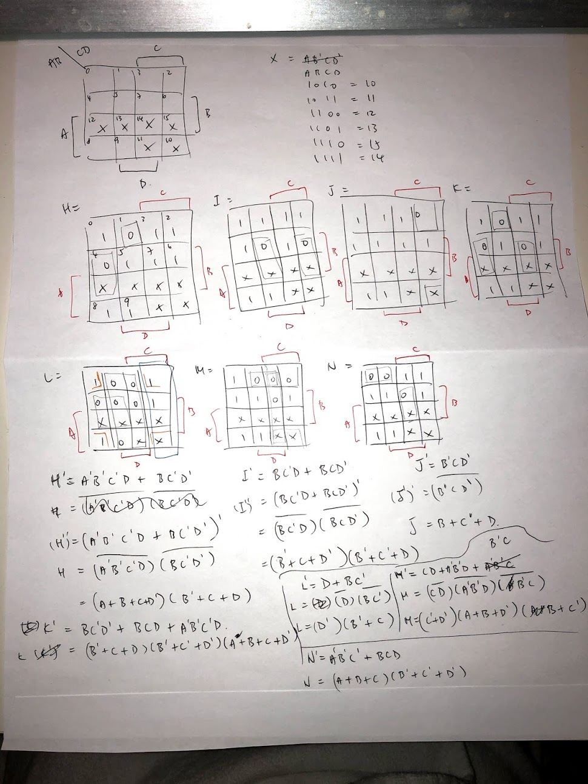

Using the above we’ve built BCD decoder and turn it into a component

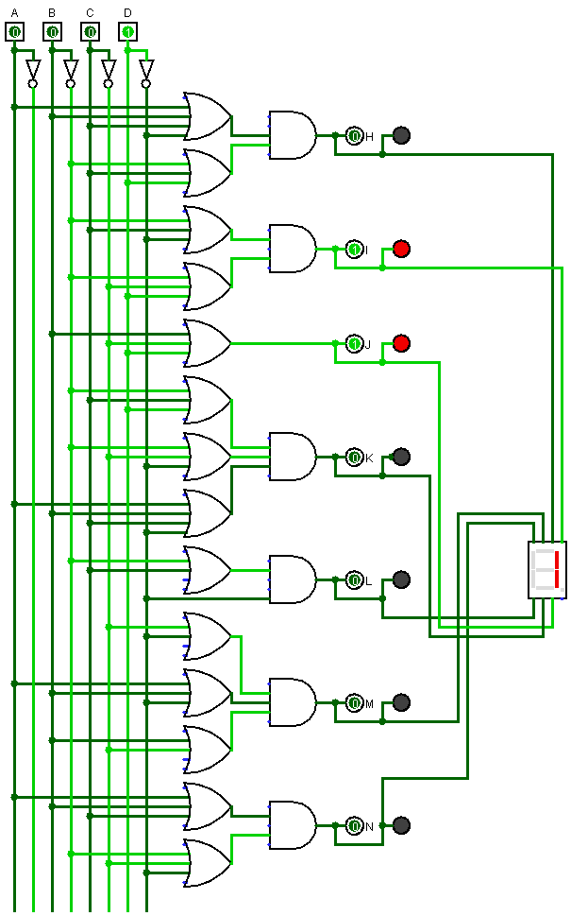

Part B solution in Logism file.

Utilizing components *full adder* from lab 3, *BCD-decoder* from this lab Part A, *4bit-to-BCD converter*, the final circuit named *Part2-final*.

