**Andy Lee**

500163559

Lab 1

1)

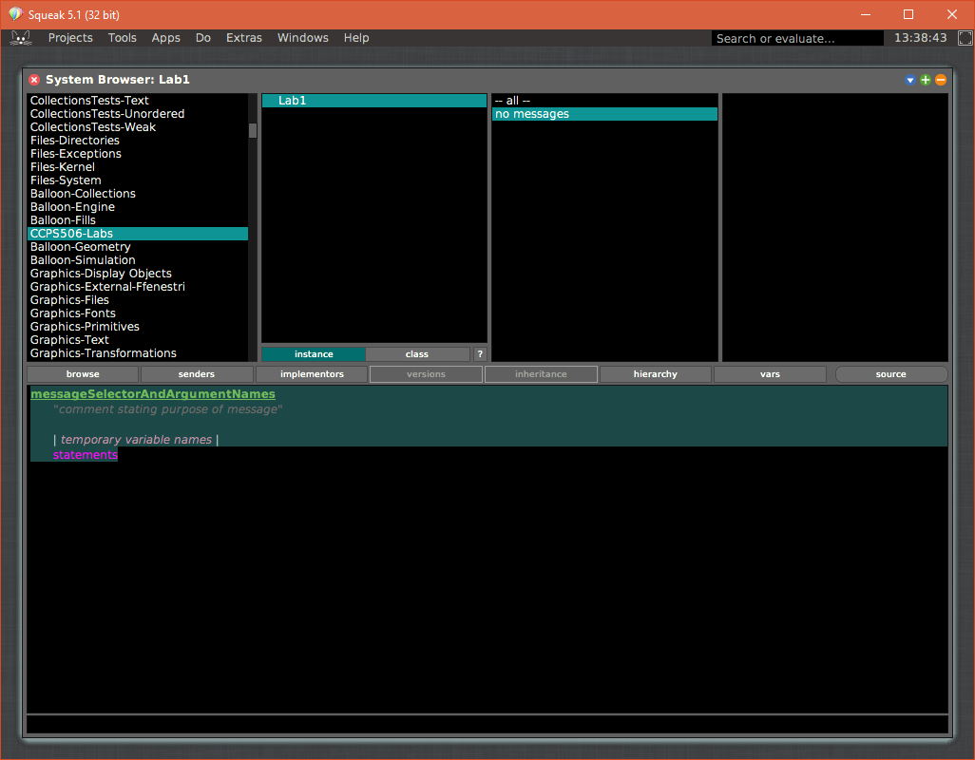

2a)

factorial: input

input class = SmallInteger

ifTrue: [| i result |

input = 0 ifTrue: [^1].

input > 0 ifTrue: [

i := input asNumber.

result := input.

[i > 1]

whileTrue: [i := i - 1.

result := result * i].

^ result]

].

^ 'error'

2b) Smalltalk methods return doesn’t require datatype declaration. Therefore returning string or integer is considered OK.

3)

flipCase: inputArg

"comment stating purpose of message"

| i currentChar |

i := 1.

inputArg class = ByteString

ifTrue: [

[i < inputArg size]

whileTrue: [

currentChar := inputArg at: i.

(currentChar isUppercase)

ifTrue: [Transcript show: currentChar asLowercase]

ifFalse: [Transcript show: currentChar asUppercase].

i := i+1.

].

^''.

].

^'Error'.

Correction

flipCase: inputArg

"comment stating purpose of message"

| i currentChar result |

i := 1.

result:=''.

inputArg class = ByteString

ifTrue: [

[i <= inputArg size]

whileTrue: [

currentChar := inputArg at: i.

(currentChar isUppercase)

ifTrue: [result:=result,currentChar asLowercase] ifFalse: [result:=result,currentChar asUppercase].

i := i+1.

].

^result.

].

^'Error'.

4a)

