A Sentiment Analysis of COVID-19 Tweets and its effects on Retweet-ability and Likeability.

**Andy Lee**  
500163559  
CIND820-D10

# Introduction

Social media has expanded tremendously in the past decade. It is common for government officials to use Twitter to relay public messages and announcements (Ontario Government, 2020), and also for individual users to rely on Twitter as their primary source of news (Glenski, et al., 2018). In the past, social media platforms has chosen a laissez-faire approach when dealing with user-generated messages (Caplan, 2017), however with a traffic of 500 millions tweets posted on Twitter per day (Pereira-Kohatsu, et al., 2019) where majority are posted by individuals users (Oren, et al., 2020), Twitter has slowly become a breeding ground for rumours and misinformation (Shao, et al., 2018); an ongoing issue social media platforms struggle to find a balance to address (Culliford, 2020).

As we step into 2020, the COVID-19 pandemic fills our everyday news while causing disturbance to all levels of society across the global (Hinshaw, 2020). Due to the novelty of the virus, governments and health officials often struggle to form straightforward and coherent guidelines and policies due to discovery of new information (Farzan, et al., 2020). This can contribute to public mistrust on the health authorities; indirectly fanning the spread of rumours and misinformation (Kouzy, et al., 2020). In turn, it hinders the effectiveness of public health policies when people feed on misinformation (Bode & Vraga, 2017) as studies have shown misinformation are spread and consumed by like-minded people; ricocheting like an echo chamber (Vicarioa, et al., 2016).

Monitoring the vast amounts of social media messages have become humanly impractical, therefore research into using machine learning and data analytic techniques to tackle the problem has become a popular research topic in recent years, and many papers have described partial or complete solutions with different degrees of success. In our capstone project, we will attempt to implement a small part of a big puzzle; using sentiment analysis techniques to label tweets on a scale of negative, positive, or neutral, and then build a classification model to predict whether sentimental levels can affect retweets or likes. This will allow us to better understand whether a tweet’s sentimentality can influence how it resonates with other people.

# Literature Review

**Twitter rumour detection in the health domain**

Add an introduction to create a smooth transition (1-2 sentences)

Sicilia et al. in “Twitter rumour detection in the health domain” (Sicilia, et al., 2018, pp. 34-35) described the construction of a complete detection system that can distinguish rumour or non-rumour tweets on topics related to the health sector. Rumours are defined as information from an unverified source, non-rumours are information that can be referenced to credible sources and official pages, and unknown are information that cannot be verified has either true or false (Sicilia, et al., 2018, p. 35). Data downloaded from Twitter, separated based on user or network level, feature selected based on performance, and finally trained into classification model (Sicilia, et al., 2018, pp. 35-36). The author used various machine learning techniques such as Support Vector Machine, Nearest Neighbour, and Random Forest and compared the results based on their averaged accuracies and compared their $p$-values (Sicilia, et al., 2018, pp. 38-39). The study was able to achieve an over accuracy of 74%, precision of 73%, and recall of 74% (Sicilia, et al., 2018, p. 39).

Ravi in “A survey on opinion mining and sentiment analysis: Tasks, approaches and applications” conducted a comprehensive review and experimented on different sentiment analysis techniques described in over 300 papers on six tasks, namely: subjectivity classification, sentiment classification, review usefulness measurement, lexicon creation, opinion spam detection, and aspect extraction” (Ravi, 2015, pp. 4-5). The study compared dozens of different sentiment analysis approaches and techniques with various degree of success on certain machine learning techniques when compared to vote count based measures (Ravi, 2015, pp. 55-57). Ravi concluded that there is still room for growth on intelligence-based techniques such as Random Forest (Ravi, 2015, p. 64).

Carlos et al. in “Detecting and Monitoring Hate Speech in Twitter” describes social media platforms dominate much of the internet, and with hundreds of millions of messages being conveyed through these platforms, hate messages begin to spread in wide varieties of subjects (Pereira-Kohatsu, et al., 2019, p. 2). The paper describes a system where it takes an input as text and emoji to help identifying and classifying hate speech in Twitter, and monitoring negative sentiments (Pereira-Kohatsu, et al., 2019, pp. 1-2). After experimenting with 19 different strategies of feature and classification models, the authors concluded with a model that combines LSTM and MLP-NN achieving AUC OF 0.828 (Pereira-Kohatsu, et al., 2019, p. 31).

Social media platforms currently are mostly unmoderated; allowing rumours or unverified information can easily spread and circulate on the platform (Zubiaga, et al., 2018, p. 32:1). Zubiaga et al. in “Detection and Resolution of Rumours in Social Media: A Survey” describes combining different various techniques in rumour detection, tracking, stance classification, and veracity classification together to form a rumour detection system that will provide users with early warning of messages containing uncertain information (Zubiaga, et al., 2018, pp. 32:1-32:2).

Sewalk et al. in “Using Twitter to Examine Web-Based Patient Experience Sentiments in the United States: Longitudinal Study” starts with the premise there is a shift to focusing more on patient experience and emotion, increasing transparency and patient engagement in health care (Sewalk, et al., 2018, p. 2). As Twitter has become a primary platform for people to voice their opinions, the authors conducted sentiment analysis on tweets based on patient tweets, such as wait time, as a method to evaluate their treatment experiences (Sewalk, et al., 2018, pp. 10-11).

# Dataset

For this project, we will use publicly available containing COVID-19 related tweets obtained from IEEE DataPort (<https://ieee-dataport.org/open-access/coronavirus-covid-19-tweets-dataset>). The initial dataset contains only the tweets IDs filtered by a list of keywords ([link](https://rlamsal.com.np/keywords.tsv)) related to COVID-19. The tweet IDs is loaded onto a re-hydrator program to become tweets again. The resulting hydrated CSV have 34 attributes: coordinates, created_at, hashtags, media, urls, favorite_count, id, in_reply_to_screen_name, in_reply_to_status_id, in_reply_to_user_id, lang, place, possibly_sensitive, retweet_count, retweet_id, retweet_screen_name, source, text, tweet_url, user_created_at, user_screen_name, user_default_profile_image, user_description, user_favourites_count, user_followers_count, user_friends_count, user_listed_count, user_location, user_name, user_screen_name, user_statuses_count, user_time_zone, user_urls, user_verified. For our project, the features selected are as follows:

Table 1 List of attributes used in this project.

|  |  |
| --- | --- |
| **Attributes** | **Description** |
| created_at | Time in UTC the tweet was created |
| favorite_count | The number of “Likes” of the tweet |
| id | The id of the tweet |
| retweet_count | The number of times this tweet has been retweeted |
| retweet_id | The tweet id where the tweet was originally from |
| retweet_screen_name | The username of the person who originally wrote the tweet |
| source | The platform which the was written from |
| text | The context of the tweet |

# Approach

Figure 1 Project approach diagram

## Step 1: Download dataset

From IEEE.org (https://ieee-dataport.org/open-access/coronavirus-covid-19-tweets-dataset), select one of the many datasets which is broken into multiple files as per date. The project can be scaled to include multiple dates depending on computational power as some of the processes are resource intensive.

## Step 2: Hydrate dataset

The dataset downloaded from IEEE only contains tweet IDs and will have to “hydrate” into texts. The process involves loading the tweet ID to a hydrator program and allow the program to pull context through Twitter API chunk by chunk. For details on this hydrating process, please refer to README.md in GitHub repository.

**Step 3: Preload Setup**

Load basic parameters such as display tables in full screen widths to improve productivity while working on the project.

**Step 4: Import Dataset**

Store the previously hydrated Twitter text file in a cloud storage services—we used Google Drive for this project, then allow Colab to have access to the dataset file. First, mount Google Drive onto the Colab project by loading the Google Colab library, then run and follow instructions to give Colab read privileges to the dataset file in Google Drive. Once Colab has read access to the dataset file, import CSV file as a Pandas dataframe.

**Step 5: Data Cleaning and Manipulation**

First, take a moment to observe and understand the dataset such as its structure and data composition. Then, we can perform data cleaning such as handle null values, convert data types, and remove noise from strings.

Since retweets are duplicated tweets from an original tweet, we only need to focus on original tweets. Therefore, we filter the dataset to only include Original Tweets and save them into a new dataframe.

The algorithm works best on English text and tweets that are not written in English waste resource and can affect our results. Using langdetect library, we parse each tweet and exclude any data points with non-English tweets. This is a resource intensive task and require extra time to process.

**Step 6: Sentiment Analysis**

From NLTK library, import SentimentIntensityAnalyzer and apply polarity_scores function onto each tweet in the Original Tweet dataframe. The function returns probability of positive, probability of neutral, probability of negative, and compound in dictionary form, which is then expanded into their own independent attribute inside the dataframe for easier data analysis.

The compound score is calculated from raw sentiment intensity (different from how positive, neutral, and negative was calculated) and provides us with single dimension metric of the sentimentality of a tweet. Using this score, we can bin tweets based on the range of scores.

**Step 8: Basic Analysis**

With all the features available, we can conduct some basic analysis such as correlation, mean, standard deviation, and the distribution of the compound score.

**Step 9: Build Classification**

From Original Tweets, features: retweet_count, user_followers_count, and compound as independent variables, and favorite_count as dependent variable, we build a linear regression model with 80% training and 20% testing.

**Step 10: Getting Results**

Calculate metrics such as Mean Square Error, Root Mean Square Error, and R-squared based on the predictions from classification models.

Using actual values on the x-axis and predicted on the y-axis as predicted, we can graph a scatterplot to visually see whether how well the model is predicting its values.

**Further Attempts**

We take the Original Tweets and break it into 80% training and 20% testing sets. Attributes retweet_count, user_followers_count, compound will be our independent variables, and favorite_count will be our dependent variable.

# Results

Explain your results here. Consider that you need to communicate your results to executives in an organization. For example:

When we take the compound value of -1 to 1 and plot a frequency histogram with 40 bins, the shape of the graph appears to be symmetric multimodal with an exceptionally high concentration from 0 to 0.05.

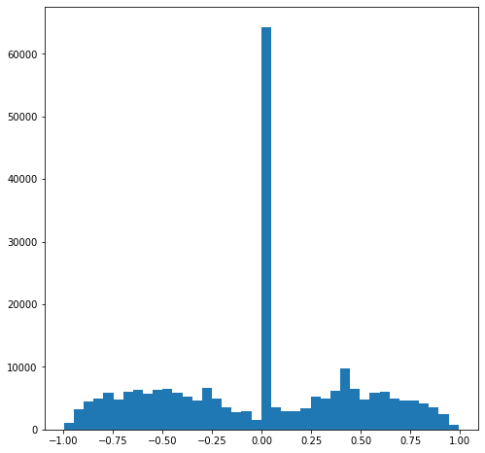

If we plot the graph again with 20 bins, the two peaks near -0.5 and 0.5 becomes more apparent. From these histograms, we see that of the approximately 245k observations, about a quarter is considered neutral. The two extremes of -1.00 negative, and +1.00 positive are relatively the lowest of all bins.

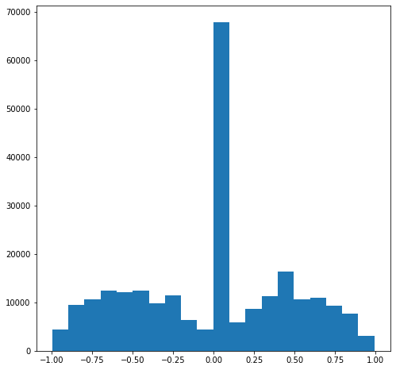

Here shows a scatterplot of the predicted values compare to the actual values. Although it does not tell us the accuracy of the predictions, it does show predicted values increases as the actual values increases as well.

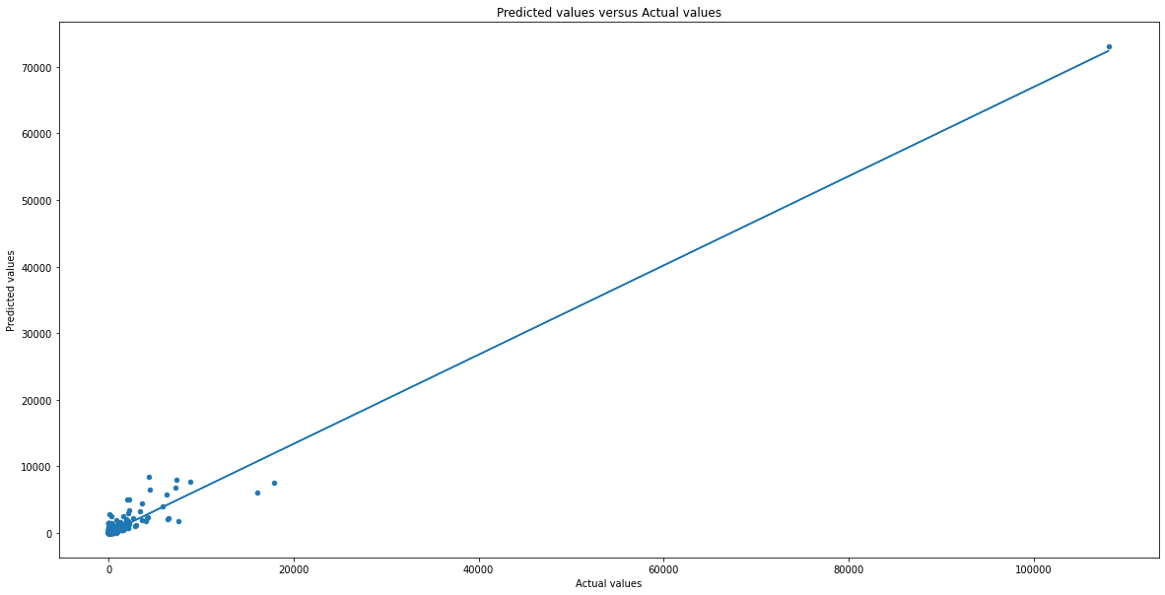

Here shows some metrics to our regression model.

Mean Square Error (MSE): 33369.46837319132

Root MSE: 182.6731189124205

R-Square: 0.8733484618869796

The Mean Square Error (MSE) is 33369 which relatively high consider the dependent variable is number of favourites in a tweet. The model has a Root MSE (RMSE)—standard deviation of errors of 182 which show the model cannot accuracy predict results. However, the model also has a R-squared of 0.87 which tells us the statistical fit of the model and that 87% of the dependent variable’s variability is explained by the independent variables in the regression model.

1. Insert tables and/or charts showing the results
2. Write description of the tables and charts, such that they show the usefulness for an organization
3. Identify the evaluation measures, such as accuracy, precision, recall, etc.

# Conclusions

Give a short summary (one to two paragraphs) of your analysis and conclude the discussion by defining the usefulness of your analysis.

# References

Bode, L., & Vraga, E. K. (2017). See Something, Say Something: Correction of Global Health Misinformation on Social Media. *Health Communication, 33*(9), 1131-1140. doi:10.1080/10410236.2017.1331312

Caplan, L. (2017, 10 11). *Should Facebook and Twitter Be Regulated Under the First Amendment?* Retrieved from WIRED: https://www.wired.com/story/should-facebook-and-twitter-be-regulated-under-the-first-amendment/

Carvalho, L. d., Silva, M. V., Costa, T. d., Oliveira, T. E., & Oliveira, G. A. (2020, 9). Public Health and the COVID-19 pandemic: challenges for global health. *Research, Society and Development, 9*(7). doi:10.33448/rsd-v9i7.4188

Culliford, E. (2020, 10 6). *Twitter is testing how its misinformation labels can be more obvious, direct*. Retrieved from Reuters: https://ca.reuters.com/article/us-usa-election-twitter-labels-focus-idCAKBN26R1ML

Farzan, A. N., Noack, R., Beachum, L., Taylor, A., Iati, M., Bellware, K., . . . Kornfield, M. (2020, 9 21). *CDC reverses statement on airborne transmission of coronavirus, says draft accidentally published*. Retrieved from Washington Post: https://www.washingtonpost.com/nation/2020/09/21/coronavirus-covid-live-updates-us/

Glenski, M., Weninger, T., & Volkova, S. (2018, 11 21). Propagation From Deceptive News Sources Who Shares, How Much, How Evenly, and How Quickly? *IEEE Xplore*, 1071-1082. doi:10.1109/TCSS.2018.2881071

Hinshaw, D. (2020, 10 12). *As Covid Cases Surge, More Public-Health Experts Say Lockdowns Aren’t the Answer*. Retrieved from Wall Street Journal: https://www.wsj.com/articles/public-health-experts-rethink-lockdowns-as-covid-cases-surge-11602514769

Kouzy, R., Jaoude, J. A., Kraitem, A., Alam, M. B., Karam, B., Adib, E., . . . Baddour, K. (2020, 3 13). Coronavirus Goes Viral: Quantifying the COVID-19 Misinformation Epidemic on Twitter. *Cureus*. doi:10.7759/cureus.7255

Ontario Government. (2020, 10 1). *Official Government of Ontario Twitter*. Retrieved from Twitter: https://twitter.com/ongov

Oren, E., Martinez, L., Hensley, R. E., Jain, P., Ahmed, T., Purnajo, I., . . . Tsou, M.-H. (2020, 7 29). Twitter Communication During an Outbreak of Hepatitis A in San Diego, 2016–2018. *American Journal of Public Health*. doi:10.2105/AJPH.2020.305900

Pereira-Kohatsu, J. C., Quijano-Sánchez, L., Liberatore, F., & Camacho-Collados, M. (2019, 11 19). Detecting and Monitoring Hate Speech in Twitter. *sensors, 19*(21), 4654. doi:10.3390/s19214654

Ravi, K. (2015, 6). A survey on opinion mining and sentiment analysis: Tasks, approaches and applications. *Knowledge-Based System, 89*, 14-46. doi:10.1016/j.knosys.2015.06.015

Sewalk, K. C., Tuli, G., Hswen, Y., Brownstein, J. S., & Hawkins, J. B. (2018, 10). Using Twitter to Examine Web-Based Patient Experience Sentiments in the United States: Longitudinal Study. *Journal of Medical Internet Research, 20*(10). doi:10.2196/10043

Shao, C., Hui, P.-M., Wang, L., Jiang, X., Flammini, A., Menczer, F., & Ciampaglia, G. L. (2018, 4). Anatomy of an online misinformation network. *PLoS One, 13*(4). doi:10.1371/journal.pone.0196087

Sicilia, R., Giudice, S. L., Pei, Y., Pechenizkiy, M., & Soda, P. (2018, 11 15). Twitter rumour detection in the health domain. *Expert Systems With Applications, 110*, 33-40. doi:10.1016/j.eswa.2018.05.019

Vicarioa, M. D., Bessib, A., Zolloa, F., Petronic, F., Scalaa, A., Caldarellia, G., . . . Quattrociocchia, W. (2016, 1 19). The spreading of misinformation online. *Proceedings of the National Academy of Sciences - PNAS, 113*(3), 554-9. doi:10.1073/pnas.1517441113

Zubiaga, A., Aker, A., Bontcheva, K., Liakata, M., & Procter, a. R. (2018). Detection and Resolution of Rumours in Social Media: A Survey. *ACM Computing Surveys, 51*(2). doi:10.1145/3161603