Assignment 2   
CPS610 – Database 2  
Wednesday Section – Group 13  
Member #1: Andy Lee (500163559)  
Member #2: Sohrab Soltani (500801172)

# Introduction

In this assignment, we will simulate and deploy a distributed database system and some other functionality such as serial transaction and locking.

The database scheme is a trimmed down version of Sohrab’s CPS510 project of an ecommerce store selling music albums. Instead of having three virtual machines running one instance on each virtual machine, we run only one virtual machine with 3 independent users. Since each user is isolated in its own environment (as an independent instance/table space), this equates and simulates running independent databases on each site. Each user (site) connects to one another through a database link. The three instances are: DB_HQ for the central headquarters site, DB_CAN for the Canadian operations satellite site, and DB_US for the United States operations satellite site. This fulfills the bonus requirement of creating a distributed database other than the university example.

DB_HQ stores the album information along with Canadian and US price in its database. DB_CAN and DB_US will store any purchase transactions from their own region respectively, pulling album data from HQ by reconstructing vertical fragmentation. DB_HQ utilizes that CPS610_Purchases_HQ view; aggregating all the purchases from CAN and US; reconstructing a horizontal fragmentation.

The following pages will lay out steps to implement this distributed database.

Contents

Introduction 1

Step 1: Create Users (01 Create Users.sql) 3

Step 2: Database for Headquarters (02 DB_HQ.sql) 4

Step 3: Database for Canada (03 DB_CAN.sql) 5

Step 4: Database for United States (04 DB_US.sql) 6

Step 5: Create View and Procedure for DB_HQ and DB_CAD 6

Step 6: Populate dummy data to HQ (05 DB_HQ – Populate.sql) 8

Step 7: Populate dummy data to DB_CAD (06 DB_CAN Populate.sql) 9

Step 8: Populate dummy data to DB_US (07 DB_US – Populate.sql) 10

Step 9: Run procedure to achieve old orders (08 DB_HQ – Serial Transaction.sql) 11

Horizontal and Vertical Fragmentation Reconstruction 12

Relational Algebra: CPS610_Users_HQ (View) 12

Relational Algebra: CPS610_ALBUMS_CAN (View) 13

Relational Algebra: CPS610_ALBUMS_US (View) 13

Table of Figures

Figure 1 Creating instances 3

Figure 2 Three instances with the three new users 3

Figure 3 Creating database link and tables in DB_HQ 4

Figure 4 Creating database link and tables in DB_CAN 5

Figure 5 Code output from DB_US. 6

Figure 6 Code output from DB_HQ 6

Figure 7 Code output from DB_CAN 7

Figure 8 Locking table 7

Figure 9 Album data inserted to DB_HQ 8

Figure 10 Insert users, purchase records, and modifying purchase on DB_CAN. 9

Figure 11 Insert users, purchase records, and modifying purchase on DB_US. 10

Figure 12 Procedure to archive old purchase records 11

# Step 1: Create Users (01 Create Users.sql)

This script creates 3 users (server1, server2, and server3) to simulate the three different sites. It should be run on a third user platform, such as system. Each of the users will be granted sufficient permission. Next in SQL Developer, create 3 instances as DB_HQ, DB_CAN, DB_US, with these credentials (See Figure 1). There should be 3 instances after this is done (See Figure 2).

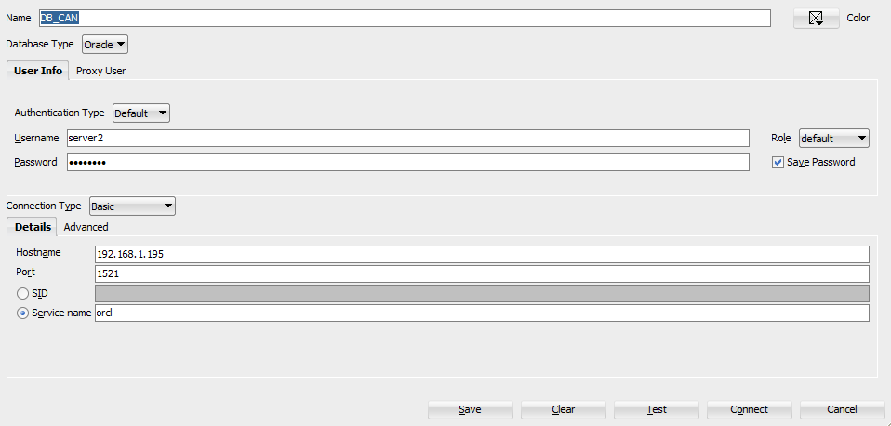

Figure Creating instances

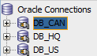

Figure Three instances with the three new users

# Step 2: Database for Headquarters (02 DB_HQ.sql)

Inside the DB_HQ instance, run only the script that creates database link, and tables. Do not run any “create view” code yet as the tables have not yet been created and will return an error, and also not the “create procedure”. See Figure 3.

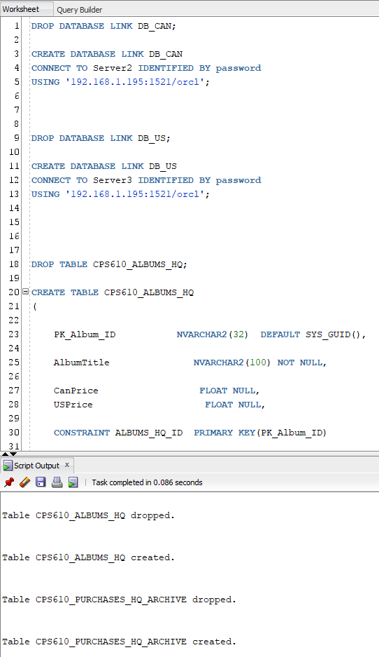

Figure Creating database link and tables in DB_HQ

# Step 3: Database for Canada (03 DB_CAN.sql)

Just like step 2, run only the portion of the code that creates database link, and new tables; ignoring the “create view”, and “create procedure” portion of the code. See Figure 4 for code output.

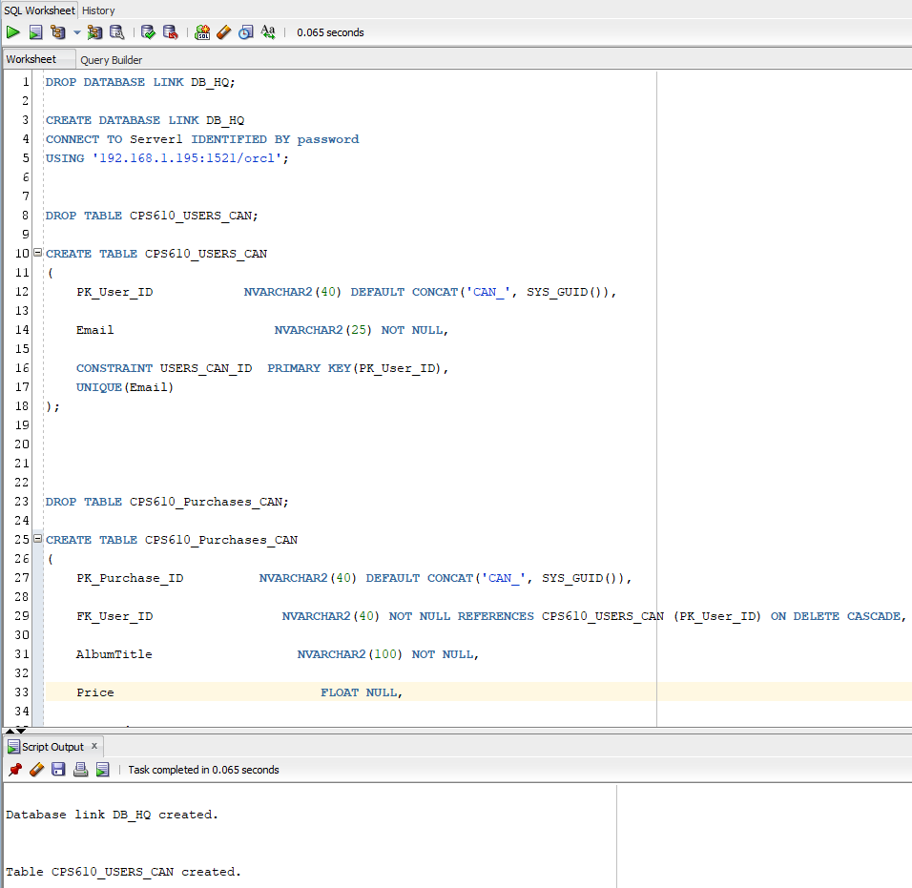

Figure Creating database link and tables in DB_CAN

# Step 4: Database for United States (04 DB_US.sql)

Just like steps 2 and 3, first run the portion of the code that creates database link, and new tables. But this time since all the tables needed have been created, run the “create view” and “create procedure”. See Figure 5 for code output.

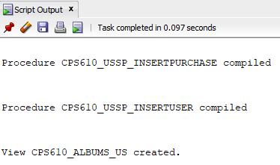

Figure Code output from DB_US.

# Step 5: Create View and Procedure for DB_HQ and DB_CAD

Go back to DB_HQ and run the “create view” and “create procedure”. Then go to DB_CAN and run the “create view” and “create procedure”. The various “views” in these files fulfil the fragmentation reconstruction requirement for lab 5. See Figure 6 and Figure 7 for code output. The procedures of locking fulfil the requirement for lab 7; see Figure 8.

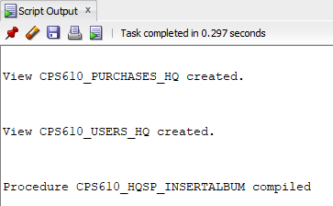

Figure Code output from DB_HQ

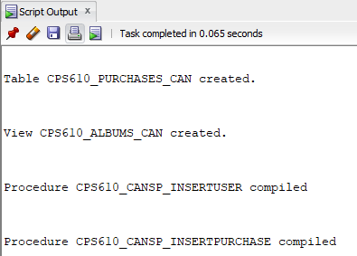

Figure Code output from DB_CAN

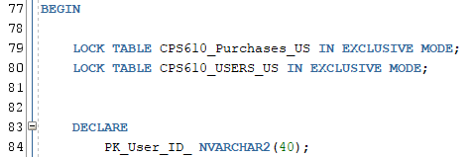

Figure Locking table

# Step 6: Populate dummy data to HQ (05 DB_HQ – Populate.sql)

This step is to create some dummy data to work on. This inserts some albums with album name, Canadian price, and US price. This fulfills the population requirement for lab 5. See Figure 8 for code output.

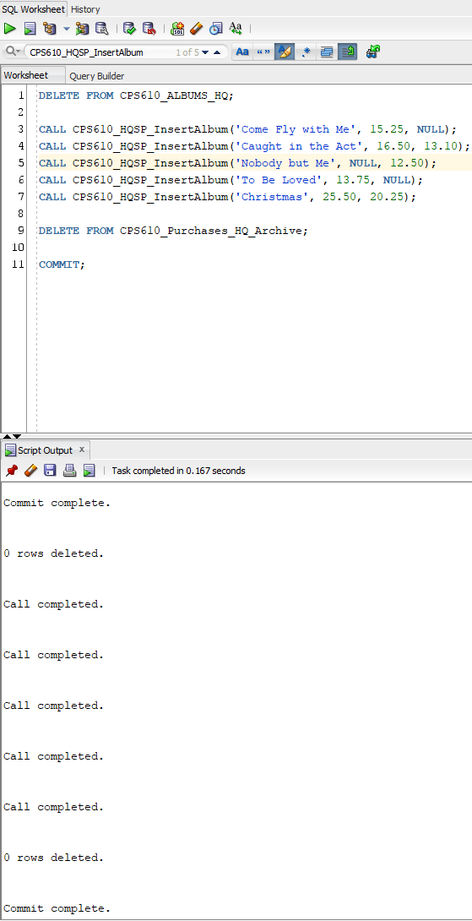

Figure Album data inserted to DB_HQ

# Step 7: Populate dummy data to DB_CAD (06 DB_CAN Populate.sql)

This will first insert some users, based on user email, using the procedural code, then insert purchases based on the user’s email address and album name. It will also select [user3@example.ca](mailto:user3@example.ca) and change the purchase date of the order with “Christmas” to 370 days ago. This fulfills the population requirement for lab 5. See Figure 9 for code output.

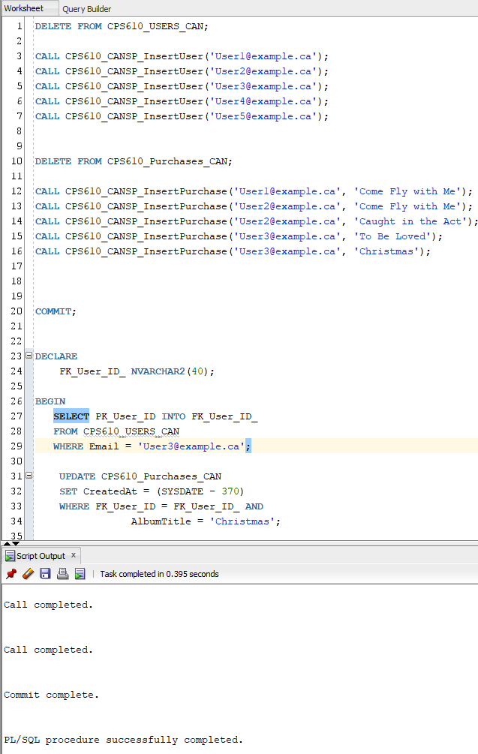

Figure Insert users, purchase records, and modifying purchase on DB_CAN.

# Step 8: Populate dummy data to DB_US (07 DB_US – Populate.sql)

Same as step 7, inserting some fake users into the US database, and also some purchases made by these users. The modify [user5@example.us](mailto:user5@example.us) Christmas purchase to 370 days ago. This fulfills the population requirement for lab 5. See Figure 10 for code output.

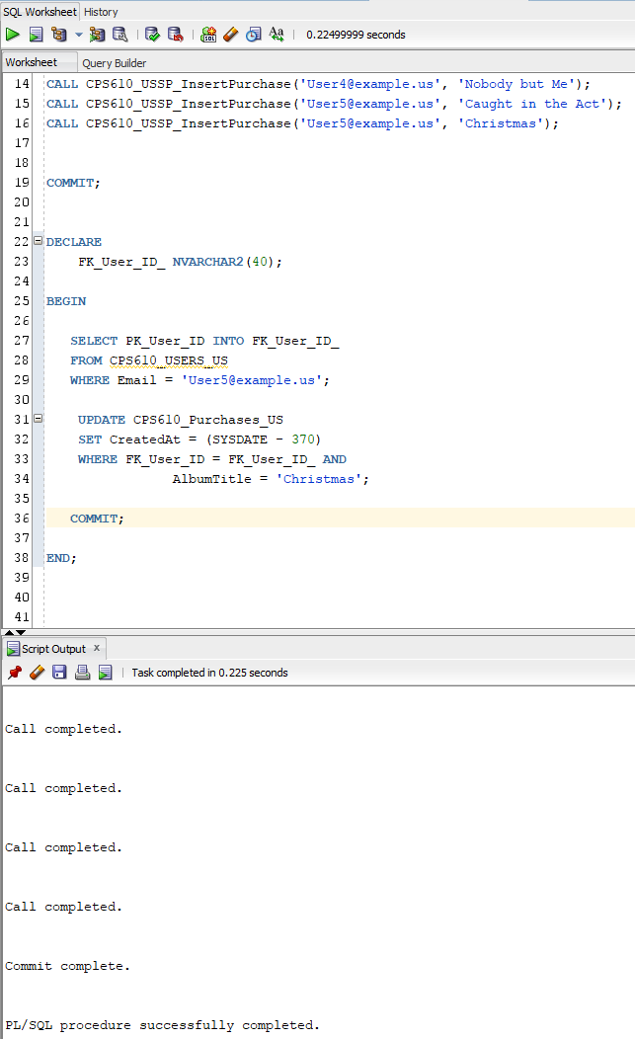

Figure Insert users, purchase records, and modifying purchase on DB_US.

# Step 9: Run procedure to achieve old orders (08 DB_HQ – Serial Transaction.sql)

This procedure first runs on the DB_CAN; finding all purchases that are at least a year old and move them to the archive table in DB_HQ. After moving the records, it will be removed from the purchase table in DB_CAN. The same procedure will then run on the DB_US. This fulfils the serial transaction requirement for lab 6. See Figure 11 for code output.

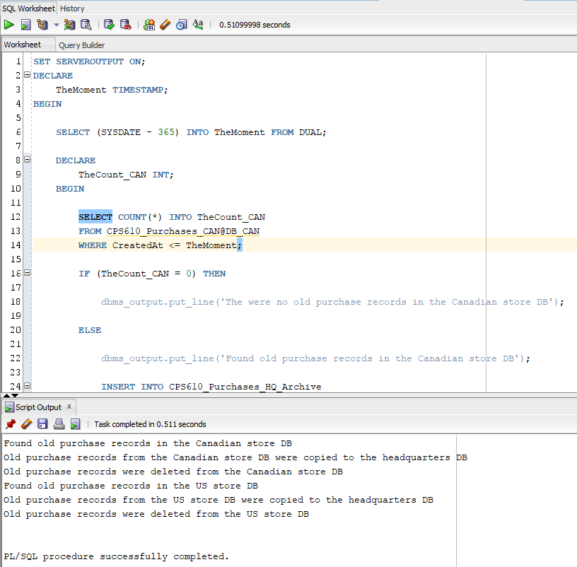

Figure Procedure to archive old purchase records

# Horizontal and Vertical Fragmentation Reconstruction

The CPS610_Purchases_HQ view showcases the reconstruction horizontal fragmentation and vertical fragmentation from the HQ based on data from 3 different sites. See below Figure 13.

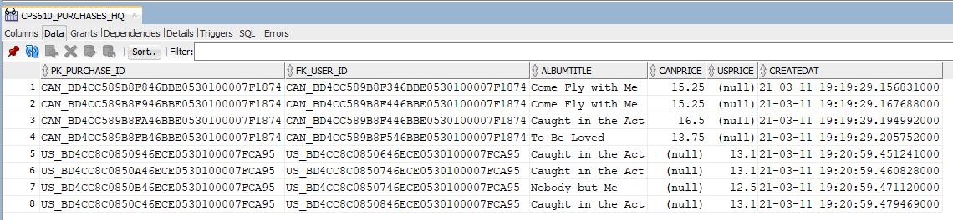

Figure 13 Horizontal and vertical fragmentation reconstruction  
  
Relational Algebra: CSP610_Purchases_HQ (View)

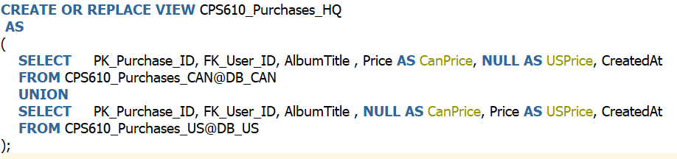

$$\prod{<PK_{Purchase_{ID}}, FK_{User_{ID}}, AlbumTitle, CanPrice, [NULL]>\left(CPS{610}_{Purchases_{CAN}}@DB_{CAN}\right)} ∪ \prod{<PK_{Purchase_{ID}}, FK_{User_{ID}}, AlbumTitle, [NULL], USPrice>\left(CPS{610}_{Purchases_{US}}@DB_{US}\right)}$$

# Relational Algebra: CPS610_Users_HQ (View)

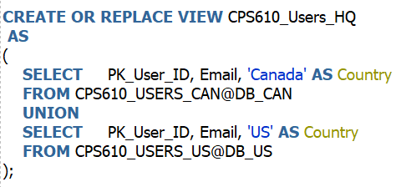

$$\prod{<PK_User_ID, FK_{User_{ID}}, Email, [Canada]>\left(CPS610_USERS_CAN@DB_CAN\right)} ∪ \prod{<PK_User_ID, FK_{User_{ID}}, Email, [US]>\left( CPS610_USERS_US@DB_US\right)}$$

# Relational Algebra: CPS610_ALBUMS_CAN (View)

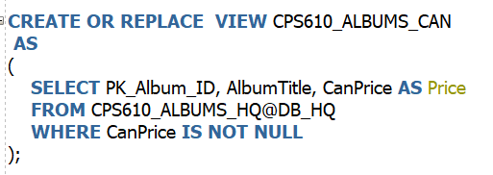

$$\prod{<PK_{Album_{ID}},AlbumTitle, Price>\left(σ_{CANPrice≠[NULL]}\right) \left(CPS610_ALBUMS_HQ@DB_HQ\right)}$$

# Relational Algebra: CPS610_ALBUMS_US (View)

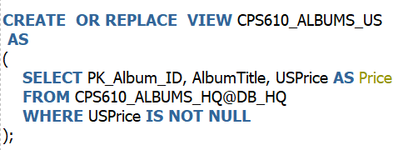

$$\prod{<PK_{Album_{ID}},AlbumTitle, Price>\left(σ_{USPrice≠[NULL]}\right) \left(CPS610_ALBUMS_HQ@DB_HQ\right)}$$