Assignment 5   
CPS610 – Database 2  
Wednesday Section – Group 13  
Member #1: Andy Lee (500163559)  
Member #2: Sohrab Soltani (500801172)

Contents

Introduction 2

Q1. Create 3 collections 2

Q2. Insert 10 students to Students collection. 3

Q3. Insert 5 professors into Profession collection 4

Q4. Insert 5 courses to Courses collection 5

Q5. List all the documents for… 6

Students 6

Professors 6

Courses 6

Q6. Use findOne() to find Students and Professors. 7

Q7. Retrieve top 5 newest student. 8

Q8. Update StudentNo 8

Q9. Changing all students from Sciences to Arts. 9

Q10. Find course description containing “advanced” 9

# Introduction

In this assignment, we build a simple database using MongoDB according to the assignment instructions.

# Q1. Create 3 collections

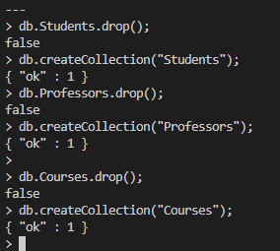

# Q2. Insert 10 students to Students collection.

|  |  |  |  |
| --- | --- | --- | --- |
|  |  |  |  |

# Q3. Insert 5 professors into Profession collection

|  |  |  |
| --- | --- | --- |
|  |  |  |

# Q4. Insert 5 courses to Courses collection

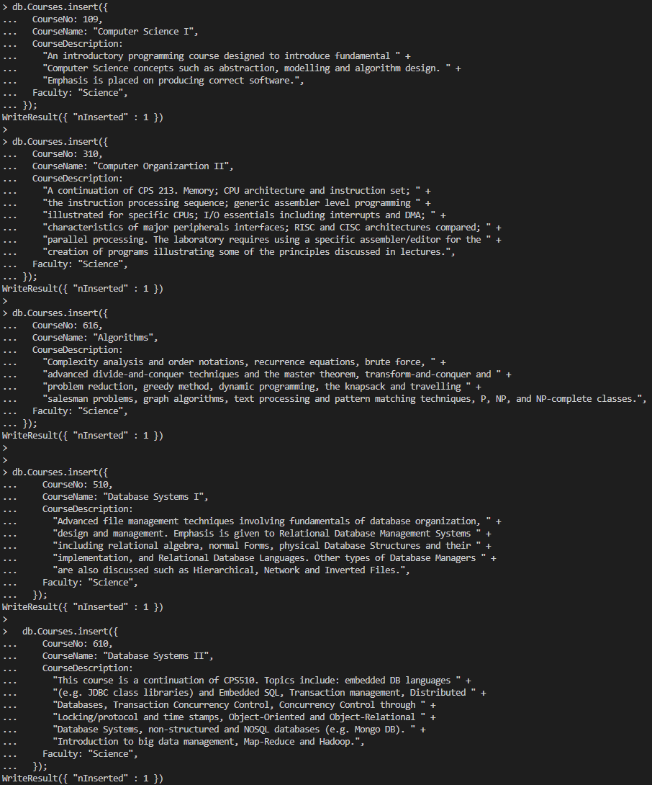

# Q5. List all the documents for…

## Students

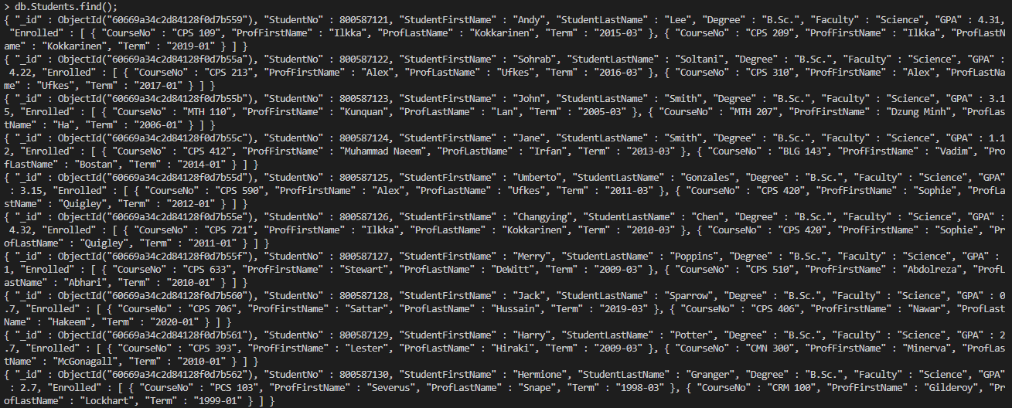

## Professors

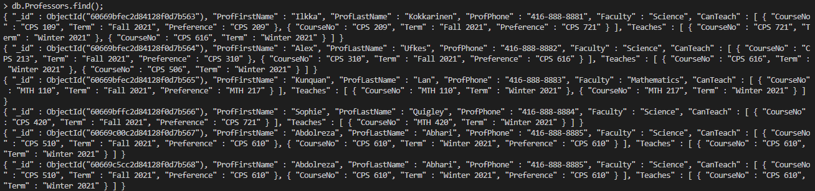

## Courses

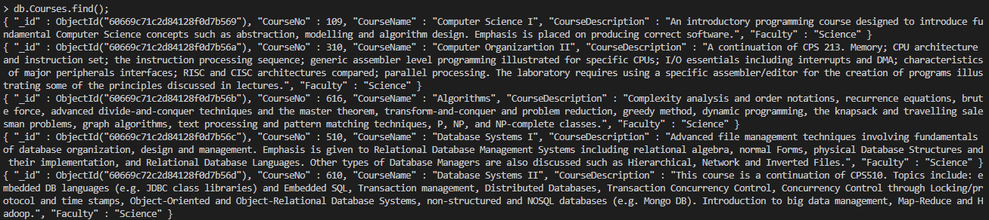

# Q6. Use findOne() to find Students and Professors.

|  |  |
| --- | --- |
|  |  |
|  |  |

# Q7. Retrieve top 5 newest student.

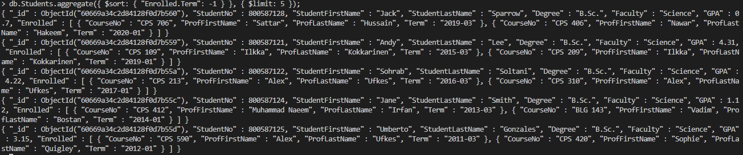

# Q8. Update StudentNo

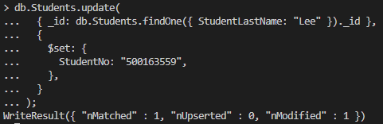

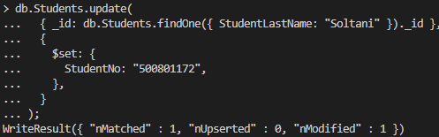

# Q9. Changing all students from Sciences to Arts.

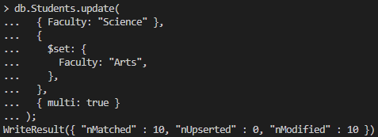

# Q10. Find course description containing “advanced”

