Assignment 6   
CPS610 – Database 2  
Wednesday Section – Group 13  
Member #1: Andy Lee (500163559)  
Member #2: Sohrab Soltani (500801172)

Table of Contents

20. Counting 'https' Occurrences 2

21. Count of Each Word in Documents 2

22. Mapper and Reducer for Wordcount 4

Figure 1 Sohrab's Q20 implementation 2

Figure 2 Andy’s Q20 implementation 2

Figure 3 Sohrab's Q21 implementation 2

Figure 4 Andy's Q21 implementation 3

Figure 5 Sohrab's Q22 implementation 4

Figure 6 Andy's Q22 implementation 4

# 20. Counting 'https' Occurrences

Part 1, 2



Figure Sohrab's Q20 implementation



Figure Andy’s Q20 implementation

# 21. Count of Each Word in Documents

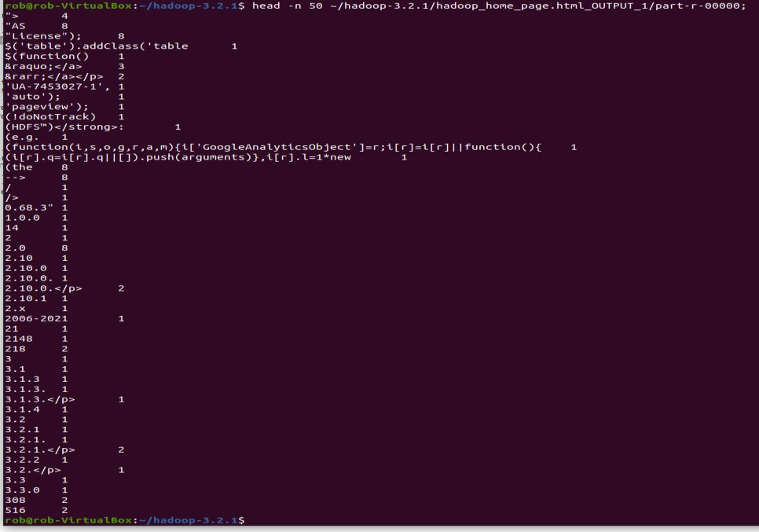

Figure Sohrab's Q21 implementation

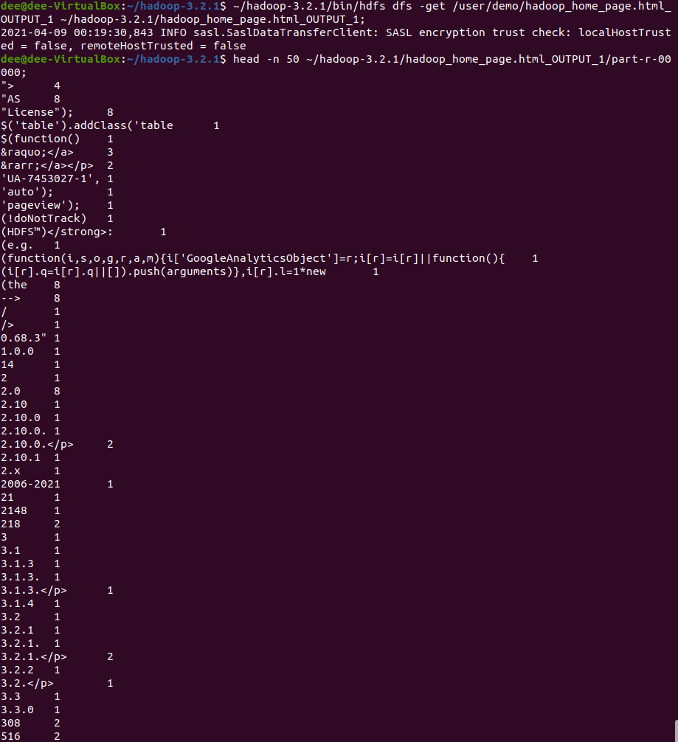

Figure Andy's Q21 implementation

# 22. Mapper and Reducer for Wordcount

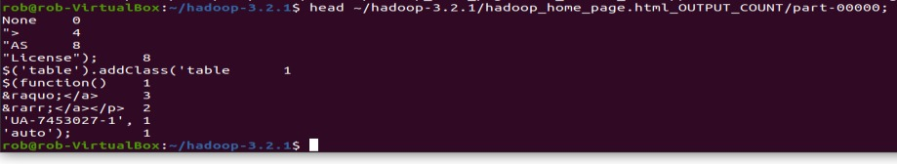

Figure Sohrab's Q22 implementation

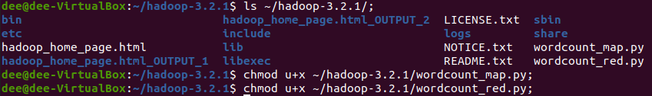

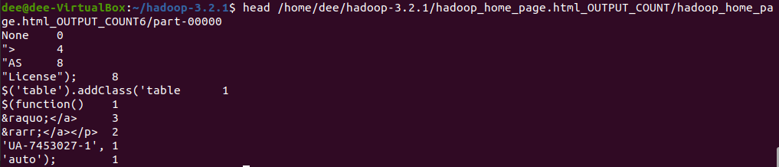

Figure Andy's Q22 implementation