Queensland University of Technology

Sprint 1 Retrospective

IFB299 – group 45

*Tutor: Mr Prakash Bhandari  
Date Submitted: 04/10/17*

|  |  |  |
| --- | --- | --- |
| STUDENT NAME | STUDENT NUMBER | ROLE |
| *Aiden Bird* | n9900489 | Product Owner |
| *Andrew Grant* | N9495291 | Developer |
| *Gyeongmin Jee* | N9665072 | Developer |
| *Sandra Finow* | N9144757 | Scrum Master |

sprint 1 retrospective

ifb299 – group 45

# TEAM communication

* *Excellent presentation of what you did (or/and did not do) well, and what you do differently next time for the communication within the team*
* *No spelling or grammatical errors*

For Sprint 1, group 45 had effective communication standards and consider it a characteristic that was done well. On top of our weekly meetings in class for our tutorials, group 45 held two weekly online meetings via *Slack* also. This ensured all team members could keep up to date with the project and were able to effectively communicate any issues or queries to the rest of the team that were either encountered during the tutorial work, homework tasks, or individual tasks related to completing the objectives for the first sprint. This also enabled all team members to proactively collaborate and enabled a formidable team environment to be built. To ensure the weekly meetings were easy to log and search, we created different weekly channels on *Slack*, such as #week1, #week2, #week3, and so forth. Five examples of our weekly online communications can be found in the *Appendices* under *Figure 1 – 5*.

Despite having two online meetings a week, as they were online meetings instead of face-to-face meetings, it meant that the meetings were quite slow and often took longer than anticipated for multiple reasons. One reason is that when talking online, communication can often be wrongly interpreted as there is no proper tone or pitch. Another reason is that online chat often goes by quickly, and different members often sent messages concurrently, causing some confusion and making it difficult to understand and keep up with everyone’s ideas or issues individually. Additionally, it is hard to really know if all members are actively monitoring the messages sent, or just tuning in occasionally.

As such, group 45 will need to modify the way they communicate throughout the week. Instead of holding two online meetings on *Slack*, one meeting can be changed to a *Skype* call meeting. This ensures all members are actively involved in the meeting and mitigates the issue of members typing messages concurrently and making the meeting difficult to follow along with. Also, as the meeting is done in real time, it should aid in the duration of the meetings not exceeding anticipated time and additionally alleviates the issue of members only tuning in occasionally into *Slack* meetings. This method of meeting does mean that there is no exact record of conversation though, and as a result of this will be tested out to see if this method is ideal.

# TEAM PARTICIPATION

* *All requirements or feedback from the tutor and client are well recorded and integrated*
* *Demonstrates team has discussed, agreed (or not agreed) and taken responsibility for the contents*

Requirements from the tutor and client in relation to both the sprint and weekly workshop tasks have been recorded on Slack during the weekly meeting. Additionally, the agreed taken responsibility for the contents was presented in the Meeting Minutes documentation created by the SCRUM Master for all members to view (Git location: [IFB299-group45](https://github.com/hemel7/IFB299-group45)/**Meeting_Minutes.docx**).

During group meetings, the tasks the group needed to complete were outlined by the group’s scrum master. The group members were then able to discuss between themselves and choose which of these tasks each member would complete, and when these tasks were to be completed by. Evidence of these discussion can be seen in Figures 6, 7 and 8 in the Appendices.

Tutor’s feedback from the sprint and release plan suggested that group 45 rethink the time to be time the group would spend working on the tasks of the sprint stages, as such, the group modified their sprint plan to incorporate these key points. Added more user stories and tasks to be completed in the first week, as well as adjusting the time estimated to complete certain tasks to a more realistic estimate. This was done after completing one user story and comparing the time taken to the time initially predicted. With this experience the team could more accurately estimate the amount of time each task would take the members.

Feedback from the tutor also informed the group that the period initially allocated for their burndown chart of 28 days was incorrect (Figure 9 in the Appendices), and thus, the number of tasks that the group needed to complete per day had to be recalculated for the new period of 20 days (Figure 10 in the Appendices). After examining the group’s newest burndown chart, the tutor suggested that the burndown chart’s function for the estimated tasks to complete over time should be a straight line. The burndown chart was therefore changed again to implement this feedback (Figure XX in the Appendices).

# PROJECT QUALITY CONTROL

* *All artefacts are monitored to ensure that the project complies with the quality standards.*
* *Quality standards are measurable.*

All artefacts were uploaded to GitHub repository to allow other members to download and review all creations. These artefacts were compared against our initially made acceptance criteria on JIRA and sprint plans to ensure they always followed quality standards.

Individually, we have managed to ensure most artefacts are implemented. In our meetings, we discussed what each member are supposed to do for the week. This ensured that we are following the sprint plan and cover most of our artefacts.

Each member with different roles we’re unaware of each other’s artefacts. This made it difficult for others to point out errors and mistakes made by members with different roles. In many cases, members have failed to check other members’ works to ensure it meets the acceptance criteria. This was also due to members being not proficient with Python and Django framework.

In the next sprint, each member must be fully aware of the artefacts different roles must complete. Each week the team must remind each other of different artefacts that need to be improved. As most members are now familiar with the language and framework, they should actively proof read each other’s work.

# INFORMING TUTOR AND CLIENT

* *All due dates of milestones and/or artifacts are clearly documented and showed to the client.*
* *The client or tutor receives all deliverables on time.*

All due dates and/or artefacts are clearly documented and showed to the client through Slack and Github. Each deliverable was uploaded prior to the workshop it was due, to ensure no late submission and in-case of any issues with submission. No issues were raised and all submissions were successful to the Tutor and Client.

# issues raised

* *Clear descriptions of all major and minor issues or problems that have hampered (or will hamper) the progress of the project*

A major issue which hampered the progress of the project was the fact that group 45 had other commitments such as work and other university units. Because of this, time spend dedicated to this sprint and its associated tasks were reduced significantly.

Another major issue was the fact that one group member was unable to get their Django tutorial to work and resulted in other group members having to help debug and assist in fixing their Django tutorial work. Additionally, their mySQL was not able to function properly after installation and caused many errors while trying to connect it to the Django framework. These two occurrences reduced time spent on the sprint individually and as a group. Moreover, this group member had to get their laptop repaired, limiting them to only work on their coding whilst at home on their desktop. This also made the debugging process harder and longer as no other members were able to see the files and errors in real time.

*“*Aiden is having issues with installing MYSQL to Python. When he attempts a pip install he gets an error. This error has been searched and the only results so far have not worked or been helpful. At the moment he is only able to do non-database work.*”*

# APPENDICES

**Figure 1.** Example of a communications segment from one Week 1 team meeting on *Slack.*  
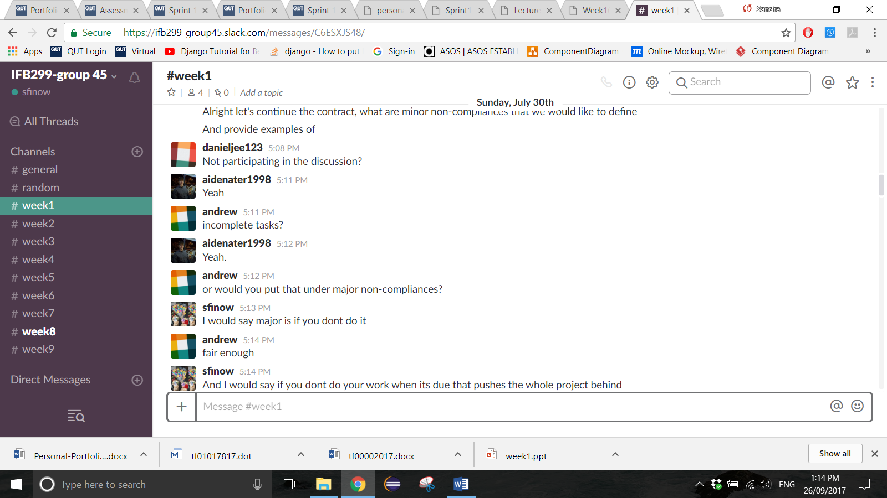

**Figure 2.** Example of a communications segment from one Week 2 team meeting on *Slack.*

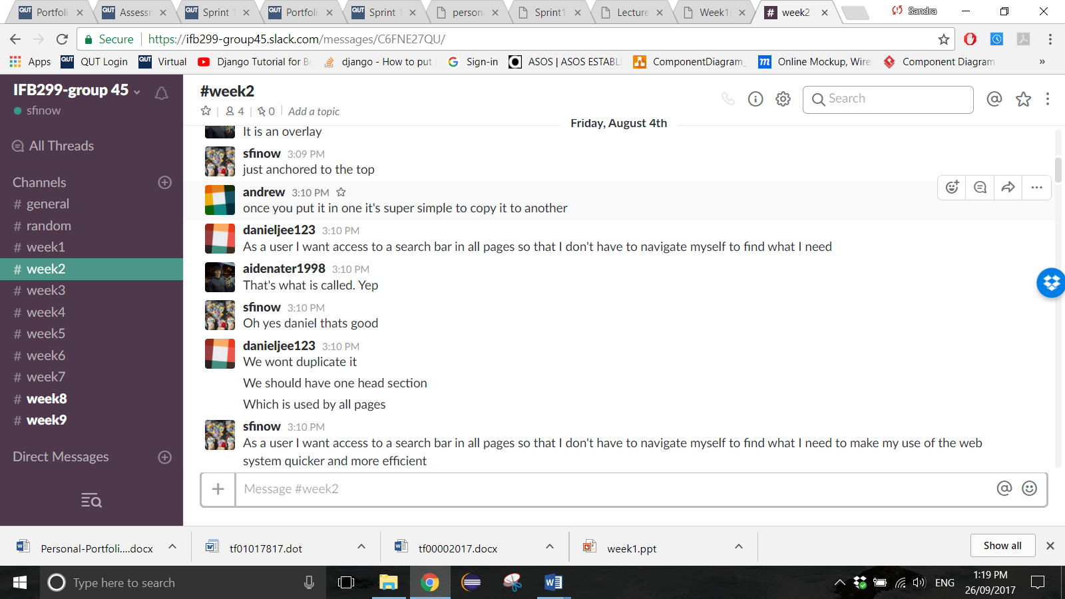

**Figure 3.** Example of a communications segment from one Week 3 team meeting on *Slack.*

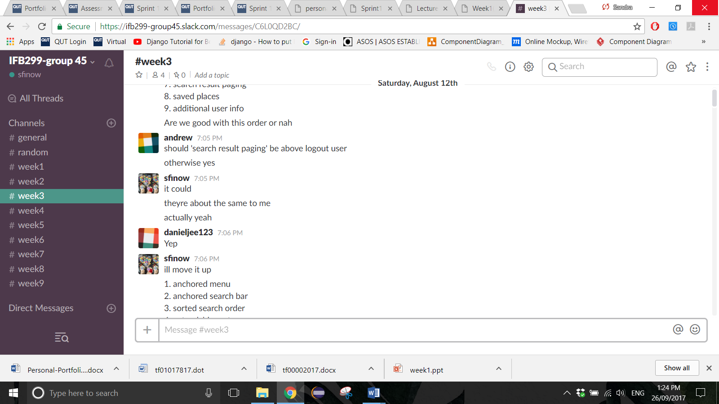

**Figure 4.** Example of a communications segment from one Week 4 team meeting on *Slack.*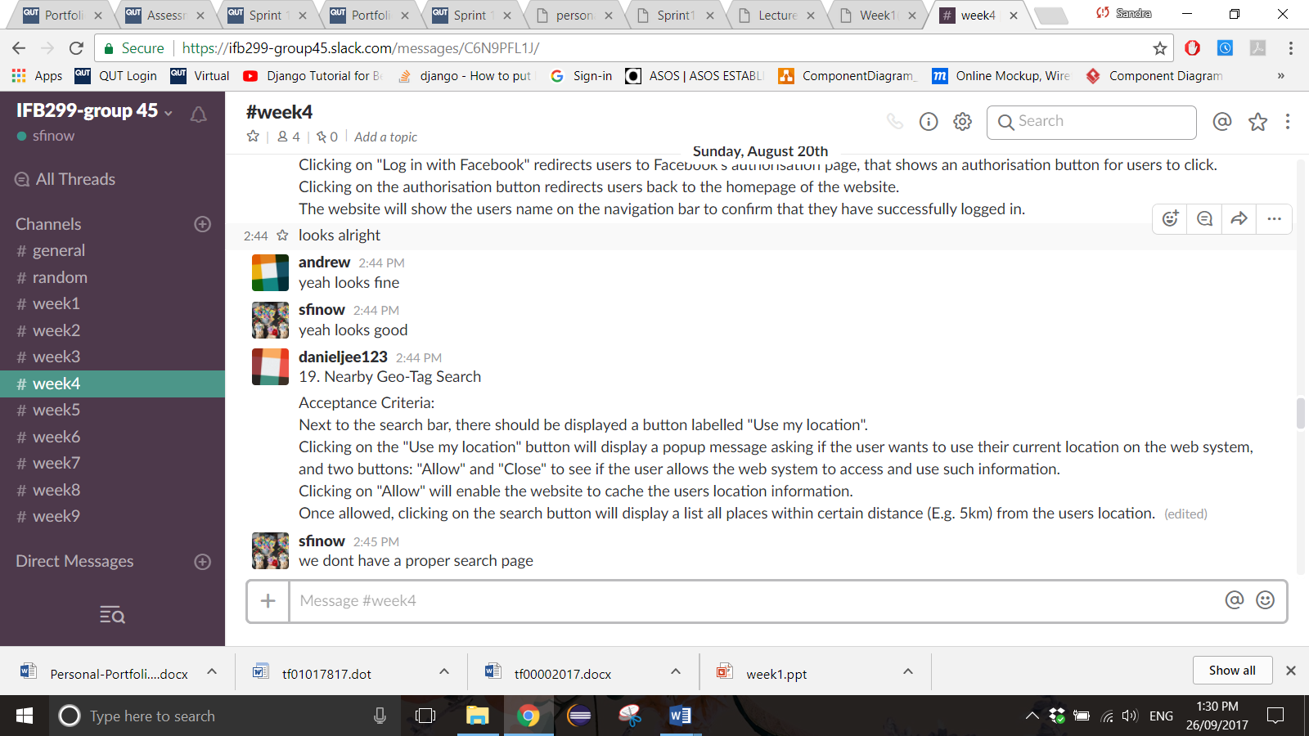

**Figure 5.** Example of a communications segment from one Week 5 team meeting on *Slack.*

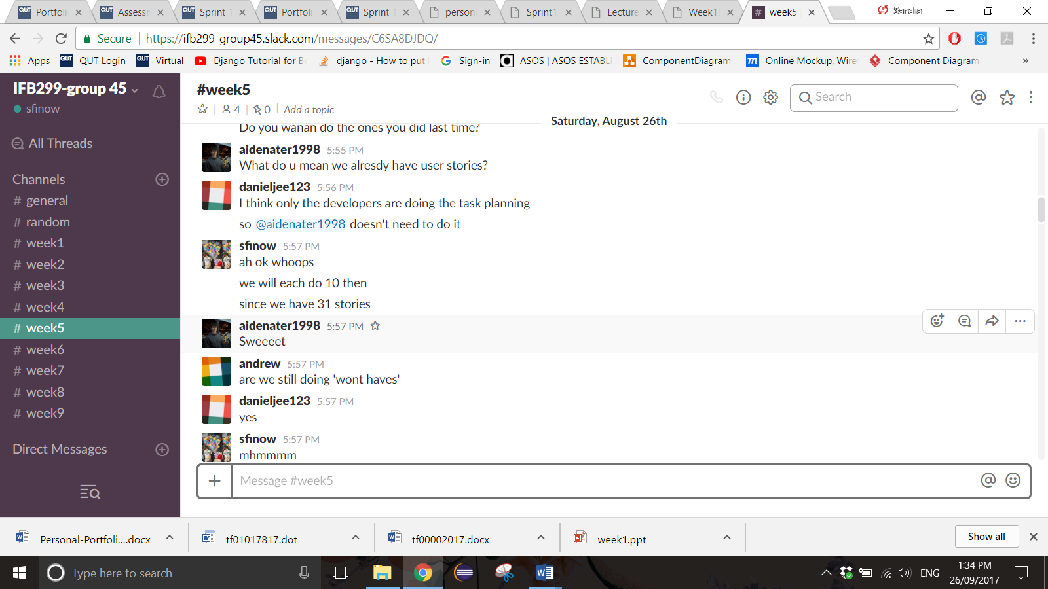

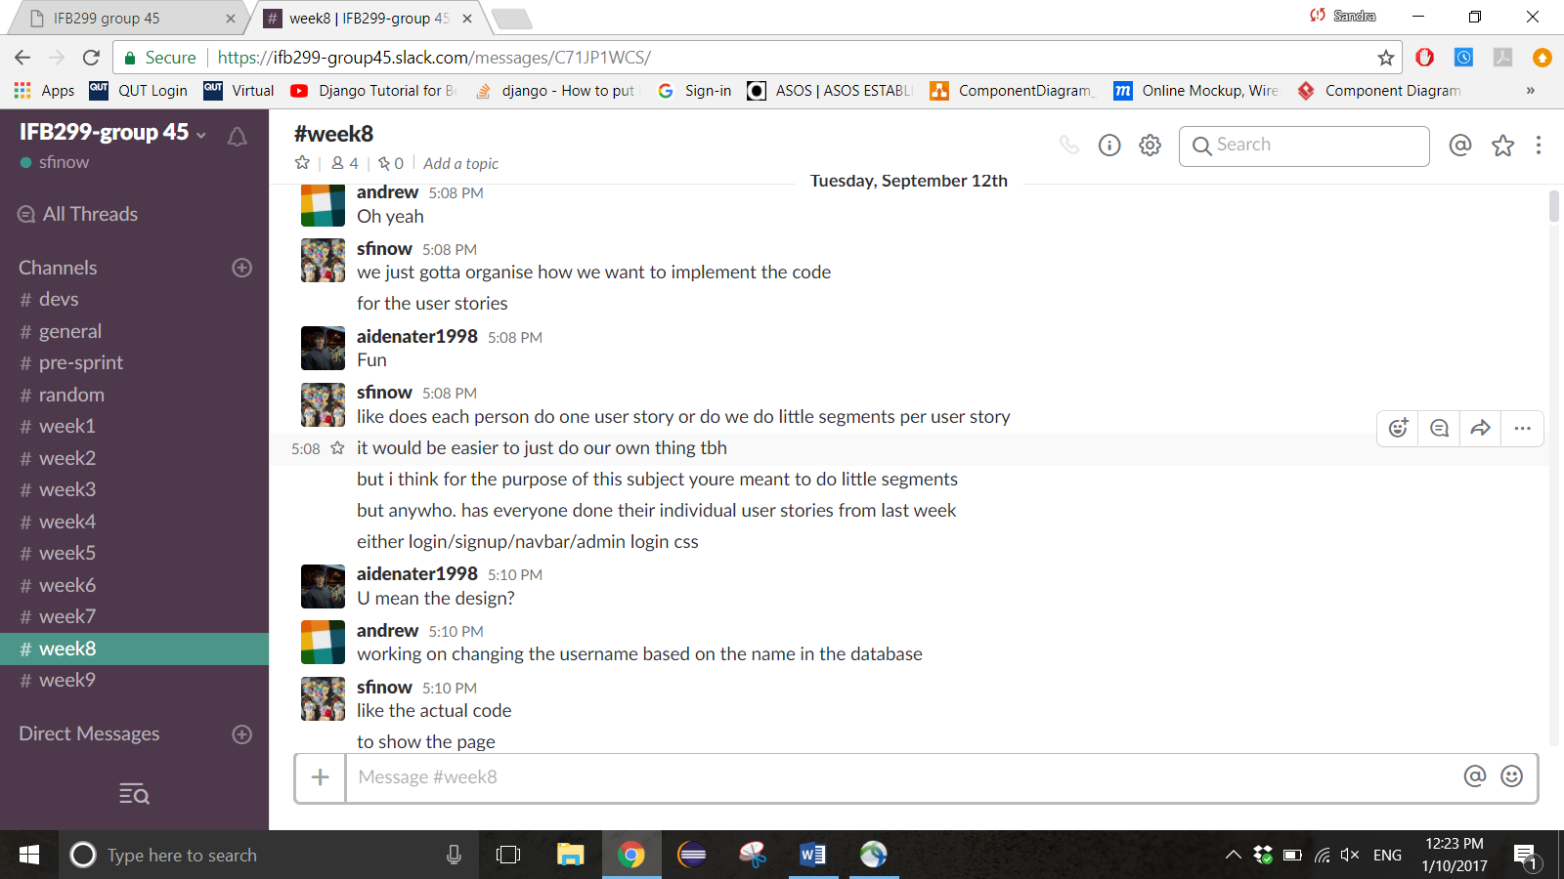

Figure 6. Evidence of discussion about confiromation of organisation of responsiblities

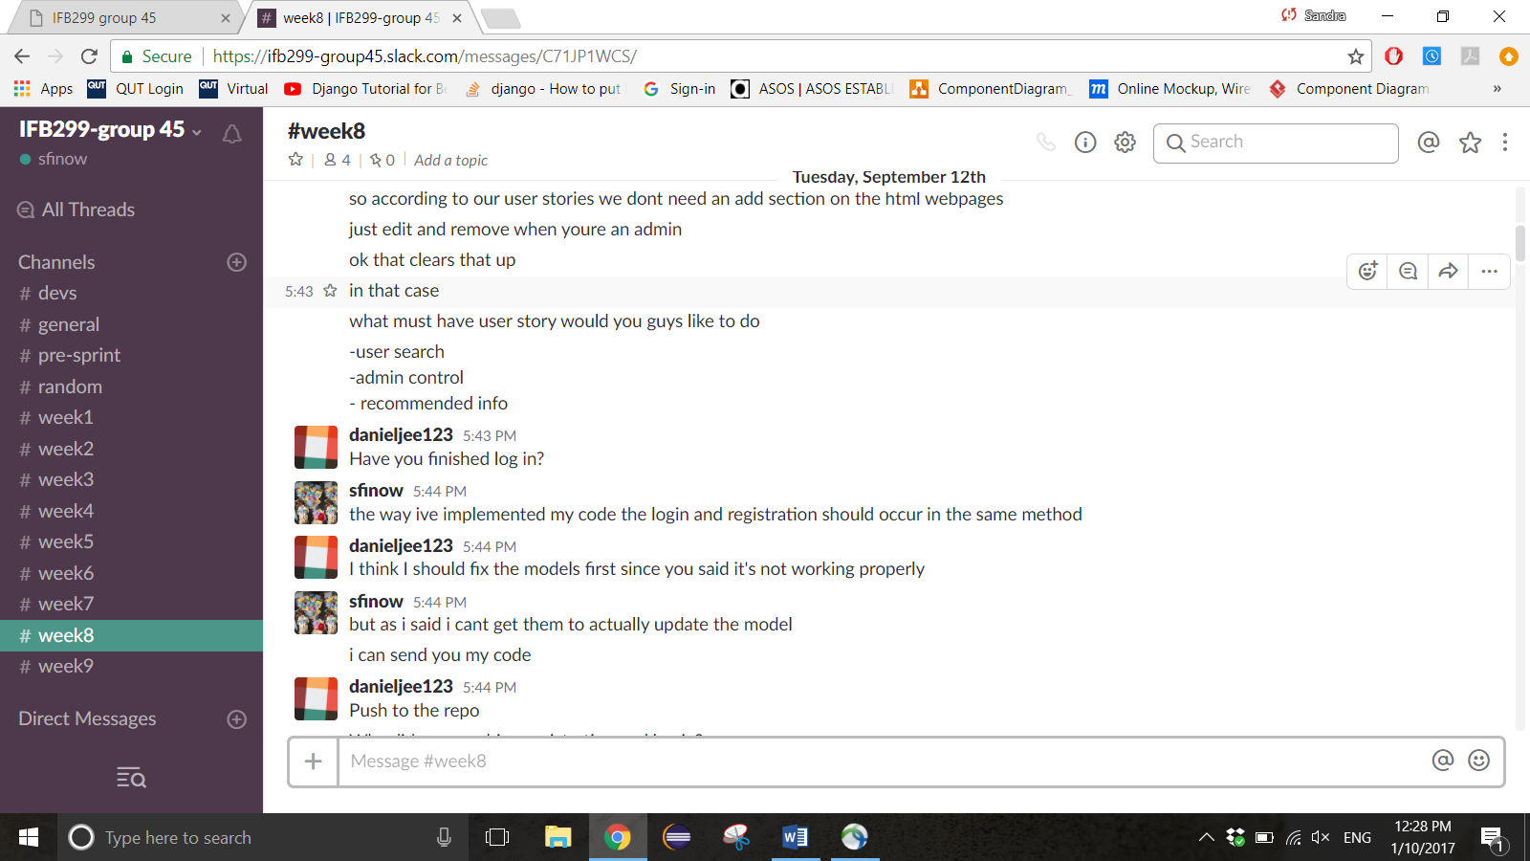

Figure 7. Evidence of discussion about confiromation of organisation of responsiblities

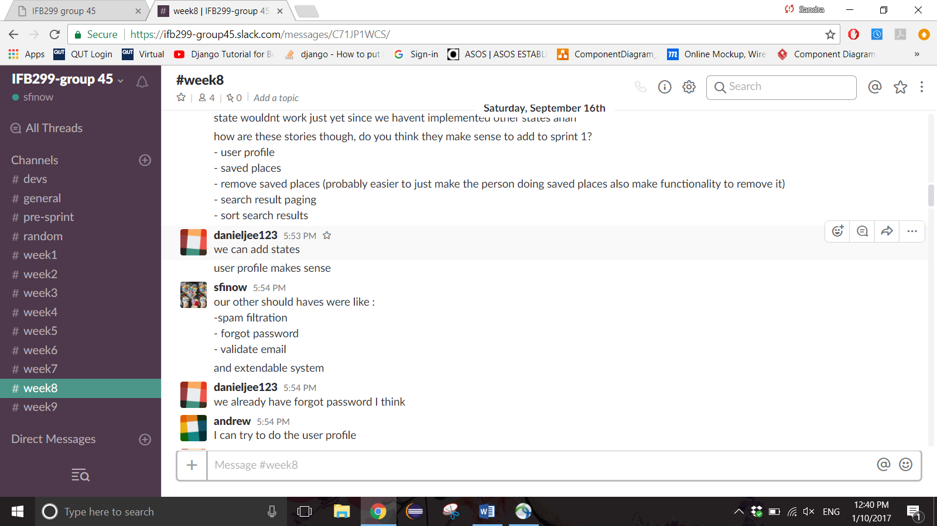

Figure 8. Evidence of discussion about confiromation of organisation of responsiblities

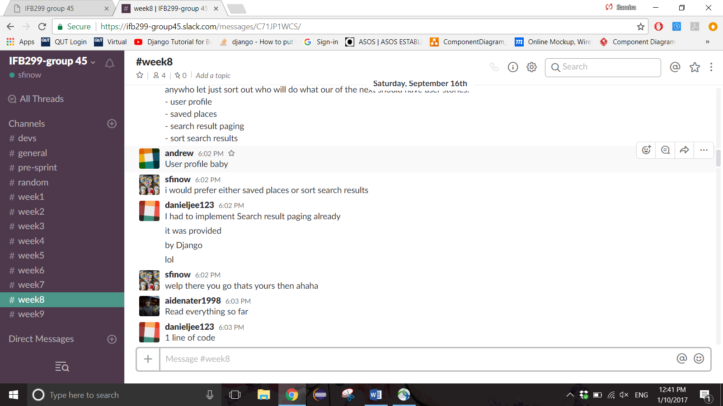

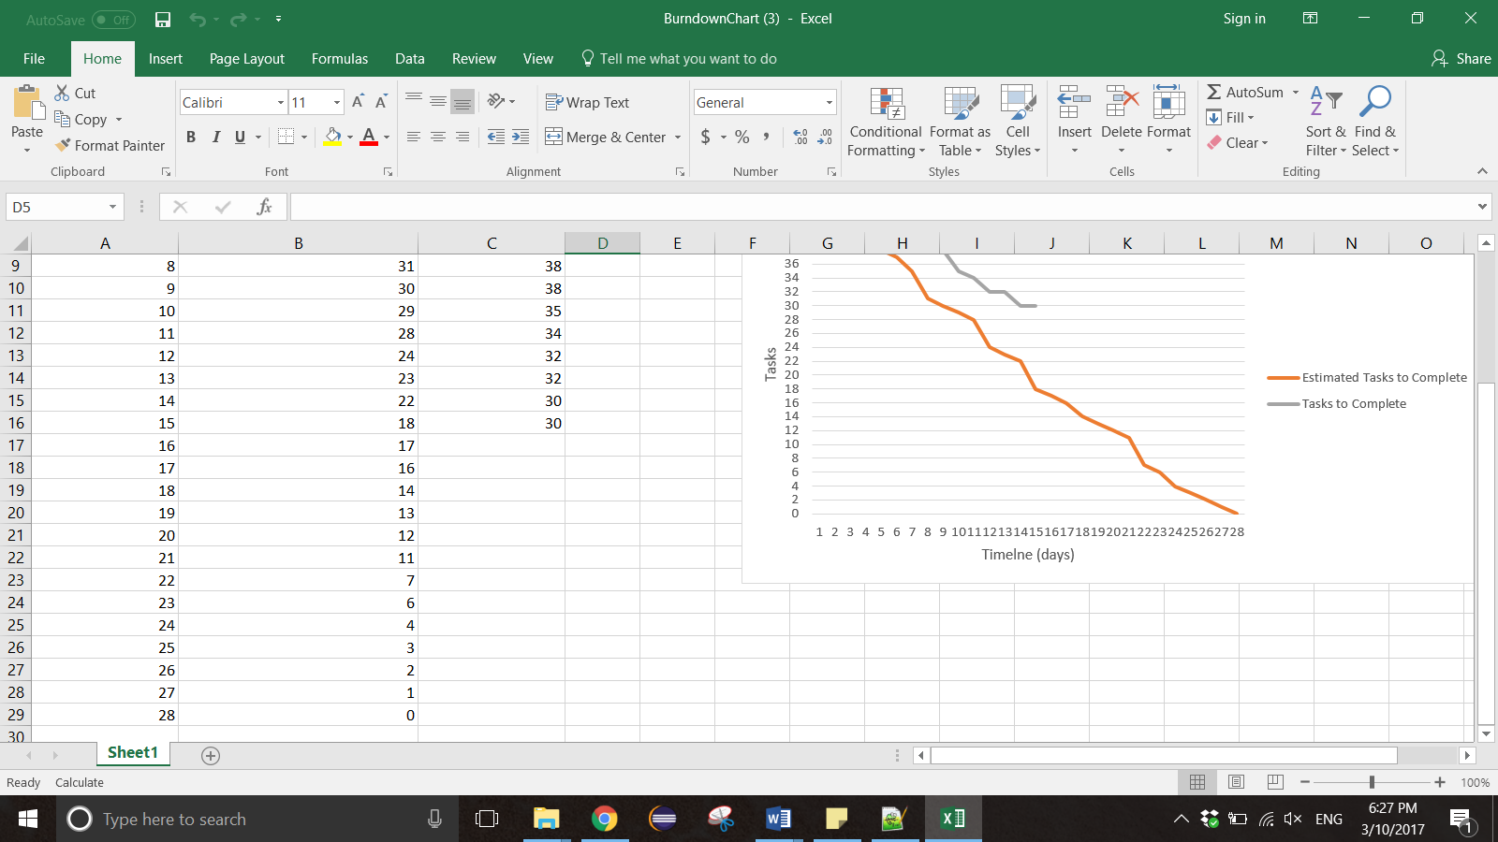Figure 9. Initial Burndown Chart before tutor’s feedback

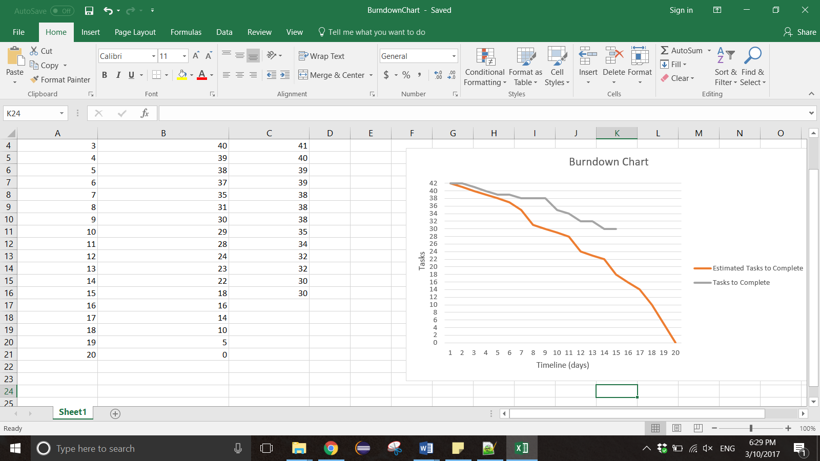

Figure 10. Burndown Chart after receiving tutor’s feedback (duration changed to 20 days)