Project Proposal – Movie Database

**Kakiuthi, Daniel [ID: 444331]**

**Conceicao, Rafael [ID: 441227]**

**Helen Gebrekidan [ID:412428]**

Software Development, Bow Valley College

SODV2101: Rapid Application Development

Instructor: Dima Marachi

Date: 2023-10-10

Project Proposal – Movie Database

**OVERVIEW**

We propose to design and implement a Movie Database Application, inspired by IMDb, as a larger-scale project for our course. This application will enable users to explore and search for information about movies, including details such as cast, crew, release dates, ratings, reviews, and more. Our project will encompass various key topics covered in this course, such as event-driven programming, user interfaces, data connections, concurrent programming, and potentially networking.

**APPLICATION PURPOSE**

The Movie Database Application will serve as a comprehensive platform for movie enthusiasts, providing them with a user-friendly interface to access detailed information about movies. Users can search for movies, discover trending films, read reviews, and explore cast and crew information.

**KEY FEATURES**

Movie Search: Users can search for movies by title, genre, actor, director, or release year. The application will do asynchronous API calls to get data from online sources.

Movie Details: Detailed movie profiles will be available, including cast, crew, plot summary, release date, ratings, and user reviews.

Movie Images and trailers: Users can view movie media content.

User Reviews: Registered users can rate and write reviews for movies they have watched.

User Authentication: Users can create accounts, log in, and manage their profiles.

Admin Panel: Administrators can manage movie information, moderate user reviews, and ensure data accuracy.

Data Synchronization: The application will periodically update its movie data from API.

Event-Driven Features: Implement event-driven features, such as real-time notifications for new reviews and movie releases.

**Supporting Materials**

To get the movies data, we plan to use a combination of APIs to get all the data that we need, like:

* <https://developer.themoviedb.org/docs>
* <https://www.omdbapi.com/>

We may use other APIs besides these two if we need any other data (for example links to get movie trailers). We will be able to relate data from different sources because, from our research, most movies APIs seem to use common ID for movies (imdb_id and/or tmdb_id).

**Initial UML Diagram**

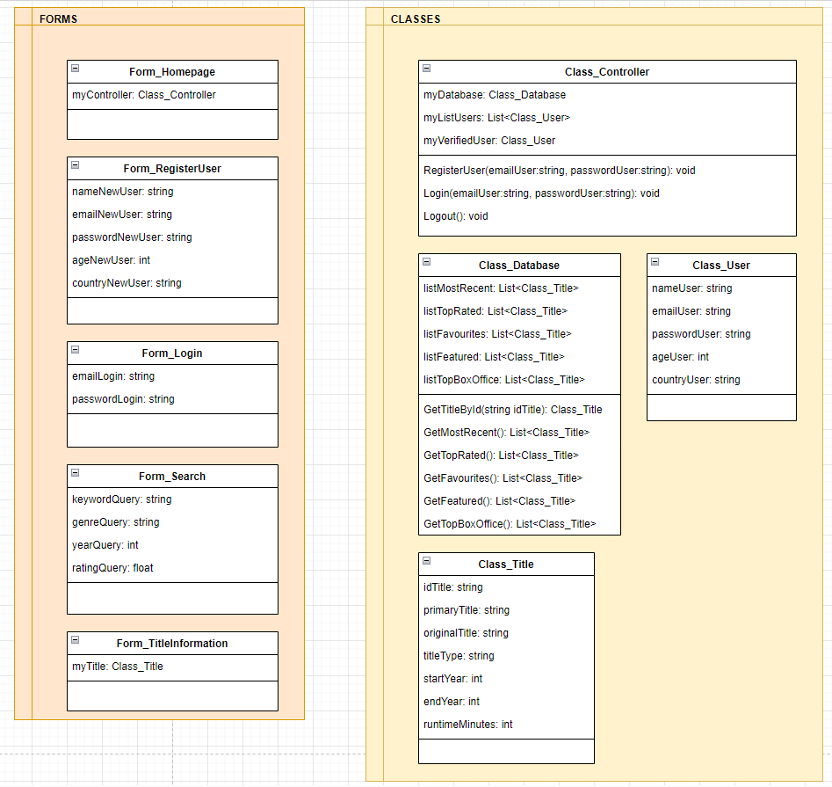

Note: The diagram above represents our preliminary design concept and may undergo refinements as we proceed with development.

**Work Distribution**

To ensure efficient progress, we propose the following division of tasks among team members:

Rafael Conceicao: Frontend development, user interface design, and event-driven features.

Daniel Kakiuthi: Backend development, data retrieval, and data synchronization.

Helen Gebrekidan: User authentication, user profile management, database management, admin panel implementation.