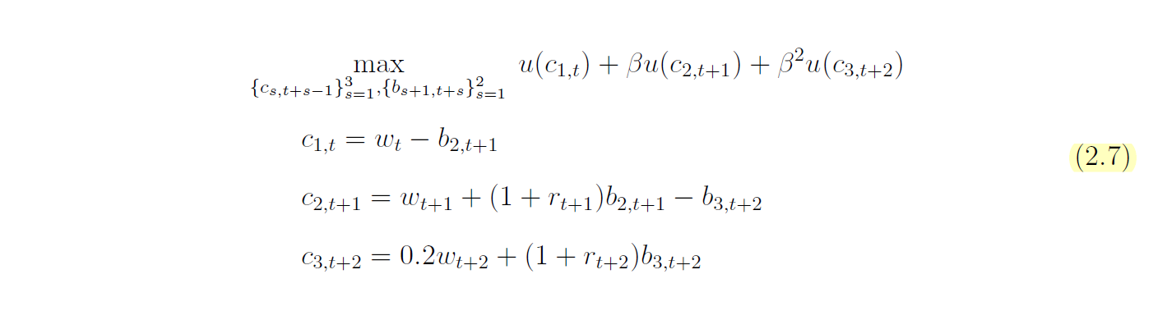

1. HH

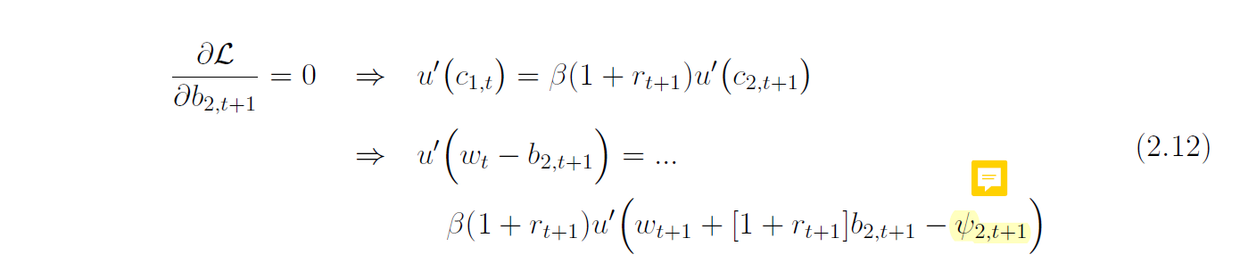

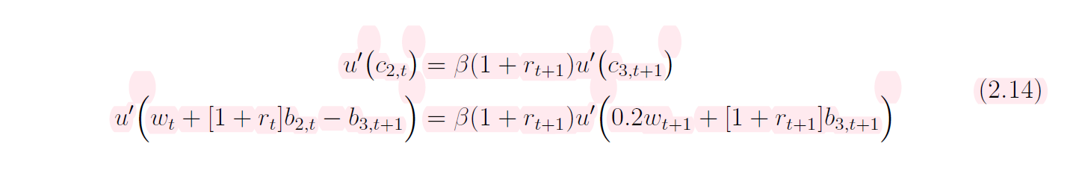

1. Firms

3. 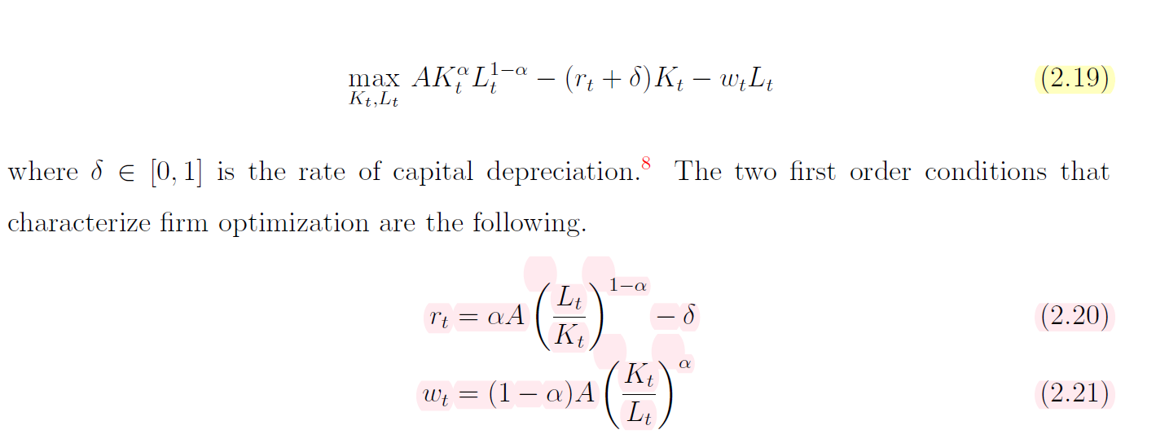

3. Market Clearing

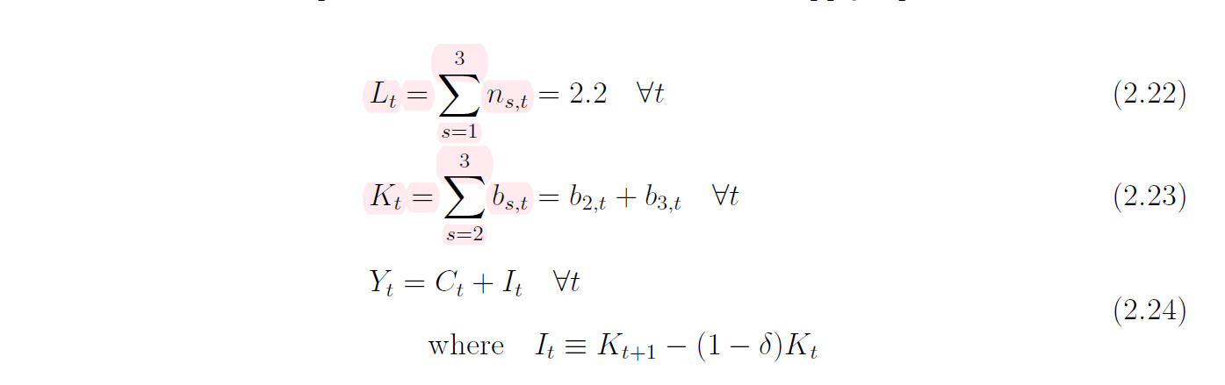

Time step iteration

1. Guess T
2. Guess K transition to T (L is fixed)
3. Guess b_21, b_31 so that they sum up to K
4. Find r, w, transitions through market clearing eqs
5. Solve for b_32 from

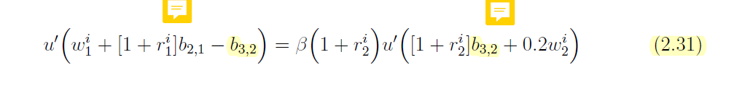

1. Solve for b22, b33 through

