Analysis of Transport North Bound Interface Use Case 3  
draft-tnbidt-ccamp-transport-nbi-analysis-uc3-00

Status of this Memo

This Internet-Draft is submitted in full conformance with the provisions of BCP 78 and BCP 79.

Internet-Drafts are working documents of the Internet Engineering Task Force (IETF), its areas, and its working groups. Note that other groups may also distribute working documents as Internet-Drafts.

Internet-Drafts are draft documents valid for a maximum of six months and may be updated, replaced, or obsoleted by other documents at any time. It is inappropriate to use Internet-Drafts as reference material or to cite them other than as "work in progress."

The list of current Internet-Drafts can be accessed at http://www.ietf.org/ietf/1id-abstracts.txt

The list of Internet-Draft Shadow Directories can be accessed at http://www.ietf.org/shadow.html

This Internet-Draft will expire on March 20, 2009.

Copyright Notice

Copyright (c) 2017 IETF Trust and the persons identified as the document authors. All rights reserved.

This document is subject to BCP 78 and the IETF Trust’s Legal Provisions Relating to IETF Documents (http://trustee.ietf.org/license-info) in effect on the date of publication of this document. Please review these documents carefully, as they describe your rights and restrictions with respect to this document. Code Components extracted from this document must include Simplified BSD License text as described in Section 4.e of the Trust Legal Provisions and are provided without warranty as described in the Simplified BSD License.

Abstract

This document analyses how YANG models being defined by IETF (TEAS and CCAMP WG in particular) can be used to support Use Case 1 (single-domain with single-layer) scenarios as referenced later in this document.

Table of Contents

1. Introduction 3

1.1. Assumptions 3

1.2. Feedbacks provided to the IETF Working Groups 3

2. Conventions used in this document 4

3. Scenario Overview 5

3.1. Topology Abstraction 7

3.1.1. Single Domain Topology 7

3.1.2. Multi-domain Topology Stitching 7

3.2. Multi-domain Service Configuration 8

3.2.1. Procedure Description 9

3.2.2. ODU Transit Service / OTN Client Private Line Service 9

3.2.3. EPL over ODU Service 10

3.2.4. Other OTN Client Services 10

3.3. Protection Scenarios 10

3.3.1. Linear Protection (end-to-end) 10

3.3.2. Segmented Protection 10

4. Topology Abstraction: detailed JSON examples 10

5. Service Configuration: detailed JSON examples 10

5.1. ODU Transit Service 10

6. Security Considerations 10

7. IANA Considerations 10

8. Conclusions 11

9. References 11

9.1. Normative References 11

9.2. Informative References 11

10. Acknowledgments 11

Appendix A. Validating a JSON fragment against a YANG Model 13

A.1. DSDL-based approach 13

A.2. Why not using a XSD-based approach 13

A.3. JSON Code: use-case-1-topology-01.json 14

A.4. JSON Code: use-case-1-topology-01.json 14

# Introduction

This document analyses how YANG models developed by IETF (TEAS and CCAMP WG) can be used to support Use Case 3 (multi-domain with single-layer) scenarios as described in [TNBI-UseCases].

## Assumptions

This document is using the ACTN [ACTN-fwk] as an architecture that deploys the IETF models. The motivation of this draft is to analyze how existing IETF models can be used on the MPI between the PNC and the MDSC to support the use case 3 scenarios as defined in section 5 of [TNBI-UseCases].

This document assumes the applicability of the YANG models to the ACTN interfaces as defined in [ACTN-YANG] and therefore considers the TE Topology YANG model defined in [TE-TOPO], with the OTN Topology augmentation defined in [OTN-TOPO] and the TE Tunnel YANG model defined in [TE-TUNNEL], with the OTN Tunnel augmentation defined in [OTN-TUNNEL].

The analysis of how to use the attributes in the I2RS Topology YANG model, defined in [I2RS-TOPO], is for further study.

Moreover this document is making the following assumptions, still to be validated with TEAS WG:

1. The MDSC can request, at the MPI, the Transport PNC to setup a Transit Tunnel Segment using the TE Tunnel YANG model: in this case, since the endpoints of the E2E Tunnel are outside the domain controlled by the Transport PNC, the MDSC would not specify any source or destination TTP (i.e., it would leave the source, destination, src-tp-id and dst-tp-id attributes empty) and it would use the explicit-route-object list to specify the ingress and egress links of the Transit Tunnel Segment.
2. The Transport PNC provides to the MDSC, at the MPI, the list of available timeslots on the access links using the TE Topology YANG model and OTN Topology augmentation. The TE Topology YANG model in [TE-TOPO] is being updated to report the label set information.

## Feedbacks provided to the IETF Working Groups

The analysis done in this version of this document has triggered the following feedbacks to TEAS WG:

* On-going discussion about how to use the TE Tunnel YANG model in [TE-TUNNEL] to support tunnel segments.
* Need to change TE Tunnel YANG model in [TE-TUNNEL] to clarify that the router-id and interface-id attributes in the unnumbered explicit-route-object corresponds to the te-node-id and te-tp-id attributes identifying an LTP in the TE Topology YANG model.
* Need to add information about the label set (e.g., list of available timeslots) in the TE Topology and TE Tunnel YANG models.
* Some detailed fixes to the TE Tunnel YANG model in [TE-TUNNEL] have also been identified during the validation of the JSON examples against the TE Tunnel YANG model.

# Conventions used in this document

This document provides some detailed JSON code examples to describe how the YANG models being developed by IETF (TEAS and CCAMP WG in particular) can be used.

The examples are provided using JSON because JSON code is easier for humans to read and write.

Different objects need to have an identifier. The convention used to create mnemonic identifiers is to use the object name (e.g., S3 for node S3), followed by its type (e.g., NODE), separated by an "-", followed by "-ID". For example the mnemonic identifier for node S3 would be S3-NODE-ID.

JSON language does not support the insertion of comments that have been instead found to be useful when writing the examples. This document inserts comments into the JSON code as JSON name/value pair with the JSON name string starting with the "//" characters. For example, when describing the example of a TE Topology instance representing the ODU Abstract Topology exposed by the Transport PNC, the following comment has been added to the JSON code:

"// comment": "ODU Abstract Topology @ MPI",

The JSON code examples provided in this document have been validated against the YANG models following the validation process described in Appendix A, which would not consider the comments.

In order to have successful validation of the examples, some numbering scheme has been defined to assign identifiers to the different entities which would pass the syntax checks. In that case, to simplify the reading, another JSON name/value pair, formatted as a comment and using the mnemonic identifiers is also provided. For example, the identifier of node S3 (S3-NODE-ID) has been assumed to be "10.0.0.3" and would be shown in the JSON code example using the two JSON name/value pair:

"// te-node-id": "S3-NODE-ID",

"te-node-id": "10.0.0.3",

The first JSON name/value pair will be automatically removed in the first step of the validation process while the second JSON name/value pair will be validate against the YANG model definitions.

# Scenario Overview

Use Case 3 is described in [TNBI-Use Cases] as a multi-domain with single layer network scenario supporting different types of services. This section provides a high-level overview of how IETF YANG models can be used to support these uses cases at the MPI between the Transport PNC and the MDSC.

Section 3.1 describes the topology abstraction provided to the MDSC by the Transport PNC at the MPI.

Section 3.2 describes how the difference services, defined in section 3.3 of [TNBI-UseCases], can be requested to the Transport PNC by the MDSC at the MPI.

Section 3.3 describes how the protection scenarios can be deployed, including end-to-end protection and segment protection, for both intra-domain and inter-domain scenario.

As an example, we are using a 3-domain topology with inter-domain link connected with each other. 3 PNCs are responsible for the topology abstraction and service configuration for the three domains respectively, and 1 MDSC is used to coordinate the 3 domains. The controller hierarchies can be found in Figure XX.

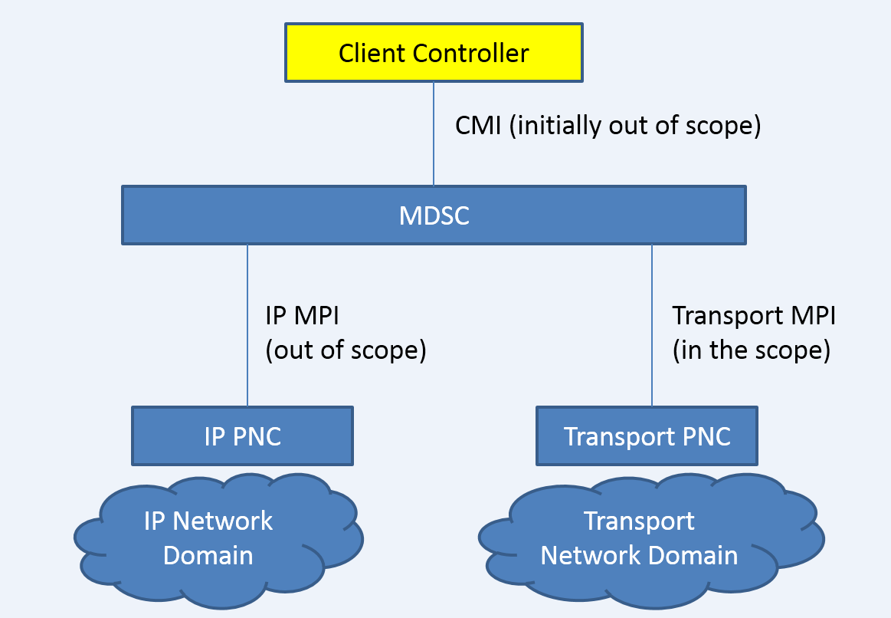

Considering the scope of controllers, it is assumed that the Customer Network Controller (CNC) has the knowledge of the C-Rx and its access link information. It is also assumed that MDSC has the knowledge on how to map C-Rx and its network side of nodes within its network domain; but MDSC does not have any topology information at all before each PNC reports its topology.

## Topology Abstraction



Figure 2 Reference Topology

### Single Domain Topology

In [TNBI-Use Cases1], single domain topology abstraction was described in section 3.1.1. This topology abstraction mechanism can be re-used in multi-domain scenario, with each of the PNC can report its respective topology to the MDSC.

### Multi-domain Topology Stitching

As assumed in the beginning of this section, MDSC does not have the knowledge of topologies from each domain until each PNC reports its topology, so the topology abstraction on MDSC starts from the topology reporting on MPI.

Given the topologies reported from multiple PNCs, the MDSC need to stitch the multi-domain topology and obtain the full map of topology. The topology of each domain main be in an abstracted shape (refer to section XX of fwk for different level of abstraction), while the inter-domain link information MUST be complete and fully configured by the MDSC.

[Issue: given assumption 3, how to/ which controller should describe the inter-domain link??]

## Multi-domain Service Configuration

Single-domain service configuration can be found as use case 1 that described in [TNBI-usecase].

In the following use cases, it is assumed that the CNC is capable to request service connectivity from the MDSC to support router connectivity. The same service scenarios, as described in section 3.3 of [TNBI-usecase], are also application to this use cases with the only difference that the two routers to be interconnected are attached to transport nodes which belong to different PNCs domains and are under the control of the CNC.

As an example, the objective in this section is to configure a transport service between C-R1 and C-R5. The cross-domain routing is assumed to be C-R1 <-> S3 <-> S2 <-> S31 <-> S33 <-> S34 <->S15 <-> S18 <-> C-R5.

According to the different client signal type, there is different adaptation required. In this document, we are trying our best to reuse what has been defined in [use-case1], which is the single domain case.

### Procedure Description

The service configuration procedure is assumed to be initiated from CNC to MDSC, by requesting a service from node A to node Z, by using XXX(LxSM, transport-service, VN, TBD) model. After receiving such request, MDSC need to determine the domain sequence, i.e., domain 1 <-> domain 2 <-> domain 3, with corresponding PNCs and boundary node. The MDSC will then decompose the tunnel request into a few tunnel segments via tunnel model (including both TE tunnel and OTN tunnel), and request different PNCs to compute each segment. Assume that each segment can be set up successfully, then each PNC response to the MDSC respectively. Given each segment, MDSC will take care of setting up the inter-domain tunnel via XXX (TE+OTN tunnel?), together with the configuration on access link. Then the end-to-end tunnel will be ready and MDSC will respond to CNC on the connection successful configuration.

### ODU Transit Service / OTN Client Private Line Service

To be added

### EPL over ODU Service

To be added

### Other OTN Client Services

To be added

## Protection Scenarios

### Linear Protection (end-to-end)

To be added

### Segmented Protection

To be added

# Topology Abstraction: detailed JSON examples

*JSON code "use-case-1-topology-03.json" will be provided at in the appendix of this document.*

# Service Configuration: detailed JSON examples

## ODU Transit Service

*JSON code "use-case-1-odu2-service-01.json" has been provided at in the appendix of this document.*

# Security Considerations

This section is for further study

# IANA Considerations

This document requires no IANA actions.

# Conclusions

This section is for further study

# References

## Normative References

[TNBI-UseCases] Busi, I., King, D. et al, "Transport Northbound Interface Use Cases", draft-tnbidt-ccamp-transport-nbi-use-cases, work in progress.

[TE-TOPO] Liu, X. et al., "YANG Data Model for TE Topologies", draft-ietf-teas-yang-te-topo, work in progress.

[OTN-TOPO] Zheng, H. et al., "A YANG Data Model for Optical Transport Network Topology", draft-ietf-ccamp-otn-topo-yang, work in progress.

[TE-TUNNEL] Saad, T. et al., "A YANG Data Model for Traffic Engineering Tunnels and Interfaces", draft-ietf-teas-yang-te, work in progress.

[OTN-TUNNEL] Zheng, H. et al., "OTN Tunnel YANG Model", draft-sharma-ccamp-otn-tunnel-model, work in progress.

## Informative References

[ACTN-YANG] Zhang, X. et al., "Applicability of YANG models for Abstraction and Control of Traffic Engineered Networks", draft-zhang-teas-actn-yang, work in progress.

[I2RS-TOPO] Clemm, A. et al., "A Data Model for Network Topologies", draft-ietf-i2rs-yang-network-topo, work in progress.

# Acknowledgments

The authors would like to thank all members of the Transport NBI Design Team involved in the definition of use cases, gap analysis and guidelines for using the IETF YANG models at the Northbound Interface (NBI) of a Transport SDN Controller.

The authors would like to thank Xian Zhang, Anurag Sharma, Sergio Belotti, Tara Cummings, Michael Scharf, Karthik Sethuraman, Oscar Gonzalez de Dios, Hans Bjursrom and Italo Busi for having initiated the work on gap analysis for transport NBI and having provided foundations work for the development of this document.

The authors would like to thank the authors of the TE Topology and Tunnel YANG models [TE-TOPO] and [TE-TUNNEL], in particular Igor Bryskin, Vishnu Pavan Beeram, Tarek Saad and Xufeng Liu, for their support in addressing any gap identified during the analysis work.

This document was prepared using 2-Word-v2.0.template.dot.

1. Validating a JSON fragment against a YANG Model

The objective is to have a tool that allows validating whether a piece of JSON code is compliant with a YANG model without using a client/server.

* 1. DSDL-based approach

The idea is to generate a JSON driver file (JTOX) from YANG, then use it to translate JSON to XML and validate it against the DSDL schemas, as shown in Figure 3.

Useful link: <https://github.com/mbj4668/pyang/wiki/XmlJson>

(2)

YANG-module ---> DSDL-schemas (RNG,SCH,DSRL)

| |

| (1) |

| |

Config/state JTOX-file | (4)

\ | |

\ | |

\ V V

JSON-file------------> XML-file ----------------> Output

(3)

1. – DSDL-based approach for JSON code validation

In order to allow the use of comments following the convention defined in section 2 without impacting the validation process, these comments will be automatically removed from the JSON-file that will be validate.

* 1. Why not using a XSD-based approach

This approach has been analyzed and discarded because no longer supported by pyang.

The idea is to convert YANG to XSD, JSON to XML and validate it against the XSD, as shown in Figure 4:

(1)

YANG-module ---> XSD-schema - \ (3)

+--> Validation

JSON-file------> XML-file ----/

(2)

1. – XSD-based approach for JSON code validation

The pyang support for the XSD output format was deprecated in 1.5 and removed in 1.7.1. However pyang 1.7.1 is necessary to work with YANG 1.1 so the process shown in Figure 4 will stop just at step (1).

* 1. JSON Code: use-case-3-topology-01.json

TBD

* 1. JSON Code: use-case-3-topology-01.json

TBDAuthors’ Addresses

Haomian Zheng (Editor)

Huawei

Email: [zhenghaomian@huawei.com](mailto:zhenghaomian@huawei.com)

Italo Busi

Huawei

Email: [italo.busi@huawei.com](mailto:italo.busi@huawei.com)

Yunbin Xu (Editor)

CAICT

Email: [xuyunbin@ritt.cn](mailto:xuyunbin@ritt.cn)

Ricard Vilalta

CTTC

Email: [ricard.vilalta@cttc.es](mailto:ricard.vilalta@cttc.es)