Ugrokit Demo Documentation

# Overview

Ugrokit Demo is an application that allows its user to download all available inventories to their mobile phone, do filtered search and convert the result to csv.

# Pages

## Download inventory

Upon opening the application, you can tap on the ‘action’ button at the top right of the page. You will be prompted to choose an action as shown in the picture below:

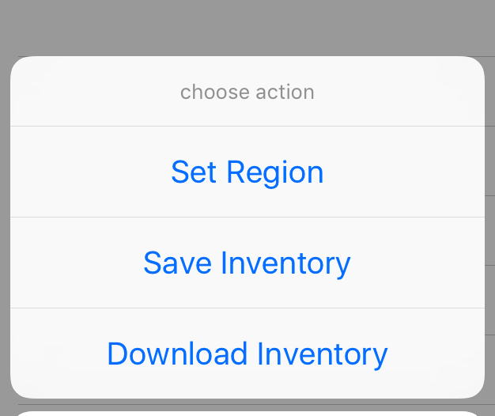

Clicking the ‘Download Inventory’ action will bring you the next page that displays all the inventories available in the database.

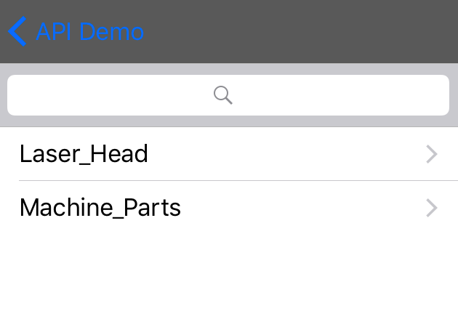

The method ‘fetchInvList’ below retrieves the inventory list from MySQL phpmyadmin site. This method sends a url to the web server defined in ‘Constants.h’.

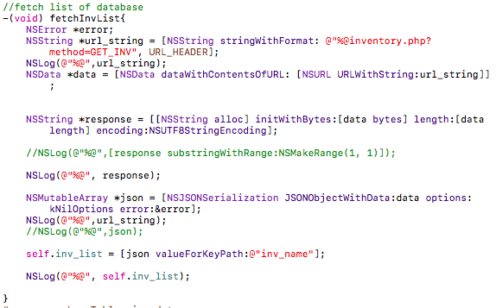

Files: downloadInv.m and downloadInv.h

## 2.2 Item List

This page displays all the items stored in the inventory selected on the ‘Download Inventory’ page.

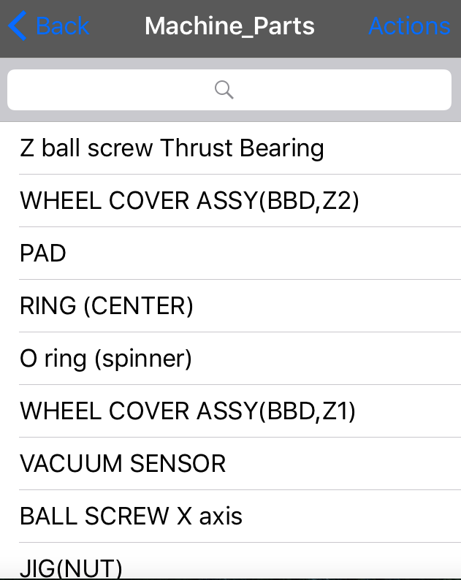

The items are retrieved by executing the method ‘fetchItemList’ below:

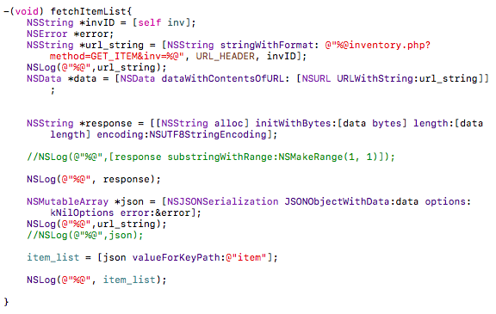

Similar to method ‘fetchInvList’, this method sends a url to the web server and store its response in the ‘response’ variable.

Files: itemList.m and itemList.h

## 2.3 Filter Page

This page allows the user to filter the items according to its name, part number, category, tag type, inspection date, and last scanned.

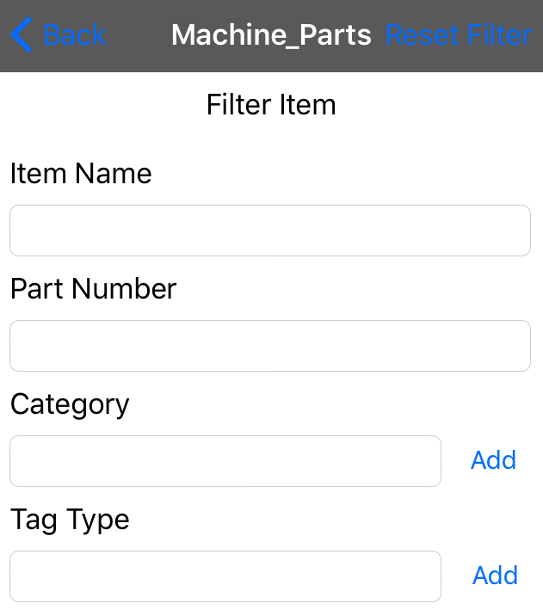

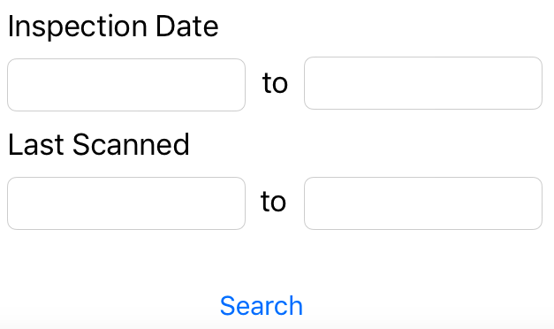

The search button is implemented as shown below:

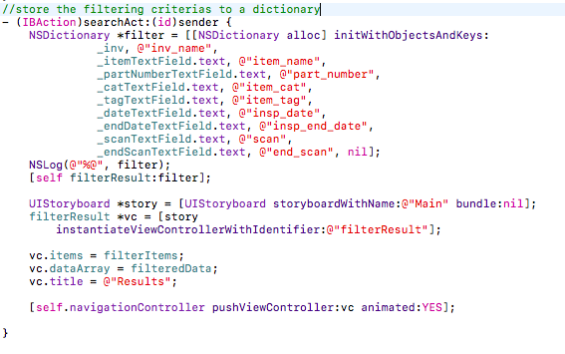

Upon pressing the button, the content of each field is stored in the ‘filter’ dictionary. This dictionary will then be sent as an argument to ‘filterResult’ function and the function will send the value of each key to ‘inventory.php’.

Files: filterPage.m and filterPage.h

## 2.4 Filter Result

This page displays the result of filtered search done on the previous page. Below is the result when the user filtered items whose category is ‘1000 days part’.

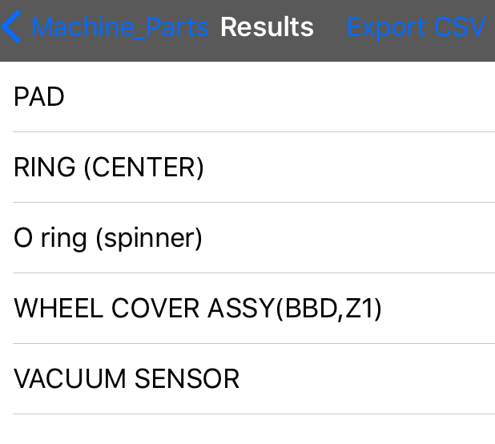

If the user clicks the ‘Export CSV’ button, the user will be prompted to choose the ‘send via Email’ or ‘open via Ms Excel’. As of now, ‘Open via Ms Excel’ action has not been implemented yet.

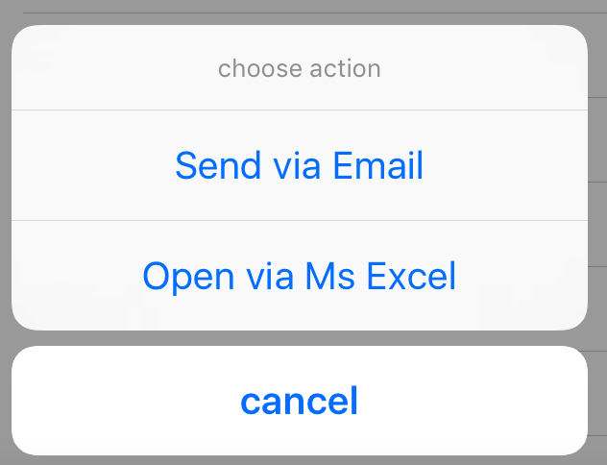

Files: filterResult.m and filterResult.h

## 2.5 Send via Email

This page displays a form in where the user needs to feel to send the csv file.

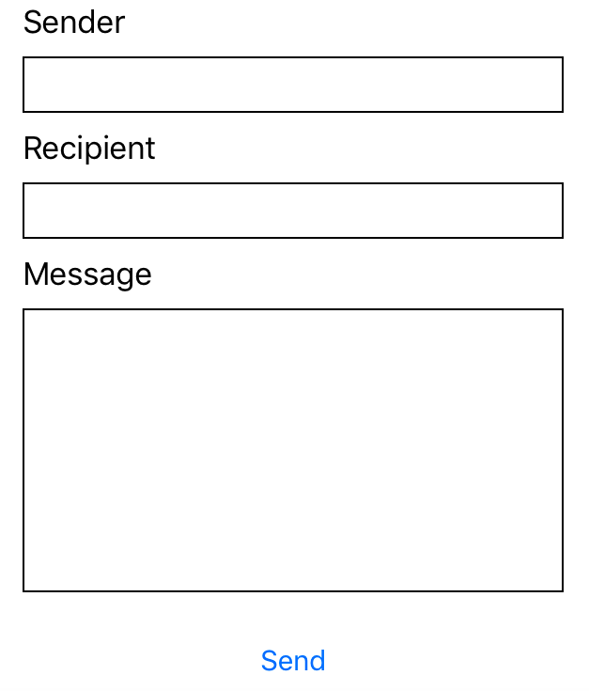

As of now, the send button is yet to be capable of sending the csv file. However, it is capable of converting the data to csv file and saving it to iOS core data.

The conversion of the data is implemented as follows:

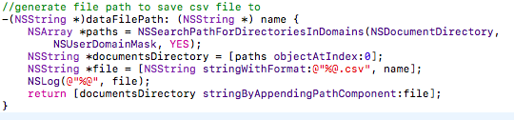

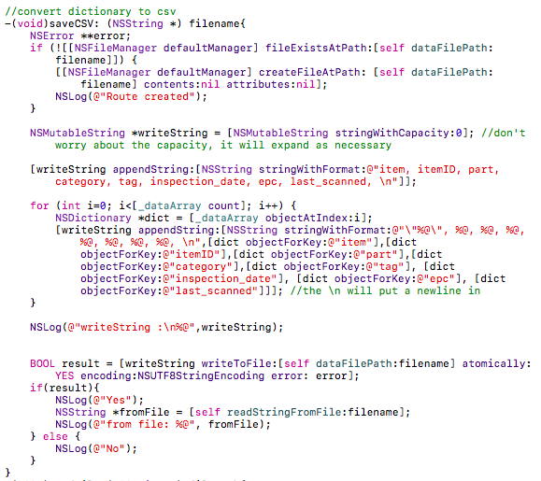

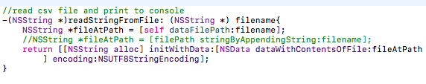

The csv file is accessible in the file path below:

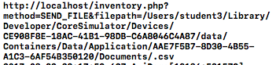

However, if the application is deployed to an iPhone, this file is not accessible.

The send button is implemented as shown below:

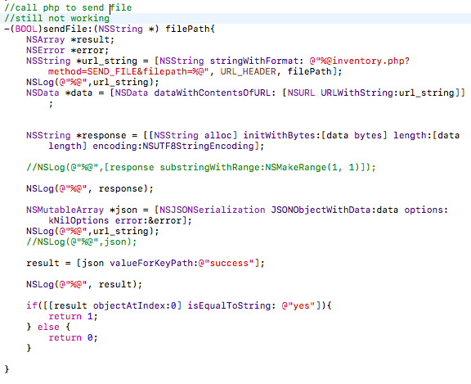

The send button will send a request to Php to send the file to user. The php ‘SEND_FILE’ method is able to send email to the user, but it is not yet able to access the csv file and attach it to the email.

Files: sendFile.m and sendFile.h

# Future Developments

1. To access the csv file once the application is deployed into an iPhone
2. To send the csv file to the user email
3. To extend the application to Ms Excel
4. To implement ‘save inventory’ action.