Results:

* Boxplot of Completion Time

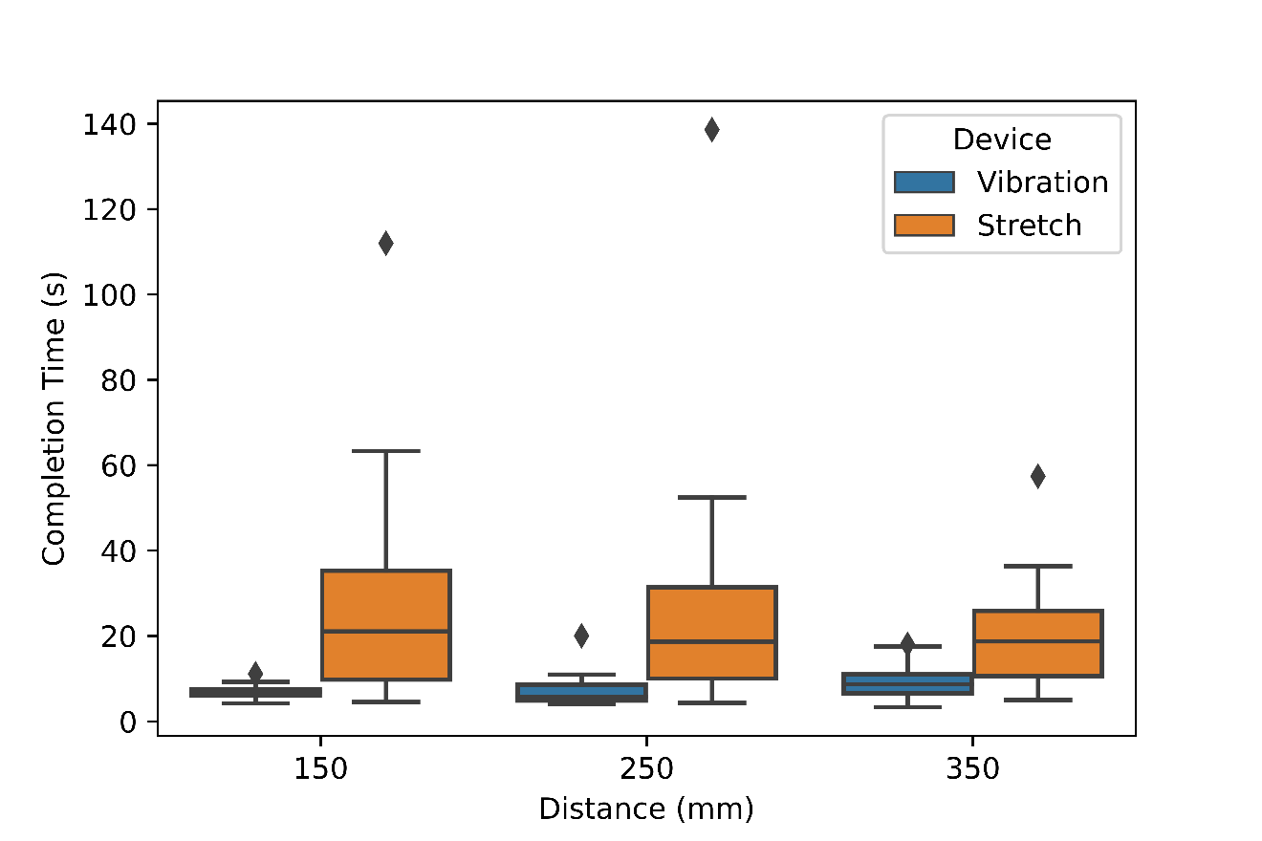

* Bootstrap CI of mean difference (n = 10,000)
  + Vibration150 – Stretch150, Mean-difference of means (-21.41, -31.22, -11.59)\*
  + Vibration250 – Stretch250, Mean-difference of means (-20.56, -30.92, -10.20)\*
  + Vibration350 – Stretch350, Mean-difference of means (-11.15, -16.11, -6.19)\*
* Bootstrap CI of mean difference (n = 10,000)
  + Vibration150 – Vibration250, Mean-difference of means (-0.43, -2.03, 1.17)
  + Vibration150 – Vibration350, Mean-difference of means (-2.43, -3.78, -1.08)\*
  + Vibration250 – Vibration350, Mean-difference of means (-1.98, -4.20, 0.24)
  + Stretch150 – Stretch250, Mean-difference of means (0.33, -7.08, 7.74)
  + Stretch150 – Stretch350, Mean-difference of means (7.96, -2.43, 18.36)
  + Stretch250 – Stretch350, Mean-difference of means (7.60, -4.13, 19.33)
* Boxplot of Reaction Time

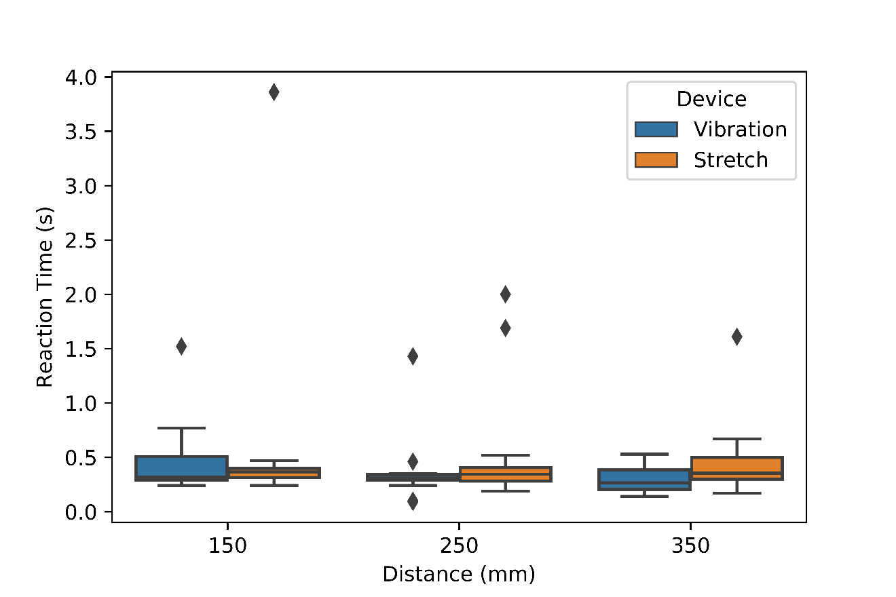

* Bootstrap CI of mean difference (n = 10,000)
  + Vibration150 – Stretch150, Mean-difference of means (-0.10, -0.43, 0.22)
  + Vibration250 – Stretch250, Mean-difference of means (-0.17, -0.38, 0.04)
  + Vibration350 – Stretch350, Mean-difference of means (-0.17, -0.27, -0.06)\*
* Bootstrap CI of mean difference (n = 10,000)
  + Vibration150 – Vibration250, Mean-difference of means (0.12, -0.03, 0.26)
  + Vibration150 – Vibration350, Mean-difference of means (0.18, 0.07, 0.29)\*
  + Vibration250 – Vibration350, Mean-difference of means (0.06, -0.03, 0.15)
  + Stretch150 – Stretch250, Mean-difference of means (0.05, -0.31, 0.41)
  + Stretch150 – Stretch350, Mean-difference of means (0.12, -0.22, 0.45)
  + Stretch250 – Stretch350, Mean-difference of means (0.07, -0.16, 0.29)