**NAME: WAQAR AHMED**

**ROLL NO:20P-0750**

**COAL LAB-REPORT 3**

***SUMMARY:.***

***Assembly instruction are made of operation code (OP) and operand. OP code identify action to be taken and operand consists of data. So in this lab we will be working on basic assembly instructions.***

***ExP 1:***

**MOVING AND ADDING DATA:**

**Explanation: moving 2 to ax then 4 to bx and adding ax to bx then adding 8 to ax**

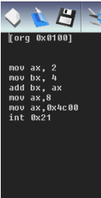[org 0x0100]

mov ax, 2

mov bx, 4

add bx, ax

mov ax,8

0x4c00

int 0x21

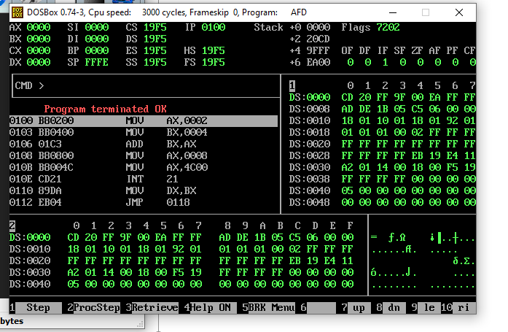

**ExP 2:**

**SWIPING TWO NUMBERS:**

**Explanation: mov 8 to ax now bx to 12 we can not to swtich directly so need 3rd register cx in which we will store value of ax then transfer value of bx to ax now we can easily transfer cx to bx**

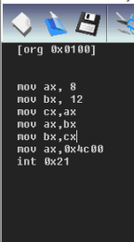**[org 0x0100]**

**mov ax, 8**

mov bx, 12

mov cx,ax

mov ax,bx

mov bx,cx

mov ax,0x4c00

int 0x21



**TASK:.**

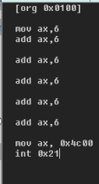[org 0x0100]

mov ax,6

add ax,6

add ax,6

add ax,6

add ax,6

add ax,6

mov ax, 0x4c00

int 0x21

