**Name: Waqar Ahmed**

**Roll #no : 20P-0750**

**Section: C**

1. **Increment**

**code ends up in the CX counter and pops up with each loop. The loop starts with CX at 0 and lasts until CX reaches 5.**

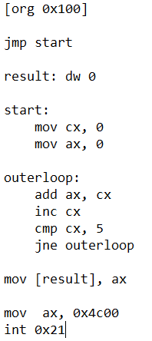

1. **Decrement**

code stores the counter in CX and decrements it with each loop. The loop starts with CX at 5 and lasts until CX reaches 0.

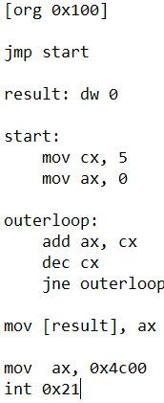

1. **Multiply**

code stores two 8-bit values in AL and DL and then multiplies them and stores them in AX which is 16-bits.

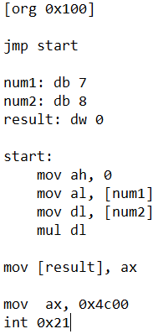

1. **Division**

code stores two values and stores them. One 16-bit into AX and one 8-bit value into DL. Then it divides DL from AX and stores it into AL.

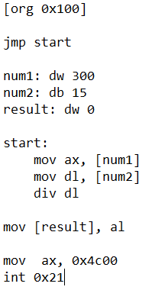

**Conclusion**

Different registers have their own different purpose. AX is an accumulator and is used to perform calculations. BX is used to store the address we would like to use. CX is used to store loop counters. DX is used to capture data that we may want to use for things like calculations