## WAQAR AHMED

## 20P-0750

## LAB REPORT 7

EXTENDED OPERATIONS:

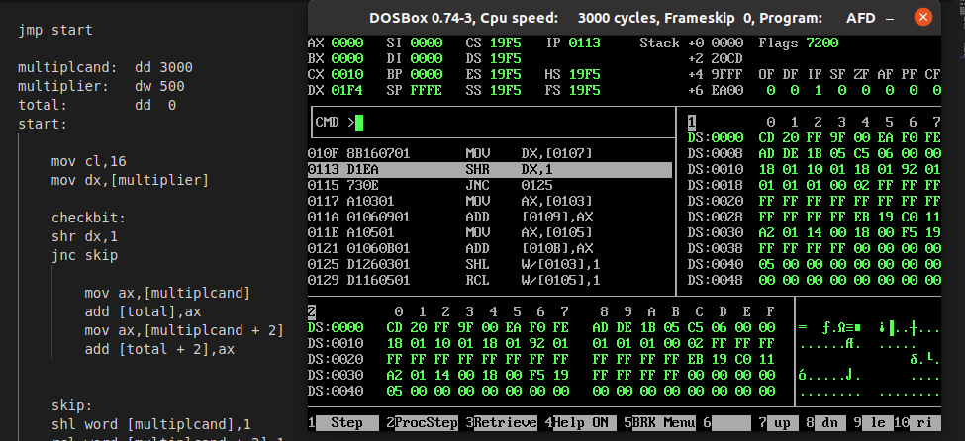

BITWISE OPERATIONS:

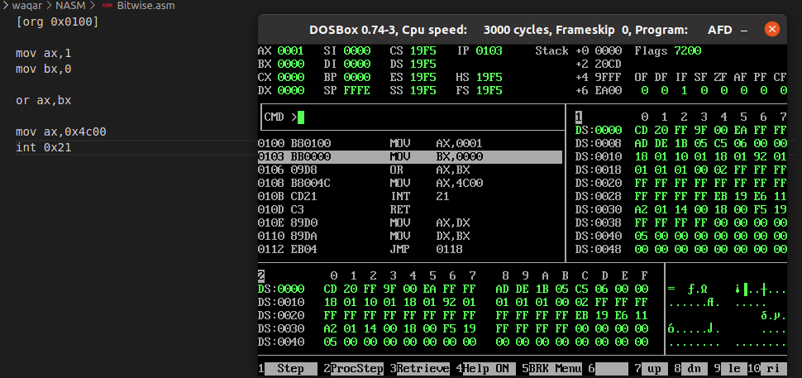

MASKING:

