## Name: Waqar Ahmed

## Roll #no: 20P-0750

## Section -4A

## CODE:

[org 0x0100]

jmp start

data: dw 2,0,0,7,5,0

result: dw 0

start:

mov ax, [data] ;adding first value to ax register

mov bx, 2 ; loading 2 to register bx

;code for maximum

maximum:

cmp [data + bx ],ax ;compare next value with first one

jbe notmaximum ;if next value is below or equal jump to notmaximum

mov ax,[data + bx] ;otherwise move maximum value to ax register

notmaximum:

add bx,2 ;increament bx by 2

cmp bx, 12 ;compare value of bx with 12

jnz maximum ;if zero flag is not set jump to maximum

mov [result],ax ; store maximum number in memory variable

mov ax , 0x4c00

int 0x21

## BEFORE EXECUTION:

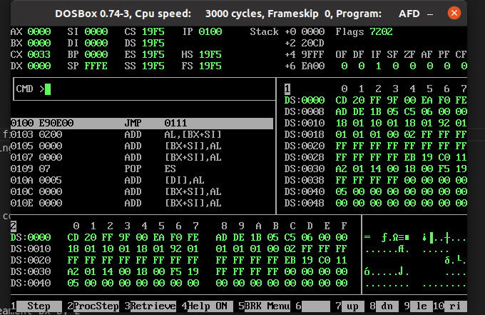

## AFTER EXECUTION:

