**Group Members:**

**Qalandar Ali (20P - 0625)**

**Sharjeel Hussain Bokhari (20P - 0150)**

**Yasir Nawaz (20P – 0557)**

**Hassan Ali (20P – 0149)**

**Farhan Ali (20P – 0019)**

**Sec: BCS 3C**

**Report: 13-14**

In this lab we did the practical implementations of what we learnt in the previous labs by programming an IC and connecting it to the 7- segment display using a breadboard.

Firstly, we looked up the datasheet of the microcontroller we were going to program then we programmed it using a burner and then looked at the microcontroller’s manual and 7 - segment manual so that we can figure out which wire connects to which pin of our microcontroller on our breadboard.

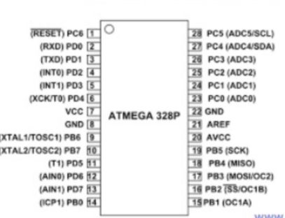

This is the datasheet of the atmega328p microcontroller that we used to get an idea of what we will be doing then we embedded our code into the microcontroller and connect that chip to a bread board then using the 7 - segment display manual we determined that which wire needed to be connected to the which part of the 7 - segment display to get our desired output

This is the seven segments display manual structure that we used:

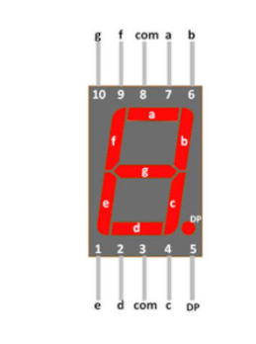

**After we had done everything we got our desired outcome when we gave power to this whole process**

**The output video will be shared in the zip file with it**