NAME : WAQAR AHMED
ROLL NO. :20P-0750
COAL LAB-REPOR 2

SUMMARY:
In the 2nd lab of COAL we have installed NASM & DOSBox.
AFD id debugger used by NASM. After the installations of NASM & DOSBOX we have to run dosbox and mount our NASM directory with virtual directory. Check debugger by using command AFD then open and excute any asm file.
Following are the steps we have followed.
- Mount x d:/ASSEMBLY
- X:
- Afd
- Quit
- Nasm first.asm -o first.com
- Afd first.com
- DIR

OPEN DOSBOX:

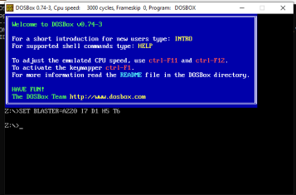

CHECKING AFD WORKING OR NOT

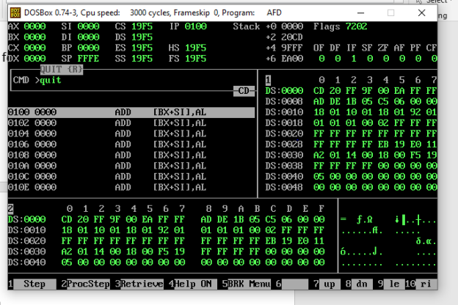

SIMPLE PROGRAM:

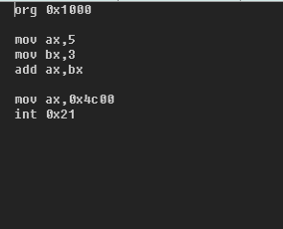

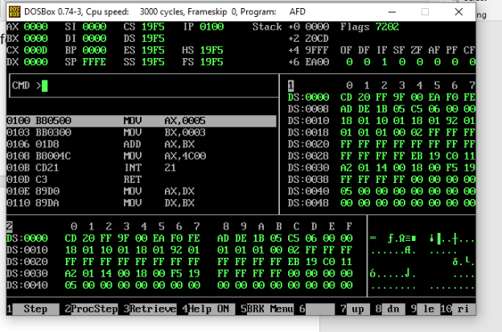
PROGRAM EXCUTED SUCCESFULLY.

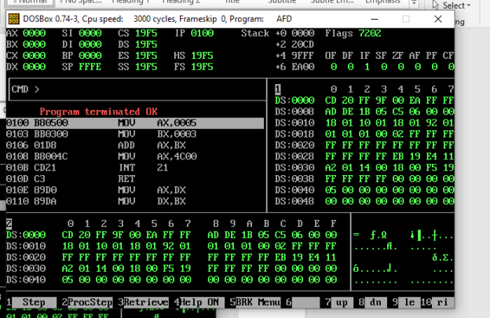

ALL STEPS THAT ARE FOLLOWED:

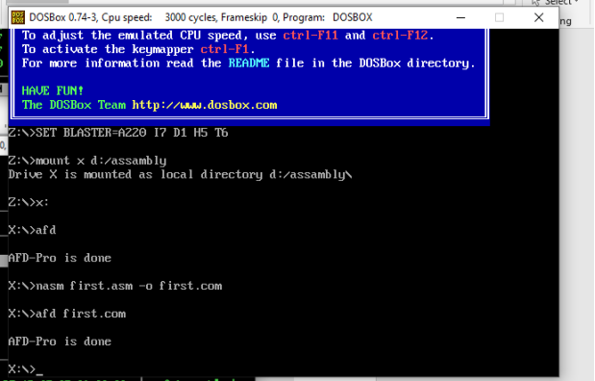

ANOTHER SIMPLE PROGRAM:

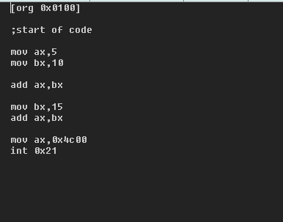

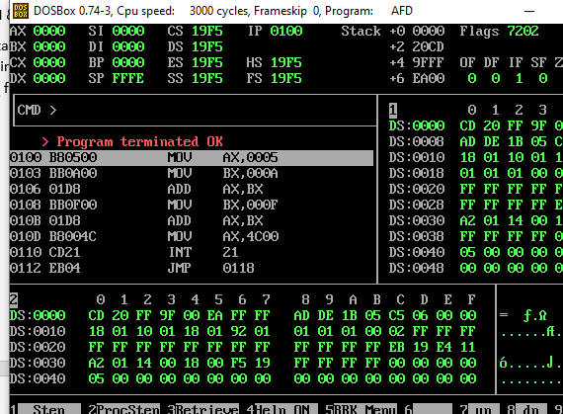

ANOTHER SIMPLE PROGRAM:

