TASK-1

def multi(l):

a=1

for i in l:

a *=i

return a

multi([2,3,5])

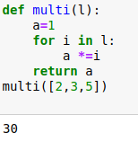

TASK-2

lst = [2,3,4,5,5,2,3,4,4,7] #temp list

a = [] #empty list

def uni_ele(lst):

for i in lst:

if i not in a:

a.append(i)

uni_ele(lst)

print("the list of unique numbers ",a)

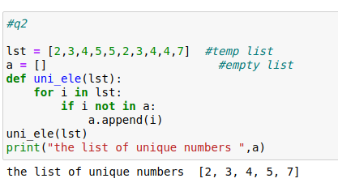

TASK-3

l = ["waqar","khan","younis","usmanjan","muzamil"]

n = 5 #length of list

for i in l:

if len(i) > len(l):

print(i)

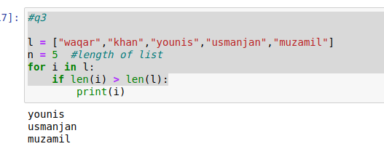

TASK-4

a = []

for i in range(1,11):

num = int(input("enter number: "))

a.append(num)

print(a)

b = int(input("enter a number for check in a list: "))

i = 0

while(i<len(a)):

i = i+1

if a[i]==b:

print("Number is Present in list")

break

else:

print("Number is Not Present in list")

break

