Name: Waqar Ahmed
RollNo: 20P-0750
LabTask 06

Q1)

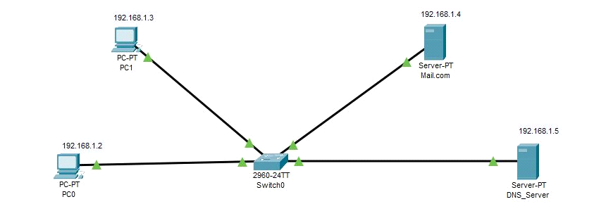
2. Configure IP addresses on the PCs, DNS Server and the Mail Server
• Mail Server IP address: 192.168.1.4
• PC0 IP address: 192.168.1.2
• PC1 IP address: 192.168.1.3
• DNS server IP address: 192.168.1.5
connect two pcs and two servers to switch. Set one server for DNS and the other one for mail. Give ips to every device. Set up the email server. Give domain name of email server to dns server. After that add users in email server.
3. Configure mail clients on the PCs and mail service on the generic server.
Mail Clients:
PC1:
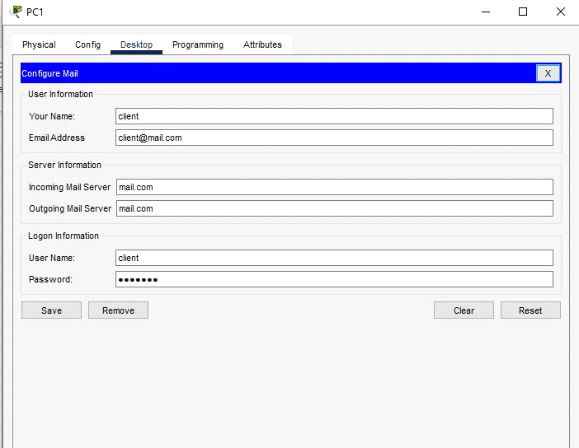

PC0:

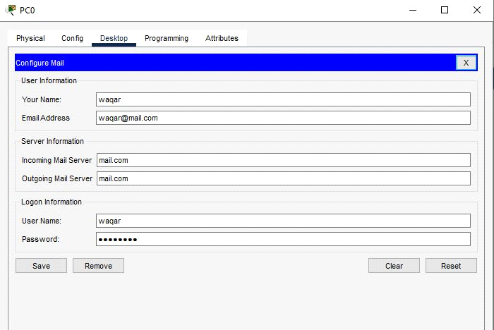

Mail Server:

Next, we’ll configure the email server.
To do this, click on the server, then click Services tab, pick email server from the menu.
Provide the Domain name of the server then click on Set to set it. In this example I’ve used the name
‘mail.com’ .
Proceed and add users and provide their passwords. I have two email clients(users) with
usernames ‘user1‘ and ‘user2‘ with a common password ‘admin‘
After entering a username and password, click on Add(+) to add the user to the server. You can
optionally remove a user by clicking on Remove (-). You can change a user’s password by clicking
on change password.

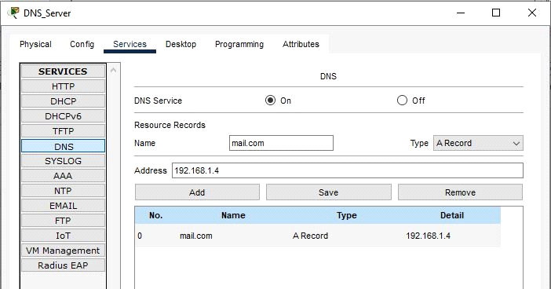
4. Lastly test the email service.
Go to PC0 email client, compose an email and send it to PC1 email address 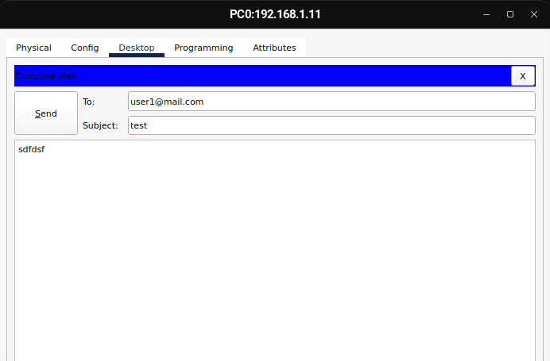
Try to see whether the email from PC0 is received on PC1. On the email client of PC1, click on Receive.
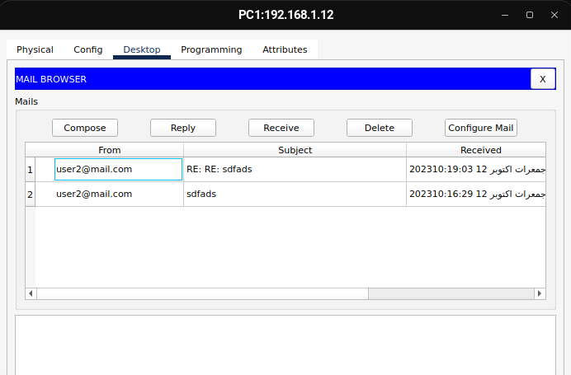
Replying to user 1:
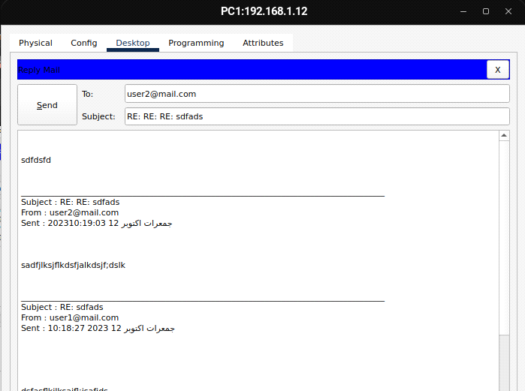
received:

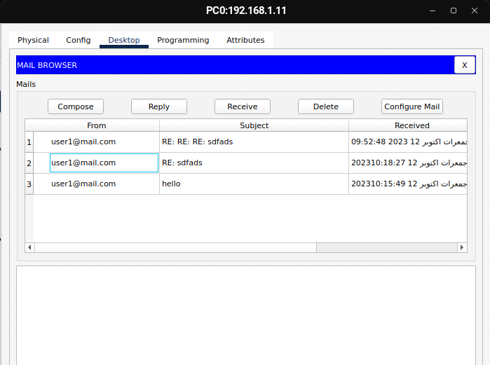

TOPOLOGY:

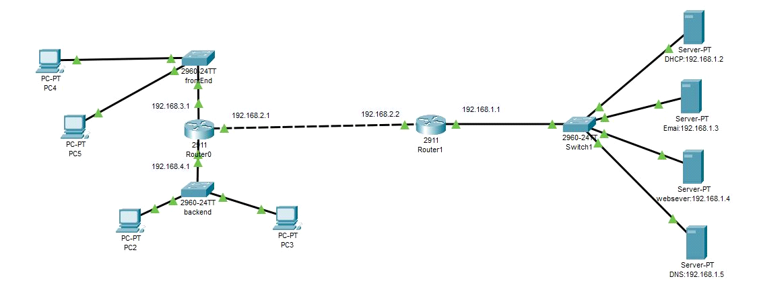

. Configure IP addresses on the Pcs, Routers
, DNS Server,Web Server, DHCP and the Mail Server
• Mail Server IP address: 192.168.1.3
• Dhcp IP address: 192.168.1.2
• Web Server IP address: 192.168.1.4
• Frontend network IP address: 192.168.3.1
• Backend network IP address: 192.168.4.1
• Management network IP address: 192.168.1.1
• PC0 IP address: 192.168.1.11
• PC1 IP address: 192.168.1.12
• DNS server IP address: 192.168.1.5

DHCP SERVER CONFIG:
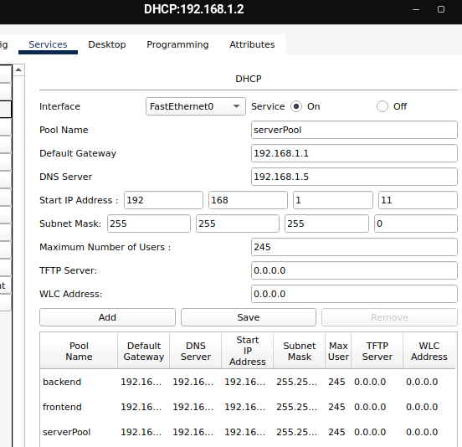

EMAIL SERVER CONFIG:
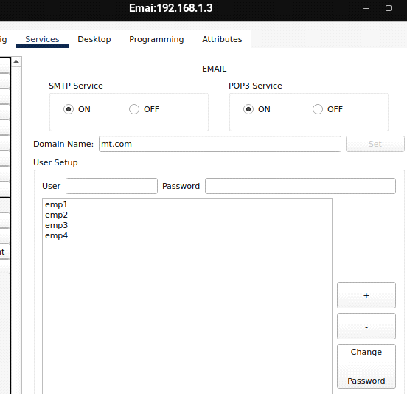

DNS SERVER CONFIG:

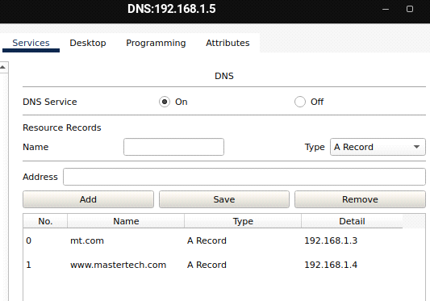
frontend network to backend network email:

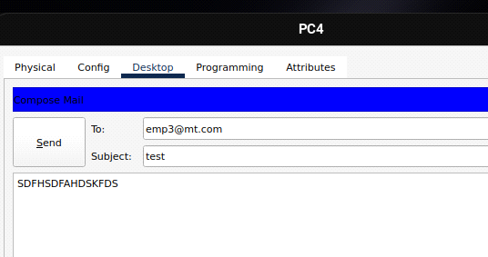
RECEIVED EMAIL FROM FRONT END TO BACKEND:

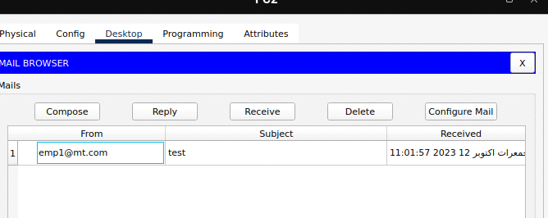
Web Server Testing:

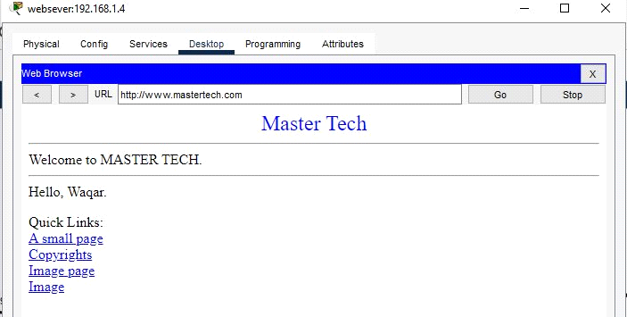

Frontend network:

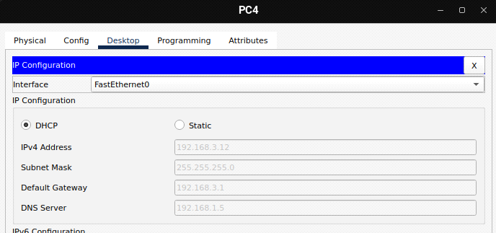

Backend network:
