



 





NATIONAL UNIVERSTIY OF COMPUTER AND EMERGING SCIENCES, FAST- PESHAWAR CAMPUS

Department of Computer Science & Software Engineering

Computer Networks Lab 11

**-----------------------------------------------------------------------------------------------**

# Objective

The objective of this lab is to provide students with a comprehensive understanding of IP addressing, subnetting, and designing an appropriate addressing scheme. Students will learn about IP address classes, subnet masks, network addresses, broadcast addresses, and the concept of subnetting. Through practical implementation in Packet Tracer, students will gain hands-on experience in subnetting and designing subnets.

# Learning Outcomes

By the end of this lab, students will be able to:

* Understand the concepts of IP address, network address, broadcast address, and subnet mask.
* Review the different IP address classes (Class A, Class B, and Class C) and their ranges.
* Explain the concept of subnetting and its importance in network design.
* Perform subnetting calculations to determine the network address, broadcast address, and number of hosts in a subnet.
* Determine the number of subnets required for a given network design.
* Design an appropriate addressing scheme using subnetting techniques.
* Implement subnetting in Packet Tracer to configure IP addresses and subnet masks for devices.
* Validate and test the functionality of the subnetted network in Packet Tracer.

Table of Contents

Objective 1

Learning Outcomes 1

Understand IP Addresses 3

Network Masks 3

Determine Network Address 4

Task 1 : Determine Network Address of the following IP Address 5

Calculating Number of Hosts 5

Task 2 : Determine the network and broadcast addresses and number of hosts bits and hosts for the given IPv4 addresses and prefixes in the following table. 5

Understand Subnetting 6

The Need for Subnets 7

The Subnetting Process 8

Possible Number of Subnets 9

Subnetting Network Topologies 9

Task 3: Network Topology A 9

Task 4: Network Topology B 10

**Understand IP Addresses**

(128+64+32+16+8+4+2+1=255)

|  |  |  |  |  |  |  |  |  |
| --- | --- | --- | --- | --- | --- | --- | --- | --- |
| Binary | 1 | 1 | 1 | 1 | 1 | 1 | 1 | 1 |
| Power of 2 | 27 | 26 | 25 | 24 | 23 | 22 | 21 | 20 |
|  | 128 | 64 | 32 | 16 | 8 | 4 | 2 | 1 |

Here is a sample octet conversion when not all of the bits are set to 1. 0 1 0 0 0 0 0 1

0 64 0 0 0 0 0 1 (0+64+0+0+0+0+0+1=65)

And this sample shows an IP address represented in both binary and decimal.

10. 1. 23. 19 (decimal)

00001010.00000001.00010111.00010011 (binary)

These octets are broken down to provide an addressing scheme that can accommodate large and small networks. There are five different classes of networks, A to E. This document focuses on classes A to C, since classes D and E are reserved and discussion of them is beyond the scope of this document.

**Network Masks**

A network mask helps you know which portion of the address identifies the network and which portion of the address identifies the node. Class A, B, and C networks have default masks, also known as natural masks, as shown here:

Class A: 255.0.0.0

Class B: 255.255.0.0

Class C: 255.255.255.0

An IP address on a Class A network that has not been sub-netted would have an address/mask pair similar to: 8.20.15.1 255.0.0.0. In order to see how the mask helps you identify the network and node parts of the address, convert the address and mask to binary numbers.

8.20.15.1 = 00001000.00010100.00001111.00000001

255.0.0.0 = 11111111.00000000.00000000.00000000

Once you have the address and the mask represented in binary, then identification of the network and host ID is easier. Any address bits which have corresponding mask bits set to 1 represent the network ID. Any address bits that have corresponding mask bits set to 0 represent the node ID.

8.20.15.1 = 00001000.00010100.00001111.00000001

255.0.0.0 = 11111111.00000000.00000000.00000000

net id | host id

netid = 00001000 = 8

hostid = 00010100.00001111.00000001 = 20.15.1

## Determine Network Address

We will use, 192.168.5.85 /24 Address. Let’s determine the network and host part of this address. This is the first example, so we are starting with an easy example.

IP Address : **192.168.5.85**

Subnet Mask : **255.255.255.0**

firstly we will convert this decimal numbers to the binary equals. IP Address : **11000000. 10101000.00000101.01010101**

Subnet Mask : **11111111. 11111111. 11111111.00000000**

For this IP and Subnet Mask, to determine the Network Address of this IP address, we will use “**AND**” operation between IP Address and Subnet Mask in binary mode.

### IP Add: 11000000. 10101000.00000101.01010101

### SubM : 11111111. 11111111. 11111111.00000000

### AND : 11000000. 10101000.00000101.00000000

When we use AND operation with this binary numbers, as you can see, the last octet will be multiple with zero **(AND is Multiplication)**. So the result of this multiplication will

be **192.168.5.0**. Here, the first three octets will be same as IP address and the last octet will be full of 0s.

For this example our broadcast address will be **192.168.5.255**. As you can see, all the host bits are full of 1s for broadcast address. The other addresses in the middle

through **192.168.5.1** to **192.168.5.254** are host addresses.

## Task 1 : Determine Network Address of the following IP Address

IP address : 10.128.240.50/30. Also, determine broadcast and range of host addresses.

## Calculating Number of Hosts

Consider the following example:

|  |  |
| --- | --- |
| **IP Address** | 172.30.239.145 |
| **Subnet Mask** | 255.255.192.0 |
| **Result (Network)** | 172.30.192.0 |

Continuing with this example, determining the number of hosts per network can be calculated by analyzing the subnet mask. The subnet mask will be represented in dotted decimal format, such as 255.255.192.0, or in network prefix format, such as /18. An IPv4 address always has 32 bits. Subtracting the number of bits used for the network portion (as represented by the subnet mask) gives you the number of bits used for hosts.

Using our example above, the subnet mask 255.255.192.0 is equivalent to /18 in prefix notation. Subtracting 18 network bits from 32 bits results in 14 bits left for the host portion. From there, it is a simple calculation:

2(number of host bits) - 2 = Number of hosts 214 = 16,384 – 2 = 16,382 hosts

## Task 2 : Determine the network and broadcast addresses and number of hosts bits and hosts for the given IPv4 addresses and prefixes in the following table.

|  |  |  |  |  |
| --- | --- | --- | --- | --- |
| **IPv4**  **Address/Prefix** | **Network Address** | **Broadcast Address** | **Total Number of Host Bits** | **Total Number of Hosts** |
| 192.168.100.25/28 |  |  |  |  |
| 172.30.10.130/30 |  |  |  |  |
| 10.1.113.75/19 |  |  |  |  |
| 198.133.219.250/24 |  |  |  |  |

**Understand Subnetting**

Subnetting allows you to create multiple logical networks that exist within a single Class A, B, or C network. If you do not subnet, you are only able to use one network from your Class A, B, or C network, which is unrealistic.

Each data link on a network must have a unique network ID, with every node on that link being a member of the same network. If you break a major network (Class A, B, or C) into smaller subnetworks, it allows you to create a network of interconnecting subnetworks. Each data link on this network would then have a unique network/subnetwork ID. Any device, or gateway, that connects *n* networks/subnetworks has *n* distinct IP addresses, one for each network / subnetwork that it interconnects.

In order to subnet a network, extend the natural mask with some of the bits from the host ID portion of the address in order to create a subnetwork ID. For example, given a Class C network of 204.17.5.0 which has a natural mask of 255.255.255.0, you can create subnets in this manner:

204.17.5.0 -

11001100.00010001.00000101.00000000

255.255.255.224 - 11111111.11111111.11111111.11100000

|sub|

By extending the mask to be 255.255.255.224, you have taken three bits (indicated by "sub") from the original host portion of the address and used them to make subnets. With these three bits, it is possible to create eight subnets. With the remaining five host ID bits, each subnet can have up to 32 host addresses, 30 of which can actually be assigned to a device *since host ids of all zeros or all ones are not allowed* (it is very important to remember this). So, with this in mind, these subnets have been created.

|  |  |  |
| --- | --- | --- |
| **Subnets** | **Subnet Masks** | **Host Range** |
| 204.17.5.0 | 255.255.255.224 | host address range 1 to 30 |
| 204.17.5.32 | 255.255.255.224 | host address range 33 to 62 |
| 204.17.5.64 | 255.255.255.224 | host address range 65 to 94 |
| 204.17.5.96 | 255.255.255.224 | host address range 97 to 126 |
| 204.17.5.128 | 255.255.255.224 | host address range 129 to 158 |

|  |  |  |
| --- | --- | --- |
| 204.17.5.160 | 255.255.255.224 | host address range 161 to 190 |
| 204.17.5.192 | 255.255.255.224 | host address range 193 to 222 |
| 204.17.5.224 | 255.255.255.224 | host address range 225 to 254 |

## The Need for Subnets

What exactly is subnetting? Subnetting is taking an IP network and subdividing it into smaller IP networks called subnetworks, or subnets. Every IP network, or subnet, is a broadcast domain. A broadcast domain is a collection of devices that can receive broadcast traffic from each other.

Broadcast traffic is traffic that is delivered to every device on the network.

Having a single broadcast domain, or a "flat network," presents two main problems.

1. In a single large broadcast domain, there is a large amount of broadcast traffic. Broadcast traffic is very inefficient and consumes large amounts of resources, such as bandwidth, processor cycles, and memory. In fact, enough broadcast traffic on a network can cause other applications, such as email, word processors, and spreadsheets, to be negatively impacted.
2. When all devices are part of the same broadcast domain, there are no protocol boundaries between devices, so implementing security policies is difficult. In other words, there is no easy way to protect one device from another device without using host-based mechanisms, such as host-based firewalls, permissions, rights, and anti-virus. These methods serve a valuable purpose, but they are not very efficient, and they can degrade performance of the host.

The solution to these problems is to break the single large broadcast domain into several smaller broadcast domains. By doing this, the number of devices connected to each broadcast domain is smaller. This reduces the amount of broadcast traffic, improving the performance of all devices on the network. Additionally, a boundary between devices is created, which greatly improves and simplifies the implementation of security policies.

As an analogy, imagine a single room, and in this room are five different groups of people; one group in each corner and one group in the center. Each group of people has a microphone and is discussing a different topic. If you were a member of one of the groups, picture how difficult it would be to hear people in your group, concentrate on your topic, and share confidential information.

Now imagine the single room being separated into five smaller rooms. Each group now has its own room with a door and can communicate without competing with the other groups. Each

person can hear and concentrate better and more easily keep confidential information within the group.

The concept of dividing a large room into smaller rooms is the same as the concept of dividing a large broadcast domain (IP network) into smaller broadcast domains (subnets).

## The Subnetting Process

In order to create IP subnets, host bits are changed to network bits. This is often called borrowing bits. It is also often referred to as taking host bits and giving them to the network. By borrowing host bits, more IP subnets are created, but each subnet can support fewer hosts.

To change a host bit to a network bit, the subnet mask must be changed. Remember, a binary 0 in the subnet mask means that bit is part of the host portion of an IP address. A binary 1 in the subnet mask means that bit is part of the network portion of an IP address. So, to change a bit from a host bit to a network bit, the binary value of the bit must be changed from 0 to 1 in the subnet mask.

When calculating subnets, the following process should be used.

1. Determine the assigned IP address space.
2. Determine the number of subnets required based on the design of the existing network, along with the structure of the organization. It is common to assign a subnet to each department within the organization.
3. Based on the class of the IP address space and the number of required subnets, determine how many host bits need to be borrowed. Also determine how many hosts each subnet can support.
4. Calculate the decimal value and prefix value of the new subnet mask.
5. Apply the subnet mask to the assigned IP address space to calculate the network address of the new possible subnets, the broadcast address for each possible subnet, and the range of usable IP addresses in each possible subnet.
6. Assign IP addresses to all devices, including router interfaces that are connected to that subnet.

## Possible Number of Subnets

To calculate the number of possible subnets, use the formula 2n , where n equals the number of host bits borrowed. For example, if three host bits are borrowed, then n=3. 23 = 8, so eight subnets are possible if three host bits are borrowed.

The table below lists the powers of 2.

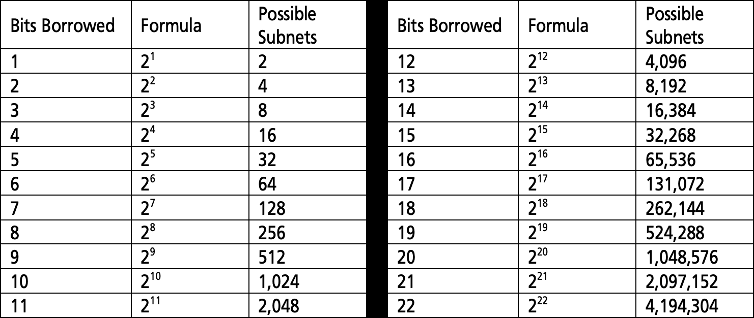

**Subnetting Network Topologies**

When given a network topology, it is important to be able to determine the number of subnets required. In this lab, several scenario topologies will be provided, along with a base network address and mask. You will subnet the network address and provide an IP addressing scheme that will accommodate the number of subnets displayed in the topology diagram. You must determine the number of bits to borrow, the number of hosts per subnet, and potential for growth as specified by the instructions.

## Task 3: Network Topology A

In Part 1,you have been given the 192.168.10.0/24 network address to subnet, with the following topology. De termine the number of networks needed and then design an appropriate addressing scheme.

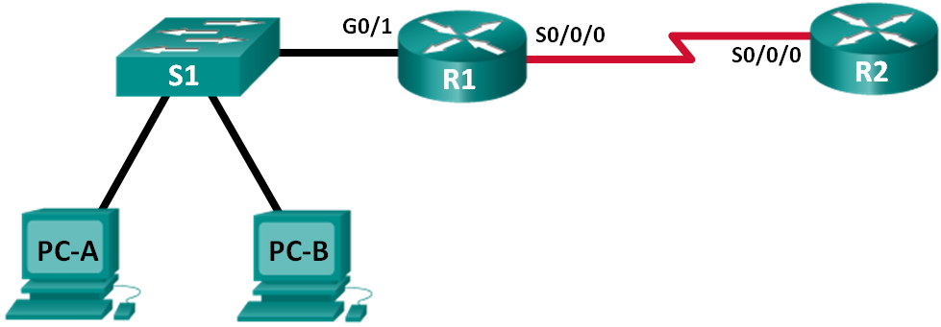

**Step 1: Determine the number of subnets in Network Topology A.**

* 1. How many subnets are there?
  2. How many bits should you borrow to create the required number of subnets?
  3. How many usable host addresses per subnet are in this addressing scheme?
  4. What is the new subnet mask in dotted decimal format?
  5. How many subnets are available for future use?

**Step 2: Record the subnet information.**

Fill in the following table with the subnet information:

|  |  |  |  |  |
| --- | --- | --- | --- | --- |
| **Subnet Number** | **Subnet Address** | **First Usable Host Address** | **Last Usable Host Address** | **Broadcast Address** |
| 0 |  |  |  |  |
| 1 |  |  |  |  |
| 2 |  |  |  |  |
| 3 |  |  |  |  |
| 4 |  |  |  |  |
| 5 |  |  |  |  |

## Task 4: Network Topology B

The topology has changed again with a new LAN added to R2 and a redundant link between R1 and R3. Use the 192.168.10.0/24 network address to provide addresses to the network devices. Also provide an IP address scheme that will accommodate these additional devices. For this topology, assign a subnet to each network.

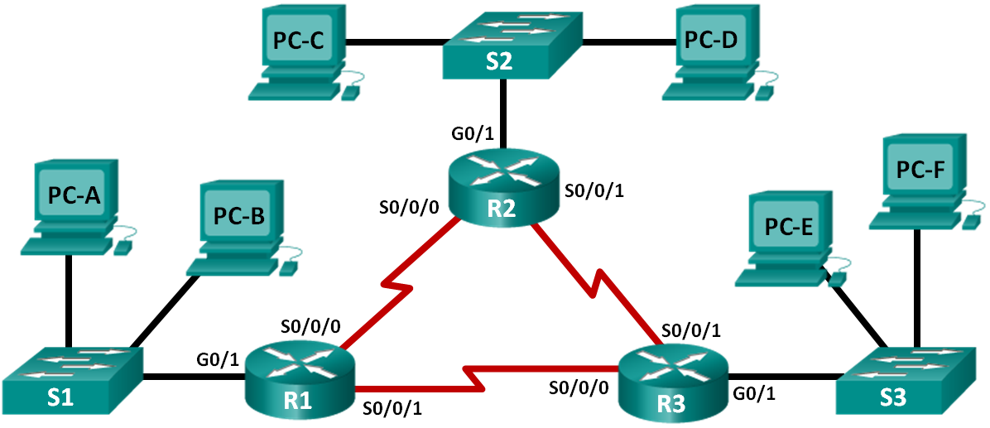

**Step 1: Determine the number of subnets in Network Topology B.**

1. How many subnets are there?
2. How many bits should you borrow to create the required number of subnets?
3. How many usable host addresses per subnet are in this addressing scheme?
4. What is the new subnet mask in dotted decimal format?
5. How many subnets are available for future use?

**Step 2: Record the subnet information.**

Fill in the following table with the subnet information:

|  |  |  |  |  |
| --- | --- | --- | --- | --- |
| **Subnet Number** | **Subnet Address** | **First Usable Host Address** | **Last Usable Host Address** | **Broadcast Address** |
| 0 |  |  |  |  |
| 1 |  |  |  |  |
| 2 |  |  |  |  |
| 3 |  |  |  |  |
| 4 |  |  |  |  |
| 5 |  |  |  |  |
| 6 |  |  |  |  |
| 7 |  |  |  |  |
| 8 |  |  |  |  |

**Step 3: Assign addresses to network devices in the subnets.**

a. Fill in the following table with IP addresses and subnet masks for the router interfaces:

|  |  |  |  |
| --- | --- | --- | --- |
| **Device** | **Interface** | **IP Address** | **Subnet Mask** |
| R1 | GigabitEthernet 0/1 | 192.168.10.1 | 255.255.255.224 |
|  | Serial 0/0/0 | 192.168.10.33 | 255.255.255.224 |
|  | Serial 0/0/1 | 192.168.10.65 | 255.255.255.224 |
| R2 | GigabitEthernet 0/1 | 192.168.10.66 | 255.255.255.224 |
|  | Serial 0/0/0 | 192.168.10.98 | 255.255.255.224 |
|  | Serial 0/0/1 | 192.168.10.161 | 255.255.255.224 |
| R3 | GigabitEthernet 0/1 | 192.168.10.34 | 255.255.255.224 |
|  | Serial 0/0/0 | 192.168.10.97 | 255.255.255.224 |
|  | Serial 0/0/1 | 192.168.10.129 | 255.255.255.224 |